UNITED NATIONS
Following are the events which led to the establishment of the United Nations.
- The declaration of St. James’ Palace (June 12, 1941): the representatives of the 9 exiled governments along with Britain, Canada, New Zealand expressed their desire to establish peace.
- The Atlantic charter (Aug 14, 1941): this was in fact meeting of the two great statesmen of the world WINSTON CHURCHILL AND F.D. ROSEVELT in Atlantic Ocean. They undertook to make join efforts to end the use of force and to institutionalize the global security.
- The United Nations declaration (Jan 1, 1942): in this declaration, for the first time, the words United Nations were used. In this declaration each state pledged to render cooperation to each other and undertook the obligation that it would not enter into any agreement or treaty separately with the enemy.
- Moscow declaration (Oct 30, 1943): the representatives of Britain, USA, China and Russia undertook to take joint action against the enemy. The urgent need of the establishment of The organization based on the principle of equality of Nations should be open.
- The Tehran conference (Dec 1, 1943): further emphasized the urgent need of establishment of organization capable of maintaining peace and security. Stalin was presented with the idea of four policeman by USA.
- Dumbarton oaks conference (1944): it formed the basis of the charter of the United Nations. Structure of UN was decided-6 organs. Idea of collective security: Art 33, ART 37 recommendations. Disagreement over the membership and veto.
- The Yalta conference (Feb 11, 1945): it gave final shape to the proposed world organization.
- San Francisco conference (June 25, 1945): in this conference UN charter was voted and unanimously adopted. The charter came into force on Oct 24, 1945, and 51 states was the original members of the United Nations.
PURPOSES/OBJECTIVES OF THE UNITED NATIONS: ART 1
- To maintain international peace and security.
- To develop friendly relations among nations.
- International cooperation in solving international problems of social, political and economic charter.
- To make the UN a center for the attainment of the above common ends.

PRINCIPLES OF THE UNITED NATIONS: ART 2
- The principle of sovereign equality of all members.
- Peaceful settlement of international dispute.
- Principle of non-intervention. (all the members shall refrain in their IR from the threat or use of force against the territorial integrity and political autonomy of any state). ARTICLE 2(4).
- all members shall give the United Nations every assistance in common actions.
- Non-intervention in the domestic matters of state. ARTICLE 2(7)

MEMBERSHIP CRITERIA:
- It must be a state.
- State must be peace-loving.
- It must accept the obligations of the charter.
- It must be willing to carry out these obligations.
- It must be able to carry out these obligations.

ACCORDING TO ARTICLE 7 OF UN CHARTER, FOLLOWING ARE THE PRINCIPAL ORGANS OF THE UNITED NATIONS
- THE GENERAL ASSEMBLY.
- THE SECURITY COUNCIL.
- INTERNATIONAL COURT OF JUSTICE.
- TRUSTEESHIP COUNCIL.
- SOCIO-ECONOMIC COUNCIL.
- THE SECRATRIAT.

- THE GENERAL ASSEMBLY OF THE UNITED NATIONS:
Composition: it consists of all the members of the UN. Each member may have not more than 5 representatives in the GA.
Voting Rights: each member has one vote. Decisions on important questions are made by a two-thirds majority of the members present and voting.
FUNCTIONS AND POWERS OF THE GENERAL ASSEMBLY:
- Deliberative functions.
- Supervisory functions.
- Financial functions.
- Elective functions.
- Constituent functions.
Apart from various administrative functions,51 the essence of the Secretary-General’s authority is contained in article 99 of the Charter, which empowers him to bring to the attention of the Security Council any matter which he feels may strengthen the maintenance of international peace and security, although this power has not often been used.
Articles 10 to 14 provide that the Assembly may discuss any question within the scope of the Charter and may consider the general principles of co-operation in the maintenance of international peace and security. The Assembly may make recommendations with respect to questions relating to international peace to members of the United Nations or the Security Council or both.
The Uniting for Peace resolution was adopted by the Assembly in 1950 and was founded on the view that as the Security Council had the primary responsibility for the maintenance of peace under article 24, it could therefore be argued that the Assembly possessed a secondary responsibility in such matters, which could be activated in the event of obstruction in the Security Council.

- DELIBERATIVE FUNCTIONS: functions of the GA regarding discussion, recommendations and passing of resolutions on different matters.
- The general assembly may discuss any question (except those which are considered by security council) or matter within the scope of present charter.
- It may consider the general principle of cooperation in the maintenance of international peace and security.
- It may call the attention of the security council in situations which are likely to endanger international peace and security.
LIMITATIONS OF GA: not a WORLD PARLIMENT
- The resolutions or declarations of the general assembly are non-binding in nature.
- ARTICLE 2(7), non-intervention in the domestic jurisdiction of any member state.

- SUPERVISORY FUNCTIONS:
- The GA particularly has sufficient control over the Economic and Social council and Trusteeship council. The economic and social council is the sub-ordinate organs of GA.
- The security council and other organs of the UN must submit annual reports to the GA.
- it also exercises some control over the secretary general of the United Nations.
- FINANCIAL FUNCTIONS:
- Article 17 provides that GA shall consider and approve budget of the organization.
- There are two types of financial contributions. i.e., compulsory contribution and voluntary contribution. Compulsory contribution is dependent on the GNP (GDP+REMITTANCES) of the country. US (22%), CHINA (12%), JAPAN (8.6%) and GERMANY (6%), almost 50% financial contributions are from these four countries.
- The power of the GA reached their zenith with the passing of the uniting for peace resolutions 1950 (according to the advisory opinion of ICJ, its budget shall be borne by the members of the general assembly.
- ELECTIVE FUNCTIONS:
- Regarding admission of the new states to the United Nations: a new state is admitting to UN by decision of the GA by two-thirds majority of the members present and voting upon the recommendation of the security council.
- ART 4, about the induction of new states, ART 5, suspension of any state, ART 6, expulsion of state.
- Regarding election of members of other organs: It elects 10 non-permanent members of security council. It elects 55 members of the economic and social council. it also appoints the secretory general by the recommendation of security council. it also takes part in the election of the judges of ICJ.

- Constituent functions:
- it takes part in the amendment of the charter by 2/3rd majority+P5. Amendments to ARTICLE 23, 27, 61, 61, 109 were adopted so far.

EXPANDING ROLE OF GENERAL ASSEMBLY… UNITING FOR PEACE RESOLUTION 1950.

- THE SECURITY COUNCIL:
COMPOSITION: it is the principal organ of the UN (ART 07). It consists of 15members 5P+10NP. 5NP members are elected every new year for a period of 2 years. President of security council is selected for 1month in alphabetical order.
By article 24 of the United Nations Charter, the Council was granted primary responsibility for the maintenance of international peace and security, and its decisions are under article 25 binding upon all member states. It was thus intended to fulfil a dynamic, executive function.
While actions adopted by the Security Council in pursuance of Chapter VI of the Charter, dealing with the pacific settlement of disputes, are purely recommendatory, matters concerning threats to, or breaches of, the peace or acts of aggression, under Chapter VII, give rise to decision-making powers on the part of the Council.
This is an important distinction and emphasises the priority accorded within the system to the preservation of peace and the degree of authority awarded to the Security Council to achieve this. The system is completed by article 103 which declares that obligations under the Charter prevail over obligations contained in other international agreements.
The adoption of Chapter VII enforcement action constitutes an exception to the principle stated in article 2(7) of the Charter, according to which the UN is not authorised ‘to intervene in matters which are essentially within the domestic jurisdiction of any state’
Article: 41: the most comprehensive range of economic sanctions thus far imposed by the Security Council was adopted in the wake of the invasion of Kuwait by Iraq on 2 August 1990.193 Security Council resolution 661 (1990), noting that Iraq had failed to withdraw immediately and unconditionally from Kuwait194 and acting specifically under Chapter VII of the Charter, imposed a wide range of economic sanctions upon Iraq, including the prohibition by states of all imports from and exports to Iraq and occupied Kuwait.
The first example of enforcement action in practice was the United Nations’ reaction to the North Korean invasion of the South in 1950,238 and this only occurred because of a fortuitous combination of circumstances. The only reason that these resolutions were in fact passed by the Council was the absence of the USSR in protest at the seating of the Nationalist Chinese delegation.
Security Council resolution 660 (1990) and to restore international peace and security in the area. All states were requested to provide appropriate support for the actions undertaken in pursuance of this resolution. The armed action commenced on 16 January 1991 by a coalition of states under the leadership of the United States can thus be seen as a legitimate use of force authorised by the UN Security Council under its enforcement powers elaborated in Chapter VII of the UN Charter and binding upon all member states of the UN by virtue of article 25.

The Council was intended to operate as an efficient executive organ of limited membership, functioning continuously. It was given primary responsibility for the maintenance of international peace and security.7 The Security Council consists of fifteen members, five of them being permanent members (USA, UK, Russia, China and France). These permanent members, chosen on the basis of power politics in 1945, have the veto. Under article 27 of the Charter, on all but procedural matters, decisions of the Council must be made by an affirmative vote of nine members, including the concurring votes of the permanent members.

A negative vote by any of the permanent members is therefore sufficient to veto any resolution of the Council, save with regard to procedural questions, where nine affirmative votes are all that is required. The veto was written into the Charter in view of the exigencies of power.
VOTING RIGHTS: according to Art 27, decision of the security council on procedural matters requires affirmative votes of 9 members. But decision on substantial matters requires affirmative votes of 9 will must include P5. P5 can also exercise double veto power. First, they can convert the procedural matter into substantial and then vetoed the resolution. ART 27(3) stated that a party (P OR NP) to the dispute shall be abstained from voting on matter in security council. (Russia cannot veto UNSC resolution on Ukraine).
FUNCTIONS AND POWERS OF SECURITY COUNCIL:
- maintenance of peace and international security.
- Elective functions.
- Supervisory functions.
- Constituent functions.

- MAINTENANCE OF INTERNATIONAL PEACE AND SECURITY: Article 24
- Its powers are concentrated in two particular categories, the peaceful settlement of disputes and the adoption of enforcement measures.
- while the admission, suspension and expulsion of member states is carried out by the General Assembly upon the recommendation of the Council.19 Amendments to the UN Charter require the ratification of all the permanent members of the Council (as well as adoption by a two-thirds vote of the Assembly and ratification by two-thirds of UN members).20 The judges of the International Court are elected by the Assembly and Council.
- Chapter vi of the United Nations charter deals with the pacific settlement of disputes. Article 33 of the charter provides that the parties to any disputes, continuance of which is likely to endanger the maintenance of international peace and security shall, seek a solution by negotiation, enquiry, mediation, conciliation, arbitration, judicial settlement or by other peaceful means. If the parties to a dispute fail to settle their disputes then they shall refer it to the security council.
- Sanction against aggressor or action with respect to threats to peace, breach of peace and acts of aggression. Chapter vii.
- Article 51 of the charter states that nothing in the present charter shall impair the inherent right of individual or collective self-defense, if an armed attack occurs against a member of the United Nations, until the security council has taken the measures necessary to maintain international peace and security.

- ELECTIVE FUNCTIONS:
- Security council participates in the election of the judges of ICJ.
- Article 97 provides that the secretary-general shall be appointed by the general assembly upon the recommendation of the security council.

- SUPERVISORY FUNCTIONS:
- Membership of the state may be suspended by the recommendation of security council. art 5
- A member of the UN which has persistently violated the principles contained in the charter may be expelled upon the recommendation of security council.

- CONSTITUENT FUNCTIONS:
- Amendments to the present charter may be passed by the 2/3rd majority from both GA and SC including+P5.
- Veto and double veto power.

LIMITATIONS OF THE SECURITY COUNCIL:
- The first was the inherent right of individual and collective self-defense against armed attack provided under ARTICLE 51 of the charter.
- Article 52 to 54 give the members liberty of action to enter regional arrangements under authorization of the UNSC. NO NO NO
- Article 2(7) of the charter.

3) THE INTERNATIONAL COURT OF JUISTICE
COMPOSITION: According to article 7 of UN charter, ICJ Is the principal organ of UN. It consists of 15 judges which are elected by the security council and general assembly separately. Theses judges are elected for 9year terms. It has become a custom that 5 judges are from the five permanent members of the security council.
The International Court is a judicial institution that decides cases on the basis of international law as it exists at the date of the decision. It cannot formally create law as it is not a legislative organ.48 The Court has emphasised that, ‘it states the existing law and does not legislate.
The Court has noted that the Security Council has functions of a political nature, while the Court itself has functions of a legal nature, and that therefore both organs could perform their separate but complementary functions with respect to the same events.
The Court may also indicate provisional measures of protection at the same time as the UN Secretary-General is organising a fact-finding mission to investigate the same events.
Once the Court has reached a decision on jurisdiction, that decision assumes the character of res judicata,96 that is it becomes final and binding upon the parties. Subject only to the possibility of revision under article 61 of the Statute,97 the findings of a judgment are, for the purposes of the case and between the parties, to be taken as correct, and may not be reopened on the basis of claims that doubt has been thrown on them by subsequent events.
Article 35(2) of the Statute further provides that the conditions under which the Court shall be open to states other than those parties to the Statute shall be laid down by the Security Council
In the East Timor case,148 the Court held that it could not rule on the lawfulness of the conduct of another state which was not a party to the case, whatever the nature of the obligations in question (i.e. even if they were erga omnes obligations as was the case with regard to the right to self-determination).
LAW APPLIED BY THE ICJ: according to article 38 of the statue of ICJ, the court shall decide the disputes submitted to it, in accordance with international law and shall use the following sources:
- International conventions.
- International customs.
- General principle recognized by civilized nations.
- Jurist decisions.
- Academic writing.
BINDING FORCE OF DECISIONS OF THE INTERNATIONAL COURT OF JUSTICE:
According to article 59 of the statue of ICJ, the decision of the court shall have a binding force upon the parties to a dispute.
JURISDICTION OF ICJ: under article 34 of the ICJ statue, only states may be parties in case before the court. There are two types of jurisdictions of the court:
- Contentious jurisdiction: ARTICLE 36 OF ICJ STATUE.
- Advisory jurisdiction: ARTICLE 65 OF ICJ STATUE.
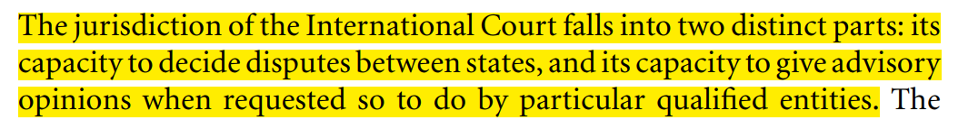
- CONTENTIOUS JURISDICTION:
- Voluntary jurisdiction:
According to article36(1) of the statue of ICJ, the jurisdiction of the court comprises of all cases which the parties refer to it. In such a case the decision of the court shall be binding upon the parties.
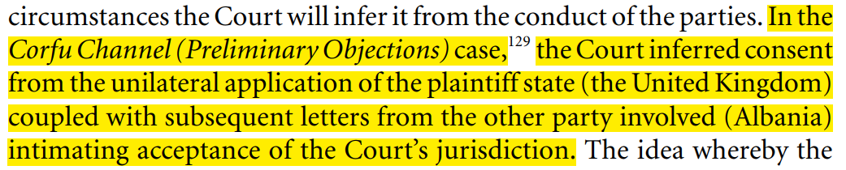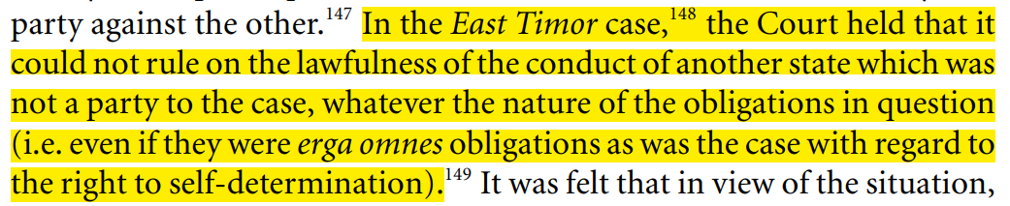
- Optional jurisdiction: article 36 (2) of the statue confers optional jurisdiction upon the court which provides that the state parties to the statue may confer compulsory jurisdiction upon the court by making such (provision in treaties) declaration in respect of any other state which also accepts similar obligations. Optional jurisdiction may confer compulsory jurisdiction upon the court in respect of the following matters:
- Interpretation of treaty.
- Any question of international law.
- The existence of any fact which if established would constitute a breach of international obligation.
- The nature and extent of reparation to be for the breach of an international obligation.
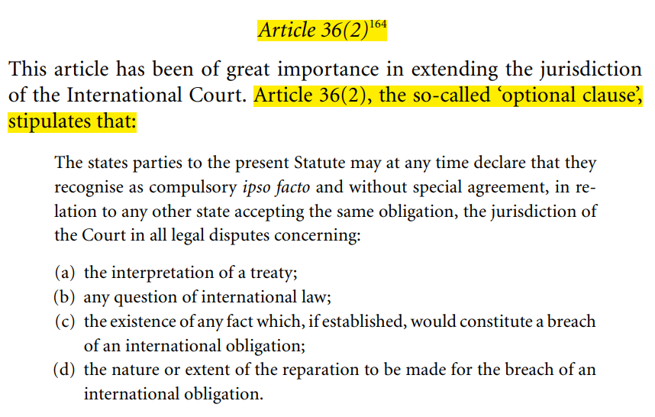
Declarations pursuant to article 36(2) are in the majority of cases conditional and, as noted, are dependent upon reciprocity for operation. This means that the Court will only have jurisdiction under article 36(2) to the extent that both the declarations of the two parties in dispute cover the same issue or issues. The doctrine of the lowest common denominator thus operates since the acceptance, by means of the optional clause, by one state of the jurisdiction of the Court is in relation to any other state accepting the same obligation. It is not that declarations in identical terms from the parties are necessary, but both declarations must grant jurisdiction to the Court regarding the dispute in question.
NOTE: under article 36 (2) the parties may make certain reservations. Article 36 (3), rather confusingly, refers to a condition of reciprocity which is optional and not a part of the statue. The most common reservations which have been made by the state parties are in respect of matters of domestic jurisdiction.
- India and Pakistan both gave consent for compulsory jurisdiction under article 36 (2), but India has made a reservation that ICJ has no compulsory jurisdiction in any dispute where the disputed party was a part of commonwealth states.

- Transferred jurisdiction: under article 36 (5) of the ICJ statue, the court has also the jurisdiction on the pending issues of PCOJ.

- ADVISORY JURISDICTION:
- ARTICLE 65: It may also give advisory opinion to the security council and GA and also to other organs of the UN and the specialized agencies of the United Nations, if they are authorized by the GA in this connection.
ARTICLE 59: the decision of the court has no binding force except between the parties and in respect of that case. It undermines the doctrine of precedent.
Unlike contentious cases, the purpose of the Court’s advisory jurisdiction is not to settle, at least directly or as such, inter-state disputes, but rather to ‘offer legal advice to the organs and institutions requesting the opinion’.
PROVISIONAL MEASURES OF THE ICJ:
Under article 41 of the Statute, the Court has the power to indicate, if it considers that circumstances so require, any provisional (or interim) measures which ought to be taken to preserve the respective rights of either party.
In deciding upon a request for provisional measures, the Court need not finally satisfy itself that it has jurisdiction on the merits of the case, although it has held that it ought not to indicate such measures unless the provisions invoked by the applicant appear prima facie to afford a basis upon which the jurisdiction of the Court might be founded,238 whether the request for the indication of provisional measures is made by the applicant or by the respondent in the proceedings on the merits.
The Court has also stated that its power to indicate provisional measures can be exercised only if there is an ‘urgent necessity to prevent irreparable prejudice to such rights, before the Court has given its final decision’249 and that ‘the sound administration of justice requires that a request for the indication of provisional measures founded on Article 73 of the Rules of Court be submitted in good time’
Thus, the purpose of exercising the power is to protect ‘rights which are the subject of dispute in judicial proceedings’243 and thus the measures must besuch that once the dispute over those rights has been resolved by the Court’s judgment on the merits, they would no longer be required.
This clear and unanimous decision that provisional measures orders are binding until judgment on the merits is likely to have a significant impact.
Remedial measures
Enforcement? Article 59 and 60
Once given, the judgment of the Court under article 60is final and without appeal. Although it has no binding force except between the parties and in respect of the particular case under article 59,such decisions are often very influential in the evolution of new rules of international law.307 The Court itself is not concerned with compliance and takes the view that ‘once the Court has found that a state has entered into a commitment concerning its future conduct it is not the Court’s function to contemplate that it will not comply with it’.
Under article 94 of the UN Charter, each member state undertakes to comply with the decision of the Court in any case to which it is a party and if this does not occur, the other party may have recourse to the Security Council which may make recommendations or take binding decisions.

SUCCESSES OF UNITED NATIONS:
- UN PREVENTS THE WORLD FROM WWIII BY RESOLVING MANY DIPUTES PEACEFULLY:
Preserving world peace is a central purpose of the United Nations. Under the charter, the member states agree to settle disputes by peaceful means and refrain from threatening or using force against other states. UN has achieved dramatic results which include helping defuse the Cuban Missile Crises in 1962 and the middle East crises in 1973. In 1988, the UN-sponsored negotiations led to the withdrawal of soviet troops from Afghanistan. The UN also played an important role in facilitating the right of self-determination for the people of East timor in 1999 and overseeing their transition to independence on may 20, 2002.
- UNITED NATIONS UNMATCH AND UNPARALLEL ENDEAVORS FOR DIS-ARMAMENT OF WEAPONS
Halting the spread of arms and reducing and eventually eliminating, all weapons of mass destruction are major goals of the UN. The UN has been ongoing forum for disarmament negotiations, making recommendation and initiating studies. Nuclear Non-proliferation treaty (1968), the Comprehensive Nuclear test ban treaty (1966) are the manifestation of UN endeavors towards disarmament. The Vienna-based international atomic energy agency, through a system of safeguard agreements, ensures that nuclear materials and equipment intended for peaceful uses are not diverted for military purposes.
- PEACE-KEEPING MISSION FOR THE MAINTENANCE OF INTERNATIONAL PEACE AND SECURITY:
The security council sets up the UN peacekeeping operations and defines their scope and mandate in its efforts to maintain international peace and security. Most operations involve military duties, such as observing a ceasefire or establishing a buffer zone. Other may require civilian police or other civilian personnel to help organize elections or monitor human rights. The UN operation at the ceasefire line between India and Pakistan in the disputed state of Jammu and Kashmir was established in 1949, ……cyprus since 1964. UN has undertaken 71 peacekeeping operations since 1948. Currently, 16 UN peacekeeping missions are in place.
- PRESERVATION OF HUMAN RIGHTS:
- Through UN efforts governments have concluded many multi-lateral agreements that make the world a safer, healthier place with greater opportunity and justice for all of us.
- UNDHR proclaimed by the GA in 1948, sets out the basic rights and freedoms to all women and men. The declaration laid the groundwork for some 80 conventions and declarations on human rights including the two international covenants (ICCPR and ICSER).
- UN high commissioner for human rights, who coordinates UN human rights activities.
- UN PLAYS A PROMINENT ROLE IN THE CODIFICATION AND DEVELOPMENT OF INTERNATIONAL LAW:
- More than 500 conventions, treaties and standards resulting from this work have provided a framework for promoting international peace and security and economic and social development.
- Kyoto protocol, UNCLOS, UNCITROL etc
- SPECIAL CRIMINAL TRIBUNAL:
- Rawanda special criminal tribual; the Rwandan genocide refers to the mass slaughter of more than 800,000 ethnic Tutsi and politically moderate Hutu by government. The duration of the 1994 genocide is usually described as 100 days.
- It was an international court established in Nov, 1994, by the UNSC in resolution 955 in order to judge people responsible for the Rwandan genocide and other serious violations of international law in Rwanda.
- There was the first time since the Nuremburg and Tokyo trials to convict a former head of government.
- Special criminal tribunal for the former Yugoslavia: it was a body of the UN that was established to prosecute the war crimes that had been committed during the Yugoslav wars and to try their perpetrators.

FAILURES OF THE UNITED NATIONS:
Historical failures:
- Rwandan Genocide 1994, conducted by Hutus against Tutsis
- In the presence of peace-keeping mission, 800,000 people were killed in the front of the peace-keeping mission. More than 20,000 women were raped.
- Congo crises in 2005
- Peace-keeping force to stop the civil war, were themselves involved in the brutalities and inhumane acts. The most famous scandal was the “Blue helmet Scandal.”
- The unresolved international dispute of Kashmir and Palestine
- Already discussed.
Contemporary failures:
- Failures to curtail the world powers
- Cold-war era, Crimean annexation, 9/11, Iraq war. How international peace and security will be maintained?
- Climate change
- Environmental science.
- No policy to contain violent Non-state Actors
- Daesh, Al-Nusra front, etc.
- UNHCR failed to tackle the problems of refuges
- Human rights violations across the Globe
- UDHR (1948), ICCPR (1966), ICSPR (1966)

REFORMS NEDDED IN THE UNITED NATIONS
There are four broader categories of reforms needed in the UN.
- General reforms.
- Administrative reforms.
- Financial reforms.
- Structural reforms.

GENRAL REFORMS
- Amendment should be done in the Article 23 of the UN charter to replace the name of USSR to Russia-as a permanent member of the security council.
- The trusteeship council has been dysfunctional since 1994. So, other functions should assign to it.
ADMINISTRATIVE REFORMS (Munir Akram)
- According to ART 109 of the UN charter, any Amendment in the UN charter should require the consent of P5 members in security council after approval from UNGA with 2/3rd majority. It means that the power and the membership of the security council will change with the consent of P5.
- The majority of staff of the administration of UN are from P5 countries, quota must be given to the third-world countries and non-permanent members of the UN.
- There is no mechanism of internal accountability in the UN.
FINANCIAL REFORMS
- Taxes on natural resources (Oil, water, gas) by the extraction of states.
- Taxes should be implemented on the weapons.
STRUCTURAL REFORMS
- Non-permanent members of the security council should be increased (Pakistan state policy).
- G-4-Germany, India, Japan, Brazil- suggested that 4P members+ 4N.P members.
- Coffee Club (Uniting for consensus)-Italy, Argentina, Pakistan- are the founding members; 10NP. The UFC favors a constructive, inclusive, and bottom-up approach, through dialogue.
- Kofi Annan model: Model A; 6P+3NP, MODEL B; 9NP.

LAST THREE SECRATRIES-GENERAL OF THE UNITED NATIONS
- Kofi Annan from Ghana-1997-2007.
- Ban Ki-moon from South Korea-2007-2017.
- Antonio Guterres from Portugal-2017 onwards.
- First general secretary of the UN was Trygve Lie from Norway-1946-1952.
UN’s Challenges in the 21st Century
- Climate change.
- Food and energy shortages.
- Extremism and terrorism.
- Rising islamophobia in the West.
- Right of self-determination of Kashmiris and Palestinians.
- Refugees’ crises.
- Human development in the South.
PAKISTAN AND THE UN
- Pakistan joined the UN on September 30, 1947, just over a month after its independence.
- Pakistan seeks resolution of Kashmir dispute on the basis of resolutions adopted by the security council. our principled position on the dispute remains a bedrock of our F. policy.
- Pakistan has since participated in 41 peacekeeping missions in 23 countries, with over 150,000 peacekeepers. Pakistan contributes almost 10% troops in the missions

WOMEN IN PEACEKEEPING
Women make up 30% of civilian, 10% of police, and 3% of military peacekeepers. Currently, there are three women leading peacekeeping missions in Cyprus, the Middle East, and the Democratic Republic of the Congo.

12PEACEKEEPING MISSIONS
There are currently 12 UN peace operations deployed in 3 different regions: seven in Africa, three in the Middle East, two in Europe, and one in Asia.

