Canal Construction and the opposition of Sindh to it
Indus River System of Pakistan:
Indus River system Accroding IRSA comprises upon the following rivers.
- Indus River—The biggest rivwer of Pakistan. All other rivers fall into Indus at different Location.
- River Swat Falls into Kabul river
- Kabul River falls into Indus at Attock.
- Neelum river falls into Jehlum River near Muzafarabad. Jehlum river —falls into Chenab River
- Chenab River Falls into Indus at Panjnad
- Sutlej river—Now the part of India as diverted in 1960s after Indus Water Treaty – IWT—it falls into Chenab before Chenab falls into Indus
- Ravi River – Diverted by india once and for all as per IWT agreement—falls into Chenab.
Furthermore, the IRS also consists upon extensive canal system of the country.

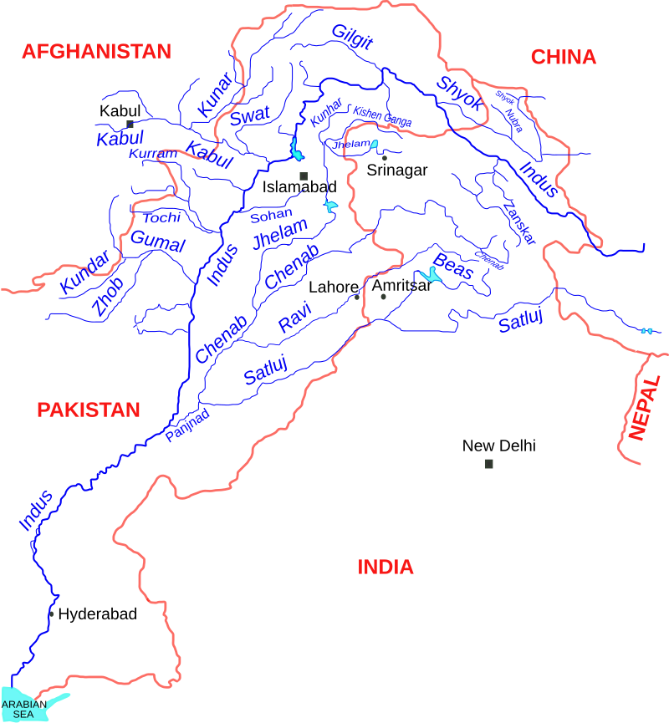
Indus River System Authority IRSA:
IRSA is a federating body established in 1991. Its main aims are
- To decide and protect the water share formula among all the federating units.
- To approve the construction of canal and Dams etc with consensus.
It comprises upon five key members, one each from the federating units and the center. Its voting criteria is to pass a resolution with majority which mean 3: 2.
In case a decision is opposed by one or two of its members and if one or two provincial assemblies pass a resolution against the decision of IRSA then the construction of project is delayed until not approved by Council of Common Interest-CCI which comprises upon PM and the CMs of all four provinces. Here the decision is unanimous.

Construction of 6 Canals approved by IRSA—Indus River system authority in 2024
IRSA approved the constructions of 6 Canals with 4:1 voting of the Indus Water System Authority.
- Greater Thal Canal (GTC--- that would constructed on Indus river and supply water to Punjab.
- Chashma Right Bank canal II—Indus River – supply water to parts of Punjab and southern KP
- Kachi Canal—Indus River --- Supply water to Baluchistan
- Rainy canal--- Indus River --water supply to Sindh
- Thar canal----Indus River and water supply to Sindh
- Cholistan Canal –Sutlej River and water supply to Cholistan area of Punjab
Recent developments regarding canal construction
- IRSA approved the construction of 6 canals with 4/1 voting . member from center , Baluchistan, KP and Punjab supported it while member from Sindh opposed
- Army Chief and CM of Punjab inaugurated the construction Cholistan Canal.
- Protests in Sindh by almost all political parties, religious groups and civil societies.
- PPP led Provincial Assembly of Sindh passed a Resolution against the construction of any canal and more specifically Cholistan Canal.
- PTI submitted a resolution in the National Assembly of Pakistan against the unilateral decision of center and Punjab and demanded a national consensus over the construction of Canals.
- President of Pak in his speech to the joint parliamentary –Joint session of NA and Senate- session criticized the policy of the federal govt Punjab govt regarding the construction Cholistan Canal and stressed on the consensus of all federating units.
Stance of Center and Punjab government
- Pakistan needs to revive and promote its declining agriculture---crops, livestock, fisheries and forest.. of the country. Agriculture contributes about 23% to GDP , accommodated approximately 60% of rural labor, meets the food demand, demand of industry, major contributor to the exports etc of the country.
But there is increasing decline in agriculture production of the country due declining water availability especially from November to April, destructive floods like that of 2025, 2022 and 2010 in monsoon season—june to august, Urbanization of agricultural land, declining canal system, lack of modern agricultural techniques etc are main reasons.
Therefore, there is a need of reviving and increasing the crops production like wheat, maize, sugarcane, rice, fruits and vegetables etc and livestock-cows, baffalows, camels, goats, sheeps etc of the country. Therefore, the state adopted the strategy of agro-farming under Special Investment Facilitation Council- SIFC- a project announced in 2022 that would focus on the increase in crop production on one hand and livestock on the other.
In this project investment is expected from China because it is the world largest consumer and impoter of agricultural goods. Its need has tremendously increased in the recent time almost 100 bn $ agri goods from pak. Therefore it wants invest in the agri sector of neeighor especially Pakistan.
Secondly, Middle Eastern countries are attracted because their need. Economically they are rich but having least agricultural l`and. Therefore they have to import food. In recent times all these countries have decided to acquire land on lease in different countries especially in Pakistan and produce agri goods.
- The construction of Cholistan Canal is prioritized to irrigate more than 1.2 million acre land on one hand and promote Camel farming on the other where 500000 camels would be produced in the next ten years.
- Punjab government says that Punjab is the main source of fulfilling the agriculture/food demand of the country. It also has a major share in providing raw material like wheat, cotton, milk etc for industry. It also has a major share in agricultural exports of the country. Rice, fruits and vegetable among major export of Pakistan which are mainly produced by Punjab. Therefore Cholistan canal is prioritized.
- To promote agro-farming, Pakistan needs investment from abroad. China is investing in the agri sector of south Asia and central Asia to meet its demand. Pak is one of the favorite destination for it. Under CPEC china wants to produce agricultural good amounting 100 bn$ by 2050. Moreover, Middle Eastern countries are rich with energy but acute shortage agricultural land and productivity. Therefore they have import food from across the world. Now ME countries want to acquire land on lease to ensure their food security. Pak is one of the prime destination. All these countries interested in agro faming in Pakistan under special investment facilitation council –SIFC. The modernization of irrigation technique like Drip and sprinklers, seed development programs, technology addition in harvesting and cutting, addition of more agricultural land, construction of cold storages etc. To make this dream a reality Pakistan must ensure the availability of water which could be done through canal construction.
- Moreover, Punjab and Central government claim that Cholistan canal is to build on Sutlej river and not a single drop of water would be taken from Indus river. Therefore, the concern of Sindh is baseless.
- Sindh receives more water than its share from Indus. Since 1970 till date Sindh has received more than 27 MAF of water every year which is more than the total need of the province. While the Cholistan canal would need around 1 MAF of water annually.
Stance of Sindh:
- Almost all the river water influx across Pakistan Like that of Indus, Chenab, Jhelum, Swat, Kabul, Ravi, Sutlej are the part of Indus River system as per IRSA. Sindh is one of the shareholder of the water of Indus River system. Being the lower riparian Sindh right over the water of IRS is more. It is the duty of the center to protect the water share of Sindh.
- Sutlej and Ravi Rivers are dried since 1960s because India diverted it with the consent of Pakistan in the Indus Water Treaty IWT and water is rarely available in these two rivers. Since 2010 only once Sutlej got major flow into Pak because of the floods in 2014 water released by India. Other than that, Sutlej never got substantial water flow in the last 15 years. It means Cholistan would get major chunk of water from Chenab. That would result in further cut in the flow of Chenab and share of Sindh already being usurped by Punjab since 2000.
- There has been a dangerous decline in the flow of the IRS in the last 30 years. Sindh quotes IRSA, ADB, WB figures Sindh received 27 MAF from 1970 till 2000 on average. But from 2000 to 24 a sharp decline has occurred in the flow of water into the province which is less than 14 MAF which less than its needs.
- The need of Sindh is diverse. Firstly, it needs irrigate the canal based land in which more than 20% of such land has already got barren because of shortage of water. Secondly, Mangrow of Sindh which contributes to total forest cover are dangerously declining above 40% because of the shortage of water. Thirdly, the livestock in Sindh is in danger. As the decline in crops/greenary results into lesser food availability for livestock. Fourthly, more than 30 % of Sindh domestic and industrial is dependent on IRS. Finally. Sindh has to throw water into the Arabian Sea in order to stop the inland incursion towards the coastal belt of Sindh especially, Tata, Badeen etc. therefore, Sindh must get its due share of water from IRS in order to stop or slow down the encroachment of the sea towards the coastal land of sindh. To ensure that no new mega projects should be built on IRS to secure the water need of Sindh.
Stance of Neutral observer- ADB, WB, Technocrats
- Cholistan canal may not be a success story. Canal system is accompanied by the traditional flood irrigation technique which has not been successful anywhere in the world. For instance India diverted Ravi and Sutlej towards Rajasthan province mostly desert area. Since 1960s India couldn’t transform the deserts of Rajasthan into green land. It is mainly because desert absorb more water and obstruct the forward flow. Therefore Pakistan may not succeed to irrigate and turn the Cholistan desert green.
- In desert areas modern irrigation technique is a better option. Drip and sprinklers irrigation system has tremendously worked in desert areas. But to make it efficient, the water must pushed into the pipelines with pressure which cannot be done by canal system rather through Pipelines, water pumps or supply of water from water Tanks at height. The government of Punjab and center must focus on utilizing the untapped water resources in the bed of Sutlej , Ravi and Chenab through tube wales.
- The federalists also opposed any initiative that is opposed by one or more of the federating units because it threatens the stability of the country. Separatist movement in Baluchistan is already a headache for center. There has been increasing security turmoil in KP. The construction of new canals have resulted into increasing protests in Sindh and rise of the sub-nationalist groups that would widen the gap between center and Sindh province. Therefore, before initiating any major project the center must build a consensus among the provinces to avoid threats for the federation.
- Council of Common Interest CCI meeting was convened. It unanimously decided that canals construction is suspended until national consensus is not achieved.
Why Pakistan needs dams?
- To reduce the intensity of floods pak needs dams. Kalabagh 10 MAF diamer Basha 8.1 MAF Indus chance os floods reduce by more than 80%
more damas -- more storage-- lesser floods
- To increase the water life of pak, we need dams. India 120 day, China 350, Pak 33 days. Kalabagh dam can add 18 days in to pak’s water life.
- Stop india from violation pak needs dams and canals
- For agriculturation pak needs dams and canal
- Hydel generaion pak need dams
Dasu 4300 mw
Diamerbasha 4500 mw
Muhmand 800 mw etc.

Indus Water Treaty
Salient Features: signed in 1960. World Bank was the facilitator. Not an arbitrator.
- Eastern Rivers Ravi, Sutlej and Bias belong to India. Ravi and Sutlej were diverted by India with the consent of Pakistan during 1960s.
- Western Rivers like Jhelum, Chenab and Indus belong to Pakistan. Jhelum and Chenab completely belong to Pakistan. While Indus is a shared river where 10% of water of the river can be consumed by India and rest belongs to Pakistan.
- From 1960 to 80 India was not allowed to use the water or build any water reservoir on the western rivers in order to give Pakistan enough time to increase its water need and utilization----construction of Dams and canals, increase water use in agriculture, domestic and industrial sectors.
- But from 1980 onwards India can use the water of the western rivers only for hydel generation. It means India can build dams on the western rivers but with list of conditionalities;
- It can use the water of western rivers if the water need downstream in Pakistan is less. What is Total annual Influx of water through rainfall and melting of Glaciers? How much water is wasted by Pakistan into the sea? It means if Pakistan wastes more water into the sea then India can use the water of the western rivers for hydle generation,.
- It cannot divert the flow of the river. It has to make on the natural or run of the river projects.
- It has to send the design of the project to Pakistan before initiating the construction.
- Pakistan can raise structural objections only like the height of the project, diversion etc
- After every 6 months India is bound to facilitate the Pakistani team to inspect the under construction project up-stream.
- In case of disagreement between the two countries over a particular project then three step process to resolve the dispute;
- Water commission of Pakistan and India would meet and resolve the structural or legal issues.
- Neutral observer –could be appointed by Indus Water Commission, World Bank-WB, by International court of Arbitration-ICA. Deals with technical issue only. Eg in 2013 ICA appointed an observer to inspect the Kishan Ganga project.
- Court of Arbitration-- International court of arbitration-ICA deals with Legal issue.
Problems/Issue:
- Unprecedented decline in the flow of the rivers. As per WB report (2021), more than 50 % cut has occurred in the flow of Indus and Jhelum while more than 55% in the flow of Chenab.
- Pakistan has overwhelming dependency on Indus, Jhelum and Chenab. According to WB more than 70% of agriculture, 20% of industrial and more than 25% of domestic dependency on these three rivers. Furthermore, Tarbela Dam is on Indus while Mangla is on Jhelum which Are the major sources of the water life of Pakistan on one hand and electricity generation on the other.
Reasons for Decline:
Stance of India;
Climate change is the major reason for decline in the flow of the river. There are repeated and prolonged draughts. Reduction in the rain fall and snowfall. Rainfall one of the major contributor to the annual flow of the rivers. Secondly, decline in the snow deposits in the hilly areas which another contributor to the river flow. Decline in the two resulted into decline in the flow of the rivers.
Stance Pakistan;
The stance of India is partially correct. Rainfall is not the major contributor and per WB ,it contributes only 33 % of the total water of western rivers. It is true that decline in the snowfall also occurred. But there gigantic glaciers which contributes approximately 67 % of the total water flow of the western river. And the melting these glaciers have speeded up instead of decline. Therefore, it is not the only reason.
The main reasons are two; First, more dams build by India upstream that result into decline in the flow of the rivers. Salal, Dulhasti, Kishan Ganga, Buglihar, Ratlee, Pak Dual etc.The construction of more dams mean more storage capacity in occupied Kashmir which has caused more cut in the flow of the rivers. India is also involved in structural violations mainly in the height of dams. For instance, neutral observer appointed by ICA in 2013 reported that India gave 33 feet more height to Kishanganga than allowed height. More height given to dams would mean more storage capacity that ultimately mean decline in flow of the rivers towards Pakistan. Moreover India is also involved in diverting the flow of the rivers. For instance, Wuller Lake is the main source of Jhelum river on which India has built wuller barrage that diverts the flow.
Problem 2.
India has repeatedly demanded from Pakistan to renegotiate the IWT. It wrote a letter to Pakistan in 2023 and another letter in 2024. In Both the letters India demanded the renegotiation on the basis of;
- The treaty is more than 60 years old now.
- Decline in the flow of the rivers due to climate change.
- The water need of India has tremendously increased.
- Pakistan still wastes more water into the sea which show that its water need is less.
Problem3.
India Unilaterally pulled out of the IWT after Phalagam attack. Modi government has threatened to severe the water war against Pakistan.
Impact: first, India would building more dams, and give more height to Dams. Both these factors would give india more storage capacity that would result into more cut in to the flow of the rivers. Secondly, India would build barrages , water tunnels for diverting the flow of the rivers that would cause more cut the flow of the rivers. Thirdly, India would not facilitate the Pakistani inspection team to inspect the under construction projects.
Resultantly the water life in Pakistan would threatned more and more. Eg. Already more than 25% of Irrigated land in Sindh province has turned barren. The agricultural land of Punjab is also faced with acute shortage of water especially in Chenab and Jhelum. This is hurting the agriculture sector badly and decline in overall production. Secondly, water reserviors of Pak Tarbella and Mangla are under serious threat as water has reached to dead level in april 2025. These threats would get severe even more with the passagfe of time especially if India doesn’t abide by the IWT.
Solutions.
- The permanent solution is one. Pakistan must increase its water need by building more dams, canals on one hand and increase in the agricultural land, domestic and industrial use on the other. Eg. The construction of Kalabagh Dam would need 10 million acre feet- MAF of water. Diamer Basha Dam would need 8.1 MAF. Dasu on Indus. Kohala, Karrot, Pir Mehal, Azad Patan are on Jhelum river. If these two dams were built earlier India would not have been able to build dams on Indus River at all. Secondly, If more canals were built for instance Greater Thal Canal or Chashma Righ Bank Canal II etc, Pakistan water need for agriculture would tremendously increase. This would have enable Pakistan to stop the wastage of water into the sea which is the weaker point of Pakistan being repeatedly exploited by India.
- Pakistan must fight its case against india on legal and diplomatic level. First of all Pakistan must serve notes to india for keeping the treaty in abeyance. Which legally it cant. 2nd Pakistan must approach World Bank to give its opinion which it already did. ‘India cannot unilaterally move out of the Treaty nor can suspend it or held it in Abeyance’. 3rdly Pakistan must approach international court of arbitration to stop india from further violation. Diplomatically Pakistan must get help of China. China and India also have water disputes over multiple rivers especially on Brahmaputra River. China may announce the construction of another Dam on this river. As india is mostly dependent on Brahmaputra River than the western rivers. And india does not have any treaty with china. in case India approaches the ICA then China may counter it with violations it has been making against Pakistan.
- Proper preparedness on the part of Pakistan to fight the case against India. In 2017, Pak-India water dialogue conducted by WB, Indian team dominated not because its stance was correct. Rather, Indian team was comprising right people for the right job. There were river experts, dams experts, legal experts headed by a diplomat. While Pak team was not prepared as it was comprising upon diplomats and politician only.. should hire technical and legal experts to fight the water case against India more efficiently.
- India cannot unilaterally pull out of the IWT agreement. The Treaty clearly states that no party/state could unilaterally pull out. It could renegotiated or even annulled through bilateral decision. After the unilateral decision of India. Therefore Pakistan has three options. First, it should serve notice reminding of the violation it has made. Second, approach World Bank which is the neutral observer and facilitator in ITW. Third, Pak should access ICA or both where India cannot stand and would have reverse its decision.
- Practically speaking India has become a powerful entity and the western countries and other bigger powers with the exception of China not oppose India to greater extent. For example India is bound to facilitate Pakistan inspection team to visit upstream every 6 months but India has not allowed Pakistan team since 2019. For this Pakistan has an alternative option. With space Techologiocal of China Pakistan can easily identify the violations made by India. Secondly Pakistan should access the WB and ICA to resolve this matter.
Pakistan India relations have always been determined by Kashmir dispute and water. The two countries may enter into war because of water as Pakistan has repeatedly termed Indian act of launching water war against Pakistan as an act of War. Pakistan would not hesitate from a nuclear war in such circumstances. Therefore, every possible step should be taken by Islamabad to stop India from violation and protect water share of Pakistan.

Why Pakistan Need Dams
- To increase the water life of pakistan we need Dams. According to WB 100-120 days water is necessary for a country. Below 100 days mean the country is in danger zone. India has 120 plus days, china 350 plus water life. While that of pak is only 33 days. Pak is extreme water short nation. Alone Kalabagh would 23 days, Diamer-Basha 18 days, Muhmand 3 days to water life of Pakistan.
- To stop India fro Voilation Pakistan needs to Build Reservoirs
- To stop water wastage, Pakistan needs to build ponds
- To reduce threat of floods Pakistan must buld dams and canals. In 2022 floods approximately 26 MAF of water flew in Indus river alone. If Kalabagh was constructed it would have store 10 MAF, Diamer-Basha 8.1 MAF, Muhmand 1.3 MAF. In this way majority of water would have bveen stored and only 6 MAF floods would left behind.
- To increase agriculturation pak needs to build dams.
- To increase hydel generation pakistan need dams.

