Nuclear Proliferation

“Our scientific power has outrun our spiritual power. We have guided missiles and misguided men.”
(Martin Luther King Jr.)
The NPT defines proliferation as manufacture and or acquisition of nuclear weapons or other nuclear explosive devices by countries which do not already possess them. However , this very definition does not include the larger problem of proliferation i.e. the countries which are multiplying nuclear weapons rapidly both in quantitative and qualitative terms.

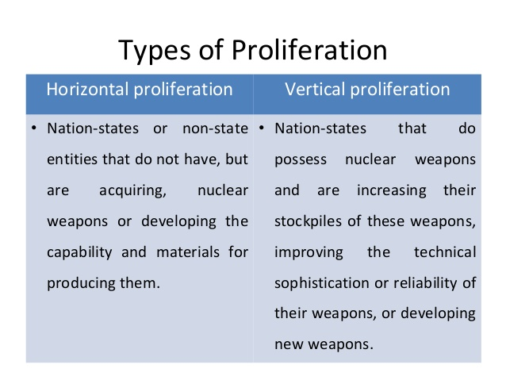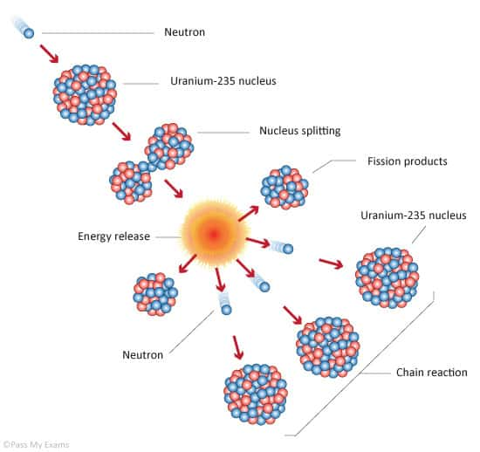

Nuclear weapons pose an enormous threat to humanity. Since their very first use, different leaders and organizations have been trying to prevent proliferation to additional countries. Despite their efforts, more states than ever before have obtained nuclear weapons.

History of Nuclear Proliferation

- The Beginning of Nuclear Age
Scientific discoveries in the late 1930s made nuclear weapons a possibility for the first time in history. During World War II, the United States and its allies were afraid that their enemies would develop nuclear weapons first, so in 1942 they started the Manhattan Project, a secret research effort led by the U.S. government to develop nuclear weapons. The creation and use of nuclear weapons ushered in the nuclear age, and growing tensions between the United States and the Soviet Union, both armed with nuclear weapons, during the Cold War made the threat of nuclear war a real possibility.

- Hiroshima and Nagasaki
In its fourth year of fighting Japan in World War II, the United States dropped the first atomic bomb used in combat on Hiroshima, Japan, on August 6, killing more than one hundred thousand people. On August 9, the United States dropped the second atomic bomb on Nagasaki, which killed more than seventy thousand people. Six days later, Emperor Hirohito of Japan announced his country’s surrender. Those atomic bombs remain the only ones ever used in war.

- Creation of IAEA (29th July 1957)
The International Atomic Energy Agency (IAEA) was created with the mission of promoting and overseeing the peaceful use of nuclear technology. U.S. President Dwight D. Eisenhower’s December 1953 “Atoms for Peace” speech is considered to have created the impetus for forming the institution. Eisenhower said that an international agency was needed to prevent the spread, or proliferation, of nuclear technology, warning that, if unchecked, it could result in “the annihilation of the irreplaceable heritage of mankind.”
- Kyshtym Nuclear Disaster Occurs In Secret
On September 29, a hastily stored tank of nuclear waste exploded in the Russian town Ozyorsk, the original site of the Soviet nuclear weapons program. The disaster released more radioactive contamination than the 1986 Chernobyl disaster and further contaminated the already heavily polluted area. Unlike other well-known nuclear accidents, this one occurred at a nuclear weapons facility instead of an energy plant, so the Soviet government tried to cover it up. In fact, the disaster was not widely known about until an exiled Soviet scientist reported on it in 1976.
- The Cuban Missile Crisis Threatens Nuclear War
On October 15, a U.S. military plane discovered Soviet nuclear missiles under construction in Cuba, only about one hundred miles from the Florida coast. President John F. Kennedy sent in the U.S. Navy to surround Cuba and demanded that Soviet leader Nikita Khrushchev dismantle the missiles. After several tense days, Khrushchev agreed to remove the missiles in exchange for a public guarantee from the United States that it would attack Cuba, a Soviet ally. The United States also secretly agreed to remove certain missiles from Turkey, out of range of the Soviet Union. The crisis remains the closest the world has ever come to a nuclear war.
- Nuclear Nonproliferation Goes Global
The late 1960s and early 1970s were marked by both progress and setbacks in nuclear nonproliferation worldwide. On one hand, the United Nations established the first framework relating to nuclear weapons with the Nuclear Nonproliferation Treaty (NPT). And the world’s two biggest nuclear powers, the United States and the Soviet Union, took initial steps toward limiting their nuclear arsenals. On the other hand, India obtained nuclear weapons.

- First Nuclear-Weapon-Free Zone Is Established
The Treaty of Tlatelolco opened for signature on February 14, establishing Latin America as the first nuclear-weapon-free zone (NWFZ): an area in which countries agree to “prohibit and prevent” the “testing, use, manufacture, production, or acquisition by any means whatsoever of any nuclear weapons.” Mexican ambassador and Nobel Peace Prize winner Alfonso Garcia Robles hoped the “territories of powers which possess those horrible tools of mass destruction will become ‘something like contaminated islets subjected to quarantine.’” The countries of the South Pacific established a NWFZ in 1985, followed by Southeast Asia in 1995, Africa in 1996, and Central Asia in 2006. Additional treaties have designated outer space and the ocean floor as additional NWFZs.

- First International Treaty to Prevent Spread of Nuclear Weapons Is Signed
In June 1968, the UN General Assembly adopted a resolution endorsing the draft text of the Treaty on the Nonproliferation of Nuclear Weapons, and countries began signing the treaty. Under this landmark international agreement, countries without nuclear weapons agreed to never obtain them; they can, however, use atomic energy peacefully. The five countries with nuclear weapons at the time—China, France, the Soviet Union, the United Kingdom, and the United States—all joined the treaty, making a commitment to eventually disarm, but none has yet.
- SALT I Treaty Is Signed
U.S. President Richard M. Nixon and the Soviet leader Leonid Brezhnev signed the interim Strategic Arms Limitations Talks agreement (SALT I), the first agreement between the United States and the Soviet Union to limit their nuclear arsenals during the Cold War. This agreement marked a victory for nonproliferation ten years after the Cuban missile crisis between the nuclear-armed rivals. SALT II, signed seven years after SALT I, by Brezhnev and U.S. President Jimmy Carter, further limited nuclear capabilities.
- End of the Cold War Improves Nonproliferation Efforts
During the Cold War, a period defined by tensions between the United States and the Soviet Union, the threat of nuclear war was always present. But after the Soviet Union collapsed in 1991 and the Cold War ended, real progress was made to strengthen the Nuclear Nonproliferation Treaty, get former Soviet countries to join the treaty, and stop further use of nuclear weapons.

- Belarus, Kazakhstan, and Ukraine Give Up Nuclear Weapons
After the fall of the Soviet Union, three of its former territories—Belarus, Kazakhstan, and Ukraine—were left in possession of nuclear weapons. An international agreement among the three former territories and Russia required that all nuclear weapons within the territories either be destroyed or transferred to Russia for destruction. The three former Soviet republics also agreed to join the Nuclear Nonproliferation Treaty as “non-nuclear-weapon” countries and, along with South Africa, are the only countries to give up their nuclear arsenals.
- The Comprehensive Nuclear Test Ban Treaty Opens for Signatures
After two years of negotiations, the Comprehensive Nuclear Test Ban Treaty (CTBT) opened for signature at the United Nations. The treaty banned nuclear explosions of any kind, including for weapons tests. But the CTBT is not yet legally binding because not all the required countries—including China, India, Pakistan, and the United States—have signed or ratified it in their home countries. Even so, most countries with nuclear weapons—including the Soviet Union and later Russia, the United Kingdom, and the United States—have not conducted nuclear tests since the early 1990s.
- The IAEA’s Model Additional Protocol is Introduced
Part of the International Atomic Energy Agency’s mandate is to monitor whether countries are using nuclear technology for peaceful purposes, like energy generation, rather than weapons. This monitoring involves inspections of nuclear facilities and power plants. After the 1990–91 Gulf War, it was discovered that Iraq had pursued an undeclared nuclear weapons program despite being subject to IAEA inspections. In response, the IAEA’s board of governors approved the Model Additional Protocol, which gave the agency further access to information and nuclear sites. Although the protocol is an optional agreement, it is now implemented in 134 countries and the European Atomic Energy Community, strengthening the IAEA’s inspection capabilities.
- North Korea Withdraws From the Nonproliferation Treaty
North Korea announced its withdrawal from the Nuclear Nonproliferation Treaty (NPT), stating: “We can no longer remain bound to the NPT, allowing the country’s security and the dignity of our nation to be infringed upon.” Months earlier, the United States had announced that North Korean officials had admitted to enriching uranium for nuclear weapons. North Korea denied the claim but then reopened nuclear facilities it had previously shut down and ordered IAEA inspectors out of the country. Almost four years later, the North Korean government announced that it had completed a nuclear test, becoming the eighth country in history to do so.
- North Korea Walks Out of Six Party Talks
Negotiations among China, Japan, North Korea, Russia, South Korea, and the United States to find a peaceful resolution to North Korea’s nuclear weapons program fell apart after the UN Security Council condemned a North Korean test launch of a rocket, which it had disguised as part of its civilian space program. The negotiations, known as the Six Party Talks, had lasted six years but failed to reach a resolution. North Korea remains one of the most unstable nuclear powers today.
- World Powers Reach a Nuclear Agreement With Iran
In 2002, U.S. officials claimed that Iran had embarked on a nuclear weapons program. U.S. researchers published satellite photographs of what they identified as a large uranium enrichment plant and a heavy water plant, crucial equipment in the production of nuclear weapons. The United States and its allies asserted that Iran intended to build a nuclear weapon, despite the country’s denials and the IAEA’s statement that Iran had not violated its commitments. In 2015, the United States, China, France, Germany, Russia, the United Kingdom, and the European Union reached a nuclear agreement with Iran after years of negotiation, known as the Joint Comprehensive Plan of Action (JCPOA). After Iran agreed to limit its nuclear program and subject its nuclear facilities to much stricter monitoring than ordinary International Atomic Energy Agency safeguards, the United States and others relaxed sanctions on Iran’s economy. But in 2018, U.S. President Donald J. Trump announced that the United States would withdraw from the deal and reimposed sanctions on Iran.
- The United Nations Adopts Nuclear Weapons Ban Treaty
At the United Nations, 122 countries adopted the Treaty on the Prohibition of Nuclear Weapons, the first legally binding treaty for nuclear disarmament in twenty years. Countries that signed the treaty, which builds on the provisions of the Nuclear Nonproliferation Treaty and the Comprehensive Test Ban Treaty, see it as an important step toward the elimination of nuclear weapons. However, countries that already have nuclear weapons did not sign, so it remains to be seen how effective the treaty will be.

Tools of Non Proliferation
The use of a single nuclear weapon could dramatically change life on Earth. So why does it matter if there are five or 5,000? Simply put, the more countries with nuclear weapons, the higher the risk one will eventually be used. This is why policy makers use multiple tools to try and stop or slow their proliferation.
- The first tool is diplomacy, which resulted in the Nuclear Nonproliferation Treaty. Nearly every country in the world has joined the NPT since it was adopted in 1970. Five countries already had nuclear weapons at the time. By joining the treaty, they pledged to work toward giving up their nuclear stockpiles and agreed not to help any country without nuclear weapons acquire them. Meanwhile, those countries without nuclear weapons pledged not to acquire them at all. But the NPT’s biggest weakness is that it is a voluntary agreement, which means a country can simply decide to leave at any point—as North Korea did in 2003. It is also fundamentally an honor system. Countries are trusted to be transparent about their nuclear programs and to cooperate with inspectors.
- Security guarantees are another important tool of nonproliferation. The United States has pledged to come to the defense of dozens of allies, discouraging them from developing nuclear arsenals of their own. But if confidence in the United States’ commitment erodes, allies may be more inclined to build their own nuclear weapons.
- Applying financial pressure through sanctions can discourage a country from developing a weapons program; lifting financial pressure by removing sanctions can have the same effect. But critics argue that sanctions can rarely get a country to act counter to its perceived self-interest. And some countries, like North Korea, have proved willing to pay the high price of sanctions.
- Increasingly cyber tools are used to interrupt nuclear programs, as was reportedly the case with both Iran and North Korea. Military force is also a policy option, one that Israel used when it launched preventive strikes against Iraq and Syria. But it can be difficult to locate weapons and even harder to hit them.And military force carries the risk of retaliation ... potentially with the same nuclear weapons that were targeted for destruction. Since the NPT went into force, these policy tools have had mixed results: four countries acquired nuclear weapons, several voluntarily gave them up, and many others had the capacity to build them but opted not to. This outcome reflects the hard reality that countries hold competing interests. And other goals, such as protecting an ally or building a strategic partnership, are often prioritized above nonproliferation despite the appeal of reducing the risk these destructive weapons pose.

The Nuclear World

THE NUCLEAR WORLD

Although the number of nuclear weapons in the world has shrunk since its peak in the 1980s, more countries now have nuclear weapons. Nine countries are known or believed to possess nuclear weapons: China, France, India, Israel, North Korea, Pakistan, Russia, the United Kingdom, and the United States. These are called nuclear weapons states. Several other countries started nuclear weapons programs but gave them up, either voluntarily or because of pressure from other countries. A few have had nuclear weapons and later destroyed them or turned them over to another nuclear weapons state.
Because countries do not reveal their military secrets, knowing exactly how many nuclear weapons each country possesses is difficult. However, all countries experience some level of security leaks, and a few decades of careful research has produced a generally accurate picture of nuclear arsenals globally.
Approximately 93 percent of all nuclear warheads, or individual weapons, belong to the United States and Russia combined, each having roughly four thousand in its stockpiles.
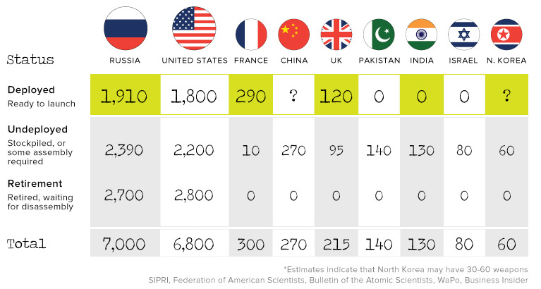

Current Threats
Nuclear conflict involving any of the five original nuclear powers—China, France, Russia, the United Kingdom, and the United States—is unlikely but remains a possibility. Although the number of weapons held by these countries has declined, most are reluctant to pursue complete disarmament because they see nuclear weapons as important components of their security posture. After all, nuclear weapons are the most powerful weapons ever created and few countries want to give them up.
In addition to these five countries, four other countries acquired nuclear weapons around the time of, or after the Nuclear Nonproliferation Treaty (NPT) went into effect.

Israel
Though Israel has never confirmed its status as a nuclear weapons state, it is believed to possess a considerable number of nuclear weapons. It never joined the NPT, the major treaty trying to halt the spread of nuclear weapons, but it has taken action to stop nearby countries from building a nuclear arsenal. Israel bombed suspected nuclear reactor sites in Iraq (1981) and Syria (2007).
It has also signaled that it would attack Iran if it feels threatened by the country’s nuclear program. A 2015 deal between Iran and China, France, Germany, Russia, the United Kingdom, the United States, and the European Union, limited Iran’s nuclear development and eased some international tension. However, in 2018, the United States alone withdrew from the agreement and reinstated sanctions against Iran, though the other parties involved have stuck to the agreement so far.

India and Pakistan: rival neighbors and nuclear powers
Sharing an 1,800-mile border, India and Pakistan have fought several conventional wars over one hundred thousand square miles of disputed territory. Both countries possess nuclear weapons. Neither joined the NPT, and both appear to be modernizing and adding to their stockpiles. Many policymakers and experts fear that nuclear war could break out between the two countries—or, even more concerning, that Pakistan could lose control of a nuclear weapon to terrorists.

North Korea
Although North Korea is believed to have a small arsenal, its continued nuclear tests have raised widespread concerns over possible nuclear conflict. It withdrew from the NPT in 2003 and conducted its first nuclear test in 2006. Since then, it has threatened to use its nuclear weapons against the United States, Japan, and South Korea.

“Only the dead have seen the end of war “
Plato
(Ammar Javaid Siddiqui)

The Nuclear World

The Nuclear World

The Nuclear(Ammar Javaid Siddiqui)

