Palestine Issue

**The Expansion of Israel as a State:**

From 1948-67, majority of the land in between Jordan river and Mediterranean sea was acquired by Israel by purchasing it from Palestinian Muslims.

From 1967 till date, majority of the land has been occupied by the use of force. In 1967 war, Jordan Valley or parts of the West Bank and Jerusalem were captured, more than 40% of the territories of Palestine were occupied since 1988. The most recent example is Sheikh Jarrah where Muslims were pulled out and Jews were settled there. More than 500,000 were settled in west bank which is originally the part of Palestine.

Approach: Israel Law/ Jewish Law – Land belongs to Jews and Muslims are declared as tenants. Jews have every right to pull out Muslims from their own territories and settled Jews there. Whenever they want, however, Muslims don't have the right of ownership of land, they are only tenant.

The normal procedure being repeatedly adopted i.e. court gives a decision in favour of government. And the government forced the Muslims out of that particular area. Jews settlement in that area instead. Palestine as one continuous territory does not exist anymore. Rather it exists in chunks like West Bank, Gaza, Ramallah and the rest of the smaller chunks.

The administrative control of Jerusalem in West Bank is with Jordan as per UN resolution. But practically, the whole of the West Bank and specifically Jerusalem is being controlled by Israel.

**The Two-State Solution:**

Recently in 2024 European countries, Spain, Ireland, Poland; this is in accordance with the UN Security Council Resolution of 1948 accepted Palestine as a sovereign state. All the three countries demanded to go back Israel to pre-1967 borders. UNGA passed a resolution demanding Israel to liberate the occupied territories within one month and go back to the pre-1967 borders. Such developments have energized the two states solution between the Jordan River and Mediterranean Sea, once again.

In 1917, Balfor the FM of Great Britain announced to establish Israel state between the Jordon River and Mediterranean Sea.

In 1948 UN Security Council resolution, it was decided to divide the Palestinian land into two parts. One part would be controlled by Israel where the other would be given to Palestine. West, the extension of Jerusalem city, would belong to Israel. While the rest of territories, including East of Jerusalem (older city) would be given to Palestine as a state.

This idea was accepted by all the western powers including US and UK and other non-Muslims countries but the idea was not accepted by Palestinian Muslims and the first intifada occurred in 1948 which was supressed by Israel by force. This two state solution was not accepted by any Muslim country. Turkey accepted it in 1949, Egypt in 1978, Jordan in 1994, and in 2020 five Muslim countries that are UAE, Bahrain, Oman, Morocco, Soudan accepted Israel but the rest of the Muslim countries did not accept by then.

The opinion of the world states and other players drastically changed with the passage of time. Majority of the Muslim countries specially the Arab world accepted the idea of two nation state so has Pakistan but on the basis of pre-1967 borders. Muslim countries would accept Israel as a sovereign state only if it goes back to pre-1967 border and return the occupied territories back to the Palestinians.

The opinion of United States of America is fluctuating. Biden administration has repeatedly reiterated the two states solutions as per UN security council is not possible as Israel will not go back to 1967 border the practical solution of Palestine Israel is only possible on present situation. Territories being captured by Israel should stay with Israel and Palestine should comprise Gaza and west bank. On the other hand trump was in favour of “the deal of the century”- between the Jordan river and Mediterranean sea only one state, Israel where Jews , Muslims and Christian has equal citizenship right.

For this idea of two states is not acceptable to Israel either. The govt. of Israel is based on Jewish ideology. The establishment of greater Israel is the dream of Zionist govt. Of Israeli govt. greater Israel would comprise upon all the territory between Jordan River and Mediterranean sea, siane region of Egypt, Golan heights of Syria and eastern part of Jordan River.

**APARTHEID STATE:**

It is the one where there is overwhelming discrimination among citizens based on creed, colour, and ethnicity. South Africa is the first ever apartheid state. Government was of White and they were superior citizens of South Africa while the blacks were inferior. They did not have equal rights. The same case is with Israel state. It is a classic example of apartheid state. Where there is inhumane discrimination based on ideology.

The government in Israel is Zionist in ideology. It is the Jewish ideology, which believes in the establishment of greater Israel,

1. Between the Jordon River and Mediterranean seas could be Israel state not any other state.
2. Every Jew across the world has the right of birth to be the citizen of Israel state.
3. Muslims cannot be the equal citizen of the Israel state, this Jewish Zionism has an ideological discrimination against the Muslims that resulted in making Israel an Apartheid State.

There is a long less discrimination between the Jewish and the Muslims in the Israel State. As the Muslims do not have equal political, economic and social rights e.g. Jews are subjected to the civil law of the country but Muslims are subjected to the military law of the country. That means, there are severe and inhuman punishments for the Muslims.

Secondly, they cannot own land as they are declared as tenants. Muslims could anytime be pulled out of their homes whenever Israeli Government wants to do that. Since 1988, there are 22 examples where Muslims are forcefully evacuated from their Homes and Jews are being settled in their places. This all was done by force.

Thirdly, they cannot acquire elite post/jobs like; they cannot become the member of the cabinet nor can become the secretaries of the cabinet, nor the head of the government. They can acquire the second grade jobs of the citizens.

Fourthly, the color of identity card and passport is different from Jews and that of the Muslims. There is even discrimination on the lane of the roads; even the number plates of the vehicles are different. In case of violation, Muslims are subjected to military law and not the civil law of Israel.

Fifthly, Muslims are forcefully displaced, made refugees & IDPs and lived a life of destitute. There are more than 3 Million refugees in Jordan and Lebanon expelled by Israel from Palestine. Currently, more than 2 Million people are living in IDP camps in Gaza and West bank.

Sixthly, war crimes against the people in Gaza.

**Gaza:**

It is the largest open-air prison in the world.

1. The West of Gaza is adjacent to the Mediterranean Sea, which is controlled by Israeli Navy and US Navy. The people of Gaza cannot access the sea for transportation,
2. The south of Gaza is adjacent to Egypt and the border is sealed. There is only one crossing with Egypt called Rafah Crossing, which is practically controlled by Israel.
3. The East and North of Gaza, till part of West, are adjacent to Israel. The longest border is with Israel. It has 3 legal crossings in between. And the people of Gaza accessed the world through the 3 crossings with Israel. It has approximately **2.2 million** population witth majority Muslims, which is mostly residing in **North, Centre and South of Gaza.**

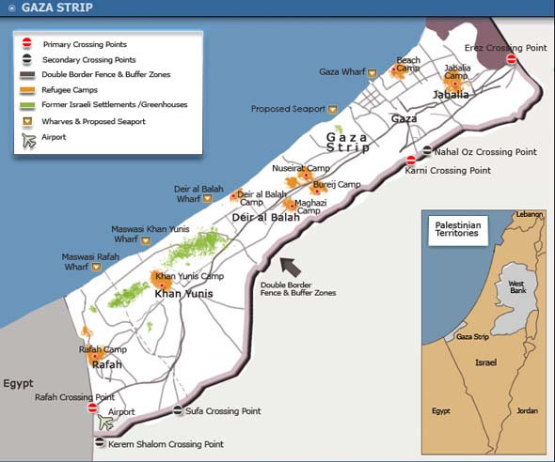

**Hamas Versus Palestinian Liberation Authority (PLA):**

PLA was originally a Jihadist organization established in the 1970s. But in 1990s, this organization stopped its military activities and transformed itself into a political union. It decided to shift its struggle against Israel from military to political. Currently, it is controlling majority of the parts of Palestine. **Mahmood Abbas** is the President of Palestine, whom belongs to PLA. (PLA founder was **Yasir Arafat**, called PLO then) Hamas, on the other hand, is an armed and political organization both at the same time. It is a Jihadist organization, fighting a Jihad against Israel. It is founded and headed by **Ismail Haniya**. It conducts elections is Gaza and wins with overwhelming majority, makes government in Gaza, and continues as a separate entity from the PLA.

**Hamas-Israel War and the War Crime/ genocide in Gaza by Israel:**

**Attack of Hamas on Israel:**

Hamas launched a surprised and unprecedented attack on Israel. More than 2200 fighters crossed the border into Israel and carried out a series of attacks. They crossed the border through Paragliding, demolished the border at different points, and crossed it. They also sailed through the sea and landed on Israeli territory. They attacked the security forces, the settlers in the recently occupied territories and attacked the Tent-Day Celebration (Daud defeated locals and placed tent). Approximately 1400 individuals were killed and approximately 240 were captured and brought into Gaza and were declared as Prisoners of War/ War Captives.

Secondly, Hamas carried out a series of missile strikes/aerial strikers. Approximately 5000 missiles were fired by Hamas into Israel, majority were intercepted by Israel AIR Defence System called “Iron Dome”. But still, many hit the target. 13 different cities of Israel were targeted by Hamas.including the capital Tel aviv and parts of Jerusalem.

**War Crimes Committed by Israel:**

State Launched terrorism against GAZA. Israel has destroyed the North and Centre of Gaza Israel has been carrying out a series of aerial bombardments, missiles jet fighters, helicopters, armoured-core tanks, and artillery.

More than 90% of the buildings (civilian buildings) in the North and Centre of Gaza are demolished/dysfunctional and this is indiscriminate bombardment. Educational Institutions including all the four universities, all being targeted, are being hit. All the hospitals in the central and northern Gaza partially or completely destroyed. Almost all the mosques and two of the churches being destroyed. Hospitals, educational institutions and religious places have not been forsaken.

More than 41,000+ Palestinians have lost their lives, including 12,000 children and 12,000 women, 140+ journalists, 700 plus doctors and health workers. More than 100,000 injured. More than 1.7 million people have been displaced from the North and Centre to the South of Gaza (close to Egypt border). Currently, the South of Gaza especially the Refugee Camps/IDP Camps are under attack. More than 400 tanks, at least 100+ of artillery and more than 50,000 of Israeli troops have been participating in the attacks on Gaza and committing War Crimes.

Israel has stopped the food supply, medicine, oil/petrol, and other necessary commodities supply into Gaza. Israel has even destroyed the electricity system in Gaza. It has even stopped the drinking water supply or hit the water sources within Gaza.(north and central Gaza)limited supplies are allowed specially food water and medicine are being allowed into the southern Gaza by Israel.

There has been an increasing voice of War Crimes committed by Israel in Gaza. South African government is on the lead which has filed a case against Israel in the International Court of Justice (ICJ). Majority of the Muslim countries, have supported South Africa against Israel.

The attorney general has recommended the proceeding of war crime against the netanyahu and other leadership on one hand and Hamas leadership on the other. Court ordered to cease fire which is not accepted by Israel. The court also issue arrest warrant against Netanyahu and his war cabinet.

United states of America has been silent on the human rights violation on the war crimes being committed by Israel on Gaza, it calls itself the champion of fundamental rights , it has always condemned china Russia for the human rights violation they make , they have also been criticizing the governments in the Arab world and afghan Taliban for human rights violation in the counties but in the case of Gaza it criticizes Hamas and not Israel.

Though the governments in European countries, US, and Canada do not support the idea, but there is increasing protests across the West by Human Rights Organizations and students, especially in the universities, demanding Israel to stop War Crimes. ICJ demanded Israel to stop the war crimes also demanding their respective governments to stop supporting Israel.

**Hamas-Israel War may expand across the region**

1. **HAMAS ATTACK ON ISRAEL – Max 1 Paragraph**
2. **Human Tragedy in Gaza – Max 2 Paragraph**
3. **Chances of the expansion of war cannot be overruled.**
4. ***Hamas-Israel War would not end any soon***

Israel has been successful in destroying the North and Centre of Gaza, or this is all through aerial bombardments, artillery and armoured-core/tanks. But this does not necessarily signify the end or decline in war. The war would end only if the two parties declared a stale-mate/cease-fire. Or Hamas is being eradicated. To defeat Hamas, Israel has to fight the Tunnel War and there are **approximately 250-500 km** of tunnels in Gaza which cannot be destroyed through bombardments. Israeli troops have to go deep down into the tunnels and fight war against Hamas.

What are the surprises for Israeli troops in the tunnels, nobody knows. In Gaza tunnels, there are Hamas fighters. These tunnels are strength of Hamas because they know where there is water, snakes etc. Hamas fighters are used to the environment of tunnels but Israel fighters have no idea about tunnels. So Israel has to pull out all the Palestinians from Gaza into Egypt. Only then Hamas could be defeated.

1. ***The Non-State Actors in the Middle-East like Hezbollah and Houthi Rebels have declared Jihad against Israel.***

Hamas in Gaza, Hizballah in Lebanon, Houthi in Yamen are the major non- state actor organization who has declared Jihad against Israel. Hizbullah has launched war against Israel by missile attacks, drone attacks, mortars etc.

* 1. Arieal Strikes – killed 500+ people in Lebanon
  2. Nasarullah killed by Israel
  3. Launched ground assault – Southern Lebanon
  4. Hizbullah giving tough time- being armed group in the region also having long range missiles

After the Hamas Israel war both organizations (Houthi’s and Hizballah) launched a series of aerial strikes against Israel, primarily Houthi Rebels. Hizballah is the strongest non- state military organization in the region. It has more than 150,000+ rockets, they both has started attacks against Israel.

The majority of the attacks launched by Houthis and Hezbollah could not reach Israel because the missiles are being intercepted by Israel, US, and UK etc. At least 100+ rockets have Hizballah and one of rocket of Houthi successfully reached Israel. It means Hamas Israel war has increased security tensions for Israel on the border with Lebanon, Gaza and attacks from the red sea by Houthi.

1. ***Iran-Israel security tension has exacerbated/increased in recent days.***

US and Israel have repeatedly levelled allegations against Iran to be supporting Houthis, Hezbollah and Hamas. Israel attacked the Iranian Embassy in Damascus (Syria’s Capital). In return, Iran launched missiles and drone attacks against Israel. Majority of those strikes were intercepted by US, UK, Jordan and Israel. But many still hit the target inside Israel. In return, Israel also carried out multiple aerial strikes in Iran. The more the continuation of war in Gaza, the more the chances of Iran-Israel tension.

Israel killed the leader of Hamas, Mr. Ismael Hania in the capital of Iran. He was invited to attend the inauguration ceremony of newly elected president of Iran. This has put Tehran in embarrassing situation. Which make compelled the Government to do another attack against Israel. Which would further escalate the situation.

1. ***Hamas-Israel War would destabilize the region as a whole but most importantly, the Red Sea and Persian Gulf.***

Houthi Rebels would continue attacks against Israel. US would intercept the attacks and would also carry-out strikes against Houthis. Houthis would in-turn attack US Warships in the Red Sea (which disturbs Persian Gul, Arabian sea, suez canal in Egypt, Mediterranean Sea). On one hand there is Yemen, on the other there is Djibouti, where US Military Base is installed. The more the tension between the two, the more the hurdles/threats to the trade in the Red Sea.

1. ***Israel-Iran Tension would have far-reaching negative implications on Iraq, Syria, Yemen, Lebanon, Red Sea and most importantly the Persian Gulf.***

US would intercept the attacks of Iran. Israel & Iran would keep attacking each other. This may force US to attack Iran. In return, Iran may attack the US Navy in the Persian Gulf.

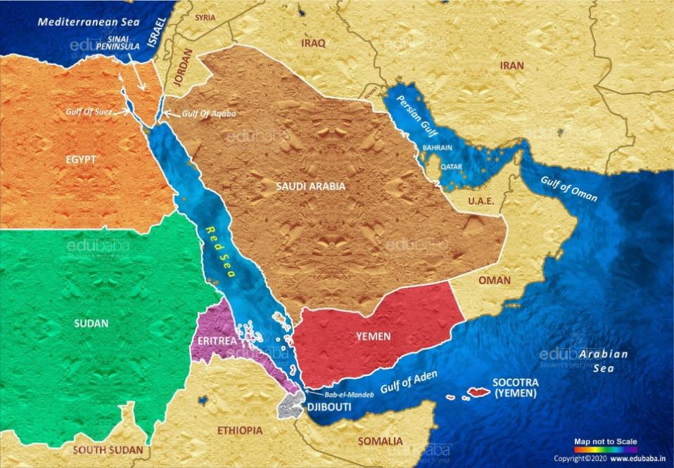

**Hamas-Israel War may push Arab-Israel away from each other and help Iran to come closer to the Arab World**

1. *Attack of Hamas on Israel (Max 1 paragraph)*
2. *State Launched terrorism by Israel on Gaza (2 Paragraph)*
3. *The Process of Arab-Israel rapprochement – normalization of relation has slowed down.*

In 2020, Abraham deals were signed by Israel with five Arab nations UAE, Bahrain, Oman, Morocco, and Sudan recognized Israel as a sovereign state. Trump played crucial role in this deal. All these countries established diplomatic countries with Israel. All these five Arab nation opened their Embassy in Israel and Israel also opened its embassy in these five countries. At the same time, all these countries-initiated trade-relations with each other. The process of people-to-people contacts also increased as all these countries announced Visa at the arrival at the airport for each other’s citizens.

However, Saudi Arabia has not announced Israel as a sovereign state yet, but there are numerous developments of growing normalization of relations between the two countries. E.g. Saudi Arabia provided air-space to Israel in order to access UAE, Oman. Secondly, increasing promotion of the literature in Saudi-Arabia that signifies the idea of Abraham religion: Muslims and Jews historically have not been rivals. This rivalry is since 1948. Original rivalry is Jews vs. Christians. Because there are numerous commonalities between Jews and Muslims. Furthermore, Arab Muslims and Israel both have the Arab origin, belonging to the same area. Thirdly, many media groups like BBC, Al-Jazeera etc. claim which are also not denied by Israel and Saudi-Arabia: the reports are that at the time of Hamas attacks, the delegation of each other’s countries were in the Capitals of each other (Saudi delegation in Tel Aviv, Israeli delegation in Riyadh).

But after the initiation of Hamas-Israel war Saudi-Arabia announced to have no secret negotiations going on with Israel. Bahrain, UAE, Egypt and Jordon have seized their trade relation and people to people contact with Israel. UAE and Bahrain even downsized its diplomatic relation with Israel. It is all because of increasing public pressure of the Arab world on their respective government to support Palestine and Severe relations with Israel. The more the prolongation and intensification of Hamas Israel war, the more the chances of deterioration of Arab Israel relations.

1. ***The chances of Arab-Iran normalization of relation have increased.***

Saudi-Arabia and Iran signed a deal with the help of China to resume diplomatic relations with each other in 2023. They also lifted up the Visa restrictions. The same has been applied by other GCC Countries (Saudi, UAE, Qatar, Kuwait, Bharain, Oman) i.e. normalization of relation with Iran. The Iranian President was invited by Muhammad Bin Salman to participate in the OIC Conference held in Riyadh on the Gaza Crisis and provided red carpet reception. The more the prolongation of Hamas-Israel War, the difficult for the Arab world to enhance relations with Israel. The situation would mainly benefit Iran to come out of the isolation and establish better working relations with the Arab world.

**Hamas-Israel War Implications on the Global Power Politics**

1. *Hamas attacked on Israel (1 paragraph)*
2. *Israel war crimes in Gaza (2 Paragraphs)*
3. *The disruption of trade in the Persian Gulf and Red Sea.*

Approximately 20% of the oil trade of world is done through Red Sea. Almost all trade between Asia and Europe as well as Asia and North-America is conducted through Red Sea and Persian Gulf. The more the disturbance in the Red and Persian Gulf Seas, the more the disruption in trade.

1. *US, UK and other Western countries have put their weight overwhelmingly in the favour of Israel.*

US has deployed its Naval Aircraft Carrier in the Mediterranean Sea, its 5th Naval Fleet in the Persian Gulf. Series of Warships in the Red Sea. All these deployments made to save Israel against the possible attacks from Iran, Houthis in Yemen, Hizballah in Lebanon and Hamas in Gaza. US has provided $3 billion military aid in the form of weaponry and approved $13 billion by US Congress. UK has also deployed its Warships in the Mediterranean and Red Sea to protect/defend Israel.

This unprecedented support for us of Israel is because of numerous reasons,

First, Israel has been the us protectorate which means the protection of Israel has been the responsibility of the United States of America since 1948. secondly, the Jewish lobby is the strongest lobby in Washington it mainly comprises upon billionaires, they are the major fund raisers for both the democrats and the republicans.no matter who so ever is in power, the deeper state of US will always support Israel. Thirdly, US has always been using Israel as a policing state in the Arab world in order to suppress those who don't comply with US policies in the region.

The unprecedented tilt of US towards Israel has antagonized the Arab world leaders more and more, Egyptian president fateh el sisi refused to meet president Biden. The jordanian king another close aly of Us also refused to meet president Biden. MBS made US secretary of states kept waiting for two hours and met him for inly 20 mins. The more the prolongation of war the more the pressure on Arab leaders to distance themselves not only from Israel but also from US.

1. *US in particular and the West in general, who have been the so-called champions of fundamental rights and have always been condemning China, Russia, Afghanistan, Iraq, North-Korea etc for human rights violations, have been criminally silent on the War Crimes carried out by Israel in Gaza.* Surprisingly, China and Russia who have been blamed for Human Rights violations by the west, are the one who have raised voice against the brutalities of Israel in Gaza. Resultantly, the image of Russia and China in the Muslim world is becoming increasingly soft and that of US increasingly hard among the common people.

1. *Hamas-Israel War has benefitted China in numerous ways.* Firstly, China along-with Russia and South Africa is raising voice against Human Rights violations and the war crimes being carried out by Israel that has helped China to soften its image across the Muslims World. Secondly, US has become stuck in an unnecessary/unwanted war in the Middle-East. It has to deploy not only its Navy and other forces but also to provide aid in billions of dollars to Israel. At the same time, US is stuck in Ukrainian War against Russia by providing weapons and billions of dollars. Resultantly, it would be highly difficult for US to think of a military option against China while being already engaged in two front-wars. This provides China with an opportunity to continue its economic growth on one hand and increasing geopolitical role in the region, whether that is Taiwan or Middle-Eastern World.
2. *Russia may also benefit from Hamas-Israel War in number of ways.*

Firstly, on humanitarian grounds Russia is making soft-corner. US got engaged in unavoidable warfront in the Middle-East in defence of Israel. This would divide the attention of US from Ukraine to the Middle-East. In such a situation, Russia would flex its muscles even more against Ukraine and try to assert itself more and more in the Eastern Europe.

**WAR IN GAZA, ISRAEL AND US BEING THE LOSER AND IRAN BEING THE BENEFICIARY**

* attack of Hamas on Israel one paragraph
* Terror launch by Israel in Gaza 2 paragraphs
* Israel being the loser

1. intelligence failure of Israel 2000 plus Hamas fighters continued training for 6 months, Intelligence agency of Israel failed to detect, Intelligence chief of Israel resigned
2. the air Defence system of Israel called Iron dome has been potentially challenged, first of all Hamas challenged it, more than 5000 missiles fired and the iron dome system could not all the missiles more than 2000 Hamas fighters crossed the border attacked and came back’
3. The threat to Israel has tremendously increased on one hand Hamas on the other hand Hizballah from Lebanon, Houthis and Iran have started attacking Israel, Israel has to fight on multiple fronts
4. Winning the war against Hamas in Gaza would not be an easy task, Israel has pushed itself into an almost un wining war
5. The pressure of war crime against Israel is increasing

* **US BEING THE MAJOR LOSER**

1. US got stuck in an unwanted war in the middle east, its commitment to defend Israel is costing it badly
2. US focus on Ukraine has divided because of Hamas Israel war and Russia would benefit from that
3. US under tremendous pressure not to escalate tension with China
4. Human rights violation AND pressure on US.

* **IRAN BEING THE BENEFICIARY**

1. Successful support provided by Iran to its proxies in the middle east especially to Hamas, Hizballah and Houthis who have become a potential threat for Israel
2. The public in the Arab world supports the stance of Iran more than they support the stance of the rulers of their respective countries
3. Iran is enhancing its presence in the Arab world more and more
4. Iran is normalizing relations with Arab world