CSS Chemistry solved papers
PART-I (2016-2023)

Rafia NIMAL

Preface
Preparing for the Central Superior Services (CSS) examination is a significant undertaking, requiring unwavering commitment and a deep understanding of the subjects being tested. Among the subjects covered in the CSS, chemistry holds a pivotal place, demanding rigorous preparation. With the aim of aiding candidates in their challenging journey, I am delighted to present this book, "Solved CSS Chemistry Papers: Part I."
This book is the culmination of hard work, research, and analysis of past CSS chemistry papers. Our primary objective is to provide candidates with a practical and insightful guide that covers the essential aspects of this subject, facilitating their preparation process.
What You'll Find in this Book:
Within these pages, you'll discover a vast collection of CSS chemistry papers from previous years (2016-2023), each accompanied by detailed and well-explained solutions. It is important to note that answers given here can be more detailed and you are not exactly supposed to reproduce the same answers but the purpose of adding detailed answer is to help you prepare the topic in detail. This will enable you to become familiar with the examination pattern, question types, and the most effective approach to answering them.
To further assist you, we've included a list of most repeated questions in the end, making it easier for you to focus your studies on the most relevant and frequently tested concepts. Also, you'll find valuable tips and strategies to enhance your problem-solving skills, manage your time efficiently during the examination, and excel in your CSS chemistry paper.
While the book provides a comprehensive view of CSS chemistry, it's essential to remember that staying up-to-date with the latest curriculum and examination trends is equally important. We encourage you to complement this resource with current textbooks and additional study materials.
Your CSS journey is a stepping stone towards a fulfilling and impactful career in public service. Success in this examination can open doors to numerous opportunities for making a positive contribution to society. As you embark on this journey, remember that hard work, perseverance, and a clear understanding of the subject matter are your best allies.
We hope that this book proves to be an invaluable tool in your CSS chemistry preparation and assists you in reaching your goal of becoming a successful CSS officer. Best of luck on your journey, and may you achieve the results you deserve.
Sincerely,
Rafia Nimal
October 2023

Q.2.a.
Ans. The Schrödinger equation is a linear partial differential equation that governs the wave function of a quantum-mechanical system. Its discovery was a significant landmark in the development of quantum mechanics. The equation is named after Erwin Schrödinger, who postulated the equation in 1925 and published it in 1926, forming the basis for the work that resulted in his Nobel Prize in Physics in 1933.
The Schrödinger equation gives the evolution over time of a wave function, the quantum-mechanical characterization of an isolated physical system. The equation was postulated by Schrödinger based on a postulate of Louis de Broglie that all matter has an associated matter wave. The equation predicted bound states of the atom in agreement with experimental observations.
Importance of Schrodinger wave equation in quantum chemistry
The Schrödinger wave equation holds immense significance in the field of quantum chemistry, playing a foundational role in understanding the behaviour of particles on a microscopic scale. This equation is at the heart of quantum mechanics, providing a mathematical framework to describe the behaviour of particles such as electrons in atoms and molecules. Here's a breakdown of its importance:
- Wave-Particle Duality: The Schrödinger equation accounts for the wave-particle duality of matter, which means that particles like electrons can exhibit both wave-like and particle-like behaviours. This concept revolutionized our understanding of the behaviour of matter at the quantum level, and the Schrödinger equation was a crucial step in developing this concept.
- Quantization of Energy Levels: The Schrödinger equation yields solutions that correspond to quantized energy levels in atomic and molecular systems. This explains phenomena such as the discrete emission and absorption lines seen in spectroscopy and is fundamental to understanding the stability of atoms and molecules.
- Atomic and Molecular Structure: The equation provides a means to describe the electronic structure of atoms and molecules. Solving the Schrödinger equation for a given system gives information about the allowed energy levels, electron distributions, and probability densities around the nucleus. This forms the basis of the electronic structure theory in quantum chemistry.
- Prediction of Chemical Properties: Quantum chemistry relies on the Schrödinger equation to predict and explain various chemical properties and phenomena. It can be used to calculate molecular geometries, bond lengths, bond angles, and vibrational frequencies, among other properties. This information is crucial for understanding and predicting chemical reactions and behaviour.
- Quantum Mechanics' Predictive Power: The Schrödinger equation, along with quantum mechanics, has demonstrated remarkable predictive power. It accurately predicts the behaviour and properties of atoms and molecules, and its solutions have been validated through experimental observations.
- Computational Chemistry: The Schrödinger equation forms the basis for computational methods in quantum chemistry. While solving the equation exactly for complex systems is often not possible, approximate solutions and numerical methods based on the equation are used to simulate and predict the behaviour of molecules, aiding drug discovery, materials science, and more.
- Understanding Bonding: The Schrödinger equation provides insights into chemical bonding. It explains how atoms come together to form molecules by sharing or transferring electrons, leading to the creation of different types of chemical bonds.
In essence, the Schrödinger wave equation underpins our understanding of the behaviour of matter at the quantum level, and its solutions provide critical insights into the properties and behaviour of atoms and molecules. Its significance spans various fields of science, from chemistry and physics to materials science and beyond.
Q.2.b.
Ans. The Schrödinger equation for a particle in a three-dimensional (3-D) box potential is given by:
$$\frac{-ħ^{2}}{2m}\left(\frac{∂^{2}Ψ}{{∂x}^{2}}+\frac{∂^{2}Ψ}{{∂y}^{2}}+\frac{∂^{2}Ψ}{{∂z}^{2}}\right)+V\left(x,y,z\right)=EΨ$$
In this case, the potential energy V(x,y,z) is zero within the box (finite well) and infinite outside of it. The box has sides of length Lx​, Ly​, and Lz​ in the x, y, and z dimensions, respectively.
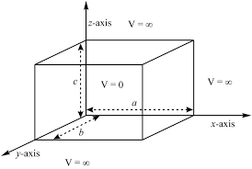
To solve the Schrödinger equation, we'll need to separate variables by assuming a product solution of the form:
$$Ψ\left(x,y,z\right)=X\left(x\right).Y\left(y\right).Z(z)$$
Substituting this into the Schrödinger equation, we obtain three separate ordinary differential equations (ODEs), one for each dimension:
Now each function has its own variable:
X(x) is a function of variable x only
Y(y) is a function of variable y only
Z(z) is a function of variable z only
$$\frac{∂^{2}Ψ}{{∂x}^{2}}=YZ\frac{∂^{2}X}{{∂x}^{2}}⇒\frac{1}{X}\frac{∂^{2}X}{{∂x}^{2}}$$
$$\frac{∂^{2}Ψ}{{∂y}^{2}}=XZ\frac{∂^{2}Y}{{∂y}^{2}}⇒\frac{1}{Y}\frac{∂^{2}Y}{{∂y}^{2}}$$
$$\frac{∂^{2}Ψ}{{∂z}^{2}}=XY\frac{∂^{2}Z}{{∂z}^{2}}⇒\frac{1}{X}\frac{∂^{2}Z}{{∂z}^{2}}$$
E is an energy constant, and is the sum of its components. For this to work, each term must equal its own constant. For example,
$$(\frac{-ħ^{2}}{2m}\frac{∂^{2}X}{{∂x}^{2}})+(\frac{-ħ^{2}}{2m}\frac{∂^{2}Y}{{∂y}^{2}})+(\frac{-ħ^{2}}{2m}\frac{∂^{2}Z}{{∂z}^{2}})=EΨ$$
ε_{x}+ε_{y}+ε_{z}=E
$\frac{∂^{2}X}{{∂x}^{2}}+\frac{2m}{ħ^{2}}E_{x}$=0$≈\frac{∂^{2}Ψ}{{∂x}^{2}}=-\frac{{4π}^{2}}{λ^{2}}$
Use the normalization wavefunction equation for each variable:
$Ψ\left(x\right)=\int_{0}^{a}{\sqrt{\frac{2}{a}}}\sin{\frac{nπx}{a}}$ if 0$≤x≤a$
if a$≤x≤0$
Normalization wavefunction equation for each variable
$$X\left(x\right)=\sqrt{\frac{2}{a}}sin{\frac{n_{x}πx}{a}} Y\left(y\right)=\sqrt{\begin{aligned} \\ \frac{2}{b}\end{aligned}}sin{\frac{n_{y}πy}{b}} Z\left(z\right)=\sqrt{\frac{2}{c}}sin{\frac{n_{z}πx}{c}}$$
The limit of three quantum numbers is:
$n_{x}=n_{y}=n_{x}=$1,2,3,...∞
For each constant use the de Broglie Energy equation:
$$ε_{x}=\frac{n_{x}^{2}h^{2}}{8ma^{2}}$$
Do the same for other variables . Combine Equations to find the wavefunctions inside a 3D box.
$$Ψ\left(r\right)=\sqrt{\frac{8}{V}}sin({\frac{n_{x}πx}{a}}). sin({\frac{n_{y}πy}{b}).} sin({\frac{n_{z}πx}{c}})$$
Hence, value of energy will be given by following equation:
$$E_{x}(n_{x},n_{y},n_{z})=\frac{h^{2}}{8m}(\frac{n_{x}^{2}}{a^{2}}+\frac{n_{y}^{2}}{b^{2}}+\frac{n_{z}^{2}}{c^{2}})$$
Q.2.c.
Ans. In the context of quantum mechanics and wave functions, the term "physically acceptable" refers to wave functions that accurately represent the behaviour of particles and systems within the framework of the theory. Physically acceptable wave functions must satisfy several requirements to accurately describe quantum systems:
- Normalization: A physically acceptable wave function must be normalized, which means that the integral of the squared magnitude of the wave function over all space is equal to 1. This ensures that the total probability of finding the particle in the system is
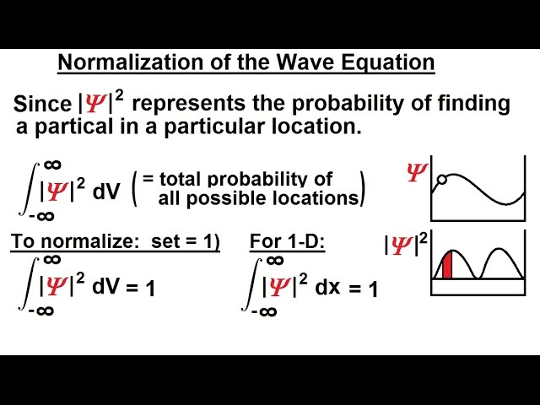
- Continuity: Physically acceptable wave functions should be continuous everywhere in their domain. This ensures that the wave function does not exhibit abrupt or discontinuous changes in probability density, which could lead to unphysical results.
- Single-Valued: A wave function must be single-valued, meaning that it provides a unique value for the probability amplitude at each point in space. This prevents ambiguities and inconsistencies in interpreting the physical meaning of the wave function.
- Square-Integrable: Physically acceptable wave functions must be square-integrable, meaning that the integral of the squared magnitude of the wave function over all space is finite. This property ensures that the total probability associated with the wave function is well-defined.
- Differentiability: In many cases, physically acceptable wave functions should be differentiable, meaning they have well-defined derivatives. This property is important for calculating physical quantities like momentum and energy.
- Finite Energy: For bound systems, the total energy associated with a wave function must be finite. This ensures that the particle's energy is well-defined and does not lead to unphysical results.
- Decay at Infinity: Physically acceptable wave functions often need to decay as distance from a particle increases. This ensures that the probability density decreases as one moves away from the particle, reflecting the decreasing likelihood of finding the particle at large distances.
- Normalization Constant: The normalization constant of the wave function should ensure that the total probability is conserved and that the wave function's squared magnitude integrates to 1 over all space.
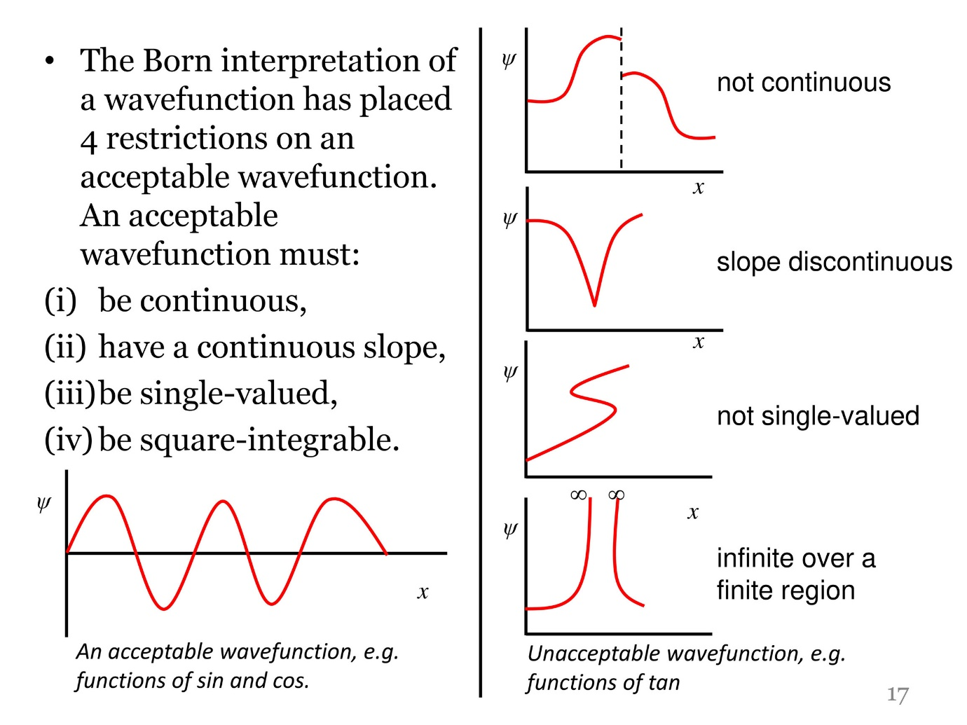
Meeting these requirements ensures that the wave function accurately represents the quantum properties of the system while avoiding unphysical results. Physically acceptable wave functions play a central role in making accurate predictions and explanations within the framework of quantum mechanics.
Q.3.a.
Ans. Gibbs free energy, often denoted as G, is a thermodynamic concept that plays a crucial role in chemistry, particularly in understanding and predicting whether a chemical reaction will occur spontaneously under certain conditions. It combines the effects of both enthalpy (H) and entropy (S) changes in a system to provide insight into the direction and feasibility of a process.
The Gibbs free energy is defined by the equation:
$$∆G=∆H-T∆S$$
Where:
$∆$H is the change in enthalpy (heat content) of the system.
T is the absolute temperature in Kelvin.
$∆$S is the change in entropy of the system.
The significance of Gibbs free energy in chemistry can be understood through the following key points:
- Spontaneity of Reactions: The Gibbs free energy change (ΔG) is a measure of the potential energy available to do useful work in a chemical system. A negative ΔG indicates that a reaction is spontaneous and can occur without the need for external influence. A positive ΔG suggests a non-spontaneous process that requires an input of energy to proceed.
- Equilibrium: At constant temperature and pressure, a chemical reaction tends to reach a state of equilibrium where the Gibbs free energy is minimized. The condition for equilibrium is ΔG=0. This concept is essential for understanding how reactions proceed and the relative concentrations of reactants and products at equilibrium.
- Direction of Change: The sign of ΔG indicates the direction of change in a reaction. If ΔG is negative, the reaction will proceed in the forward direction (products forming from reactants). If ΔG is positive, the reaction will proceed in the reverse direction (reactants reforming from products).
- Standard Gibbs Free Energy Change (ΔG∘): This is the Gibbs free energy change when reactants and products are in their standard states (usually 1 atm pressure and 25°C). It provides a measure of the inherent tendency of a reaction to proceed and is used to compare the spontaneity of different reactions.
- Free Energy and Work: Gibbs free energy is related to the maximum non-expansion work that a system can perform. This is particularly important in processes involving gases and non-mechanical forms of work.
- Chemical Potential: In addition to its role in reactions, Gibbs free energy is also connected to the concept of chemical potential, which describes how the free energy of a substance changes with its concentration in a mixture.
- Phase Transitions: Gibbs free energy helps explain phase transitions and the conditions under which a substance will undergo changes in state (e.g., melting, boiling) based on the balance between enthalpy and entropy changes.
In summary, Gibbs free energy is a fundamental concept in chemistry that provides insights into the spontaneity, direction, and equilibrium of chemical processes. It unifies the concepts of energy, entropy, and temperature, allowing chemists to predict and understand the behaviour of chemical reactions and phase transitions.
Q.3.b.
Ans. In chemistry, transition state theory (TST) explains the reaction rates of elementary chemical reactions. The theory assumes a special type of chemical equilibrium (quasi-equilibrium) between reactants and activated transition state complexes.
TST is used primarily to understand qualitatively how chemical reactions take place. TST has been less successful in its original goal of calculating absolute reaction rate constants because the calculation of absolute reaction rates requires precise knowledge of potential energy surfaces, but it has been successful in calculating the standard enthalpy of activation (ΔH‡, also written Δ‡H^{ɵ}), the standard entropy of activation (ΔS‡ or Δ‡S^{ɵ}), and the standard Gibbs energy of activation (ΔG‡ or Δ‡G^{ɵ}) for a particular reaction if its rate constant has been experimentally determined.
Before the development of TST, the Arrhenius rate law was widely used to determine energies for the reaction barrier. The Arrhenius equation derives from empirical observations and ignores any mechanistic considerations, such as whether one or more reactive intermediates are involved in the conversion of a reactant to a product. Therefore, further development was necessary to understand the two parameters associated with this law, the pre-exponential factor (A) and the activation energy (E_{a}).
The basic ideas behind transition state theory are as follows:
- Rates of reaction can be studied by examining activated complexes near the saddle point of a potential energy surface. The details of how these complexes are formed are not important. The saddle point itself is called the transition state.
- The activated complexes are in a special equilibrium (quasi-equilibrium) with the reactant molecules.
- The activated complexes can convert into products, and kinetic theory can be used to calculate the rate of this conversion.
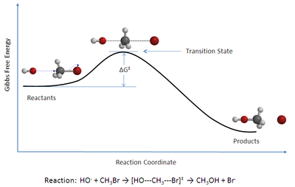
In 1884, Jacobus van 't Hoff proposed the Van 't Hoff equation describing the temperature dependence of the equilibrium constant for a reversible reaction:
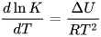
where ΔU is the change in internal energy, K is the equilibrium constant of the reaction, R is the universal gas constant, and T is thermodynamic temperature. Based on experimental work, in 1889, Svante Arrhenius proposed a similar expression for the rate constant of a reaction, given as follows:
where k is the rate constant. A was referred to as the frequency factor (now called the pre-exponential coefficient), and E_{a} is regarded as the activation energy. By the early 20th century many had accepted the Arrhenius equation, but the physical interpretation of A and E_{a} remained vague. This led many researchers in chemical kinetics to offer different theories of how chemical reactions occurred in an attempt to relate A and E_{a} to the molecular dynamics directly responsible for chemical reactions.
In 1910, French chemist René Marcelin introduced the concept of standard Gibbs energy of activation. His relation can be written as
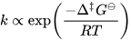
At about the same time as Marcelin was working on his formulation, Dutch chemists Philip Abraham Kohnstamm, Frans Eppo Cornelis Scheffer, and Wiedold Frans Brandsma introduced standard entropy of activation and the standard enthalpy of activation. They proposed the following rate constant equation
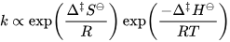
Statistical mechanics played a significant role in the development of TST. However, the application of statistical mechanics to TST was developed very slowly given the fact that in mid-19th century, James Clerk Maxwell, Ludwig Boltzmann, and Leopold Pfaundler published several papers discussing reaction equilibrium and rates in terms of molecular motions and the statistical distribution of molecular speeds.
It was not until 1912 when the French chemist A. Berthoud used the Maxwell–Boltzmann distribution law to obtain an expression for the rate constant.
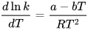
where a and b are constants related to energy terms.
Two years later, René Marcelin made an essential contribution by treating the progress of a chemical reaction as a motion of a point in phase space. He then applied Gibbs' statistical-mechanical procedures and obtained an expression similar to the one he had obtained earlier from thermodynamic consideration.
In 1915, another important contribution came from British physicist James Rice. Based on his statistical analysis, he concluded that the rate constant is proportional to the "critical increment". His ideas were further developed by Richard Chace Tolman. In 1919, Austrian physicist Karl Ferdinand Herzfeld applied statistical mechanics to the equilibrium constant and kinetic theory to the rate constant of the reverse reaction, k₋₁, for the reversible dissociation of a diatomic molecule.
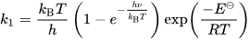
where is the dissociation energy at absolute zero, k_{B} is the Boltzmann constant, h is the Planck constant, T is thermodynamic temperature, is vibrational frequency of the bond. This expression is very important since it is the first time that the factor k_{B}T/h, which is a critical component of TST, has appeared in a rate equation.
In 1920, the American chemist Richard Chace Tolman further developed Rice's idea of the critical increment. He concluded that critical increment (now referred to as activation energy) of a reaction is equal to the average energy of all molecules undergoing reaction minus the average energy of all reactant molecules.
Transition State Theory (TST) is a concept in chemistry that provides a more detailed and realistic framework for understanding the rates of chemical reactions compared to the simpler Collision Theory. It offers a more refined picture of the reaction process by considering the intermediate state between reactants and products, known as the transition state.
Transition State Theory (TST): Transition State Theory proposes that during a chemical reaction, there exists a transition state that represents the highest-energy point along the reaction pathway. At this point, the reactant molecules have partially transformed into products but have not yet completed the reaction. The transition state is a fleeting, short-lived arrangement of atoms and molecules in which bonds are being broken and formed. It is often characterized by an energy barrier called the activation energy (��Ea​).
Advantages of Transition State Theory over Collision Theory:
- Incorporates Energy Barrier: While Collision Theory assumes that reactions occur when molecules collide with sufficient energy and proper orientation, Transition State Theory recognizes that not all collisions lead to a reaction. It introduces the concept of an energy barrier that reactants must overcome to reach the transition state, thus providing a more accurate representation of the reaction process.
- Accounts for Reaction Mechanisms: Transition State Theory acknowledges that reactions often involve multi-step processes with intermediates. It can provide insight into which steps of a reaction are rate-determining and why certain pathways are favoured over others.
- Temperature Dependence: Transition State Theory explains the temperature dependence of reaction rates more comprehensively than Collision Theory. It considers the distribution of energy among molecules and how it affects the likelihood of reaching the transition state.
- Catalysis: Transition State Theory offers a more sophisticated explanation for catalysis. Catalysts work by providing an alternative reaction pathway with a lower activation energy. TST helps explain how catalysts lower the energy barrier, making reactions proceed more readily.
- Rate Constants and Equilibrium Constants: Transition State Theory allows for the calculation of rate constants and equilibrium constants based on the characteristics of the transition state. It provides a link between thermodynamics (equilibrium) and kinetics (rate) of reactions.
- Quantitative Predictions: Transition State Theory provides a more quantitative framework for predicting rate constants and reaction rates based on fundamental principles and molecular properties.
In summary, Transition State Theory is a more sophisticated model than Collision Theory, accounting for the energy barrier and the complex nature of chemical reactions. It offers a deeper understanding of reaction mechanisms, temperature dependence, and the role of intermediates and catalysts. While it requires more detailed knowledge of molecular properties, it provides a more accurate representation of reaction rates and mechanisms in chemical reactions.
Q.3.c.
Ans. The third law of thermodynamics, often referred to as Nernst's heat theorem, is a fundamental principle in the field of thermodynamics. It states that as the temperature of a system approaches absolute zero (0 Kelvin or -273.15°C), the entropy of the system approaches a constant minimum value. In other words, at absolute zero temperature, the entropy of a perfect crystalline substance is precisely zero.
Absolute zero is the lowest possible temperature where the thermal motion of particles nearly comes to a standstill. As the temperature of a system decreases towards absolute zero, the entropy becomes minimal because there is almost no randomness or disorder in the system. This is in line with the idea that entropy is a measure of disorder or randomness in a system.
The absolute value of entropy refers to the numerical magnitude of entropy without considering its sign (positive or negative). Entropy can be positive or negative based on the direction of heat transfer and the increase or decrease in randomness within a system. When considering the absolute value of entropy, the focus is solely on the numerical value itself, disregarding whether it's increasing or decreasing.
The entropy of a perfect crystal lattice as defined by Nernst's theorem is zero provided that its ground state is unique, because ln(1) = 0. If the system is composed of one-billion atoms that are all alike and lie within the matrix of a perfect crystal, the number of combinations of one billion identical things taken one billion at a time is Ω = 1. Hence:

The difference is zero; hence the initial entropy S₀ can be any selected value so long as all other such calculations include that as the initial entropy. As a result, the initial entropy value of zero is selected S₀ = 0 is used for convenience.

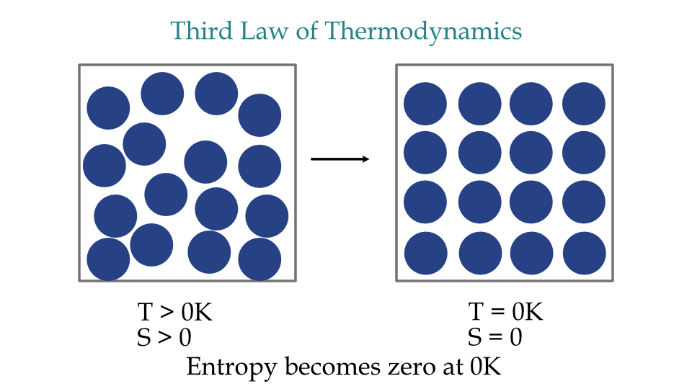
In thermodynamic calculations and analyses, the absolute value of entropy can be useful to compare the magnitude of entropy changes in different processes or systems, without being concerned with the direction of change. This can provide insights into the relative disorder or randomness associated with different states or conditions of a system, regardless of whether the entropy is increasing or decreasing in those circumstances.
Q.4.a.
Ans. Whenever a gas is in contact with a solid there will be an equilibrium established between the molecules in the gas phase and the corresponding adsorbed species (molecules or atoms) which are bound to the surface of the solid.
As with all chemical equilibria, the position of equilibrium will depend upon a number of factors:
- The relative stabilities of the adsorbed and gas phase species involved
- The temperature of the system (both the gas and surface, although these are normally the same)
- The pressure of the gas above the surface
In general, factors (2) and (3) exert opposite effects on the concentration of adsorbed species - that is to say that the surface coverage may be increased by raising the gas pressure but will be reduced if the surface temperature is raised.
The Langmuir isotherm was developed by Irving Langmuir in 1916 to describe the dependence of the surface coverage of an adsorbed gas on the pressure of the gas above the surface at a fixed temperature. There are many other types of isotherm (Temkin, Freundlich ...) which differ in one or more of the assumptions made in deriving the expression for the surface coverage; in particular, on how they treat the surface coverage dependence of the enthalpy of adsorption. Whilst the Langmuir isotherm is one of the simplest, it still provides a useful insight into the pressure dependence of the extent of surface adsorption.
When considering adsorption isotherms it is conventional to adopt a definition of surface coverage (θ) which defines the maximum (saturation) surface coverage of a particular adsorbate on a given surface always to be unity, i.e. θ_{max}=1. This way of defining the surface coverage differs from that usually adopted in surface science where the more common practice is to equate θ with the ratio of adsorbate species to surface substrate atoms (which leads to saturation coverages which are almost invariably less than unity).
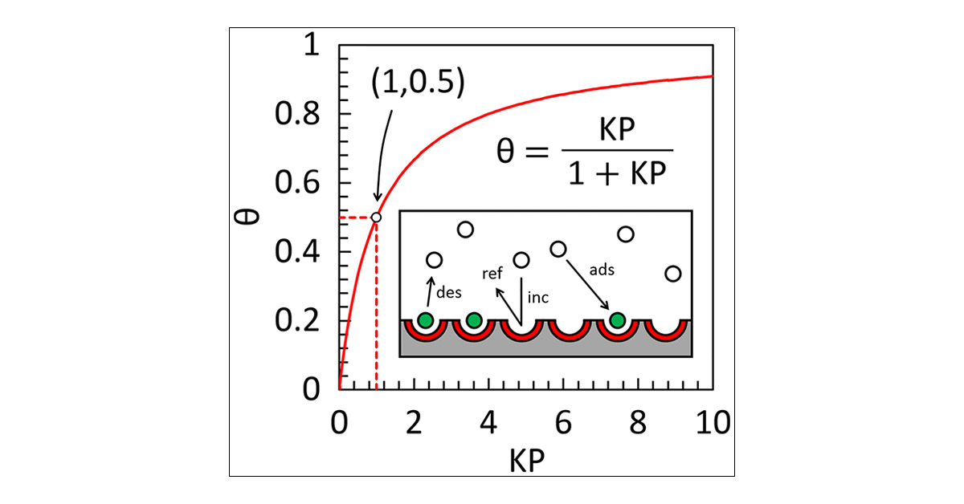
We may derive the Langmuir isotherm by treating the adsorption process as we would any other equilibrium process - except in this case the equilibrium is between the gas phase molecules (M), together with vacant surface sites, and the species adsorbed on the surface. Thus, for a non-dissociative (molecular) adsorption process, we consider the adsorption to be represented by the following chemical equation:
$$S-*+M⇌S-M$$
where:
S−∗ represents a vacant surface site
In writing Equation we are making an inherent assumption that there are a fixed number of localized surface sites present on the surface. This is the first major assumption of the Langmuir adsorption isotherm. Now define an equilibrium constant (K) in terms of the concentrations of "reactants" and "products".
$$K=\frac{[ S - M ] }{[ S - * ][ M ]}$$
It can be noted that:
- [ S - M ] is proportional to the surface coverage of adsorbed molecules, i.e. proportional to θ
- [ S - * ] is proportional to the number of vacant sites, i.e. proportional to (1-θ)
- [ M ] is proportional to the pressure of gas, P
$$K=\frac{θ}{\left(1-θ\right)P}$$
Rearrangement then gives the following expression for the surface coverage
$$θ=\frac{KP}{1+KP}$$
which is the usual form of expressing the Langmuir Isotherm. As with all chemical reactions, the equilibrium constant, b, is both temperature-dependent and related to the Gibbs free energy and hence the enthalpy of adsorption is independent of coverage.
Limitations of Langmuir adsorption isotherm
The Langmuir adsorption isotherm, while widely used and helpful in describing certain adsorption processes, does have its limitations and may not accurately capture all aspects of real-world adsorption phenomena. Some of the key limitations of the Langmuir model include:
- Assumption of Monolayer Adsorption: The Langmuir isotherm assumes that adsorption occurs in a single molecular layer on the surface, forming a complete monolayer of adsorbate molecules. This assumption may not hold true for all adsorption systems, especially in cases where multilayer adsorption or complex interactions occur.
- Homogeneous Surface: The model assumes a homogeneous and uniform surface for adsorption, without considering the presence of surface heterogeneities, defects, or variations in adsorption sites. In reality, surfaces are often heterogeneous, which can lead to deviations from the Langmuir behaviour.
- No Interaction Among Adsorbed Molecules: The Langmuir model assumes that adsorbed molecules do not interact with each other. However, in many cases, adsorbate molecules can interact through various forces, such as van der Waals forces, hydrogen bonding, or electrostatic interactions. These interactions can lead to deviations from the Langmuir isotherm.
- Constant Adsorption Energy: The model assumes a constant energy of adsorption for all adsorbate molecules, regardless of the coverage on the surface. In reality, the adsorption energy may change as the surface coverage increases, especially when surface crowding or lateral interactions occur.
- Equilibrium Assumption: The Langmuir model assumes that equilibrium is rapidly achieved and that adsorption and desorption processes are reversible. However, in some cases, adsorption may be slow or irreversible, leading to deviations from the Langmuir behaviour.
- No Surface Diffusion: The Langmuir model does not account for the possibility of surface diffusion of adsorbate molecules before they settle into their final adsorption sites. Surface diffusion can be particularly relevant for porous or heterogeneous surfaces.
- Non-Ideal Behaviour: The Langmuir model assumes ideal behaviour and does not consider deviations caused by non-ideal interactions, molecular size, shape, and other factors that can affect adsorption in complex ways.
- Limited Applicability to Competitive Adsorption: The Langmuir model does not handle well situations where multiple adsorbate species compete for the same adsorption sites. In reality, competitive adsorption can lead to deviations from the Langmuir behaviour.
Overall, while the Langmuir adsorption isotherm provides a simple and convenient framework for describing adsorption phenomena under certain conditions, its assumptions and limitations must be carefully considered when applying it to real-world systems. For more complex or realistic adsorption scenarios, other models or more sophisticated approaches may be required.
Q.4.b.
Ans. Acid-Base Catalysis
Acid and bases are the most widely used reagents in chemical laboratories. In various reactions, it performs the role of catalyst. Acid-base catalysis is the addition of an acid or a base to a chemical reaction to speed up the reaction without consuming the acid or base. Acid catalysis, as in the decomposition of sucrose into glucose and fructose in sulfuric acid, or base catalysis, as in the addition of hydrogen cyanide to aldehydes and ketones in the presence of sodium hydroxide, are two examples of catalytic reactions. Acids and bases both catalyse a variety of reactions.
General Acid-Base Catalysis Mechanism
The Bronsted-Lowry principle of acids and bases describes the mechanism of acid- and base-catalysed reactions as an initial transfer of protons from an acidic catalyst to the reactant or from the reactant to a basic catalyst. The reaction involves the exchange of an electron pair donated by a base catalyst or embraced by an acid catalyst, according to the Lewis theory of acids and bases.
Acid catalysis is used in many industrial processes, including the conversion of petroleum hydrocarbons to gasoline and other products. High-molecular-weight hydrocarbons are decomposed (cracked) using alumina-silica catalysts (Bronsted-Lowry acids), unsaturated hydrocarbons are polymerized using sulfuric acid or hydrogen fluoride (Bronsted-Lowry acids), and aliphatic hydrocarbons are isomerized using aluminium chloride (Bronsted-Lowry acids) (a Lewis acid). There are two types of acid catalysis: basic acid catalysis and general acid catalysis.

Specific Catalysis
A protonated solvent is the catalyst in basic acid catalysis. The rate of reaction is proportional to the amount of protonated solvent molecules SH⁺ present. The acid catalyst (AH) only helps to accelerate the rate by changing the chemical equilibrium between the solvent S and the AH in favour of the SH⁺ species. Strong acids in polar solvents, such as water, often undergo this form of catalysis.
$$S+AH⇌SH^{+}+A^{-}$$
In an aqueous buffer solution, for example, the rate of reaction for reactants R is affected by the pH of the system but not by the concentrations of different acids.
$$Rate=-\frac{dR_{1}R_{2}}{dt}=K[SH^{+}]R_{1}R_{1}R_{2}R_{2}$$
When the reactant R₁ is in a quick equilibrium with its conjugate acid R₁H⁺, which then continues to react slowly with R₂ to produce the reaction product, this form of chemical kinetics is observed; for example, in the acid catalysed aldol reaction.
General Catalysis
In general, all species capable of contributing protons contribute to the acceleration of reaction rates in acid catalysis. The most powerful acids are the most effective. General acid catalysis is seen in reactions where proton transfer determines the rate of the reaction, such as diazonium coupling reactions.
A change in the rate indicates general acid catalysis when the pH is kept constant but the buffer concentration is changed. The presence of a constant rate indicates the presence of a particular acid catalyst. This type of catalysis is significant when reactions are carried out in nonpolar media because the acid is often not ionized.
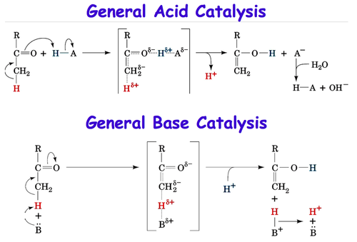

General acid catalysis and/or general base catalysis can be essential mechanisms for specificity and rate enhancement in any reaction involving proton transfer. Acid-base catalysis can be divided into two types: general catalysis and specific catalysis. Specific acid or specific base catalysis occurs when a hydronium or hydroxide ion catalyses a reaction that is determined solely by the pH, rather than the buffer concentration. Consider the hydrolysis of ethyl acetate as an example of how complex acid-base catalysis functions. Since both the nucleophile and the electrophile (the carbonyl of ethyl acetate) are unreactive at neutral pH, this reaction is extremely slow. However, if the reactivity of either the nucleophile or the electrophile could be increased, the reaction rate could be accelerated. The concentration of the hydroxide ion, which is a much stronger nucleophile than water, increases as the pH rises, and the rate of hydrolysis rises as well. Similarly, lowering the pH raises the concentration of the hydronium ion, which can protonate the ester carbonyl, raising its electrophilicity and speeding up the hydrolysis process. If that's the case, the hydrolysis rate should be doubled when the base and acid are combined, right? Not. As acid is added to a base in solution, it is neutralised, and any catalytic effect is lost.
It's important to understand that the pKa values of amino acid side chain groups inside enzyme active sites aren't quite the same as those determined in the solution. In addition, in hydrophobic conditions, pKa values can change dramatically. As a result, the removal of higher pKa protons from substrates by active-site bases may not be as absurd as it seems if only solution chemistry is considered.
Significance of acid-base catalysis in Chemistry
Acid-base catalysis is a fundamental concept in chemistry that plays a crucial role in various chemical reactions and processes. It involves the use of acids or bases to accelerate reaction rates and promote the conversion of reactants into products. This catalytic mechanism is of immense significance in several aspects of chemistry:
- Reaction Acceleration: Acid-base catalysis can greatly increase the rate of chemical reactions. By facilitating the transfer of protons (H+) or hydroxide ions (OH-) between reactants, acids and bases help overcome energy barriers and lower the activation energy of reactions. This enables reactions to occur more rapidly, making them feasible under milder conditions.
- Enzymatic Reactions: Many biological processes rely on acid-base catalysis, particularly in enzyme-catalyzed reactions. Enzymes, which are biological catalysts, often use acidic or basic residues within their active sites to facilitate reactions necessary for metabolism, cellular signaling, and other vital functions.
- Hydrolysis Reactions: Acid-base catalysis is commonly involved in hydrolysis reactions, where water molecules split larger molecules into smaller components. For instance, ester hydrolysis, peptide bond cleavage, and DNA digestion by restriction enzymes are facilitated by acid or base catalysis.
- Protonation and Deprotonation: Acid-base catalysis is essential for protonation (addition of a proton) and deprotonation (removal of a proton) reactions. These processes influence the properties of molecules, such as their acidity, basicity, and reactivity, and are central to many chemical transformations.
- Industrial Processes: Acid-base catalysis is extensively used in industrial processes, such as petroleum refining, polymer synthesis, and the production of fertilizers, fuels, and pharmaceuticals. It allows for more energy-efficient and selective routes to desired products.
- Green Chemistry: Acid-base catalysis can enable cleaner and greener chemical processes. It often reduces the need for harsh reaction conditions, such as high temperatures and pressures, resulting in decreased energy consumption and minimized waste generation.
- Catalytic Converters: In the field of environmental chemistry, acid-base catalysis plays a role in catalytic converters used to reduce harmful emissions from vehicles. These converters help convert harmful gases into less toxic substances through catalytic reactions involving acids and bases.
- Organic Synthesis: Acid-base catalysis is indispensable in organic synthesis, enabling the formation of complex molecules through reactions like Friedel-Crafts acylation, aldol condensation, and Beckmann rearrangement.
- Catalytic Mechanisms: The study of acid-base catalysis contributes to a deeper understanding of reaction mechanisms and the interactions between reactants and catalysts. This knowledge aids in designing new catalysts and optimizing reaction conditions.
- Drug Development: Acid-base catalysis is relevant to pharmaceutical research and drug development. Understanding the catalytic role of certain functional groups in drug molecules helps predict their reactivity and potential interactions within the human body.
In summary, acid-base catalysis is a cornerstone of chemistry, impacting fields ranging from organic synthesis and industrial processes to biochemistry and environmental protection. Its ability to accelerate reactions, modify reaction pathways, and enhance the efficiency of chemical transformations makes it an essential tool for scientists and engineers in numerous disciplines.
Q.4.c.
Ans. The phase rule is a generalization given by Willard Gibbs (1874), which seeks to explain the equilibria existing in heterogeneous system. It may be stated as: “provided the equilibrium between any number of phases is not influenced by gravity, or electrical, or magnetic forces or by surface action and only by temperature, pressure and concentration, then the number of degrees of freedom (F) of the system is related to number of components (C) and of phases (P) by the phase rule equation for any system at equilibrium at a definite temperature and pressure.
F = C – P + 2
This rule, if properly applied, has no exception.
A phase is defined as “an homogeneous, physically distinct and mechanically separable portion of system, which is separated from other such parts of the system by definite boundary surface”. For Example: At freezing point, water consists of three phase :
Ice _{(s)} Water _{(l)} Water vapour _{(g)}
- A gaseous mixture, being thoroughly miscible in all proportion, will constitute one phase only. Thus, a mixture of N₂ and H₂ forms one phase only.
- If two liquids are miscible (i.e., alcohol and water), they will form one liquid phase only.
- A solution of a substance in a solvent consists of phase only, e. g, glucose solution in water.
- Each solid mark up a separate phase, except in the case of solid solution, e. g, many forms of sulphur can exist together, but these are all separate phases.
- A heterogeneous mixture like :
CaCO3 _{(s)} CaO_{(s)} + CO_{2 (g)}
Consists of three phases (i.e., two solids and one gaseous). Similarly, in the equilibrium reaction,
Fe_{(s)} + H₂O FeO_{(s)} + H_{2(g)}
There are two solid phases, Fe and FeO and one gaseous phase consisting of H₂O_{(g)} and H_{2(g)}. Thus, three phases exists in equilibrium.
Component: by the term component is meant “the smallest number of independent variable constituents, taking part in state of equilibrium, by mean of which the composition of each phase can be expressed in the form of chemical equation”. For example:
i. In the water system,
Ice _{(s)} Water _{(l)} vapour _{(g)}
The chemical composition of all the three phases is H₂O. Hence, it is one component system.
ii. the sulphur system consists of four phases, rhombic, monoclinic, liquid and vapour, the chemical composition of all phases is S. hence, it is one component system.
iii. In the dissociation of NH₄CI in a closed vessel,
NH₄CI_{(g)}NH₄CI_{(g)} NH_{3(g)}+HCI_{(g)}
The proportions of NH₃ and HCl are equivalent and hence, the composition of both phases (solid and gaseous) can be expressed in terms of NH₄CI alone. Hence, the number of component is one. However, if NH₃ or HCl is in excess, the system become a two component system .
Number of component of a system may alternatively be defined as the number of chemical constituents of the system minus the number of equations relating to these constituents in an equilibrium state. For example:
- Dissociation of KClO₃ in a closed vessel: following equilibrium exists :
KClO_{3(s)} 2KCl_{(s)} + 3O₂ _{(g)}
No. of constituents = 3
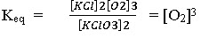
No. of equations relating the concentration of constituents =1.
Hence, number of components = 3-1 = 2 i.e., it is a two component system.
Degree of freedom or variance
By the term “degree of freedom is meant by” the minimum number of independently variable factors, such as temperature, pressure and composition of the phases, which must be arbitrarily specified in order to represent perfectly the condition of a system. For example
i. In case of water system, Ice_{(s )} Water_{(l)} Vapour_{(g),}
if all the three phases are present in equilibrium, then no condition need to be specified, as the three phases can be in equilibrium only at particular temperature and pressure. If condition (e.g. Temperature or pressure is altered, three phases will not remain in equilibrium and one of the phase disappears.
ii. For a system consisting of water n in contact with its vapour,
Water_{(l)} Vapour_{(g)}
We must state either the temperature or pressure to define it completely. Hence, degree of freedom is one or system is univariant.
iii. For a system consisting of water vapour phase only, we must the values of both the temperature and pressure in order to describe the system completely. Hence, the system is bivariant or has two degrees of freedom.
The phase rule, also known as the Gibbs phase rule or Gibbs-Duhem equation, is a fundamental principle in thermodynamics that describes the number of degrees of freedom in a system in equilibrium. It's particularly useful for understanding the behavior of multi-component systems, including mixtures of different substances. However, in the case of a one-component system like water, the phase rule simplifies to some extent.
In a one-component system, like pure water, there is only one chemical species present. Here's how the phase rule applies to such a system:
The phase rule is given by the formula:
F = C - P + 2
Where:
- F is the number of degrees of freedom
- C is the number of components (chemical species)
- P is the number of phases in equilibrium (solid, liquid, gas, etc.)
In the case of pure water, there is only one component (H2O), so C = 1. Also, water can exist in different phases depending on temperature and pressure: solid (ice), liquid (water), and gas (steam). So, P = 3 (for the three phases).
Plugging these values into the phase rule formula:
F = 1 - 3 + 2 = 0
This result indicates that in a one-component system like pure water, you have no degrees of freedom. In other words, the state of the system is entirely determined by the temperature and pressure. Once you fix the temperature and pressure, the system will exist in a specific phase (solid, liquid, or gas), and there is no variation possible.
In more practical terms, this means that for a one-component system like pure water, you can't change the state of the system (phase) by simply adjusting temperature and pressure. If you're at a specific temperature and pressure, you'll have a specific phase of water. You can't, for example, change ice to liquid water at a given temperature and pressure just by adjusting those variables.
While the phase rule in this case might seem trivial, it lays the foundation for understanding more complex systems with multiple components where phase transitions and equilibria become more intricate and interesting.

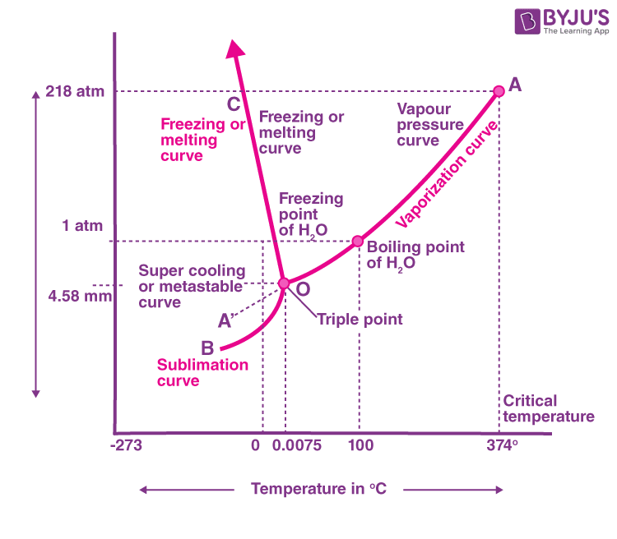
Q.5.a.
Ans. Solubility product
The solubility product (K_{sp}) is a fundamental concept in chemistry that describes the equilibrium constant for the dissolution of a sparingly soluble compound in a solvent. It's used to quantitatively express the solubility of a compound in terms of its ions in solution. The solubility product is typically defined for ionic compounds that dissociate into ions when they dissolve in water.
For a general chemical reaction involving an ionic compound dissolving in water:
aA(s) + bB(s) ⇌ cC(aq) + dD(aq)
The corresponding solubility product expression is:
$$K_{sp}=\frac{{C^{c}D}^{d}}{A^{a}B^{b}}$$
Where:
- [C] and [D] are the concentrations of the ions C and D in the saturated solution.
- [A] and [B] are the concentrations of the ions A and B that were originally present in the solid compound before dissolution.
- c, d, a, and b are the coefficients of the balanced equation.
The solubility product is a measure of how far the dissolution reaction proceeds before equilibrium is reached. If the ion concentrations in solution exceed the K_{sp} value, then precipitation of the solid compound will occur.
Common Ion Effect
The common ion effect is a phenomenon that occurs when the addition of an ion that is already present in a solution, either through another solute or as a dissociation product, reduces the solubility of a sparingly soluble compound in that solution. It's a consequence of Le Chatelier's principle, which states that a system in equilibrium will adjust to counteract changes imposed on it.
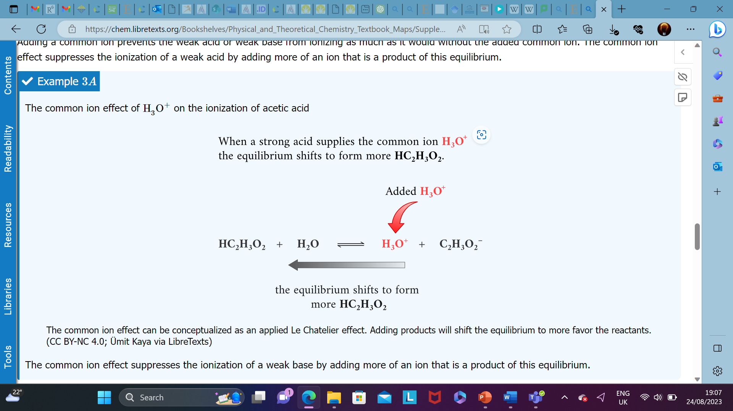

Significance of common ion effect and solubility product
The common ion effect and solubility product are both significant concepts in chemical analysis, particularly in understanding and manipulating equilibrium systems involving ionic compounds in solution. Their significance lies in their applications to various analytical techniques and methods. Here's how they are relevant in chemical analysis:
1. Precipitation Reactions and Separation Techniques: In chemical analysis, one often encounters situations where it's necessary to selectively precipitate certain ions from a mixture for separation and identification. The common ion effect plays a crucial role here. By adding a compound containing a common ion to a solution, you can reduce the solubility of a specific ionic compound, causing it to precipitate. This is used in techniques like gravimetric analysis, where the mass of the precipitate is used to determine the original concentration of the analyte.
2. Qualitative Analysis: In qualitative analysis, the identification of ions in a mixture is based on their characteristic reactions. The solubility product is used to predict the solubility of various ionic compounds and hence helps in determining which ions will form precipitates in a given solution. This aids in identifying the presence of specific ions through the observation of precipitate formation.
3. Determination of Ion Concentrations: The solubility product is used to determine the concentration of ions in solution when precipitates are formed. By measuring the amount of precipitate formed and understanding the equilibrium established, one can calculate the concentration of ions in the original solution. This information is vital in quantitative analysis.
4. Standard Solutions and Calibration Curves: In instrumental analysis, standard solutions of known concentrations are used to calibrate instruments. The solubility product helps in preparing these standard solutions of ions with known concentrations. The common ion effect can also be exploited to modify the concentrations of ions in standard solutions to match those present in the sample.
5. Complexometric Titration and Complex Formation: In complexometric titration, complexation reactions between metal ions and chelating agents are used for titration. The solubility product and common ion effect are relevant here as they influence the formation of complexes and the equilibrium between metal ions and chelating agents.
6. pH and Buffer Systems: The common ion effect is also seen in buffer systems. A buffer solution resists changes in pH upon the addition of an acid or base. This is achieved by having a weak acid and its conjugate base (or a weak base and its conjugate acid) present in solution. The common ion effect helps maintain the desired pH by shifting the equilibrium position in response to changes in H⁺ ion concentration.
In summary, both the common ion effect and the solubility product are essential tools in chemical analysis. They are used to understand, predict, and manipulate equilibria involving ionic compounds in solution, enabling accurate qualitative and quantitative analyses across a wide range of analytical techniques and methods.
Q.5.b.
Ans. (i) VSEPR calculation for boron trifluoride, BF. Boron trifluoride only has six valence electrons and is one of the relatively rare second period covalent molecules that disobeys the octet rule. There are three bonded groups and so no lone pairs. Six electrons implies three electron pairs and therefore a trigonal geometry.
Lewis structure: | 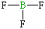
Central atom: | boron
Valence electrons on central atom: | 3
3 F each contribute 1 electron: | 3
Total: | 6
Divide by 2 to give electron pairs | 3
3 electron pairs: | trigonal geometry for the three shape-determining electron pairs
(ii) steps of drawing a Lewis diagram:-
1. The first step is to count all the valence electrons of each molecule.
In the case of IF₅,
The Iodine atom has 7 valence electrons. F also has 7 valence electrons. But since there are 5 atoms of F, we multiply 7×5= 35 valence electrons.
Adding both we get 35+7= 42.
Hence, a total number of valence electrons of IF5= 42.
2. Determining the central atom.
A central atom is usually the one to which each atom is bound to. There is usually only one of it in a molecule. In the case of IF₅, I (Iodine) is the central atom.
3. Draw single bonds to the central atom. A single bond represents 2 electrons being shared.
4. Put all the remaining valence electrons on the atoms as lone pairs (2 dots).
5. Turn the lone pairs into a double or a triple bond so that each atom has its complete octet.
As a last resort, check the formal charge of each atom. It should be the lowest possible and can be calculated. Now in the case of IF5, we can see that ‘I’ not only had completed its octet but had exceeded it by 2 electrons. Now arrange the remaining valence electrons around all the atoms to complete their octet. After this, we observe that it still have 2 valence electrons remaining.
Place these on the central atom I as lone pairs. Thus have completed the Lewis structure of IF₅. Now notice that the Iodine atom has 12 valence electrons around it.
This is an exception to the rule of octet known as expanded octet’s rule which states that central atoms that are found in the third period or below which are bound to highly electronegative terminal atoms (F) can have an expanded octet containing up to 12 valence electrons.
Hence I can hold up to 12 valence electrons. Now if you check the formal charge of each atom it comes out to be 0, which is the lowest value possible.
so the formula given below.
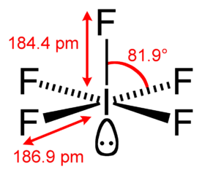
Q.5.c.
Ans. The H-S-H bond angle in hydrogen sulphide (H₂S) is slightly less than the tetrahedral angle of 109.5 degrees. This phenomenon can be explained by considering the repulsion between electron pairs around the sulphur atom and the resulting molecular geometry.
Hydrogen sulphide (H₂S) has a bent molecular geometry due to the presence of two lone pairs of electrons on the sulphur atom. In a water molecule (H₂O), which has a similar bent geometry, the lone pairs on oxygen create repulsion that causes the H-O-H bond angle to be less than the tetrahedral angle. The same principle applies to hydrogen sulphide.
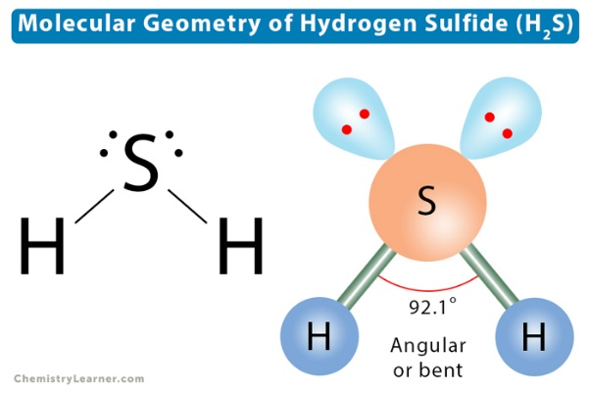
The repulsion between electron pairs can be understood using VSEPR theory. According to VSEPR theory, electron pairs, whether bonding or non-bonding (lone pairs), arrange themselves in a way that minimizes the repulsion between them. In the case of hydrogen sulphide, the two lone pairs on the sulphur atom repel the bonding pairs, causing a slight compression of the H-S-H bond angle.
The actual H-S-H bond angle in hydrogen sulphide is around 92 degrees, which is noticeably less than the tetrahedral angle of 109.5 degrees. This deviation is a result of the influence of the lone pairs on the sulphur atom. The lone pairs tend to take up more space in the molecule, leading to a reduction in the bond angle between the hydrogen atoms attached to sulphur.
Q.6.a.
Ans. Crystal field theory (CFT) describes the breaking of orbital degeneracy in transition metal complexes due to the presence of ligands. CFT qualitatively describes the strength of the metal-ligand bonds. Based on the strength of the metal-ligand bonds, the energy of the system is altered. This may lead to a change in magnetic properties as well as color.
Basic Concept
In Crystal Field Theory, it is assumed that the ions are simple point charges (a simplification). When applied to alkali metal ions containing a symmetric sphere of charge, calculations of bond energies are generally quite successful. The approach taken uses classical potential energy equations that take into account the attractive and repulsive interactions between charged particles (that is, Coulomb's Law interactions).
$$E∝\frac{q_{1}q_{2}}{r}$$
with
- E the bond energy between the charges and
- q₁ and q₂ are the charges of the interacting ions and
- r is the distance separating them.
This approach leads to the correct prediction that large cations of low charge, such as K⁺ and Na⁺, should form few coordination compounds. For transition metal cations that contain varying numbers of d electrons in orbitals that are NOT spherically symmetric, however, the situation is quite different. The shapes and occupations of these d-orbitals then become important in building an accurate description of the bond energy and properties of the transition metal compound.
When examining a single transition metal ion, the five d-orbitals have the same energy (Figure). When ligands approach the metal ion, some experience more opposition from the d-orbital electrons than others based on the geometric structure of the molecule. Since ligands approach from different directions, not all d-orbitals interact directly. These interactions, however, create a splitting due to the electrostatic environment.
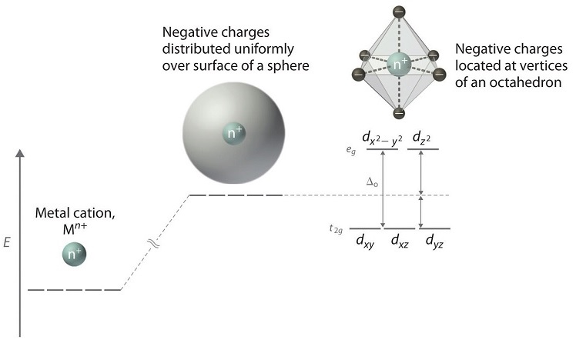Figure: Distributing a charge of −6 uniformly over a spherical surface surrounding a metal ion causes the energy of all five d orbitals to increase due to electrostatic repulsions, but the five d orbitals remain degenerate. Placing a charge of −1 at each vertex of an octahedron causes the d orbitals to split into two groups with different energies: the d_{x}²_{−y}² and d_{z}² orbitals increase in energy, while the, d_{xy}, d_{xz}, and d_{yz} orbitals decrease in energy. The average energy of the five d orbitals is the same as for a spherical distribution of a −6 charge, however. Attractive electrostatic interactions between the negatively charged ligands and the positively charged metal ion (far right) cause all five d orbitals to decrease in energy but does not affect the splitting of the orbitals. The two e_{g} orbitals point directly at the six negatively charged ligands, which increases their energy compared with a spherical distribution of negative charge. In contrast, the three t_{2g} orbitals point between the negatively charged ligands, which decreases their energy compared with a spherical distribution of charge.
For example, consider a molecule with octahedral geometry. Ligands approach the metal ion along the x, y and z axes. Therefore, the electrons in the dz² and dx²−y² orbitals (which lie along these axes) experience greater repulsion. It requires more energy to have an electron in these orbitals than it would to put an electron in one of the other orbitals. This causes a splitting in the energy levels of the d-orbitals. This is known as crystal field splitting. For octahedral complexes, crystal field splitting is denoted by Δ_{o} (or Δ_{oct}). The energies of the dz² and dx²−y² orbitals increase due to greater interactions with the ligands. The dxy, dxz, and dyz orbitals decrease with respect to this normal energy level and become more stable.
Electrons in Orbitals
According to the Aufbau principle, electrons are filled from lower to higher energy orbitals (Figure). For the octahedral case above, this corresponds to the d_{xy}, d_{xz}, and d_{yz} orbitals. Following Hund's rule, electrons are filled in order to have the highest number of unpaired electrons. For example, if one had a d³ complex, there would be three unpaired electrons. If one were to add an electron, however, it has the ability to fill a higher energy orbital ( d_{z²} or d_{x²-y²}) or pair with an electron residing in the d_{xy}, d_{xz}, or d_{yz} orbitals. This pairing of the electrons requires energy (spin pairing energy). If the pairing energy is less than the crystal field splitting energy, ∆₀, then the next electron will go into the d_{xy}, d_{xz}, or d_{yz} orbitals due to stability. This situation allows for the least amount of unpaired electrons, and is known as low spin. If the pairing energy is greater than ∆₀, then the next electron will go into the d_{z}² or d_{x}²-_{y}² orbitals as an unpaired electron. This situation allows for the most number of unpaired electrons, and is known as high spin. Ligands that cause a transition metal to have a small crystal field splitting, which leads to high spin, are called weak-field ligands. Ligands that produce a large crystal field splitting, which leads to low spin, are called strong field ligands.
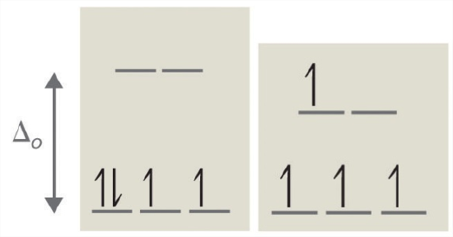
Figure: Low Spin, Strong Field (∆_{o}˃P) High Spin, Weak Field (∆_{o}˂P)Splitting for a d4 complex under a strong field (left) and a weak field (right). The strong field is a low spin complex, while the weak field is a high spin complex.
As mentioned above, CFT is based primarily on symmetry of ligands around a central metal/ion and how this anisotropic (properties depending on direction) ligand field affects the metal's atomic orbitals; the energies of which may increase, decrease or not be affected at all. Once the ligands' electrons interact with the electrons of the d-orbitals, the electrostatic interactions cause the energy levels of the d-orbital to fluctuate depending on the orientation and the nature of the ligands. For example, the oxidation state and the strength of the ligands determine splitting; the higher the oxidation state or the stronger the ligand, the larger the splitting. Ligands are classified as strong or weak based on the spectrochemical series:
I⁻ < Br⁻ < Cl⁻ < SCN⁻ < F⁻ < OH⁻ < ox²⁻< ONO⁻ < H₂O < SCN⁻ < EDTA⁴⁻ < NH₃ < en < NO₂⁻ < CN⁻
Note that SCN⁻ and NO₂- ligands are represented twice in the above spectrochemical series since there are two different Lewis base sites (e.g., free electron pairs to share) on each ligand (e.g., for the SCN⁻ ligand, the electron pair on the sulphur or the nitrogen can form the coordinate covalent bond to a metal). The specific atom that binds in such ligands is underlined.
In addition to octahedral complexes, two common geometries observed are that of tetrahedral and square planar. These complexes differ from the octahedral complexes in that the orbital levels are raised in energy due to the interference with electrons from ligands. For the tetrahedral complex, the d_{xy}, d_{xz}, and d_{yz} orbitals are raised in energy while the d_{z²}, d_{x²-y²} orbitals are lowered. For the square planar complexes, there is greatest interaction with the d_{x²-y²} orbital and therefore it has higher energy. The next orbital with the greatest interaction is d_{xy}, followed below by d_{z²}. The orbitals with the lowest energy are the d_{xz} and d_{yz} orbitals. There is a large energy separation between the d_{z²} orbital and the d_{xz} and d_{yz} orbitals, meaning that the crystal field splitting energy is large. We find that the square planar complexes have the greatest crystal field splitting energy compared to all the other complexes. This means that most square planar complexes are low spin, strong field ligands.

Description of d-Orbitals
To understand CFT, one must understand the description of the lobes:
- d_{xy}: lobes lie in-between the x and the y axes.
- d_{xz}: lobes lie in-between the x and the z axes.
- d_{yz}: lobes lie in-between the y and the z axes.
- d_{x}²-y²: lobes lie on the x and y axes.
- d_{z2}: there are two lobes on the z axes and there is a donut shape ring that lies on the xy plane around the other two lobes.
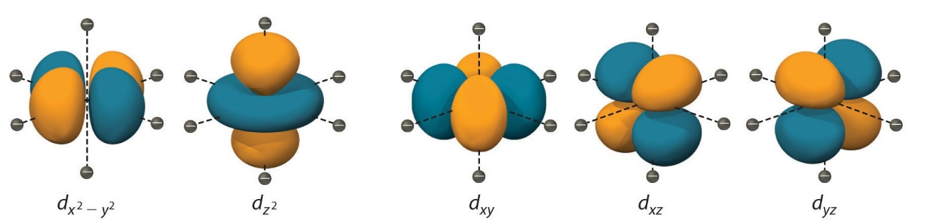Figure: Spatial arrangement of ligands in the an octahedral ligand field with respect to the five d-orbitals.
Octahedral Complexes
In an octahedral complex, there are six ligands attached to the central transition metal. The d-orbital splits into two different levels (Figure ). The bottom three energy levels are named dxy, dxz, and dyz (collectively referred to as t_{2g}). The two upper energy levels are named dx²−y² , and dz² (collectively referred to as eg).
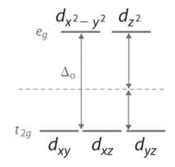
The reason they split is because of the electrostatic interactions between the electrons of the ligand and the lobes of the d-orbital. In an octahedral, the electrons are attracted to the axes. Any orbital that has a lobe on the axes moves to a higher energy level. This means that in an octahedral, the energy levels of e_{g} are higher (0.6∆_{o}) while t₂g is lower (0.4∆_{o}). The distance that the electrons have to move from t₂g from eg and it dictates the energy that the complex will absorb from white light, which will determine the colour. Whether the complex is paramagnetic or diamagnetic will be determined by the spin state. If there are unpaired electrons, the complex is paramagnetic; if all electrons are paired, the complex is diamagnetic.
Tetrahedral Complexes
In a tetrahedral complex, there are four ligands attached to the central metal. The d orbitals also split into two different energy levels. The top three consist of the dxy, dxz, and dyz orbitals. The bottom two consist of the dx²−y² and dz² orbitals. The reason for this is due to poor orbital overlap between the metal and the ligand orbitals. The orbitals are directed on the axes, while the ligands are not.
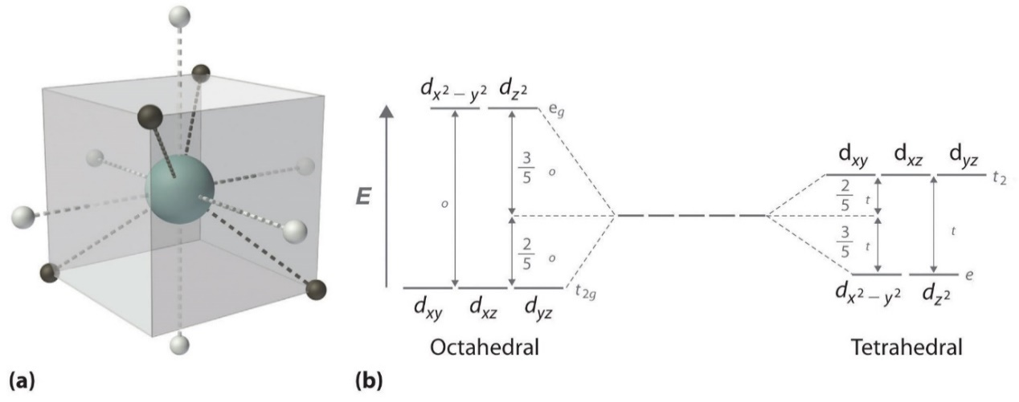Figure: (a) Tetrahedral ligand field surrounding a central transition metal (blue sphere). (b) Splitting of the degenerate d-orbitals (without a ligand field) due to an octahedral ligand field (left diagram) and the tetrahedral field (right diagram).
Consequentially, Δt is typically smaller than the spin pairing energy, so tetrahedral complexes are usually high spin.
Square Planar Complexes
In a square planar, there are four ligands as well. However, the difference is that the electrons of the ligands are only attracted to the xy plane. Any orbital in the xy plane has a higher energy level (Figure). There are four different energy levels for the square planar (from the highest energy level to the lowest energy level): d_{x}²_{-y}², d_{xy}, d_{z}², and both d_{xz} and d_{yz}.
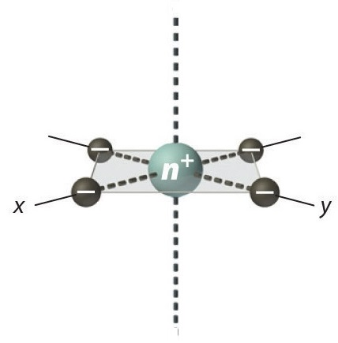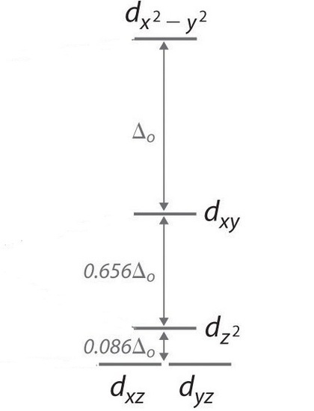
Figure: Splitting of the degenerate d-orbitals (without a ligand field) due to an square planar ligand field.
The splitting energy (from highest orbital to lowest orbital) is Δsp and tends to be larger than Δo. Moreover, Δsp is also larger than the pairing energy, so the square planar complexes are usually low spin complexes.
Q.6.b.
Ans.
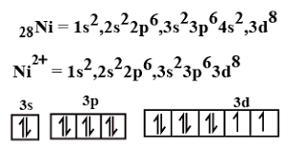
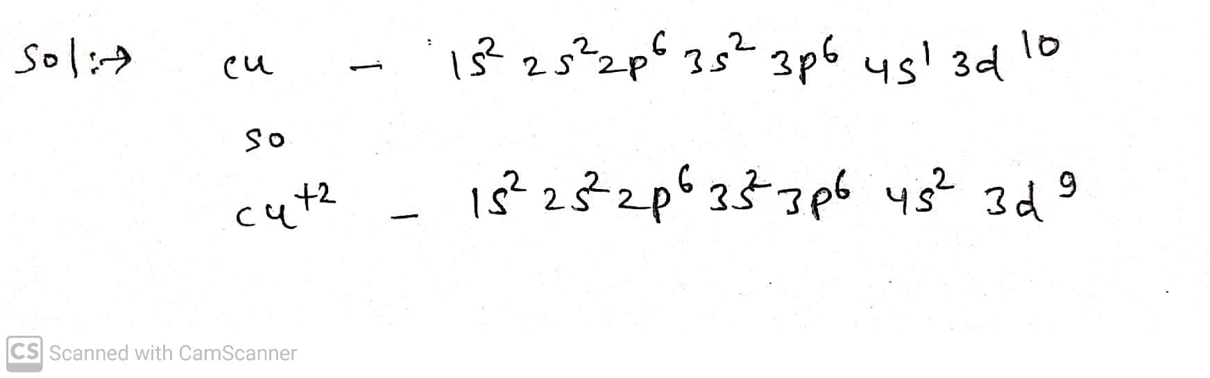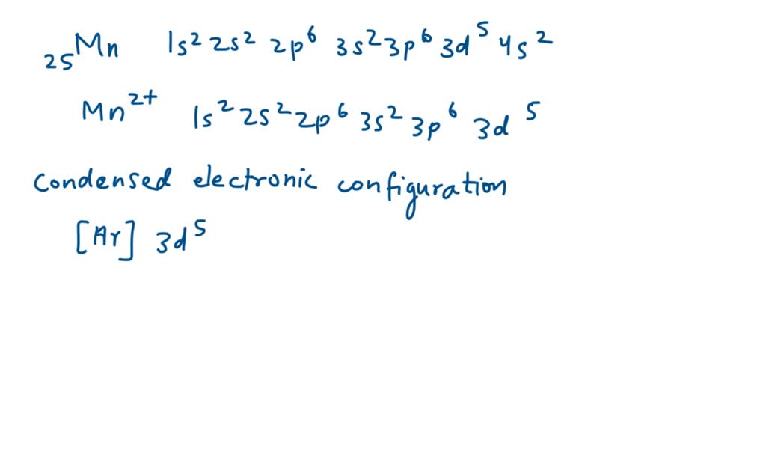
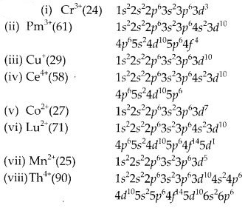
Q.6.c.
Ans. Jahn Teller theorem
The Jahn-Teller Theorem (named after Hermann Arthur Jahn and Edward Teller), was published in 1937 and essentially means that:
"any non-linear molecular system in a degenerate electronic state will be unstable and will undergo distortion to form a system of lower symmetry and lower energy thereby removing the degeneracy"
In an octahedral crystal field, the t_{2g} orbitals occur at lower energy than the e_{g} orbitals. This is a reflection of the orientation of the orbitals since the t_{2g} are directed between bond axes while the e_{g} point along bond axes. The shielding effect this has on the electrons is used to explain why the Jahn-Teller effect is generally only important for odd number occupancy of the e_{g} level.
The effect of Jahn-Teller distortions is best documented for Cu(II) complexes (with 3 electrons in the e_{g} level) where the result is that most complexes are found to have elongation along the z-axis.
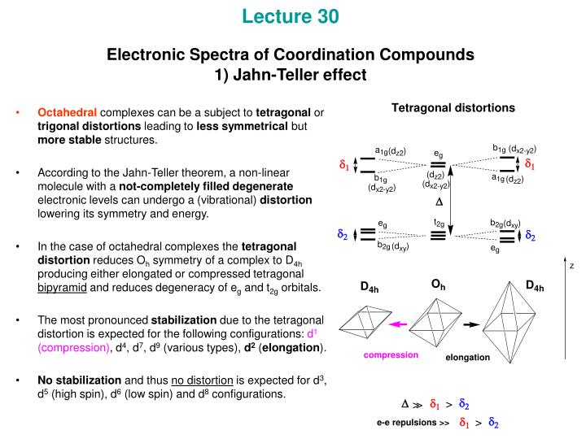
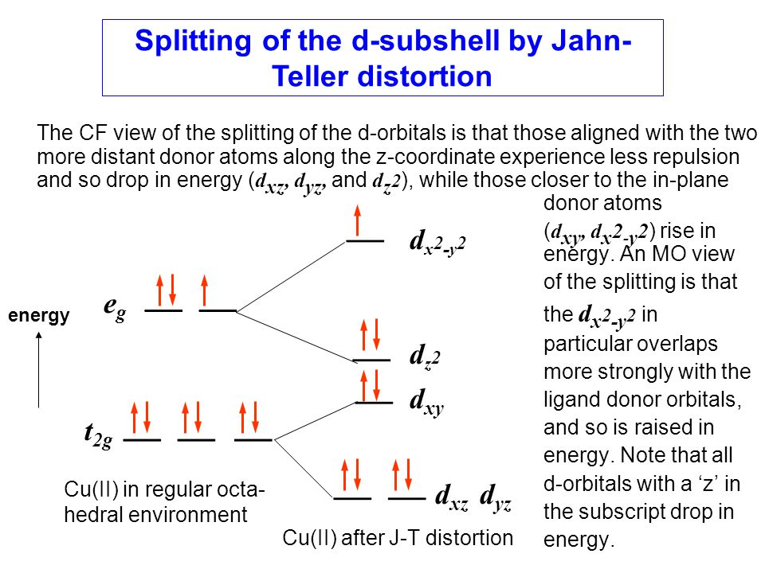
Significance of Jahn Teller theorem in coordination chemistry
The Jahn-Teller theorem is of significant importance in the field of coordination chemistry as it explains the distortion of certain molecules and complexes from their symmetric geometries. This phenomenon arises when a molecule or complex has degenerate electronic energy levels in a non-linear molecule or coordination complex. The theorem provides insights into the stability and properties of these distorted systems, particularly transition metal complexes, which have partially filled d or f orbitals.
Here are the key significances of the Jahn-Teller theorem in coordination chemistry:
- Stabilization of Complexes: The Jahn-Teller theorem explains that if a molecule or complex has degenerate electronic states, it will undergo a geometric distortion to remove the degeneracy and lower the overall energy. This distortion often leads to the stabilization of the complex, as the energy difference between the distorted and undistorted states results in a lower overall energy level.
- Electronic Transitions and Spectroscopy: In spectroscopy, the Jahn-Teller effect is observed through electronic transitions between the distorted and undistorted geometries of a molecule or complex. These transitions are associated with changes in symmetry and energy, leading to observable spectral features that provide valuable information about the electronic structure and coordination environment.
- Stability of Transition Metal Complexes: Many transition metal complexes exhibit the Jahn-Teller effect due to the degeneracy of their d orbitals. This effect can significantly influence the stability and reactivity of these complexes. Understanding the distortion patterns and their impact on stability is crucial in designing and predicting the behavior of transition metal complexes.
- Magnetic and Spectroscopic Properties: The Jahn-Teller effect can lead to changes in magnetic and spectroscopic properties. For example, distorted geometries can influence the intensity and selection rules of electronic transitions, affecting the absorption and emission spectra of the complexes.
- Structural Determination: The Jahn-Teller distortion can provide valuable structural information about a complex. By analysing the distortion patterns and their effects, researchers can deduce the arrangement of ligands around the central metal ion and gain insights into the complex's geometry.
- Catalysis and Reactivity: Understanding the Jahn-Teller effect in coordination complexes is important for predicting their reactivity in catalytic processes. The distortion of the complex can affect the energy barriers for various reaction pathways, influencing the overall catalytic activity.
- Quantum Chemistry and Computational Studies: The Jahn-Teller theorem plays a crucial role in quantum chemistry and computational studies. The theorem is used to calculate the energy changes associated with geometric distortions, aiding in the prediction of complex stability and electronic properties.
In summary, the Jahn-Teller theorem is a fundamental concept in coordination chemistry that explains the geometrical distortions of molecules and complexes with degenerate electronic energy levels. Its significance extends to various areas of chemistry, including spectroscopy, stability analysis, reactivity prediction, and the understanding of complex electronic structures.
Q.7.a.
Ans. Lanthanides, also known as rare earth elements, are a group of 15 metallic chemical elements that belong to the lanthanide series in the periodic table. They are commonly referred to as "rare earths" due to their scarcity in the Earth's crust, although they are not actually rare. The lanthanides include the elements from atomic number 57 (lanthanum, La) to atomic number 71 (lutetium, Lu).
The lanthanides are characterized by their similar chemical properties, which make them difficult to separate from each other. They have unique electronic configurations due to the filling of their 4f orbitals, leading to various applications in technology, electronics, and materials science. Lanthanides exhibit a wide range of properties, including magnetic, electrical, and optical properties, which make them essential for various industrial and technological applications.
Extraction of Lanthanides from Ores:
Lanthanides are typically found in low concentrations in various minerals, making their extraction and purification processes quite complex. The primary ores containing lanthanides include monazite, bastnäsite, and xenotime. The general process of extracting lanthanides from these ores involves several steps:
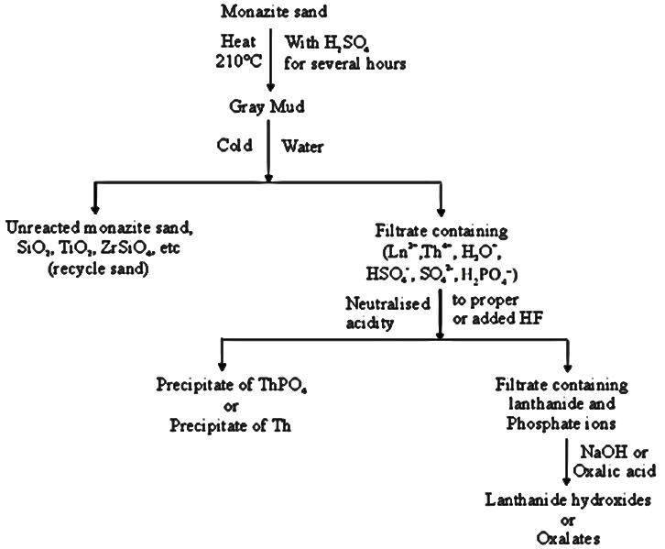
- Ore Mining: The ores containing lanthanides are first mined from deposits. These ores are usually mixtures of various minerals, and the concentration of lanthanides can be quite low.
- Ore Beneficiation: The mined ores are subjected to beneficiation processes to separate the valuable minerals from the waste materials. Techniques such as crushing, grinding, and flotation are used to concentrate the lanthanide-bearing minerals.
- Leaching: After beneficiation, the concentrated ore is subjected to a leaching process, where the lanthanides are dissolved into a suitable solvent. The choice of solvent depends on the specific ore and its mineral composition.
- Solvent Extraction: Solvent extraction is a common method used to separate the lanthanides from the leach solution. This process involves transferring the lanthanides from one solvent phase to another, based on their different chemical affinities for certain solvents.
- Ion Exchange: Ion exchange is another technique used to separate lanthanides from their leach solutions. It involves passing the solution through a resin that selectively binds certain ions, including the lanthanides.
- Precipitation: Once the lanthanides are separated from impurities, they can be selectively precipitated from solution using various chemical methods.
- Purification: Lanthanides are often not separated individually but as a mixture. Additional purification steps may be required to separate the individual lanthanides from each other, as they have very similar chemical properties.
- Reduction and Refining: The separated lanthanides are then often converted to their oxide form through a reduction process. The resulting oxides are further refined and processed to obtain high-purity lanthanide compounds that are suitable for various applications.
The extraction and separation of lanthanides from their ores are complex and resource-intensive processes. Due to the similarities in their chemical properties, achieving high-purity individual lanthanides can be challenging. However, the unique properties of lanthanides make them crucial for a wide range of applications, including electronics, catalysts, magnets, lighting, and more.
Q.7.b.
Ans. Radioactive decay law
The radioactive decay law states that the probability per unit time that a nucleus will decay is constant, independent of time. This constant is called the decay constant and is denoted by λ. This constant probability may vary greatly between different types of nuclei, leading to the many different observed decay rates. The radioactive decay of a certain number of atoms (mass) is exponential in time.
There are only certain combinations of neutrons and protons, which form stable nuclei. As the number of protons increases, an increasing ratio of neutrons to protons is needed to form a stable nucleus. If there are too many (neutrons also obey the Pauli exclusion principle) or too few neutrons for a given number of protons, the resulting nucleus is not stable, and it undergoes radioactive decay. Radioactive decay is a random process at the level of single atoms, in that, according to quantum theory, it is impossible to predict when a particular atom will decay. In other words, a nucleus of a radionuclide has no “memory”. The radioactive decay law is valid for all modes of decay. There are three basic modes of radioactive decay:
  - Alpha decay.
  - Beta-decay.
  - Gamma decay.
Additional important decay modes:
  - Electron capture.
  - Internal conversion.
  - Neutron decay.
  - Proton decay.
  - Spontaneous fission.
A measure of radioactivity (activity) is based on the counting of disintegrations per second. The SI unit of activity is the becquerel (Bq), equal to one reciprocal second.
The rate of nuclear decay is also measured in terms of half-lives. Radioactive material with a short half-life is much more radioactive (at the time of production) but will obviously lose its radioactivity rapidly. The half-life is the amount of time it takes for a given isotope to lose half of its radioactivity. If a radioisotope has a half-life of 14 days, half of its atoms will have decayed within 14 days. In 14 more days, half of that remaining half will decay, and so on. Half-lives range from millionths of a second for highly radioactive fission products to billions of years for long-lived materials (such as naturally occurring uranium). In radioactivity calculations, one of two parameters (decay constant or half-life), which characterize the rate of decay, must be known. There is a relation between the half-life (t_{1/2}) and the decay constant λ.
The radioactive decay law is an universal law that describes the statistical behaviour of a large number of nuclides. Thus, the probability of its breaking down does not increase with time but stays constant no matter how long the nucleus has existed. During its unpredictable decay, this unstable nucleus spontaneously and randomly decomposes to form a different nucleus (or a different energy state – gamma decay), giving off radiation in the form of atomic particles or high energy rays.
Calculations of the decay of radioactive nuclei are relatively straightforward because there is only one fundamental law governing all decay processes.
The radioactive decay law states that the probability per unit time that a nucleus will decay is constant, independent of time. This constant is called the decay constant and is denoted by λ, “lambda”. This constant probability may vary greatly between different types of nuclei, leading to the many different observed decay rates. The radioactive decay of a certain number of atoms (mass) is exponential in time.
Radioactive decay law: N = N.e^{-λt}
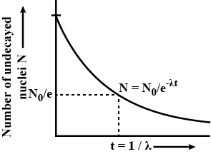
The rate of nuclear decay is also measured in terms of half-lives. The half-life is the amount of time it takes for a given isotope to lose half of its radioactivity. If a radioisotope has a half-life of 14 days, half of its atoms will have decayed within 14 days. In 14 more days, half of that remaining half will decay, and so on. Half-lives range from millionths of a second for highly radioactive fission products to billions of years for long-lived materials (such as naturally occurring uranium). Notice that short half-lives go with large decay constants. Radioactive material with a short half-life is much more radioactive (at the time of production) but will obviously lose its radioactivity rapidly. No matter how long or short, the half-life is after seven half-lives have passed, less than 1 percent of the initial activity remaining.
The radioactive decay law can also be derived for activity calculations or mass of radioactive material calculations:
(Number of nuclei) N = N.e^{-λt}
Activity) A = A.e^{-λt}
(Mass) m = m.e^{-λt}
Where N (number of particles) is the total number of particles in the sample, A (total activity) is the number of decays per unit time of a radioactive sample, m is the mass of remaining radioactive material.

Q.2.a.
Ans. The particle in a box problem is a common application of a quantum mechanical model to a simplified system consisting of a particle moving horizontally within an infinitely deep well from which it cannot escape. The solutions to the problem give possible values of E and ψ that the particle can possess. E represents allowed energy values and ψ(x) is a wavefunction, which when squared gives us the probability of locating the particle at a certain position within the box at a given energy level.
The potential energy is 0 inside the box (V=0 for 0<x<L) and goes to infinity at the walls of the box (V=∞ for x<0 or x>L). We assume the walls have infinite potential energy to ensure that the particle has zero probability of being at the walls or outside the box. Doing so significantly simplifies our later mathematical calculations as we employ these boundary conditions when solving the Schrödinger Equation.
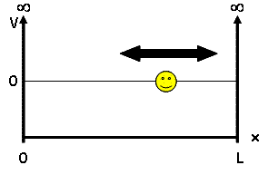
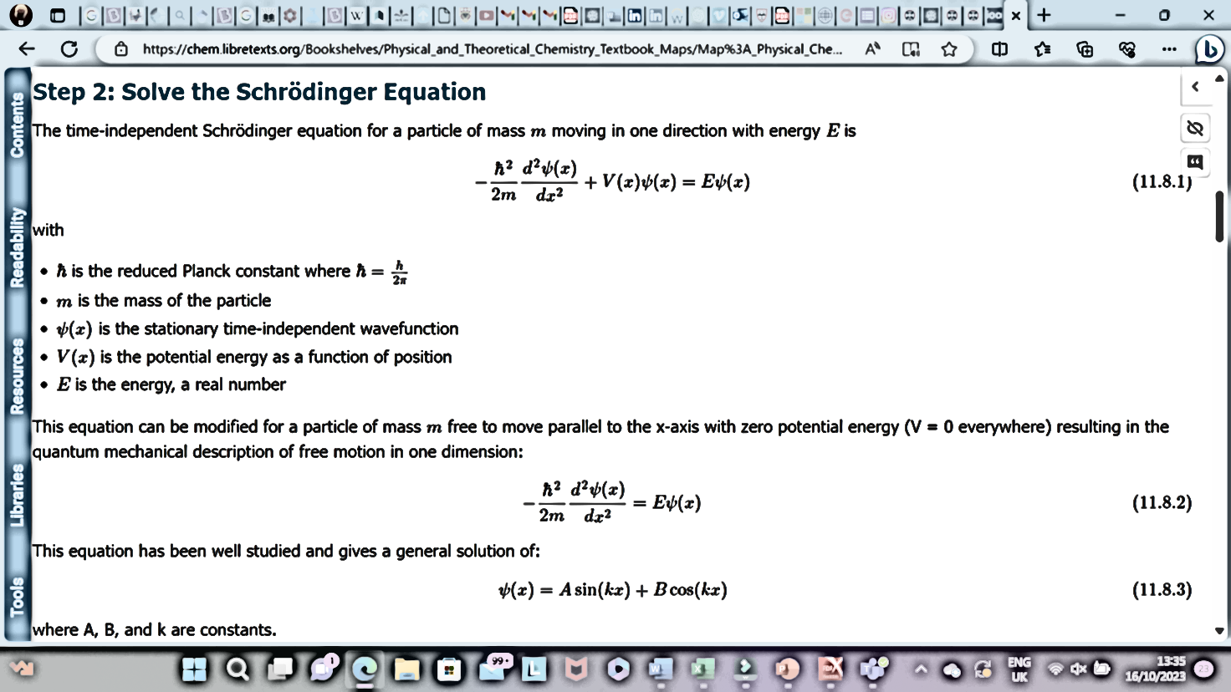
Q.2.b.
Ans.
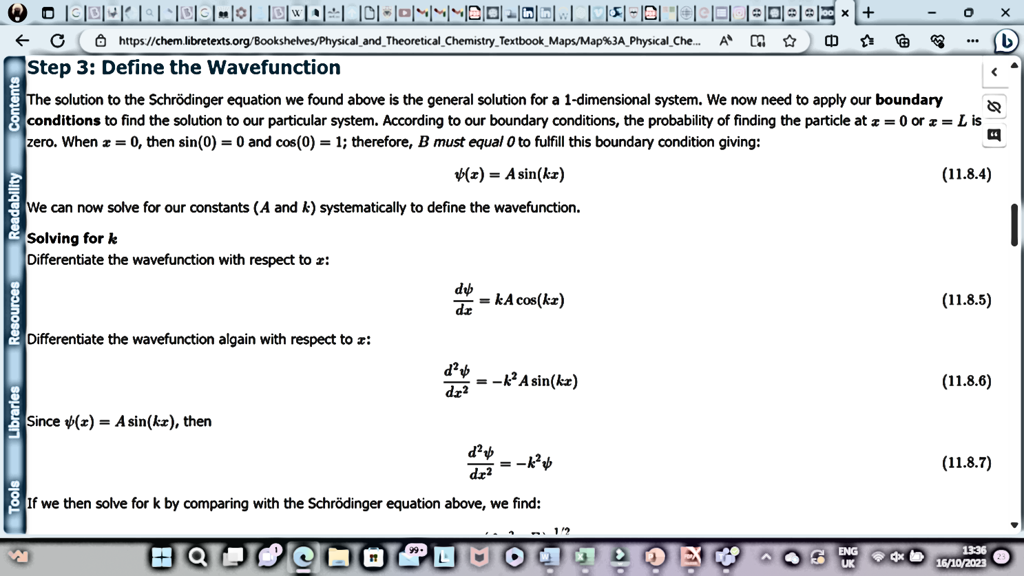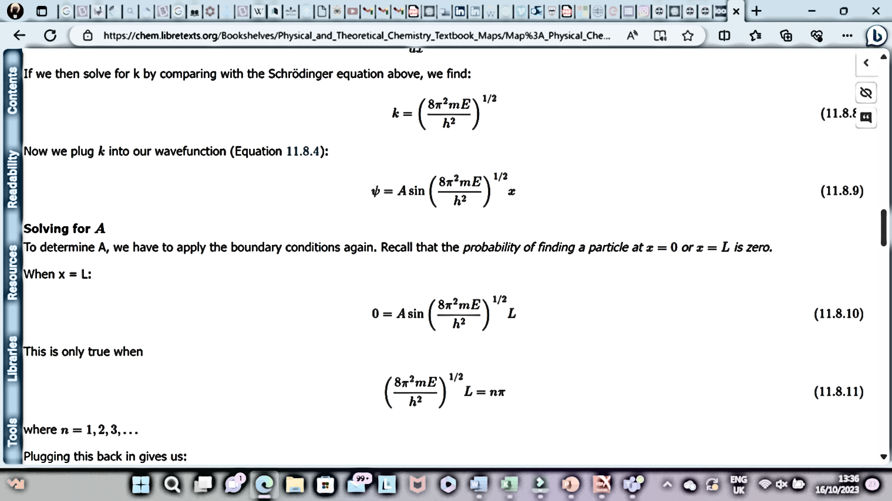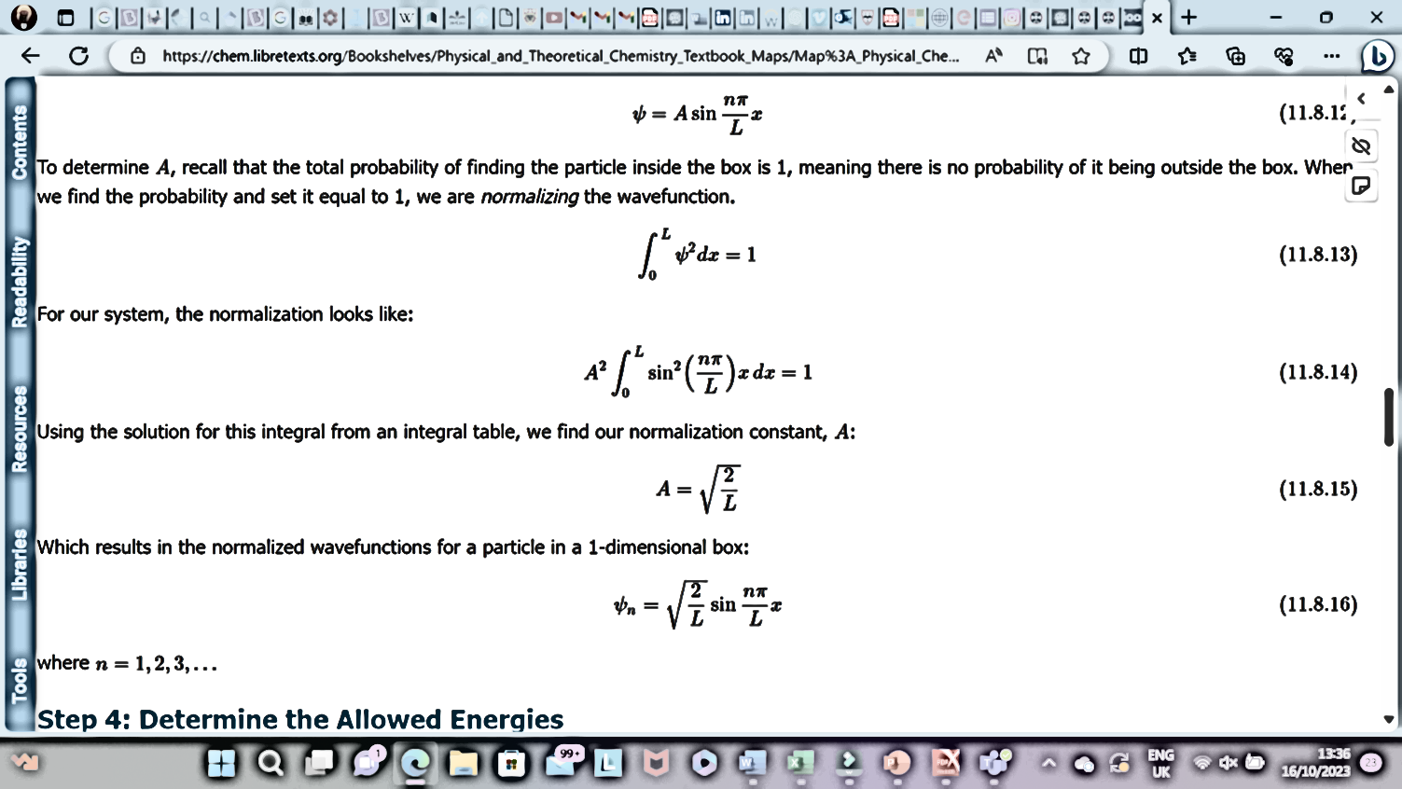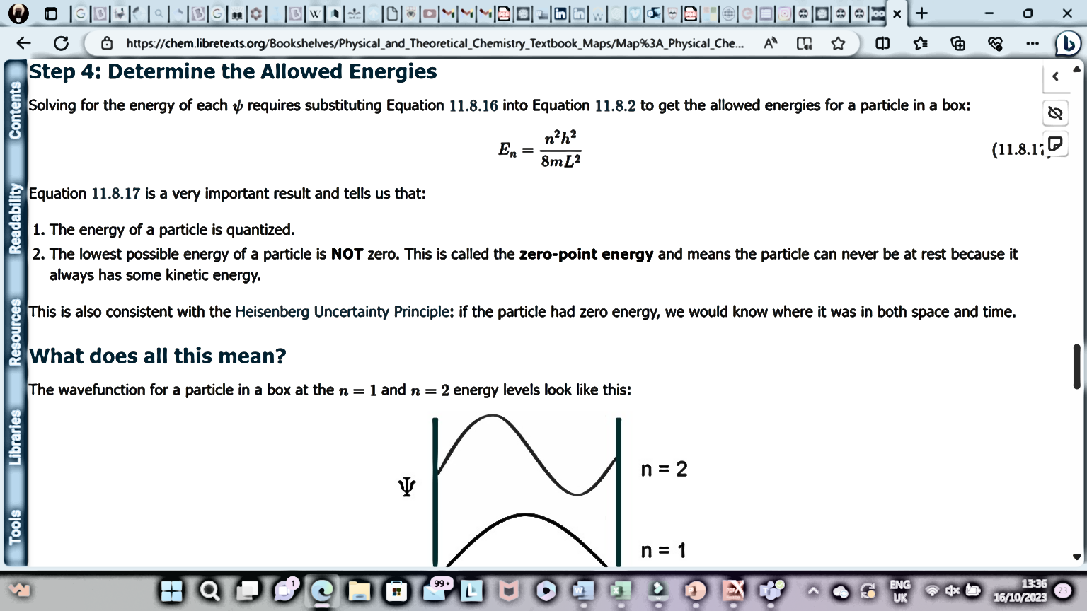
Q.2.c.
Ans. Eigen value and eigen functions
The wavefunction for a given physical system contains the measurable information about the system. To obtain specific values for physical parameters, for example energy, you operate on the wavefunction with the quantum mechanical operator associated with that parameter. The operator associated with energy is the Hamiltonian, and the operation on the wavefunction is the Schrodinger equation. Solutions exist for the time independent Schrodinger equation only for certain values of energy, and these values are called "eigenvalues*" of energy.
Corresponding to each eigenvalue is an "eigenfunction*". The solution to the Schrodinger equation for a given energy involves also finding the specific function which describes that energy state. The solution of the time independent Schrodinger equation takes the form
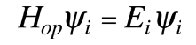
The eigenvalue concept is not limited to energy. When applied to a general operator Q, it can take the form
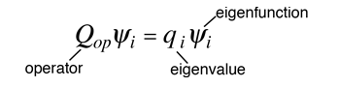
if the function ψ_{i} is an eigenfunction for that operator. The eigenvalues q_{i} may be discrete, and in such cases we can say that the physical variable is "quantized" and that the index i plays the role of a "quantum number" which characterizes that state.
Q.3.a.
Ans. Heat capacities and molar heat capacities
Heat Capacity - C - is a characteristic of an object - the amount of heat required to change its temperature by one degree. Heat Capacity has the units of energy per degree.
The amount of heat supplied to heat an object can be expressed as:
$$C=qT$$
Where q is the amount of heat supplied (J), C is heat capacity of system or object (J/K) and dt denotes temperature change (K)
The SI unit for heat capacity is J/K (joule per kelvin).
Molar Heat Capacity ( C _{p} ) is the amount of heat needed to increase the temperature of one mole of a substance by one degree at constant pressure.
It is expressed in joules per moles per degrees Kelvin (mol K) .
The molar heat capacity of iron is 25.10 J/(mol K), which means that it takes 25.10 Joules of heat to raise 1 mol of iron by 1 degree Kelvin.
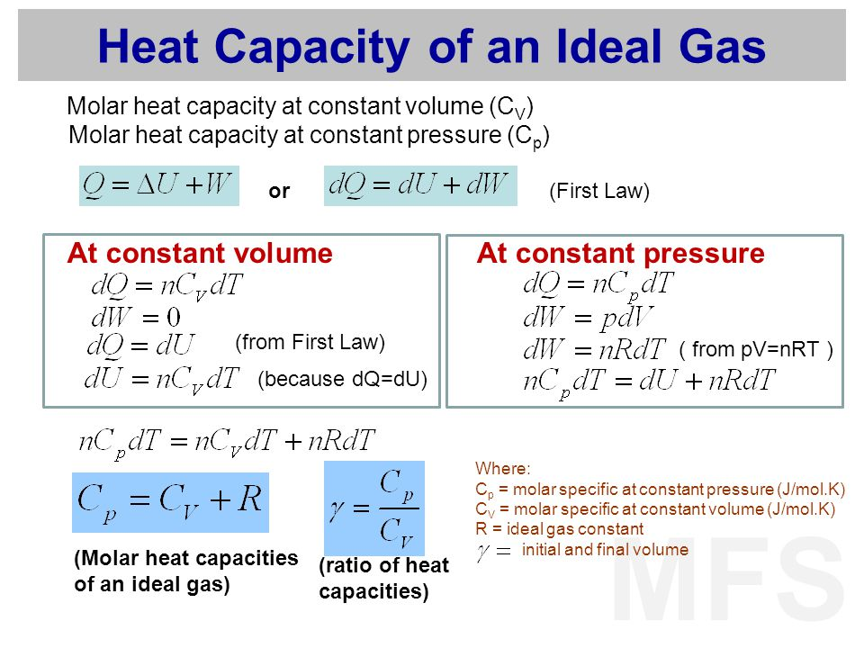
Q.3.b.
Ans. The second law of thermodynamics implies that the entropy of the universe always increases for a spontaneous process. At constant temperature and pressure, the change in Gibbs free energy is defined as
$$∆G=∆H-T∆S$$
When ΔG is negative, a process will proceed spontaneously and is referred to as exergonic. The spontaneity of a process can be dependent on the temperature.

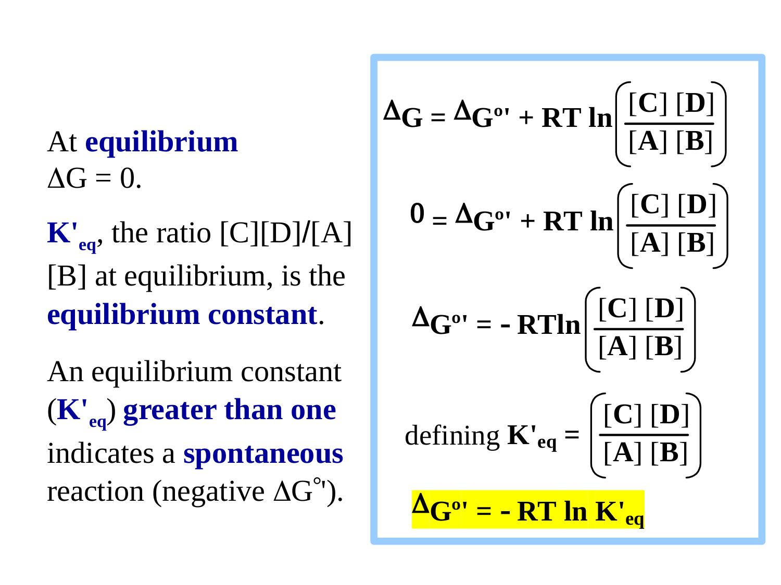
Ans.
Q.3.c. Spontaneous and non- spontaneous processes
In chemistry, a spontaneous processes is one that occurs without the addition of external energy. A spontaneous process may take place quickly or slowly, because spontaneity is not related to kinetics or reaction rate. A classic example is the process of carbon in the form of a diamond turning into graphite, which can be written as the following reaction:
$$C(diamond)→C(graphite)$$
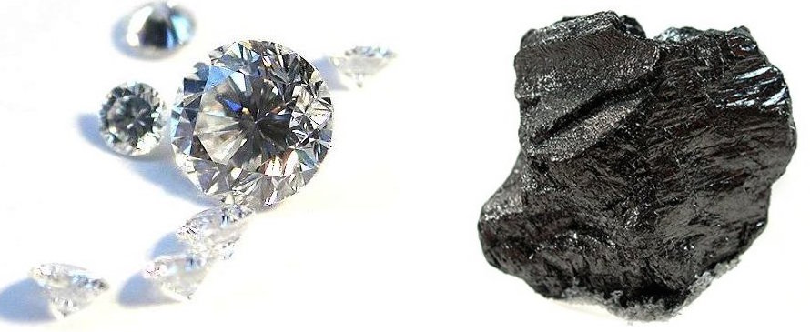
On left, multiple shiny cut diamonds. On right, chunk of black graphitic carbon.
It is said, "graphite is forever" If we waited long enough, we would observe a diamond spontaneously turn into the more stable form of carbon, graphite.
This reaction takes so long that it is not detectable on the timescale of (ordinary) humans, hence the saying, "diamonds are forever." If we could wait long enough, we should be able to see carbon in the diamond form turn into the more stable but less shiny, graphite form.
Another thing to remember is that spontaneous processes can be exothermic or endothermic. That is another way of saying that spontaneity is not necessarily related to the enthalpy change of a process, ΔH.
Second law of thermodynamics can predict if a process will occur spontaneously. According to the second law of thermodynamics, any spontaneous process must increase the entropy in the universe. When ΔG<0ΔG<0delta, start text, G, end text, is less than, 0, the process is exergonic and will proceed spontaneously in the forward direction to form more products.
- When ΔG is greater than, 0, the process is endergonic and not spontaneous in the forward direction. Instead, it will proceed spontaneously in the reverse direction to make more starting materials.
- When ΔG=0 the system is in equilibrium and the concentrations of the products and reactants will remain constant.
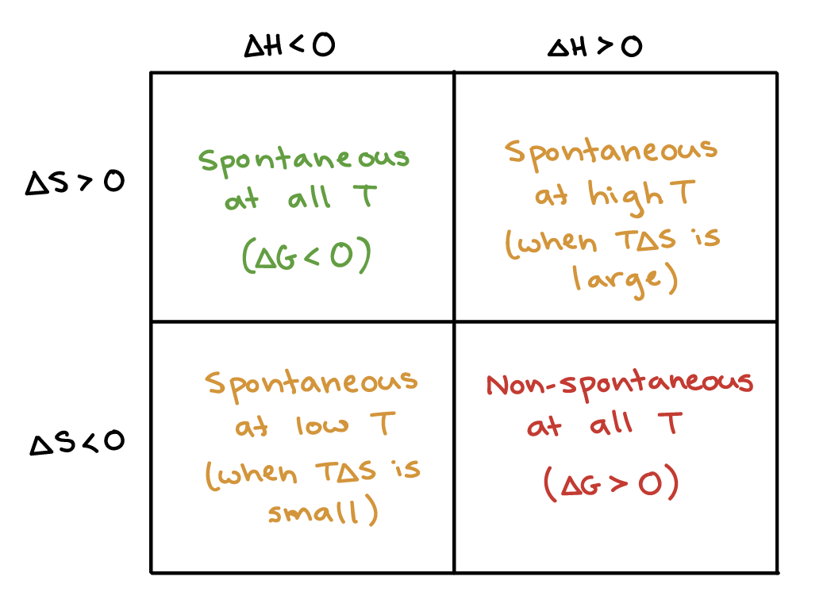
Q.4.a.
Ans. Kohlrausch’s law
Kohlrausch’s law states that the equivalent conductivity of an electrolyte at infinite dilution is equal to the sum of the conductance of the anions and cations.
The molar conductivity of a solution at a given concentration is the conductance of the volume of solution containing one mole of electrolyte kept between two electrodes with the unit area of cross-section and distance of unit length. The molar conductivity of a solution increases with the decrease in concentration. This increase in molar conductivity is because of the increase in the total volume containing one mole of the electrolyte. When the concentration of the electrolyte approaches zero, the molar conductivity is known as limiting molar conductivity, Ë_{m}°.
Kohlrausch observed certain regularities while comparing the values of limiting molar conductivities of some strong electrolytes. On the basis of his observations, Kohlrausch proposed “limiting molar conductivity of an electrolyte can be represented as the sum of the individual contributions of the anions and cations of the electrolyte”. This law is popularly known as Kohlrausch law of independent migration of ions. For example, limiting molar conductivity, Λ of sodium chloride can be determined with the knowledge of limiting molar conductivities of sodium ion and chloride ion.
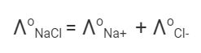
Some important applications of Kohlrausch law of independent migration of ions are:
- Kohlrausch law helps us in the determination of limiting molar conductivities for any electrolyte. Weak electrolytes have lower molar conductivities and lower degree of dissociation at higher concentrations. The graph plotted between molar conductivity and c^{1/2} (where c is the concentration) is not a straight line for weak electrolytes. The molar conductivity of weak electrolyte increases steeply at lower concentrations. Therefore, limiting molar conductivity, Λ cannot be obtained by extrapolation of molar conductivity to zero concentration. Hence, we use the Kohlrausch law of independent migration of ions for the determination of limiting molar conductivity, Λ for weak electrolytes.
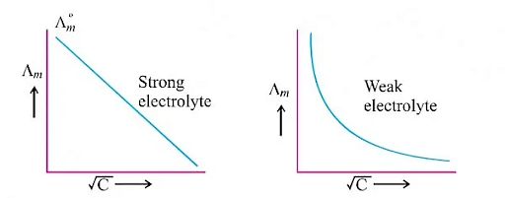
- Kohlrausch law also helps us in determining the value of dissociation constant from the value of molar conductivity and limiting molar conductivity for a weak electrolyte at a given concentration.
$$α=\frac{Λ}{Ëm°}$$

Where,
α = dissociation constant
Λ = molar conductivity
Ë_{m}° = limiting molar conductivity
Q.4.b.
Ans. Standard Deviation is a statistical measure that quantifies the amount of variation or dispersion in a set of data points. It provides a way to understand how individual data points in a dataset deviate from the mean (average) of the data. In other words, it indicates the spread of data around the mean.
Mathematically, the standard deviation (σ) is calculated using the following steps:
- Calculate the mean (μ) of the data points.
- For each data point, subtract the mean and square the result.
- Calculate the average of the squared differences.
- Take the square root of the average calculated in step 3.
The formula can be represented as:
σ = √(Σ(xi - μ)² / N)
where:
- σ is the standard deviation.
- xi represents each individual data point.
- μ is the mean of the data.
- N is the total number of data points.
In analytical chemistry, the standard deviation plays a crucial role in assessing the precision and reliability of experimental data. Here's why it's significant:
- Quality Control: In analytical chemistry, accuracy and precision are essential. The standard deviation is used to assess the precision of a measurement technique or instrument. A smaller standard deviation indicates higher precision and less variability in repeated measurements.
- Error Estimation: Standard deviation helps to estimate the error or uncertainty associated with measurements. The larger the standard deviation, the more spread out the data points are from the mean, suggesting a greater degree of uncertainty in the measurements.
- Method Validation: When developing and validating new analytical methods, understanding the standard deviation is crucial. It helps determine the method's reliability, sensitivity, and ability to produce consistent results.
- Outlier Detection: Outliers are data points that significantly deviate from the rest of the dataset. Standard deviation can be used to identify outliers; data points that fall beyond a certain number of standard deviations from the mean are often considered outliers.
- Data Interpretation: When comparing different sets of data or experimental results, the standard deviation provides insights into the variability between the datasets. It helps researchers understand whether observed differences are statistically significant.
- Reporting Results: When presenting analytical data, it's important to include information about the precision of the measurements. Reporting the standard deviation along with the mean provides a comprehensive view of the data's reliability.

Q.4.c.
Ans. Conductometric Titration is the method that involves the regular addition of a reactant to the reaction mixture. In this mixture, corresponding changes in its electrolytic conductivity are observed and documented. When acids are reacted with a standard base solution, we can determine the acid’s strength.
- An increase or decrease in the electrolytic conductivity of the reaction mixture is related to the change in the concentration of hydrogen and hydroxyl ions.
- Sudden change in the electrolytic conductivity can lead to the inference that a stoichiometric point has been reached.
The conductometric titration principle works on the fact that during titration one of the ions is replaced by another, leading to a difference in the conductivity of both ions. This results in a variation of conductivity of the given solution throughout the titration through the principle of conductometry. An equivalent point is determined by using a graph of Conductance vs Volume of titrant (solution in burette).
The conductometric titration process or conductometry works in the following way:
- We take the titrant in a burette and the titrate in a beaker.
- Conductometer is used to measure the change in conductance against the volume of titrant being used.
- There is drop by drop addition of titrant, simultaneously conductivity is measured corresponding to the volume of titrant used.
- These measurements are plotted on the graph. The point at which there is a sharp change in conductance of the solution, that point is referred to as the Equivalence point.
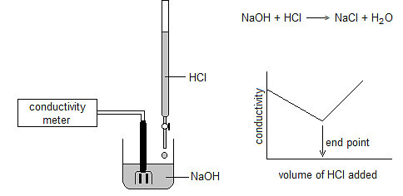
Q.5.a.
Ans. Thermal energy relates direction to motion at the molecular level. As the temperature rises, molecules move faster and collide more vigorously, greatly increasing the likelihood of bond cleavages and rearrangements. Whether it is through the collision theory, transition state theory, or just common sense, chemical reactions are typically expected to proceed faster at higher temperatures and slower at lower temperatures.
In 1890 it was common knowledge that higher temperatures speed up reactions, often doubling the rate for a 10-degree rise, but the reasons for this were not clear. Finally, in 1899, the Swedish chemist Svante Arrhenius (1859-1927) combined the concepts of activation energy and the Boltzmann distribution law into one of the most important relationships in physical chemistry:
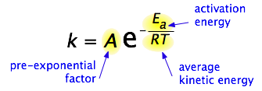
This is another form of the exponential decay law. What is "decaying" here is not the concentration of a reactant as a function of time, but the magnitude of the rate constant as a function of the exponent –E_{a} /RT. RT is the average kinetic energy, it becomes apparent that the exponent is just the ratio of the activation energy E_{a} to the average kinetic energy. The larger this ratio, the smaller the rate (hence the negative sign). This means that high temperature and low activation energy favour larger rate constants, and thus speed up the reaction. Because these terms occur in an exponent, their effects on the rate are quite substantial.
Determining the Activation Energy from the Arrhenius equation
can be written in a non-exponential form that is often more convenient to use and to interpret graphically. Taking the logarithms of both sides and separating the exponential and pre-exponential terms yields
$$lnk=lnA-\frac{E_{a}}{RT}$$

Equation is in the form of y=mx+b - the equation of a straight line.
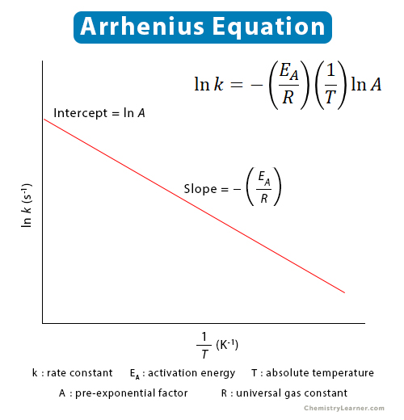
where temperature is the independent variable and the rate constant is the dependent variable. So if one were given a data set of various values of k, the rate constant of a certain chemical reaction at varying temperature T, one could graph ln(k) versus 1/T. From the graph, one can then determine the slope of the line and realize that this value is equal to −Ea/R. One can then solve for the activation energy by multiplying through by -R, where R is the gas constant. This affords a simple way of determining the activation energy from values of k observed at different temperatures, by plotting lnk as a function of 1/T.

Calculating E_{a} without a plot
Because the ln k-vs.-1/T plot yields a straight line, it is often convenient to estimate the activation energy from experiments at only two temperatures. To see how this is done, consider that
$$lnk_{2}-lnk_{1}=\left(lnA-\frac{E_{a}}{RT_{2}}\right)\left(lnA-\frac{E_{a}}{RT_{1}}\right)=\frac{E_{a}}{R}(\frac{1}{T_{1}}-\frac{1}{T_{2}})$$
The ln-A term is eliminated by subtracting the expressions for the two ln-k terms.) Solving the expression on the right for the activation energy yields
$$E_{a}=\frac{Rln(\frac{k_{2}}{k_{1}})}{(\frac{1}{T_{1}}-\frac{1}{T_{2}})}$$
Q.5.c.
Ans.
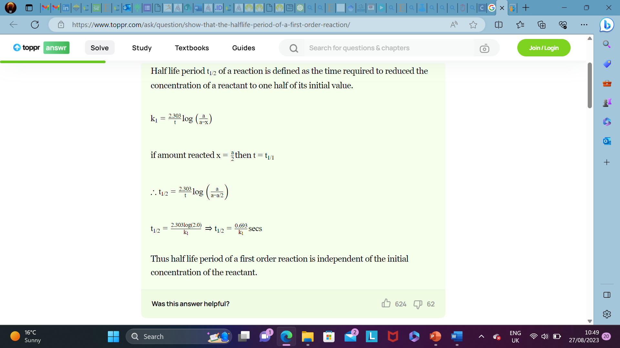

Q.5.b.
. 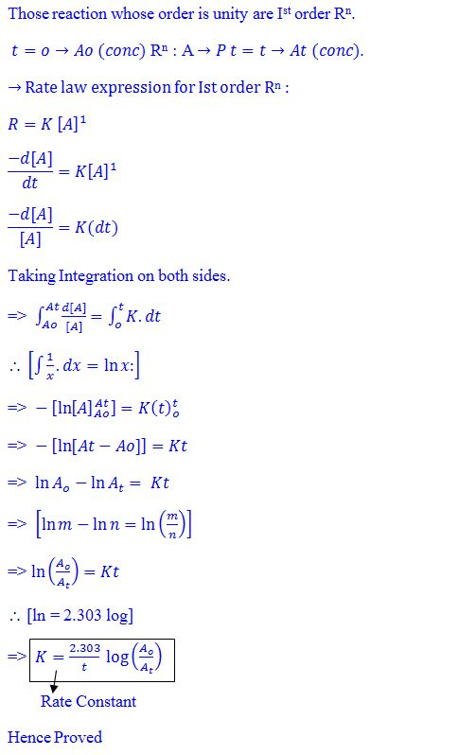
Q.6.a.
Ans. Adsorption isotherm
An adsorption isotherm is a graphical or mathematical representation that describes the relationship between the amount of a substance adsorbed onto a solid surface and the concentration of that substance in the surrounding medium, typically a gas or liquid. It helps understand how adsorption changes with varying conditions, such as temperature and pressure, providing insights into surface interactions and adsorption mechanisms.
Langmuir adsorption isotherm
The Langmuir isotherm was developed by Irving Langmuir in 1916 to describe the dependence of the surface coverage of an adsorbed gas on the pressure of the gas above the surface at a fixed temperature.
When considering adsorption isotherms it is conventional to adopt a definition of surface coverage (θ) which defines the maximum (saturation) surface coverage of a particular adsorbate on a given surface always to be unity, i.e. θ_{max}=1. This way of defining the surface coverage differs from that usually adopted in surface science where the more common practice is to equate θ with the ratio of adsorbate species to surface substrate atoms (which leads to saturation coverages which are almost invariably less than unity).
We may derive the Langmuir isotherm by treating the adsorption process as we would any other equilibrium process - except in this case the equilibrium is between the gas phase molecules (M), together with vacant surface sites, and the species adsorbed on the surface. Thus, for a non-dissociative (molecular) adsorption process, we consider the adsorption to be represented by the following chemical equation:
$$S-*+M⇌S-M$$
where:
S−∗ represents a vacant surface site
In writing Equation we are making an inherent assumption that there are a fixed number of localized surface sites present on the surface. This is the first major assumption of the Langmuir adsorption isotherm. Now define an equilibrium constant (K) in terms of the concentrations of "reactants" and "products".
$$K=\frac{[ S - M ] }{[ S - * ][ M ]}$$
It can be noted that:
- [ S - M ] is proportional to the surface coverage of adsorbed molecules, i.e. proportional to θ
- [ S - * ] is proportional to the number of vacant sites, i.e. proportional to (1-θ)
- [ M ] is proportional to the pressure of gas, P
$$K=\frac{θ}{\left(1-θ\right)P}$$
Rearrangement then gives the following expression for the surface coverage
$$θ=\frac{KP}{1+KP}$$
which is the usual form of expressing the Langmuir Isotherm. As with all chemical reactions, the equilibrium constant, b, is both temperature-dependent and related to the Gibbs free energy and hence the enthalpy of adsorption is independent of coverage.

Q.6.b.
Ans. Enzyme catalysis
Like other catalysts, enzymes provide an alternate pathway from substrate to product with a lower E_{a} yet the enzyme does not alter the equilibrium between substrates and products.
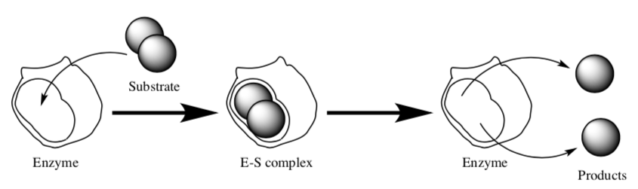
Michaelis–Menten kinetics is one of the simplest and best-known models of enzyme kinetics. It is named after German biochemist Leonor Michaelis and Canadian physician Maud Menten. This model is based on the single substrate reaction below:
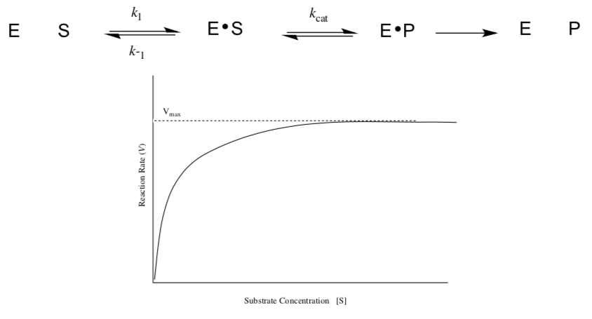
Because enzyme catalysed reactions are saturable, their rate of catalysis does not show a linear response to increasing substrate.
- If the initial rate of the reaction is measured over a range of substrate concentrations (denoted as [S]), the reaction rate ( increases / decreases ) as [S] increases.
- As [S] gets higher, the enzyme becomes saturated with substrate and the rate reaches V_{max}, the enzyme's maximum rate. When the enzyme reaches V_{max}, the rate:
stops increasing | stops completely | keeps increasing
Here is a simplified scheme for enzyme catalysis:
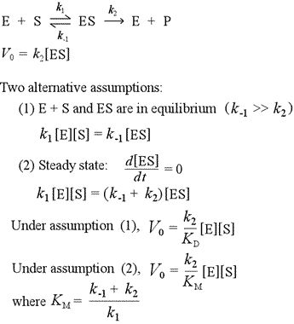 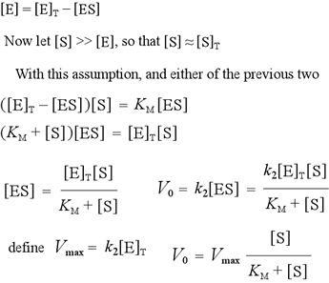These conditions are called “saturation”: the enzyme is full. An experiment in which we measure kinetics at high levels of substrate is called a saturation kinetics experiment.
Q.6.c. Surfactant
Surfactant, also called surface-active agent, substance such as a detergent that, when added to a liquid, reduces its surface tension, thereby increasing its spreading and wetting properties. In the dyeing of textiles, surfactants help the dye penetrate the fabric evenly. They are used to disperse aqueous suspensions of insoluble dyes and perfumes.
Properties of surfactants
The surface-active molecule must be partly hydrophilic (water-soluble) and partly lipophilic (soluble in lipids, or oils). It concentrates at the interfaces between bodies or droplets of water and those of oil, or lipids, to act as an emulsifying agent, or foaming agent.
Other surfactants that are more lipophilic and less hydrophilic may be used as defoaming agents, or as demulsifiers. Certain surfactants are germicides, fungicides, and insecticides.
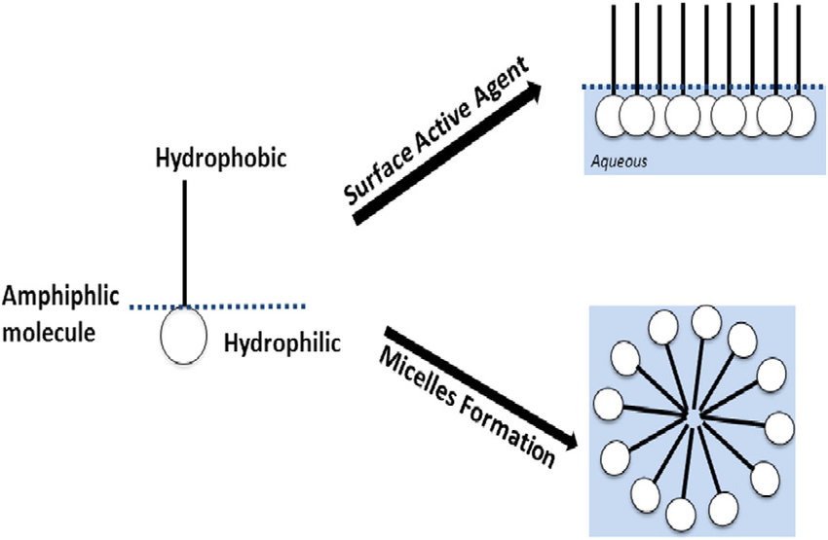
Q.7.a. Electrophoresis
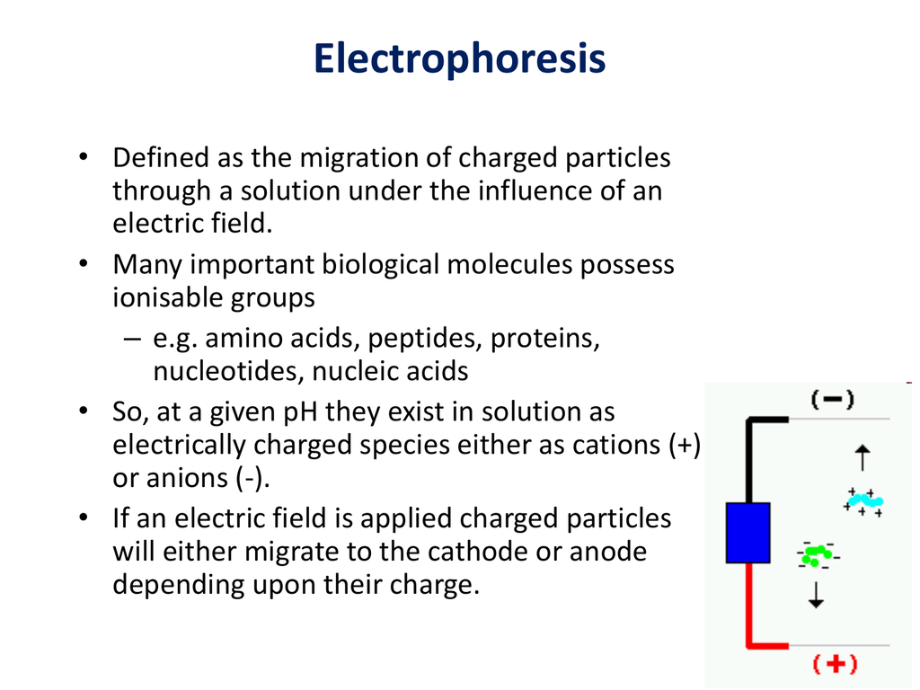
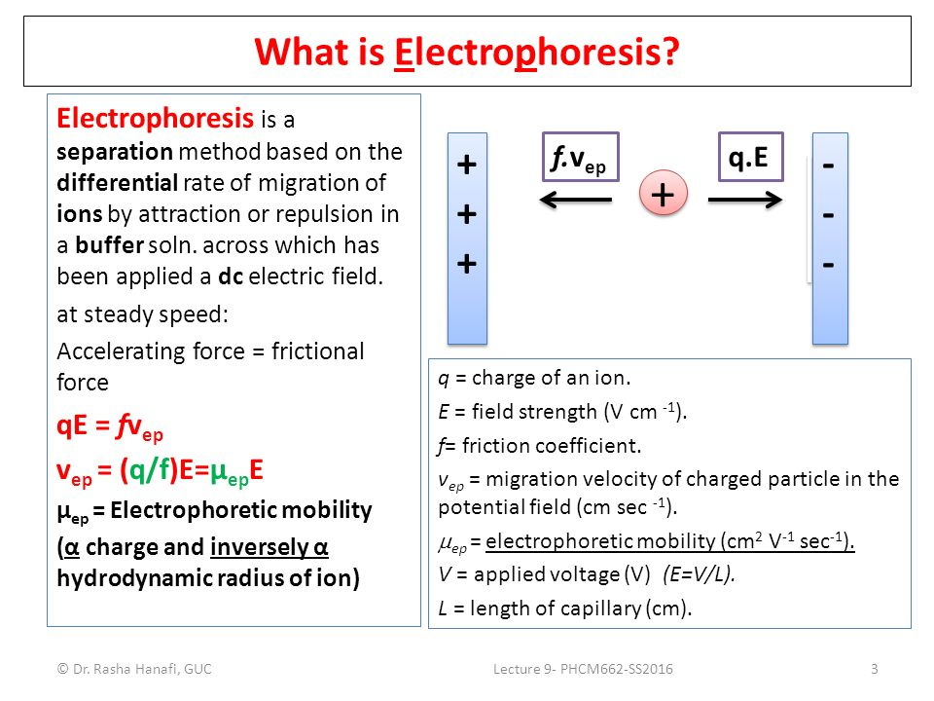
Applications in biochemistry
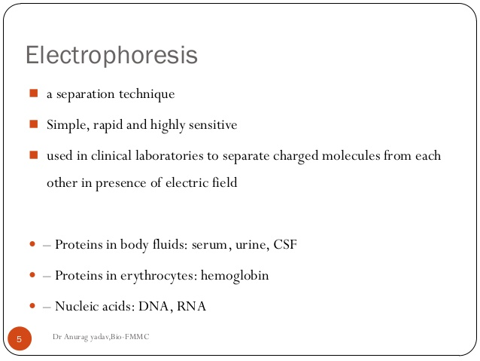
Q.7.b.
- Reaction with Oxygen to Form Nitrogen Oxides:
  - Formation of Nitric Oxide (NO): 2N₂ + O₂ → 2NO
  - Formation of Nitrogen Dioxide (NO₂): 2NO + O₂ → 2NO2
- Ammonia Formation:
  - Haber-Bosch Process: N₂ + 3H₂ → 2NH₃
  - A crucial reaction for producing ammonia, an essential component of fertilizers.
- Nitrification Reaction:
- Conversion of Ammonia to Nitrites and Nitrates by Bacteria:
NH₃ + O₂ → ${NO}_{2}^{-}$ + 3H⁺ + 2e⁻
- Conversion of Nitrites to Nitrates: ${NO}_{2}^{-}$ + O₂ → ${NO}_{3}^{-}$
- Nitration Reactions:
  - Nitration of Organic Compounds: Nitrogen compounds can be used to introduce nitro groups (-NO₂) into organic molecules, a common example being the nitration of benzene to form nitrobenzene.
- Nitrogen Fixation:
  - Haber Process (Industrial Nitrogen Fixation): N₂ + 3H₂ → 2NH₃
- Biological Nitrogen Fixation: Conversion of atmospheric nitrogen into ammonia by nitrogen-fixing bacteria, such as Rhizobium in legume root nodules.
Q.7.c.
Ans. Common Ion Effect
The common ion effect is a phenomenon that occurs when the addition of an ion that is already present in a solution, either through another solute or as a dissociation product, reduces the solubility of a sparingly soluble compound in that solution. It's a consequence of Le Chatelier's principle, which states that a system in equilibrium will adjust to counteract changes imposed on it.
Applications of common ion effect
The common ion effect is a significant concept in chemical analysis, particularly in understanding and manipulating equilibrium systems involving ionic compounds in solution. In chemical analysis, one often encounters situations where it's necessary to selectively precipitate certain ions from a mixture for separation and identification. The common ion effect plays a crucial role here. By adding a compound containing a common ion to a solution, you can reduce the solubility of a specific ionic compound, causing it to precipitate. This is used in techniques like gravimetric analysis, where the mass of the precipitate is used to determine the original concentration of the analyte. The common ion effect can also be exploited to modify the concentrations of ions in standard solutions to match those present in the sample.
The common ion effect is also seen in buffer systems. A buffer solution resists changes in pH upon the addition of an acid or base. This is achieved by having a weak acid and its conjugate base (or a weak base and its conjugate acid) present in solution. The common ion effect helps maintain the desired pH by shifting the equilibrium position in response to changes in H⁺ ion concentration.
Q.8.a.
Ans. Jahn Teller theorem
The Jahn-Teller Theorem (named after Hermann Arthur Jahn and Edward Teller), was published in 1937 and essentially means that:
"any non-linear molecular system in a degenerate electronic state will be unstable and will undergo distortion to form a system of lower symmetry and lower energy thereby removing the degeneracy"
In an octahedral crystal field, the t_{2g} orbitals occur at lower energy than the e_{g} orbitals. This is a reflection of the orientation of the orbitals since the t_{2g} are directed between bond axes while the e_{g} point along bond axes. The shielding effect this has on the electrons is used to explain why the Jahn-Teller effect is generally only important for odd number occupancy of the e_{g} level.
The effect of Jahn-Teller distortions is best documented for Cu(II) complexes (with 3 electrons in the e_{g} level) where the result is that most complexes are found to have elongation along the z-axis.

Significance of Jahn Teller theorem in coordination chemistry
The Jahn-Teller theorem
Q.8.b.
Ans. Werner, a well-known scientist, proposed his theory of coordination compounds in 1823, which describes the formation and structure of complex compounds and was later named Werner’s Theory of Coordinate Compounds.
Werner’s theory’s important postulates are as follows:
- The central metal or metal atoms in coordination compounds have two forms of valency which are primary valency and secondary valency. The oxidation state corresponds to the primary valency, while the coordinate number corresponds to the secondary valency.
- Each metal atom has a fixed number of secondary valencies, like it has a fixed coordinate number.
- The metal atom satisfies both its primary and secondary valencies. Negative ions satisfy primary valencies, but neutral molecules or negative ions satisfy secondary valencies.
- The secondary valencies are always directed towards a particular place in space, resulting in determination of geometry of the coordinate compound’s. As an example: A metal ion’s secondary valencies are grouped octahedrally around the central metal ion if it has six of them. If the metal ion contains four secondary valencies, they are organized in a tetrahedral or square planar pattern around the center metal ion. The stereochemistry of the complex ion is thus determined by the secondary valency while the primary valency is non-directional.
Cobalt has a primary valency of three and a secondary valency (coordination number) of six. Secondary valencies are depicted by thick lines, while primary valencies are represented by broken lines.
- CoCl₃.6NH₃ Complex: The coordination number of Co in this compound is 6, and all six secondary valencies are met by ammonia molecules . Cl⁻ ions satisfy the three primary valencies . These have a non-directional character. When silver nitrate is added, these chloride ions precipitate instantly. In this scenario, there are four ions: three chloride ions and one complex ion. While writing the compound’s formula, the central ion and neutral molecules or ions satisfying secondary valencies are enclosed in square brackets. Therefore, the complex can be written as [Co(NH₃)₆]Cl₃ and is depicted in fig.
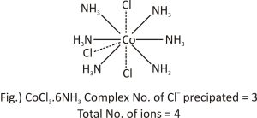
- CoCl₃.5NH₃ complex: The coordination number of cobalt in this compound is also 6, but the number of NH₃ molecules is reduced to 5 from 6 and one remaining slot is now occupied by chloride ions. Because it has both primary and secondary valency, this chloride ion exhibits dual behaviour. In the figure, the secondary valency is represented by a full line, while the main valency is represented by a dotted line.
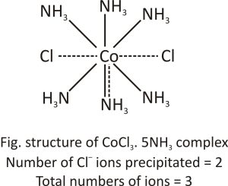
This structure satisfies cobalt’s three primary and six secondary valencies. As a result, the complex formed can be written as [CoCl(NH₃)₅]Cl₂ with five ammonia molecules and one chloride ion inside the square brackets and two chloride ions outside the brackets.
- CoCl₃.4NH₃ complex: Two chloride ions in this compound exhibit dual behaviour, satisfying both Primary and Secondary valencies. This compound will precipitate AgNO₃, which corresponds to one Cl⁻ ion, and the total number of ions, in this case is two. As a result, it can be written as [CoCl₂(NH₃)₄]Cl.
- 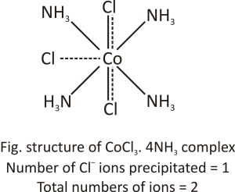
- CoCl₃.3NH₃ complex: In this molecule, three chloride ions satisfy primary and also secondary valency. At room temperature, silver nitrate does not precipitate Cl⁻. Hence, the complex compound behaves as a neutral non-conducting molecule. It may be written as [CoCl₃(NH₃)₃].
- 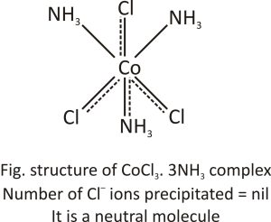
Q.8.c.
Ans. Radioactive decay law
The radioactive decay law states that the probability per unit time that a nucleus will decay is constant, independent of time. This constant is called the decay constant and is denoted by λ, “lambda”. This constant probability may vary greatly between different types of nuclei, leading to the many different observed decay rates. The radioactive decay of a certain number of atoms (mass) is exponential in time.
Radioactive decay law: N = N.e^{-λt}
The rate of nuclear decay is also measured in terms of half-lives. The half-life is the amount of time it takes for a given isotope to lose half of its radioactivity.
The radioactive decay law can also be derived for activity calculations or mass of radioactive material calculations:
(Number of nuclei) N = N.e^{-λt}
Activity) A = A.e^{-λt}
(Mass) m = m.e^{-λt}
Where N (number of particles) is the total number of particles in the sample, A (total activity) is the number of decays per unit time of a radioactive sample, m is the mass of remaining radioactive material.

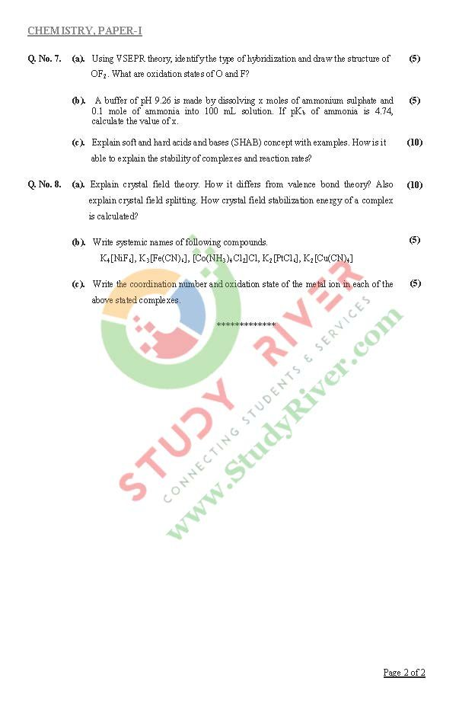
Q.2.a.
Ans.
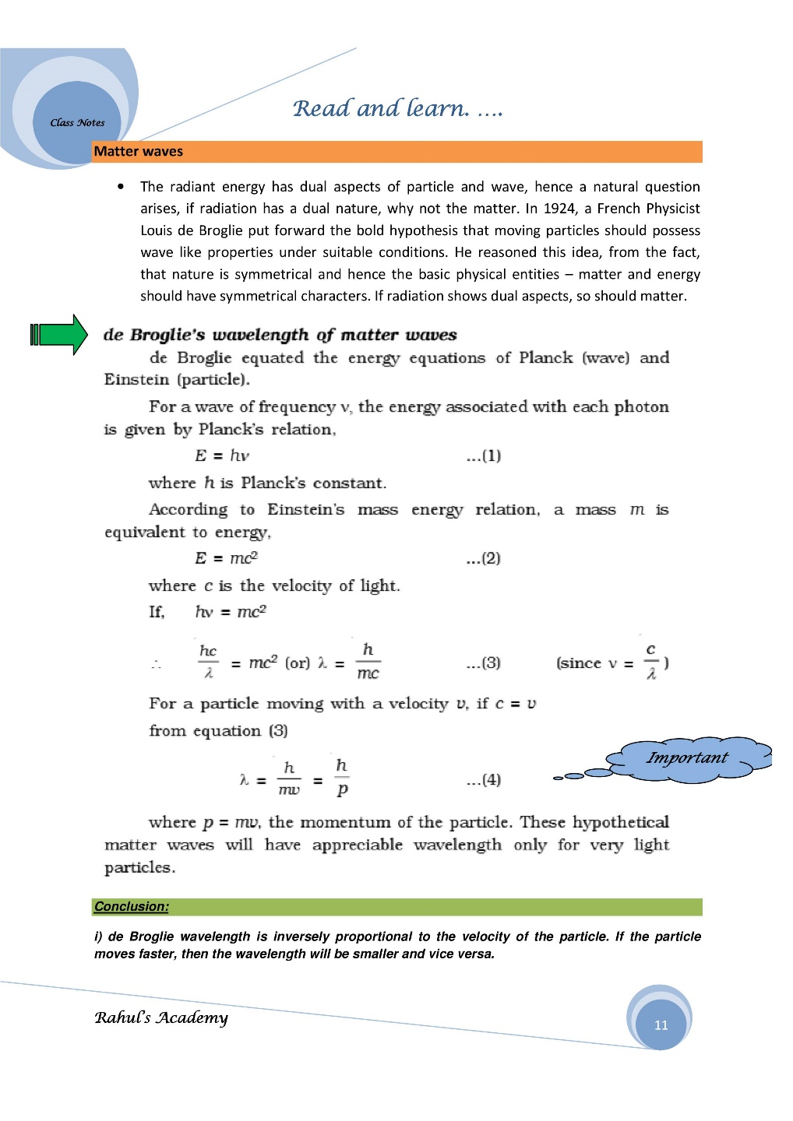
The Davisson-Germer experiment
The Davisson-Germer experiment demonstrated the wave nature of the electron, confirming the earlier hypothesis of de Broglie. Davisson and Germer designed and built a vacuum apparatus for the purpose of measuring the energies of electrons scattered from a metal surface. Electrons from a heated filament were accelerated by a voltage and allowed to strike the surface of nickel metal.
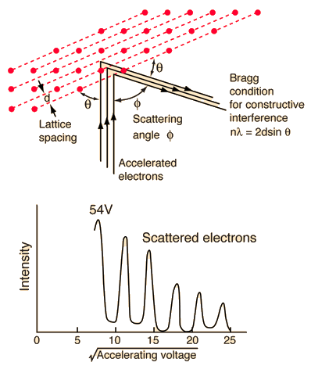
The electron beam was directed at the nickel target, which could be rotated to observe angular dependence of the scattered electrons. Their electron detector (called a Faraday box) was mounted on an arc so that it could be rotated to observe electrons at different angles. It was a great surprise to them to find that at certain angles there was a peak in the intensity of the scattered electron beam. This peak indicated wave behaviour for the electrons, and could be interpreted by the Bragg law to give values for the lattice spacing in the nickel crystal.
The experimental data above, reproduced above Davisson's article, shows repeated peaks of scattered electron intensity with increasing accelerating voltage. This data was collected at a fixed scattering angle. Using the Bragg law, the de Broglie wavelength expression, and the kinetic energy of the accelerated electrons gives the relationship
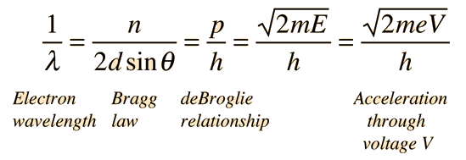
In the historical data, an accelerating voltage of 54 volts gave a definite peak at a scattering angle of 50°. The angle theta in the Bragg law corresponding to that scattering angle is 65°, and for that angle the calculated lattice spacing is 0.092 nm. For that lattice spacing and scattering angle, the relationship for wavelength as a function of voltage is empirically
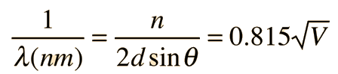
Q.2.b.
Ans. Transport number
Ion transport number, also called the transference number, is the fraction of the total current carried in an electrolyte by a given ion. Differences in transport number arise from the difference in electrical mobility.
Hittorf method for determination of transport number
Hittorf method for determination of transport number is one of the commonly used methods, which is based on Hittorf’s rule. Actually, hittorf’s rule state that loss of concentration around an electrode is proportional to the speed of the ions moving away from that electrode. The transport number of an ion is determined experimentally from the changes in the concentration of ions around the electrode.
The required Hittorf’s apparatus consists of two vertical glass tubes joined together through U-tube in the middle. There are stopcocks at the bottom of all three tubes. But, the stopcocks are also present at the tops of the two limbs of the U-tube as shown below.
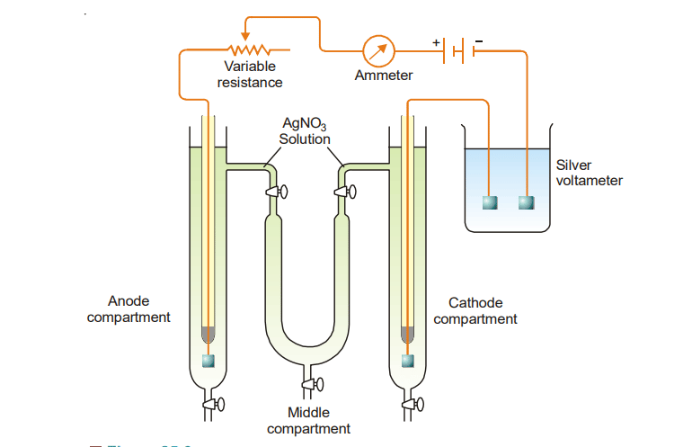
These stopcocks are used to communicate between the solution in the cathode and anode limbs. The whole apparatus is filled with a solution of silver nitrate and a very small constant current is passed for two or three hours. Current is passed only for a short time to avoid a large change in concentration.
After passing the current for 2-3 hours, the stopcocks at top of the U-tube are closed. Then the whole liquid of the anode compartment is carefully drained into a weighted flask and its weight determined. The silver content of the solution is determined by titrating against standard solutions of potassium thiocyanate. The weight of silver deposited in the silver coulometer is also noted.
Q.3.a.
Ans. A quinhydrone electrode can be used to measure the hydrogen ion concentration (pH) of solutions containing acidic substances.

Principles and operation
Quinones form quinhydrone species via hydrogen bonding between ρ-quinone and ρ-hydroquinone. A quinhydrone electrode is formed when an equimolar mixture of ρ-quinone and ρ-hydroquinone is brought into contact with an inert metal electrode such as antimony. Such devices can be used to measure the pH of solutions. The quinhydrone electrode provides fast response time and high accuracy. However, it can only measure pH in the range 1-9 and the solution must not contain strong oxidizing or reducing agents. When a platinum wire electrode is immersed in a saturated aqueous solution of quinhydrone, the following equilibrium holds:
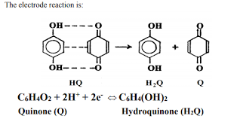
The potential difference between the platinum electrode and the reference electrode is activity dependent be H. + , the amount of hydrogen ions in solution.
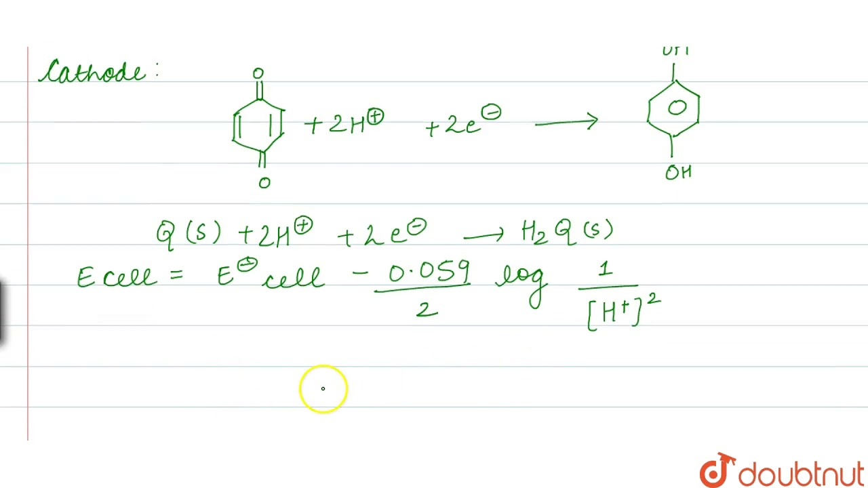
Q.3.b.
Ans.
$${3C}_{\left(s\right)}+4H_{2\left(g\right)}→C_{3}H_{8\left(l\right) }∆H=?$$
Given data
$$C_{3}H_{8}+5O_{2\left(g\right)}→3CO_{2\left(g\right)}+{{4H}_{2}O}_{\left(l\right)} ∆H=-2220.2 kJ{mol}^{-1}$$
$${3C}_{\left(s\right)}+4H_{2\left(g\right)}→C_{3}H_{8\left(l\right) }∆H=?$$
$$C_{\left(s\right)}+O_{2\left(g\right)}→{CO}_{2\left(g\right) }∆H=-393.5 kJ{mol}^{-1}$$
$$H_{2\left(g\right)}+{\frac{1}{2}O}_{2\left(g\right)}→{H_{2}O}_{\left(l\right)} ∆H=-285.8 kJ{mol}^{-1}$$
Solution
Reverse the first equation: $CO_{2\left(g\right)}+{H_{2}O}_{\left(l\right)}→C_{3}H_{8}+4O_{2\left(g\right)} ∆H=+2220.2 kJ{mol}^{-1}$
$$(C_{\left(s\right)}+O_{2\left(g\right)}→{CO}_{2\left(g\right) }∆H=-393.5 kJ{mol}^{-1})×3$$
${(H}_{2\left(g\right)}+{\frac{1}{2}O}_{2\left(g\right)}→{H_{2}O}_{\left(l\right)} ∆H=-285.8 kJ{mol}^{-1}$)$×4$
$$3CO_{2\left(g\right)}+{{4H}_{2}O}_{\left(l\right)}→C_{3}H_{8}+5O_{2\left(g\right)} ∆H=+2220.2 kJ{mol}^{-1}$$
$${3C}_{\left(s\right)}+{3O}_{2\left(g\right)}→{3CO}_{2\left(g\right) }∆H=-1180 kJ{mol}^{-1}$$
$${4H}_{2\left(g\right)}+{2O}_{2\left(g\right)}→{{4H}_{2}O}_{\left(l\right)} ∆H=-1143.2 kJ{mol}^{-1}$$
${3C}_{\left(s\right)}+4H_{2\left(g\right)}→C_{3}H_{8\left(l\right) }∆H=-103 kJ{mol}^{-1}$p
Q.3.c.
Ans. Spontaneous and non- spontaneous processes
In chemistry, a spontaneous processes is one that occurs without the addition of external energy. A spontaneous process may take place quickly or slowly, because spontaneity is not related to kinetics or reaction rate.
Spontaneous processes can be exothermic or endothermic. That is another way of saying that spontaneity is not necessarily related to the enthalpy change of a process, ΔH. Second law of thermodynamics can predict if a process will occur spontaneously. According to the second law of thermodynamics, any spontaneous process must increase the entropy in the universe. When ΔG<0, the process is exergonic and will proceed spontaneously in the forward direction to form more products.
- When ΔG is greater than, 0, the process is endergonic and not spontaneous in the forward direction. Instead, it will proceed spontaneously in the reverse direction to make more starting materials.
- When ΔG=0 the system is in equilibrium and the concentrations of the products and reactants will remain constant.
- 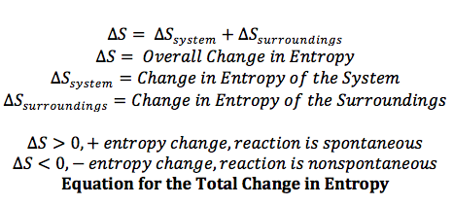
- 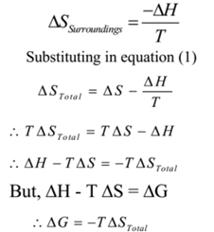
Q.4.a.
Ans. Factors affecting rate of chemical reaction
- Concentration of reactants
Rate of a reaction is directly proportional to the concentration of reactants.
i.e. rate (r) ∝ c^{n}
Reacting molecules increase with increase in concentration. Therefore, according to the collision theory, the rate of a reaction should increase with increase in the concentration since the rate is directly proportional to the collision frequency.
i.e., rate of reaction ∝ collision frequency (Z)
The rate of a reaction decreases exponentially with time as the concentration of reactants is decreasing. This can be shown graphically as follows:
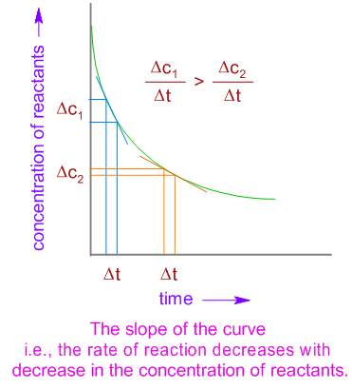
- Temperature
The average kinetic energy increases with increase in absolute temperature. Hence the number of molecules with energy greater than the threshold energy also increases (see the Maxwell distribution curves shown below). As a result, the number of effective collisions between reactant molecules also increases. Therefore, usually it is observed that the rate of reaction increases with increase in temperature.
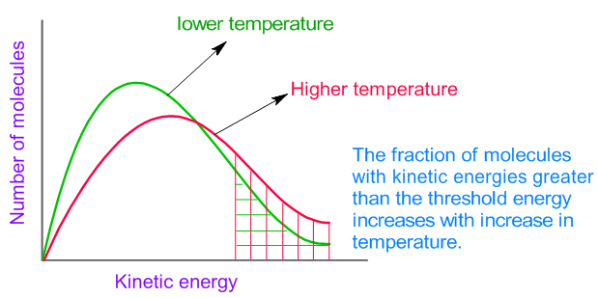
However note that increase in temperature also increases the number of collisions and hence the number of effective collisions are also expected to increase. But this is a minor factor affecting the rate.
It is known that the collision frequency, Z is proportional to the square root of absolute temperature, √T of the gas. i.e., For example, if the temperature is increased by 10 ºC from 293 K to 303 K, the collision frequency can be increased by a factor of only 1.7% . But usually the rate of a reaction is doubled (i.e., increased by 100%) when the temperature is increased by 10 ºC. Hence the effect of collision frequency is minor on the rate of reaction.
The ratio of rate constants of a reaction at two different temperatures which differ by 10 ºC is called temperature coefficient.
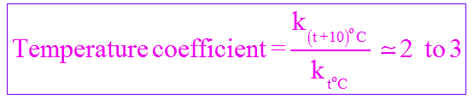
- Catalyst
Catalyst is a substance which alters the rate of a reaction without being consumed or without undergoing any chemical change during the reaction. A catalyst increases the rate of reaction by providing a new path with lower activation energy (E_{a}) for the reaction.
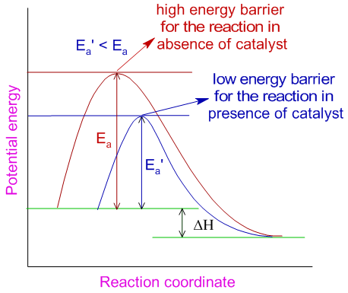
In case of reversible reactions, the catalyst lowers the activation energies of both forward and backward reactions to the same extent and helps in attaining the equilibrium quickly. Note that, as it is evident from the above diagram, when a catalyst increases the rate of forward reaction, it also increases the rate of backward reaction.
- Nature of reactants
Rate of a reaction depends on the nature of bonding in the reactants. Usually the ionic compounds react faster than covalent compounds. The reactions between ionic compounds in water occur very fast as they involve only exchange of ions, which were already separated in aqueous solutions during their dissolution. E.g. AgCl is precipitated out immediately when AgNO₃ solution is added to NaCl solution.
This reaction involves only the exchange of ions as shown below and hence occurs very fast.
Whereas, the reactions between covalent compounds take place slowly because they require energy for the cleavage of existing bonds. E.g., The esterification of acetic acid occurs slowly since the breaking of bonds requires energy.
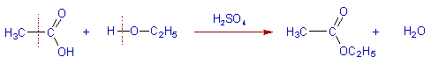
- Surface area
The rate of a reaction increases with increase in the surface area of solid reactant, if any used. The surface of a solid can be increased by grinding it to a fine powder. E.g. The reaction between zinc and hydrochloric acid occurs within seconds if the zinc metal is finely powdered. But the reaction will be slower when a zinc wire is used. This is also true with the solid catalysts, which are usually employed in finely powdered form, while carrying out a chemical reaction. E.g. Finely powdered nickel is used during the hydrogenation of oils.
Q.4.b.
Ans. In 1890 it was common knowledge that higher temperatures speed up reactions, often doubling the rate for a 10-degree rise, but the reasons for this were not clear. Finally, in 1899, the Swedish chemist Svante Arrhenius (1859-1927) combined the concepts of activation energy and the Boltzmann distribution law into one of the most important relationships in physical chemistry:
Determining the Activation Energy from the Arrhenius equation
Above equation can be written in a non-exponential form that is often more convenient to use and to interpret graphically. Taking the logarithms of both sides and separating the exponential and pre-exponential terms yields
$$lnk=lnA-\frac{E_{a}}{RT}$$
Equation is in the form of y=mx+b - the equation of a straight line.
where temperature is the independent variable and the rate constant is the dependent variable. So if one were given a data set of various values of k, the rate constant of a certain chemical reaction at varying temperature T, one could graph ln(k) versus 1/T. From the graph, one can then determine the slope of the line and realize that this value is equal to −Ea/R. One can then solve for the activation energy by multiplying through by -R, where R is the gas constant. This affords a simple way of determining the activation energy from values of k observed at different temperatures, by plotting lnk as a function of 1/T.
Q.4.c.
Ans. Enzyme catalysis
Like other catalysts, enzymes provide an alternate pathway from substrate to product with a lower E_{a} yet the enzyme does not alter the equilibrium between substrates and products.
Examples of enzyme catalysis
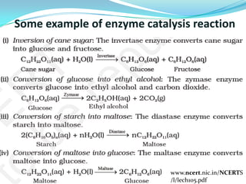
Characteristics of enzyme catalysis
Like all other catalysts, enzymes are characterized by two fundamental properties. First, they increase the rate of chemical reactions without themselves being consumed or permanently altered by the reaction. Second, they increase reaction rates without altering the chemical equilibrium between reactants and products.
Q.5.a.
Ans. Colloids
Colloids, also known as colloidal solutions or colloidal systems, are mixtures in which microscopically dispersed insoluble particles of one substance are suspended in another substance. The size of the suspended particles in a colloid can range from 1 to 1000 nanometres (10⁻⁹ metres). For a mixture to be classified as a colloid, its suspended particles must not settle (in the manner that the particles of suspensions settle at the bottom of the container if left undisturbed). Colloidal solutions are known to exhibit the Tyndall Effect, which is a phenomenon in which beams of light incident on colloids are scattered due to the interactions between the light and the colloidal particles.
Classification of Colloid
Based on the types of colloids, their classification is done. These are classified as follows:
Multimolecular colloids: A large number of smaller molecules of a substance add on together on mixing and form species that are in the colloidal range. Example: A sulphur sol consists of particles containing 1000s of S8 sulphur molecules.
Macromolecular Colloids: In this colloid, the macromolecule forms a solution with a solvent. The size of particles remains in the range of colloidal particle size. Here, the colloidal particles are macromolecules having a very large molecular mass. Example: Starch, proteins, cellulose, enzymes, and polystyrene.
Associated Colloids: Few substances react as strong electrolytes when they are in low concentration, but act as colloidal sols when they are in high concentration. In high concentration, particles aggregate and show colloidal behaviour and these particles are known as the micelles. They are also known as associated colloids.
Colloids can also be classified based on the nature of the interaction between the dispersed phase and medium:
Hydrophilic Colloid: These are water-loving or are attracted to the water. They are also known as reversible sols. Example: Agar, gelatin, and pectin
Hydrophobic Colloid: These are the opposite in nature and are repelled by water. These are also called irreversible sols. Example: Gold sols and clay particles.
Colloidal sulphur can be obtained by passing oxygen gas through a solution of hydrogen sulphides. In this method, any oxidising agent like HNO₃ and H₃Br₂ can also be used.
2H₂S + O₂ → 2H₂O + 2S (Sulphur sol)

Q.5.b.
Ans. Confidence limits (also known as confidence intervals) provide a range within which a population parameter, such as the mean, is likely to fall.
To calculate the confidence limits, first need to find the sample mean (x̄) and the sample standard deviation (s) from the data given:
Data: 21.9, 21.5, 19.9, 21.3, 21.7, 23.8, 24.7
- Calculation of the sample mean (x̄)
x̄ = (21.9 + 21.5 + 19.9 + 21.3 + 21.7 + 23.8 + 24.7) / 7 x̄ = 154.8 / 7 x̄ ≈ 22.114 ng/mL
- Calculating the sample standard deviation (s)
s = √[Σ(xi - x̄)² / (n - 1)]
s = √[( (21.9 - 22.114)² + (21.5 - 22.114)² + (19.9 - 22.114)² + (21.3 - 22.114)² + (21.7 - 22.114)² + (23.8 - 22.114)² + (24.7 - 22.114)² ) / (7 - 1)]
s ≈ √[17.308 / 6] s ≈ √2.8847 s ≈ 1.698 ng/mL
Now from the values of sample mean (x̄) and the sample standard deviation (s), we can calculate the confidence limits.
For a 95% Confidence Interval: Here we will use t-distribution because the sample size is small (n = 7). t-value for a 95% confidence level with 6 degrees of freedom (n - 1). For a 95% confidence level and 6 degrees of freedom, the t-value is approximately 2.4477.
Calculate the margin of error (MOE): MOE = (t-value) * (s / √n) MOE = 2.4477 * (1.698 / √7) MOE ≈ 2.4477 * (1.698 / √7) MOE ≈ 2.4477 * 0.642 MOE ≈ 1.573 ng/mL
Now calculate the confidence limits: Lower Limit = x̄ - MOE Lower Limit ≈ 22.114 - 1.573 Lower Limit ≈ 20.541 ng/mL
Upper Limit = x̄ + MOE Upper Limit ≈ 22.114 + 1.573 Upper Limit ≈ 23.687 ng/mL
So, the 95% confidence limits for the measurements are approximately 20.541 ng/mL to 23.687 ng/mL.
For a 99% Confidence Interval: Follow the same process, but use the t-value for a 99% confidence level with 6 degrees of freedom, which is approximately 3.7074.
MOE = 3.7074 * (1.698 / √7) Lower Limit ≈ 22.114 - (3.7074 * 0.642) Upper Limit ≈ 22.114 + (3.7074 * 0.642)
The 99% confidence limits for the measurements will be wider than the 95% confidence limits.
Q.5.c.
Ans. The components, visible as separated spots, are identified by comparing the distances they have traveled with those of the known reference materials. Measure the distance of the start line to the solvent front (=d). Then measure the distance of center of the spot to the start line (=a). Divide the distance the solvent moved by the distance the individual spot moved. The resulting ratio is called R_{f}-value. The value should be between 0.0 (spot did not move from starting line) and 1.0 (spot moved with solvent front) and is unitless.
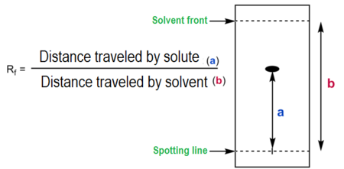
The R_{f} (=retention factor) depends on the following parameters:
- solvent system
- absorbent (grain size, water content, thickness)
- amount of material spotted
- temperature
- Due to the fact that all those variables are difficult to keep constant, a reference compound is usually applied to the plate as well.
In paper chromatography using a nonpolar solvent like hexane, the polarity of a compound directly affects its affinity for the solvent and, consequently, its migration distance on the paper. Less polar compounds move farther, yielding higher R_{f} values, while more polar compounds move less, resulting in lower R_{f} values. This behaviour allows for the separation and identification of different compounds in a mixture based on their polarity and movement along the chromatography paper.
Q.6.a.
Ans. Electrophoresis
Applications
Q.6.b.
Ans. Oxygen O₂ is paramagnetic due to the presence of two unpaired electrons in its last molecular orbital. The Molecular orbital electronic configuration is as follows:
$${\left(σ1s\right)}^{2}{\left(σ^{*}1s\right)}^{2}{\left(σ2s\right)}^{2}{\left(σ^{*}2s\right)}^{2}{\left(σ2p_{z}\right)}^{2}\left(π2p_{x}^{2}=π2p_{y}^{2}\right)\left(π^{*}2p_{x}^{1}=π^{*}2p_{y}^{1}\right)$$
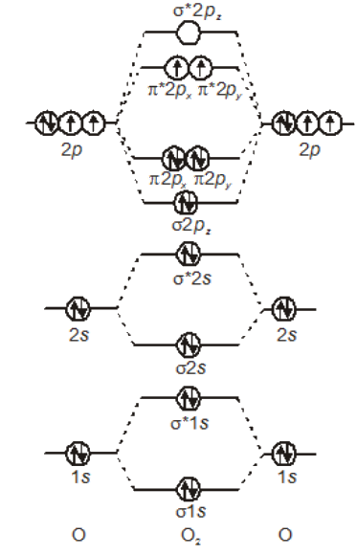
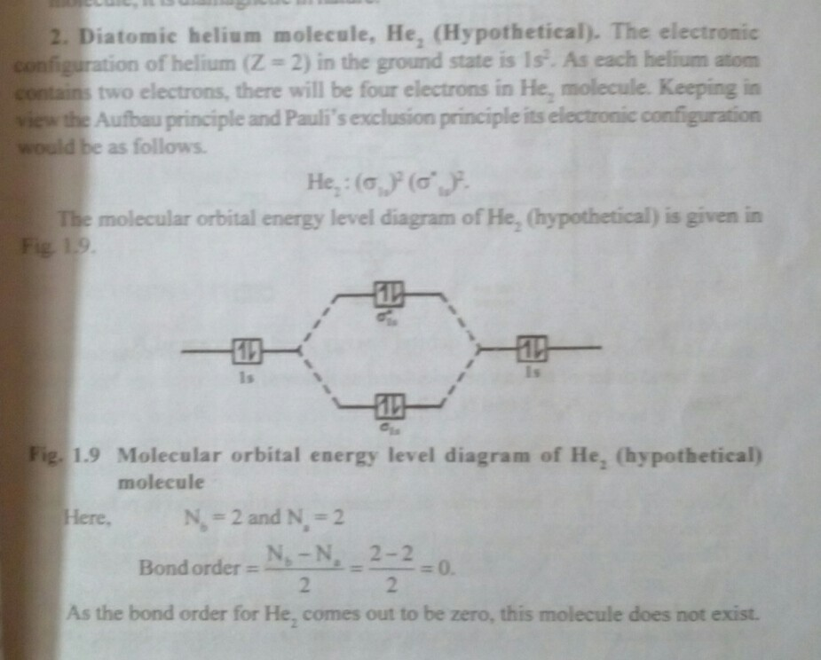
Q.6.c.
Ans. [Ni(CN)₄]²⁻ = Ni²⁺ + 4CN⁻
In [Ni(CN)₄]²⁻, there is Ni²⁺ ion for which the electronic configuration in the valence shell is 3d⁸ 4s⁰. In presence of strong field CN⁻ ions, all the electrons are paired up. The empty 3d, 3s and two 4p orbitals undergo dsp² hybridization to make bonds with CN⁻ ligands in square planar geometry. Thus [Ni(CN)₄]²⁻ is diamagnetic. It is said to be a low spin inner orbital complex.
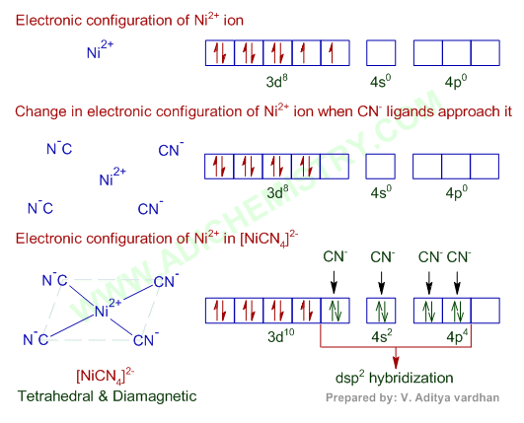
Hybridization of [Ni(CN)₄]²⁻ : dsp²
Shape of [Ni(CN)₄]²⁻: Square planar
Magnetic nature: Diamagnetic (low spin)
Q.7.a.
Ans.
Oxygen atom shares two electrons with both Fluorine atoms, which means there are two bonding pairs of electrons in the Lewis structure of OF₂ along with two nonbonding pairs of electrons on the central atom. To share electrons with Fluorine atoms, the orbitals of Oxygen undergo hybridization to accommodate the electrons. The electronic configuration of the Oxygen atom in its ground state is 1s² 2s² 2p⁴. The 2s and 2p orbitals of Oxygen atom are hybridized, which means there is a formation of four hybridized orbitals: 2s, 2px, 2py and 2pz. And such hybridization makes this molecule sp³ hybridized.
The electrons in the molecule are always arranged in a way that minimizes the repulsion between the electrons. In OF₂, the electrons are arranged that tetrahedrally. Hence it has a tetrahedral electron geometry. The bond angle of F-O-H is 109° 27.
The shape of any molecule depends upon the arrangement of electrons and atoms in the molecule. Here both the Fluorine atoms are on the outside and share two valence electrons of the Oxygen atom. But as there are two lone pairs of electrons on the Oxygen atom, there will be repulsion between these two pairs, which causes a bend in the shape of its molecule. Even Though the molecule is linear, OF₂ will have a bent shape.
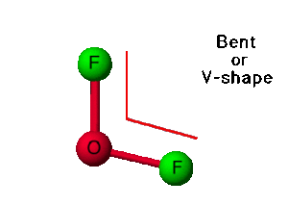

Q.7.b.
Ans. Hard and Soft Acids and Bases (HSAB) Principle
It is a qualitative concept introduced by Ralph Pearson to explain the stability of metal complexes and the mechanisms of their reactions. However, it is also possible to quantify this concept based on Klopman's FMO analysis using interactions between HOMO and LUMO.
According to HSAB principle, the Lewis acids and bases can be further divided into hard or soft or borderline types.
Hard Lewis acids are characterized by small ionic radii, high positive charge, strongly solvated, empty orbitals in the valence shell and with high energy LUMOs.
Soft Lewis acids are characterized by large ionic radii, low positive charge, completely filled atomic orbitals and with low energy LUMOs.
Hard Lewis bases are characterized by small ionic radii, strongly solvated, highly electronegative, weakly polarizable and with high energy HOMOs.
Soft Lewis bases are characterized by large ionic radii, intermediate electronegativity, highly polarizable and with low energy HOMOs.
The Borderline Lewis acids and bases have intermediate properties.
In short, Hard acids and bases are small and non-polarizable, whereas Soft acids and bases are larger and more polarizable.
According to HSAB concept, hard acids prefer binding to the hard bases to give ionic complexes, whereas the soft acids prefer binding to soft bases to give covalent complexes. It is sometimes referred to as Hard-Soft Interaction Principle (HSIP).
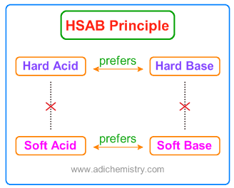
The large electronegativity differences between hard acids and hard bases give rise to strong ionic interactions. The electronegativities of soft acids and soft bases are almost same and hence have less ionic interactions. i.e., the interactions between them are more covalent. The interactions between hard acid - soft base or soft acid - hard base are mostly polar covalent and tend to be more reactive or less stable. The polar covalent compounds readily form either more ionic or more covalent compounds if they are allowed to react.
According to FMO analysis, the interactions between acids and bases are controlled by the relative energies of the participating frontier molecular orbitals (FMO) i.e., HOMO and LUMO.
Greater the energy gap between the HOMO & LUMO, harder is the species.
Quantitatively the absolute hardness of a species is determined by following equations.
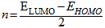
Q.7.c.
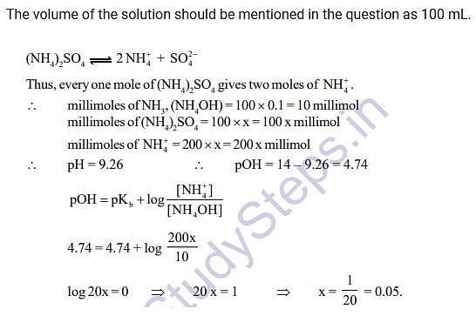
Q.8.a.
Ans. Crystal field theory (CFT) describes the breaking of orbital degeneracy in transition metal complexes due to the presence of ligands. CFT qualitatively describes the strength of the metal-ligand bonds. Based on the strength of the metal-ligand bonds, the energy of the system is altered. This may lead to a change in magnetic properties as well as color.

Basic Concept
In Crystal Field Theory, it is assumed that the ions are simple point charges . When examining a single transition metal ion, the five d-orbitals have the same energy (Figure). When ligands approach the metal ion, some experience more opposition from the d-orbital electrons than others based on the geometric structure of the molecule. Since ligands approach from different directions, not all d-orbitals interact directly. These interactions, however, create a splitting due to the electrostatic environment.
Figure: Distributing a charge of −6 uniformly over a spherical surface surrounding a metal ion causes the energy of all five d orbitals to increase due to electrostatic repulsions, but the five d orbitals remain degenerate.
CFT is based primarily on symmetry of ligands around a central metal/ion and how this anisotropic (properties depending on direction) ligand field affects the metal's atomic orbitals; the energies of which may increase, decrease or not be affected at all. Once the ligands' electrons interact with the electrons of the d-orbitals, the electrostatic interactions cause the energy levels of the d-orbital to fluctuate depending on the orientation and the nature of the ligands. For example, the oxidation state and the strength of the ligands determine splitting; the higher the oxidation state or the stronger the ligand, the larger the splitting. Ligands are classified as strong or weak based on the spectrochemical series:
I⁻ < Br⁻ < Cl⁻ < SCN⁻ < F⁻ < OH⁻ < ox²⁻< ONO⁻ < H₂O < SCN⁻ < EDTA⁴⁻ < NH₃ < en < NO₂⁻ < CN⁻
In addition to octahedral complexes, two common geometries observed are that of tetrahedral and square planar. These complexes differ from the octahedral complexes in that the orbital levels are raised in energy due to the interference with electrons from ligands. For the tetrahedral complex, the d_{xy}, d_{xz}, and d_{yz} orbitals are raised in energy while the d_{z²}, d_{x²-y²} orbitals are lowered. For the square planar complexes, there is greatest interaction with the d_{x²-y²} orbital and therefore it has higher energy. The next orbital with the greatest interaction is d_{xy}, followed below by d_{z²}. The orbitals with the lowest energy are the d_{xz} and d_{yz} orbitals. There is a large energy separation between the d_{z²} orbital and the d_{xz} and d_{yz} orbitals, meaning that the crystal field splitting energy is large. We find that the square planar complexes have the greatest crystal field splitting energy compared to all the other complexes. This means that most square planar complexes are low spin, strong field ligands.
Octahedral Complexes
In an octahedral complex, there are six ligands attached to the central transition metal. The d-orbital splits into two different levels. The bottom three energy levels are named dxy, dxz, and dyz (collectively referred to as t_{2g}). The two upper energy levels are named dx²−y² , and dz² (collectively referred to as eg).
The reason they split is because of the electrostatic interactions between the electrons of the ligand and the lobes of the d-orbital. In an octahedral, the electrons are attracted to the axes. Any orbital that has a lobe on the axes moves to a higher energy level. This means that in an octahedral, the energy levels of e_{g} are higher (0.6∆_{o}) while t₂g is lower (0.4∆_{o}). The distance that the electrons have to move from t₂g from eg and it dictates the energy that the complex will absorb from white light, which will determine the colour. Whether the complex is paramagnetic or diamagnetic will be determined by the spin state. If there are unpaired electrons, the complex is paramagnetic; if all electrons are paired, the complex is diamagnetic.
Tetrahedral Complexes
In a tetrahedral complex, there are four ligands attached to the central metal. The d orbitals also split into two different energy levels. The top three consist of the dxy, dxz, and dyz orbitals. The bottom two consist of the dx²−y² and dz² orbitals. The reason for this is due to poor orbital overlap between the metal and the ligand orbitals. The orbitals are directed on the axes, while the ligands are not.
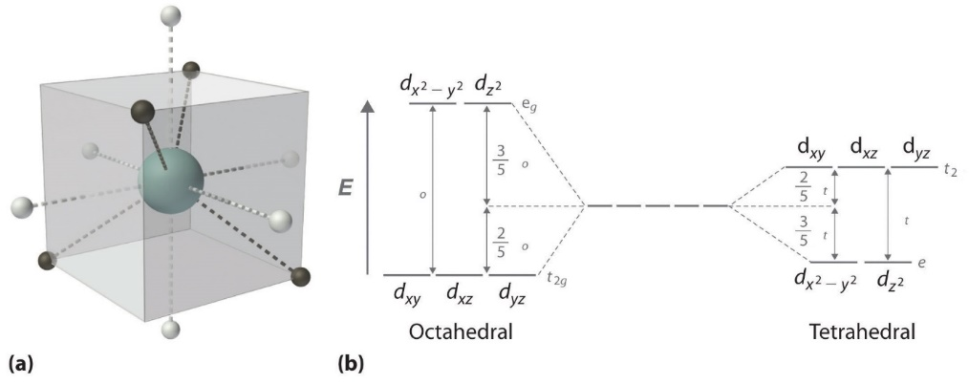Figure: (a) Tetrahedral ligand field surrounding a central transition metal (blue sphere). (b) Splitting of the degenerate d-orbitals (without a ligand field) due to an octahedral ligand field (left diagram) and the tetrahedral field (right diagram).
Difference between CFT and VBT
The term VBT stands for valence bond theory. It is a theory used to describe the formation of different chemical bonds between atoms. This theory explains the overlapping or mixing of atomic orbitals to form chemical bonds. CFT is a model that is designed to explain the breaking of degeneracies (electron shells of equal energy) of electron orbitals (usually d or f orbitals) due to the static electric field produced by a surrounding anion or anions (or ligands). The key difference between VBT and CFT is that VBT explains the mixing of orbitals whereas CFT explains the splitting of orbitals.
Q.8.b. c.
Ans.
Complex formula | Complex name | Coordination number | Valency of central metal
K₄[NiF₆] | Potassium hexafluoronickelate(II) | 6 | II
K₃[Fe(CN)₆] | Potassium hexacyanoferrate(III) | 6 | III
[(NH₃)₄F₂]Cl | Tetraamminedifluorocobalt(I) chloride | 6 | I
K₂[PtCl₆] | Potassium hexachloroplatinate(IV) | 6 | IV
K₂[Cu(CN)₄] | Potassium tetracyanocuprate(II) | 4 | II

Q.2.a.
Ans. The electrons move around in a predictable path called orbits. Bohr modified Rutherford’s model where he explained that electrons move around in fixed orbital shells. Furthermore, he explained that each orbital shell has fixed energy levels. Therefore, Rutherford basically explained a nucleus of an atom whereas Bohr took the model one step ahead. He explained about electrons and the different energy levels associated with them.
According to the Bohr Atomic model, a small positively charged nucleus is surrounded by revolving negatively charged electrons in fixed orbits. He concluded that electron will have more energy if it is located away from the nucleus whereas electrons will have less energy if it located near the nucleus.
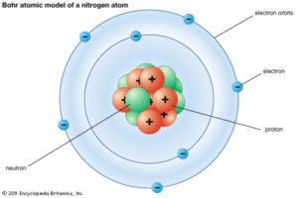
Bohr’s Model of an Atom

Postulates of Bohr Atomic Model
- Electrons revolve around the nucleus in a fixed circular path termed “orbits” or “shells” or “energy level.”
- The orbits are termed as “stationary orbit.”
- Every circular orbit will have a certain amount of fixed energy and these circular orbits were termed orbital shells. The electrons will not radiate energy as long as they continue to revolve around the nucleus in the fixed orbital shells.
- The different energy levels are denoted by integers such as n=1 or n=2 or n=3 and so on. These are called quantum numbers. The range of quantum numbers may vary and begin from the lowest energy level (nucleus side n=1) to the highest energy level.
- The different energy levels or orbits are represented in two ways such as 1, 2, 3, 4… or K, L, M, N….. shells. The lowest energy level of the electron is called the ground state.
- The change in energy occurs when the electrons jump from one energy level to other. In an atom, the electrons move from lower to higher energy level by acquiring the required energy. However, when an electron loses energy it moves from higher to lower energy level.
Therefore,
- 1st orbit (energy level) is represented as K shell and it can hold up to 2 electrons.
- 2nd orbit (energy level) is represented as L shell and it can hold up to 8 electrons.
- 3rd orbit (energy level) is represented as M shell and it can contain up to 18 electrons.
- 4th orbit (energy level) is represented as N Shell and it can contain maximum 32 electrons.
The orbits continue to increase in a similar manner.
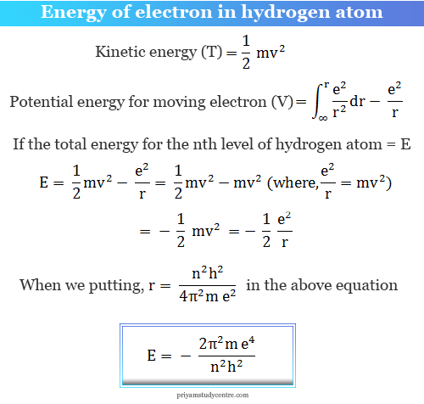
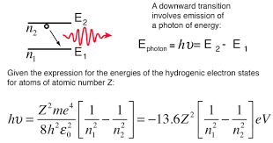

Q.2.b.
Ans.
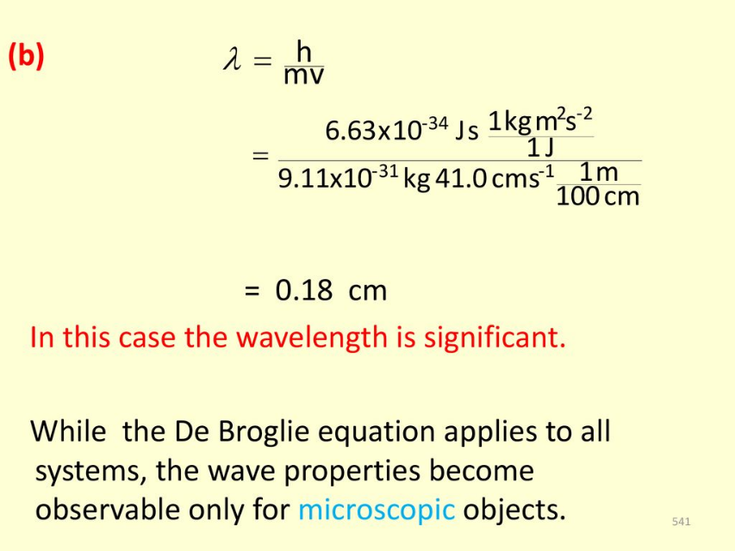
Q.2.c.
Ans. Postulates of Quantum Mechanics
- The state of a quantum mechanical system is completely specified by the wavefunction 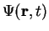.
- To every observable in classical mechanics, there corresponds a linear, Hermitian operator in quantum mechanics. For example, in coordinate space, the momentum operator corresponding to momentum in the direction for a single particle is 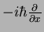.
- In any measurement of the observable associated with operator , the only values that will ever be observed are the eigenvalues which satisfy . Although measurements must always yield an eigenvalue, the state does not originally have to be in an eigenstate of . An arbitrary state can be expanded in the complete set of eigenvectors of ( 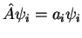) as 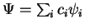, where the sum can run to infinity in principle. The probability of observing eigenvalue is given by 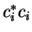.
- The average value of the observable corresponding to operator is given by
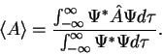 | (3)

- The wavefunction evolves in time according to the time-dependent Schrödinger eq.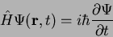
- The total wavefunction must be antisymmetric with respect to the interchange of all coordinates of one fermion with those of another. Electronic spin must be included in this set of coordinates. The Pauli exclusion principle is a direct result of this antisymmetry principle.
Q.3.a.
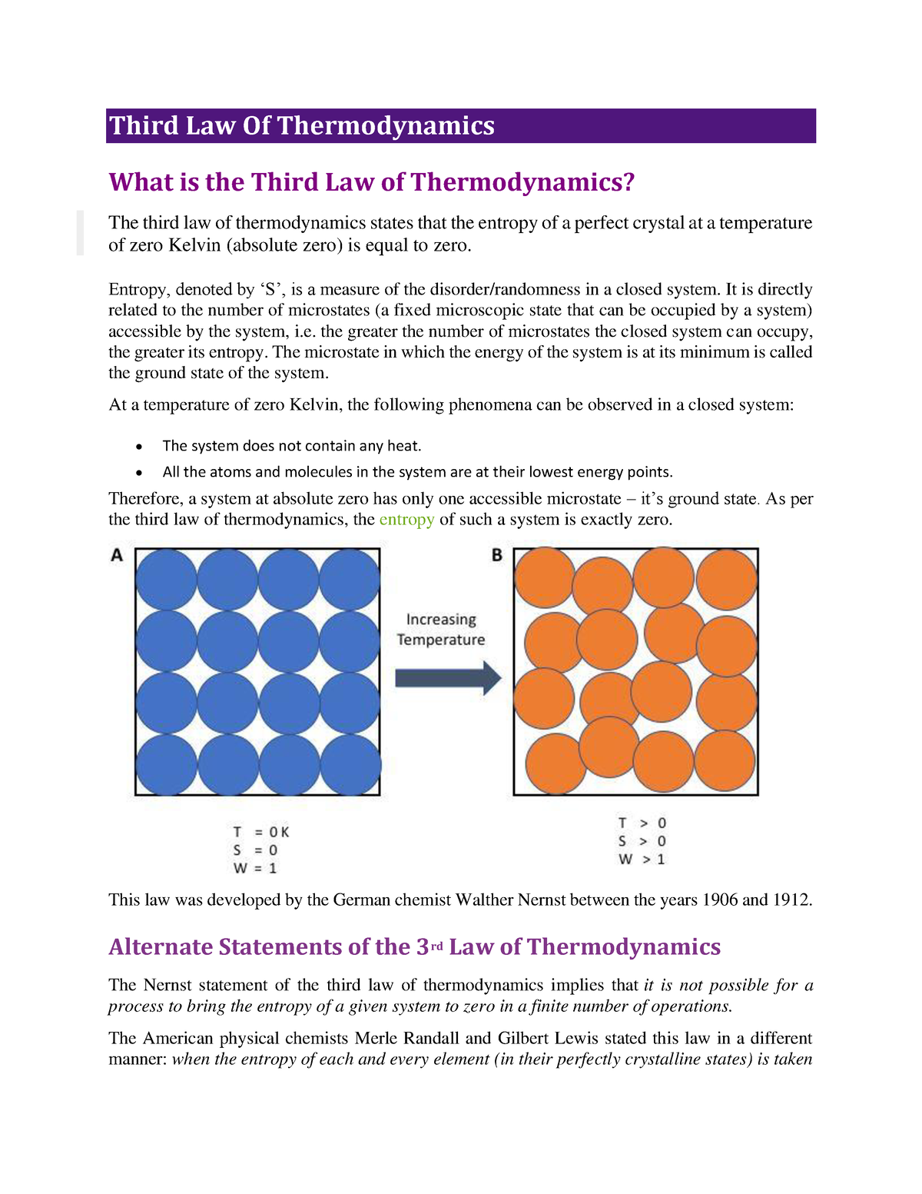
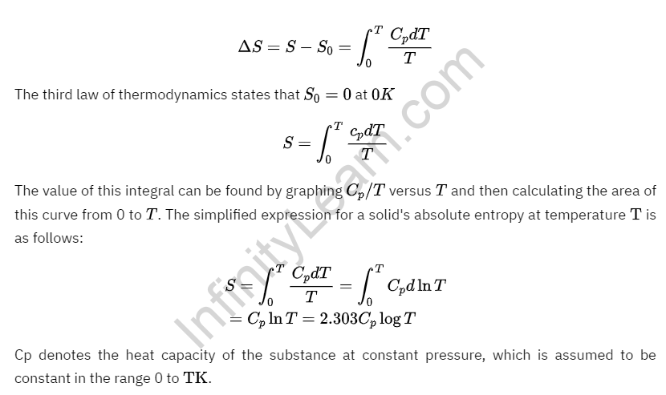
Q.3.b.
Ans. isothermal expansion is the increase in volume under constant-temperature conditions. In this situation, the gas does work, so the work is negatively-signed because the gas exerts energy to increase in volume. During isothermal conditions, the change in internal energy ΔU is 0 for only an ideal gas, so efficient work done is entirely transformed into efficient heat flow.
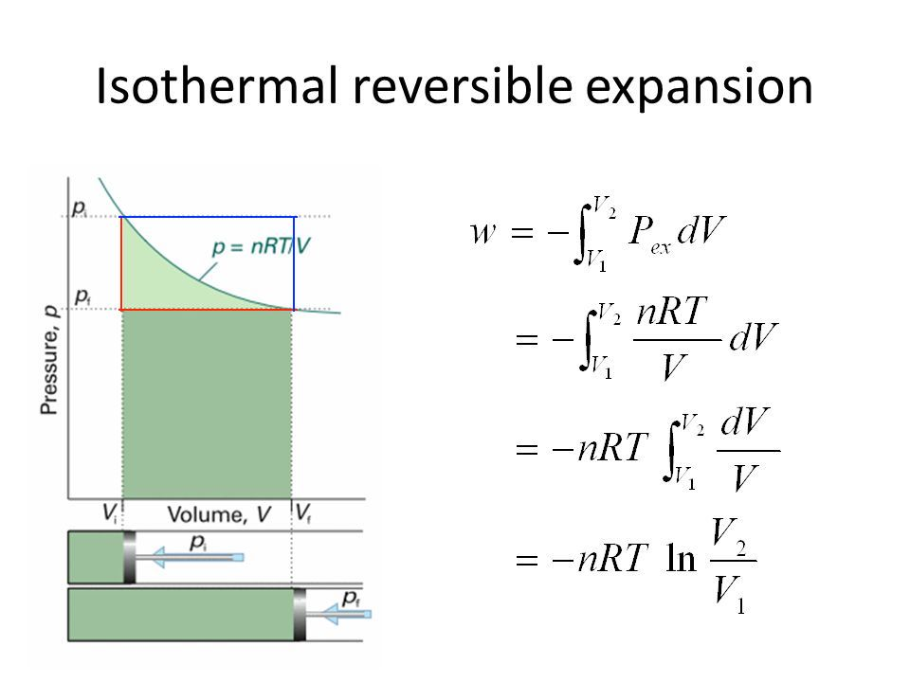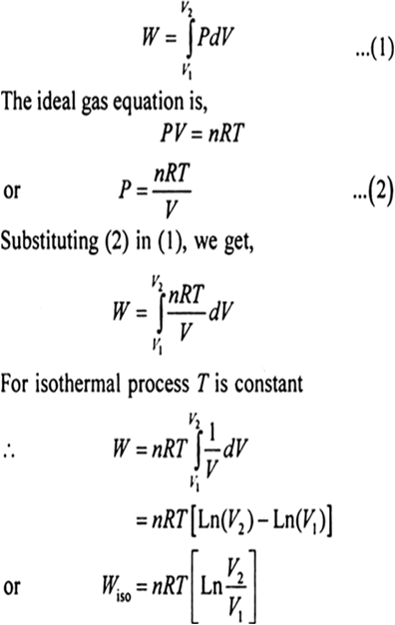
where:
- W is the most efficient work possible (reversible work) in J. It is as slow as possible to ensure that no energy is lost to the atmosphere.
- P is the pressure in, say, bars, atm, etc.
- ∫V₂V₁dV is the integral from the initial to the final volume, which basically gives you the result of performing infinitesimally slow work.
- dV is the differential volume; that is, it is an infinitesimally small change in the volume.
- nRT is a constant for an isothermal situation, and each variable holds the same meaning as in the ideal gas law. This can be pulled out as a coefficient in the integral.
For expansion, V₂>V₁, so we know that ln∣V₂V₁∣>0. Thus, for isothermal expansion, W<0.
During isothermal conditions, the internal energy from the first law of thermodynamics is
ΔU=q+W=0,
which means q=-W
As a brief comparison, isothermal contraction is when the volume decreases. It means work was done on the gas. This makes the work positive because the gas absorbs the energy that was imparted into it to do work on it.
Q.3.c.
Ans. The principle of Corresponding States (PCS) was stated by van der Waals and reads: “Substances behave alike at the same reduced states. Substances at same reduced states are at corresponding states.” That is,
“Substances at corresponding states behave alike.”
Reduced properties are used to define corresponding states. Reduced properties provide a measure of the “departure” of the conditions of the substance from its own critical conditions and are defined as follows:
$$P_{r}=\frac{P}{P_{c}}, T_{r}=\frac{T}{T_{c}}, V_{r}=\frac{V}{V_{c}}$$

−
If P_{r} = T_{r} = v_{r} = 1, the substance is at its critical condition. If we are beyond critical conditions, T_{r} > 1, P_{r} > 1 and v_{r} > 1. By the same token, if all the conditions are subcritical, T_{r} < 1, P_{r} < 1 and v_{r} < 1. Critical conditions become the scaling factor by which substances can be compared among each other in terms of their “departure from criticality” or reduced properties.
The PCS says that all gases behave alike at the same reduced conditions. That is, if two gases have the same “relative departure” from criticality (i.e., they are at the same reduced conditions), the corresponding state principle demands that they behave alike. In this case, the two conditions “correspond” to one another, and we are to expect those gases to have the same properties.
The Corresponding State Principle can be derived from vdW EOS.
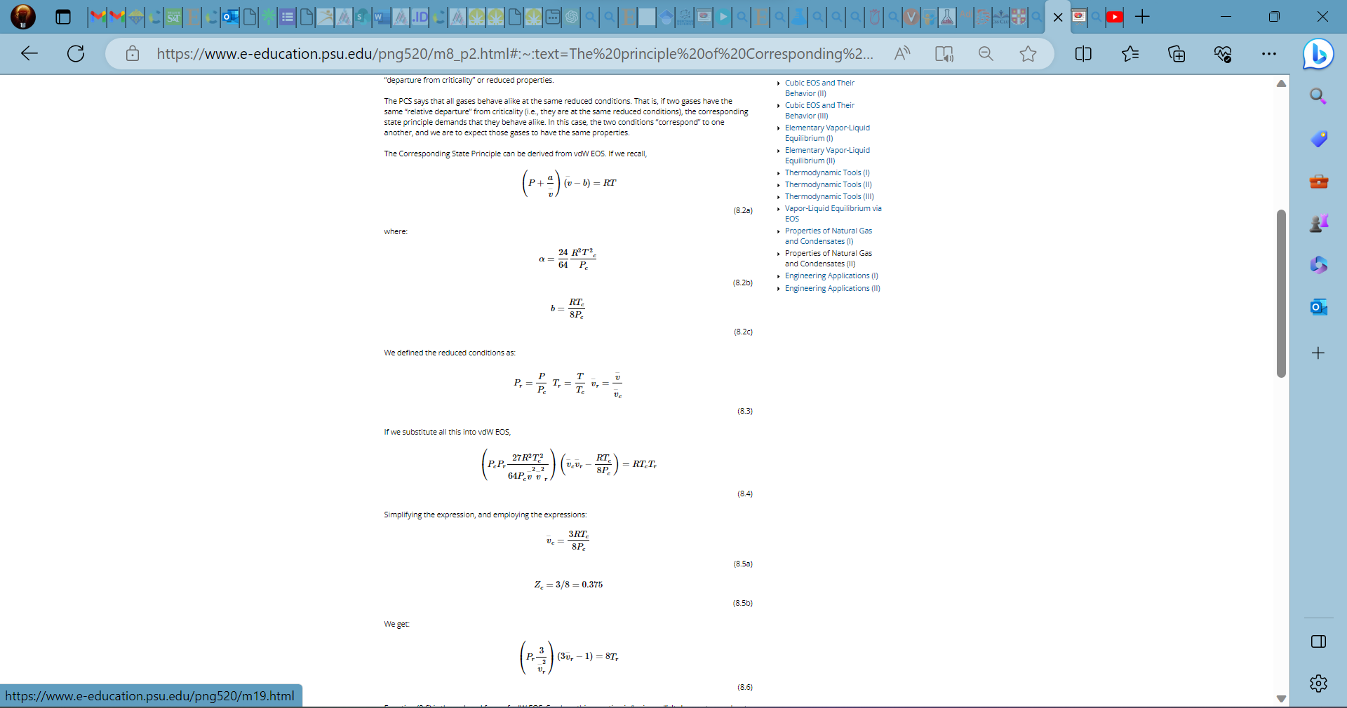
Q.4.a.
Ans. To describe how the rate of a second-order reaction changes with concentration of reactants or products, the differential (derivative) rate equation is used as well as the integrated rate equation. The differential rate law can show us how the rate of the reaction changes in time, while the integrated rate equation shows how the concentration of species changes over time. The latter form, when graphed, yields a linear function and is, therefore, more convenient to look at. Nonetheless, both of these equations can be derived from the above expression for the reaction rate. Plotting these equations can also help us determine whether or not a certain reaction is second-order.
Two of the same reactant (AA) combine in a single elementary step.
2A⟶P
The reaction rate for this step can be written as
$$Rate=-\frac{1}{2}\frac{d\left[A\right]}{dt}=+\frac{d\left[P\right]}{dt}$$
and the rate of loss of reactant AA
$$\frac{d\left[A\right]}{dt}=-k{[A]}^{2}$$
where k is a second order rate constant with units of M⁻¹min⁻¹ or M⁻¹s⁻¹. Therefore, doubling the concentration of reactant AA will quadruple the rate of the reaction
Integration of Equation yields
$$\frac{1}{[A]}=\frac{1}{{[A]}_{0}}+kt$$
which is easily rearranged into a form of the equation for a straight line and yields plots similar to the one shown below.
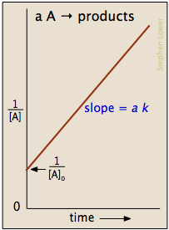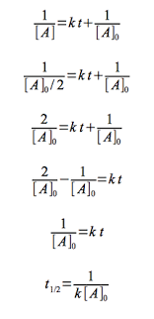
Half-life INCREASES over time, since reactant concentration is going down. This makes sense, since fewer molecules of A means fewer collisions, and so it takes longer for half of the reactant to disappear.
Q.4.b.
Ans. Activation energy is the minimum quantity of energy which the reacting species must possess in order to undergo a specified reaction.
In 1899, the Swedish chemist Svante Arrhenius (1859-1927) combined the concepts of activation energy and the Boltzmann distribution law into one of the most important relationships in physical chemistry:
This shows that high temperature and low activation energy favour larger rate constants, and thus speed up the reaction. Because these terms occur in an exponent, their effects on the rate are quite substantial.
Determining the Activation Energy from the Arrhenius equation
This equation can be written in a non-exponential form that is often more convenient to use and to interpret graphically. Taking the logarithms of both sides and separating the exponential and pre-exponential terms yields
$$lnk=lnA-\frac{E_{a}}{RT}$$
Equation is in the form of y=mx+b - the equation of a straight line.
where temperature is the independent variable and the rate constant is the dependent variable. So if one were given a data set of various values of k, the rate constant of a certain chemical reaction at varying temperature T, one could graph ln(k) versus 1/T. From the graph, one can then determine the slope of the line and realize that this value is equal to −Ea/R. One can then solve for the activation energy by multiplying through by -R, where R is the gas constant. This affords a simple way of determining the activation energy from values of k observed at different temperatures, by plotting lnk as a function of 1/T.
Q.4.c.
Ans. In chemistry, transition state theory (TST) explains the reaction rates of elementary chemical reactions. The theory assumes a special type of chemical equilibrium (quasi-equilibrium) between reactants and activated transition state complexes.
The basic ideas behind transition state theory are as follows:
- Rates of reaction can be studied by examining activated complexes near the saddle point of a potential energy surface. The details of how these complexes are formed are not important. The saddle point itself is called the transition state.
- The activated complexes are in a special equilibrium (quasi-equilibrium) with the reactant molecules.
- The activated complexes can convert into products, and kinetic theory can be used to calculate the rate of this conversion.
In 1884, Jacobus van 't Hoff proposed the Van 't Hoff equation describing the temperature dependence of the equilibrium constant for a reversible reaction:
where ΔU is the change in internal energy, K is the equilibrium constant of the reaction, R is the universal gas constant, and T is thermodynamic temperature. Based on experimental work, in 1889, Svante Arrhenius proposed a similar expression for the rate constant of a reaction, given as follows:
where k is the rate constant. A was referred to as the frequency factor (now called the pre-exponential coefficient), and E_{a} is regarded as the activation energy. In 1910, French chemist René Marcelin introduced the concept of standard Gibbs energy of activation. His relation can be written as
At about the same time as Marcelin was working on his formulation, Dutch chemists Philip Abraham Kohnstamm, Frans Eppo Cornelis Scheffer, and Wiedold Frans Brandsma introduced standard entropy of activation and the standard enthalpy of activation. They proposed the following rate constant equation
It was not until 1912 when the French chemist A. Berthoud used the Maxwell–Boltzmann distribution law to obtain an expression for the rate constant.
where a and b are constants related to energy terms.
In 1919, Austrian physicist applied statistical mechanics to the equilibrium constant and kinetic theory to the rate constant of the reverse reaction, k₋₁, for the reversible dissociation of a diatomic molecule.
Transition State Theory (TST) is a concept in chemistry that provides a more detailed and realistic framework for understanding the rates of chemical reactions compared to the simpler Collision Theory. It offers a more refined picture of the reaction process by considering the intermediate state between reactants and products, known as the transition state.
Q.5.a.
Ans. The phase rule is a generalization given by Willard Gibbs (1874), which seeks to explain the equilibria existing in heterogeneous system. It may be stated as: “provided the equilibrium between any number of phases is not influenced by gravity, or electrical, or magnetic forces or by surface action and only by temperature, pressure and concentration, then the number of degrees of freedom (F) of the system is related to number of components (C) and of phases (P) by the phase rule equation for any system at equilibrium at a definite temperature and pressure.
F = C – P + 2
This rule, if properly applied, has no exception.
A phase is defined as “an homogeneous, physically distinct and mechanically separable portion of system, which is separated from other such parts of the system by definite boundary surface”. For Example: At freezing point, water consists of three phase :
Ice _{(s)} Water _{(l)} Water vapour _{(g)}
- A gaseous mixture, being thoroughly miscible in all proportion, will constitute one phase only. Thus, a mixture of N₂ and H₂ forms one phase only.
- If two liquids are miscible (i.e., alcohol and water), they will form one liquid phase only.
- A solution of a substance in a solvent consists of phase only, e. g, glucose solution in water.
- Each solid mark up a separate phase, except in the case of solid solution, e. g, many forms of sulphur can exist together, but these are all separate phases.
- A heterogeneous mixture like :
CaCO3 _{(s)} CaO_{(s)} + CO_{2 (g)}
Consists of three phases (i.e., two solids and one gaseous). Similarly, in the equilibrium reaction,
Fe_{(s)} + H₂O FeO_{(s)} + H_{2(g)}
There are two solid phases, Fe and FeO and one gaseous phase consisting of H₂O_{(g)} and H_{2(g)}. Thus, three phases exists in equilibrium.
Component: by the term component is meant “the smallest number of independent variable constituents, taking part in state of equilibrium, by mean of which the composition of each phase can be expressed in the form of chemical equation”. For example:
i. In the water system,
Ice _{(s)} Water _{(l)} vapour _{(g)}
The chemical composition of all the three phases is H₂O. Hence, it is one component system.
ii. the sulphur system consists of four phases, rhombic, monoclinic, liquid and vapour, the chemical composition of all phases is S. hence, it is one component system.
iii. In the dissociation of NH₄CI in a closed vessel,
NH₄CI_{(g)}NH₄CI_{(g)} NH_{3(g)}+HCI_{(g)}
The proportions of NH₃ and HCl are equivalent and hence, the composition of both phases (solid and gaseous) can be expressed in terms of NH₄CI alone. Hence, the number of component is one. However, if NH₃ or HCl is in excess, the system become a two component system .
Number of component of a system may alternatively be defined as the number of chemical constituents of the system minus the number of equations relating to these constituents in an equilibrium state. For example:
- Dissociation of KClO₃ in a closed vessel: following equilibrium exists :
KClO_{3(s)} 2KCl_{(s)} + 3O₂ _{(g)}
No. of constituents = 3
No. of equations relating the concentration of constituents =1.
Hence, number of components = 3-1 = 2 i.e., it is a two component system.
Degree of freedom or variance
By the term “degree of freedom is meant by” the minimum number of independently variable factors, such as temperature, pressure and composition of the phases, which must be arbitrarily specified in order to represent perfectly the condition of a system. For example
i. In case of water system, Ice_{(s )} Water_{(l)} Vapour_{(g),}
if all the three phases are present in equilibrium, then no condition need to be specified, as the three phases can be in equilibrium only at particular temperature and pressure. If condition (e.g. Temperature or pressure is altered, three phases will not remain in equilibrium and one of the phase disappears.
ii. For a system consisting of water n in contact with its vapour,
Water_{(l)} Vapour_{(g)}
We must state either the temperature or pressure to define it completely. Hence, degree of freedom is one or system is univariant.
iii. For a system consisting of water vapour phase only, we must the values of both the temperature and pressure in order to describe the system completely. Hence, the system is bivariant or has two degrees of freedom.
The phase rule, also known as the Gibbs phase rule or Gibbs-Duhem equation, is a fundamental principle in thermodynamics that describes the number of degrees of freedom in a system in equilibrium. It's particularly useful for understanding the behavior of multi-component systems, including mixtures of different substances. However, in the case of a one-component system like water, the phase rule simplifies to some extent.
In a one-component system, like pure water, there is only one chemical species present. Here's how the phase rule applies to such a system:
The phase rule is given by the formula:
F = C - P + 2
Where:
- F is the number of degrees of freedom
- C is the number of components (chemical species)
- P is the number of phases in equilibrium (solid, liquid, gas, etc.)
In the case of pure water, there is only one component (H2O), so C = 1. Also, water can exist in different phases depending on temperature and pressure: solid (ice), liquid (water), and gas (steam). So, P = 3 (for the three phases).
Plugging these values into the phase rule formula:
F = 1 - 3 + 2 = 0
This result indicates that in a one-component system like pure water, you have no degrees of freedom. In other words, the state of the system is entirely determined by the temperature and pressure. Once you fix the temperature and pressure, the system will exist in a specific phase (solid, liquid, or gas), and there is no variation possible.
In more practical terms, this means that for a one-component system like pure water, you can't change the state of the system (phase) by simply adjusting temperature and pressure. If you're at a specific temperature and pressure, you'll have a specific phase of water. You can't, for example, change ice to liquid water at a given temperature and pressure just by adjusting those variables.
While the phase rule in this case might seem trivial, it lays the foundation for understanding more complex systems with multiple components where phase transitions and equilibria become more intricate and interesting.

Q.5.b.
Ans. 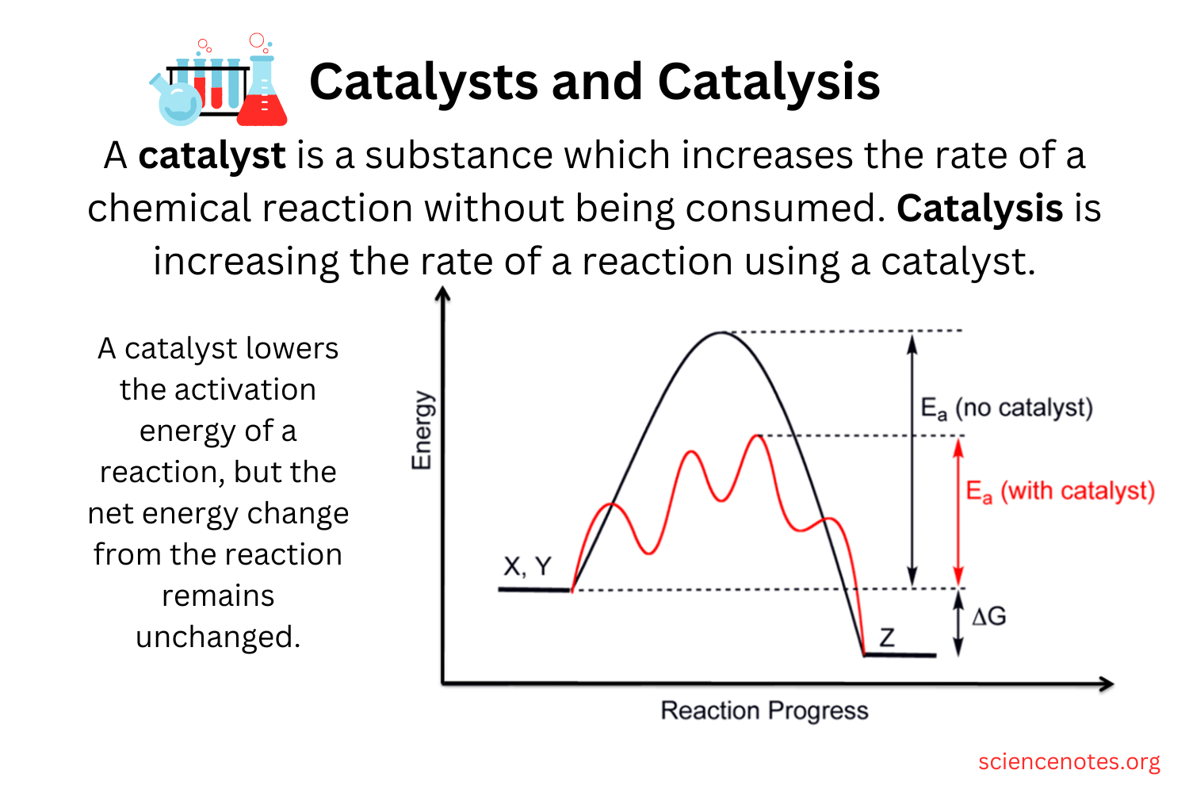
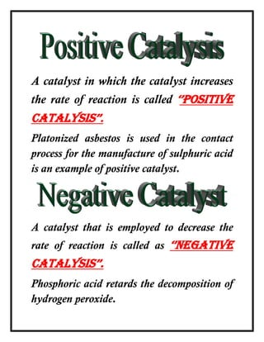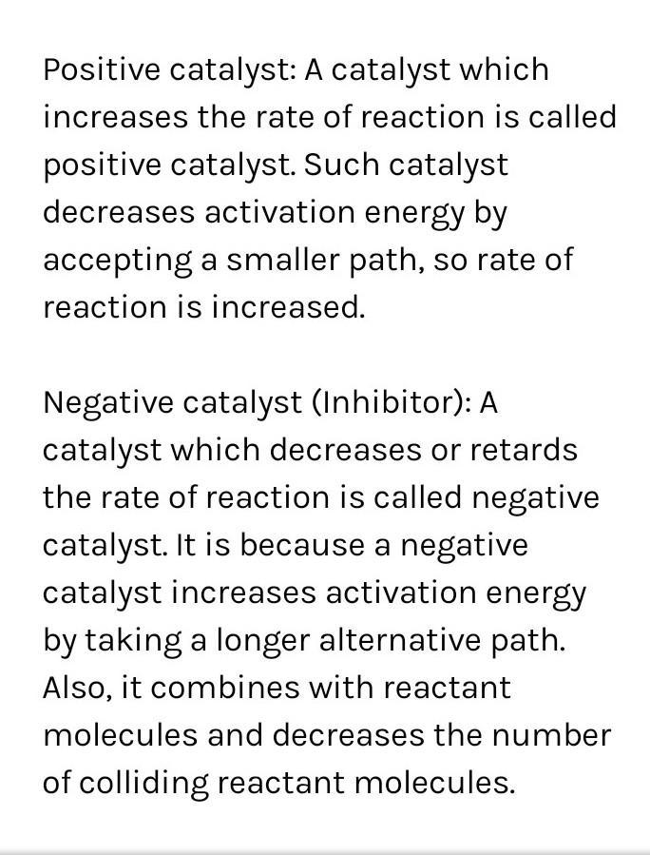
Q.5.c.
Ans. Stoichiometry is a section of chemistry that involves using relationships between reactants and/or products in a chemical reaction to determine desired quantitative data. In Greek, stoikhein means element and metron means measure, so stoichiometry literally translated means the measure of elements. In order to use stoichiometry to run calculations about chemical reactions, it is important to first understand the relationships that exist between products and reactants and why they exist, which require understanding how to balance reactions.
Example of stoichiometric problems:
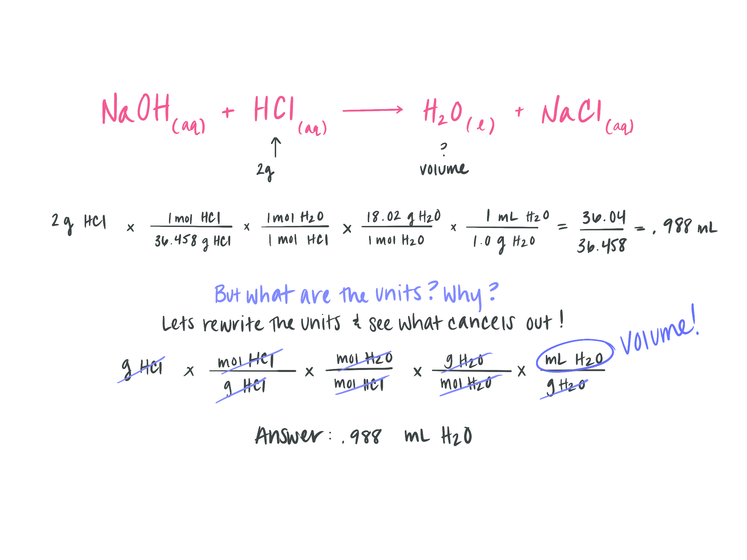
Q.6.a.
Ans. Brønsted-Lowry theory, also called proton theory of acids and bases, a theory, introduced independently in 1923 by the Danish chemist Johannes Nicolaus Brønsted and the English chemist Thomas Martin Lowry, stating that any compound that can transfer a proton to any other compound is an acid, and the compound that accepts the proton is a base. A proton is a nuclear particle with a unit positive electrical charge; it is represented by the symbol H⁺ because it constitutes the nucleus of a hydrogen atom.
According to the Brønsted-Lowry scheme a substance can function as an acid only in the presence of a base; similarly, a substance can function as a base only in the presence of an acid. Furthermore, when an acidic substance loses a proton, it forms a base, called the conjugate base of an acid, and when a basic substance gains a proton, it forms an acid called the conjugate acid of a base. Thus, the reaction between an acidic substance, such as hydrochloric acid, and a basic substance, such as ammonia, may be represented by the equation:
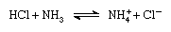
In the equation the ammonium ion (NH⁺₄ ) is the acid conjugate to the base ammonia, and the chloride ion (Cl⁻) is the base conjugate to hydrochloric acid.
The Brønsted-Lowry theory enlarges the number of compounds considered to be acids and bases to include not only the neutral molecules (e.g., sulfuric, nitric, and acetic acids, and the alkali metal hydroxides) but also certain atoms and molecules with positive and negative electrical charges (cations and anions). The ammonium ion, the hydronium ion, and some hydrated metal cations are considered acids. The acetate, phosphate, carbonate, sulfide, and halogen ions are considered bases.
Lewis theory
In 1923, G.N. Lewis from UC Berkeley proposed an alternate theory to describe acids and bases. His theory gave a generalized explanation of acids and bases based on structure and bonding. Through the use of the Lewis definition of acids and bases, chemists are now able to predict a wider variety of acid-base reactions. Lewis' theory used electrons instead of proton transfer and specifically stated that an acid is a species that accepts an electron pair while a base donates an electron pair.
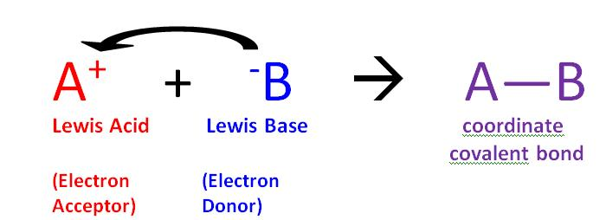Figure 11: A Lewis Base (B) donates it electrons to a Lewis Acid (A) resulting in a coordinate covalently bonded compound, also known as an adduct.
The reaction of a Lewis acid and a Lewis base will produce a coordinate covalent bond (Figure 11). A coordinate covalent bond is just a type of covalent bond in which one reactant gives it electron pair to another reactant. In this case the lewis base donates its electrons to the Lewis acid. When they do react this way the resulting product is called an addition compound, or more commonly an adduct.
- Lewis Acid: a species that accepts an electron pair (i.e., an electrophile) and will have vacant orbitals
- Lewis Base: a species that donates an electron pair (i.e., a nucleophile) and will have lone-pair electrons
Brønsted-Lowry theory is very restrictive and focuses primarily on acids and bases acting as proton donors and acceptors. Sometimes conditions arise where the theory does not necessarily fit, such as in solids and gases. For those systems Lewis theory works best.
Q.6.b.
Ans. Buffer is a solution that resists dramatic changes in pH. Buffers do so by being composed of certain pairs of solutes: either a weak acid plus a salt derived from that weak acid, or a weak base plus a salt of that weak base. For example, a buffer can be composed of dissolved acetic acid (HC₂H₃O₂, a weak acid) and sodium acetate (NaC₂H₃O₂, a salt derived from that acid). Another example of a buffer is a solution containing ammonia (NH₃, a weak base) and ammonium chloride (NH₄Cl, a salt derived from that base).
Here is acetic acid–sodium acetate buffer example to demonstrate how buffers work. If a strong base, a source of OH⁻(aq) ions is added to the buffer solution, those hydroxide ions will react with the acetic acid in an acid-base reaction:
$${HC}_{2}H_{3}O_{2}+{OH}^{-}→C_{2}H_{3}O_{2}^{-}+H_{2}O$$
Rather than changing the pH dramatically by making the solution basic, the added hydroxide ions react to make water, and the pH does not change much.
If a strong acid—a source of H⁺ ions—is added to the buffer solution, the H⁺ ions will react with the anion from the salt. Because HC₂H₃O₂ is a weak acid, it is not ionized much. This means that if lots of hydrogen ions and acetate ions (from sodium acetate) are present in the same solution, they will come together to make acetic acid:
Rather than changing the pH dramatically and making the solution acidic, the added hydrogen ions react to make molecules of a weak acid. Figure illustrates both actions of a buffer.
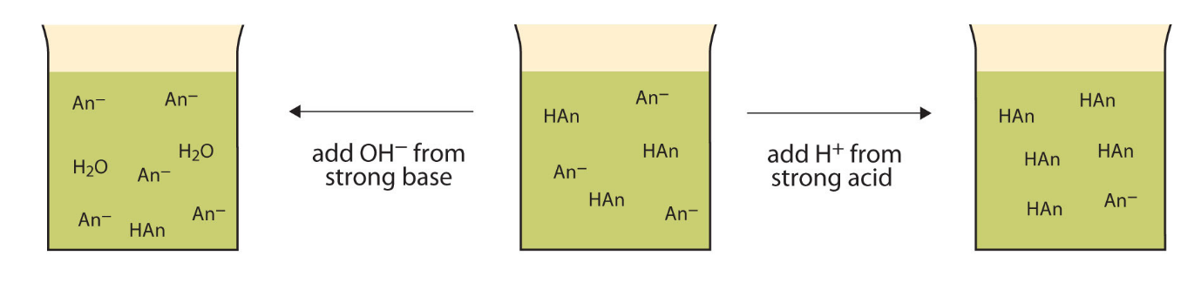
Figure: The Action of Buffers. Buffers can react with both strong acids (top) and strong bases (bottom) to minimize large changes in pH.
Q.6.c.
Ans. Acid - Base indicators (also known as pH indicators) are substances which change colour with pH. They are usually weak acids or bases, which when dissolved in water dissociate slightly and form ions. Consider an indicator which is a weak acid, with the formula HIn. At equilibrium, the following equilibrium equation is established with its conjugate base:
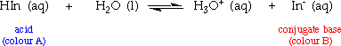
The acid and its conjugate base have different colours. At low pH values the concentration of H₃O⁺ is high and so the equilibrium position lies to the left. The equilibrium solution has the colour A. At high pH values, the concentration of H₃O⁺ is low - the equilibrium position thus lies to the right and the equilibrium solution has colour B.
Phenolphthalein is an example of an indicator which establishes this type of equilibrium in aqueous solution:
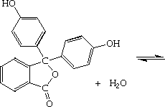 | 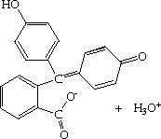
colourless (Acid) | pink (Base)

Phenolphthalein is a colourless, weak acid which dissociates in water forming pink anions. Under acidic conditions, the equilibrium is to the left, and the concentration of the anions is too low for the pink colour to be observed. However, under alkaline conditions, the equilibrium is to the right, and the concentration of the anion becomes sufficient for the pink colour to be observed.
We can apply equilibrium law to indicator equilibria - in general for a weak acid indicator:
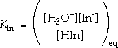
K_{ln} is known as the indicator dissociation constant. The colour of the indicator turns from colour A to colour B or vice versa at its turning point. At this point:
So from equation:
The pH of the solution at its turning point is called the pK_{ln} and is the pH at which half of the indicator is in its acid form and the other half in the form of its conjugate base.
An indicator is chosen based on various factors including pH range, nature of substituents, experimental conditions etc.
Q.7.a.
Ans. Isomerism in Coordination Compounds
The coordination compounds which have the same molecular formula but have their ligands attached to the central metal atom in different ways are called isomers. These isomers have different properties. The phenomenon that gives rise to different isomers is called isomerism. Isomerism include two types; structural isomerism and stereo isomerism Structural Isomerism This isomerism arises due to difference in the structures of complex (coordination compounds. This isomerism include the following:
Ionization isomerism: Compounds with the same formula, but which give different ions in solution, exhibit ionization isomerization. The difference is in which ion is included as a ligand and which is present to balance the overall charge (the ligands given in coordination sphere and the anions present outside the coordination sphere are exchanged with each other). 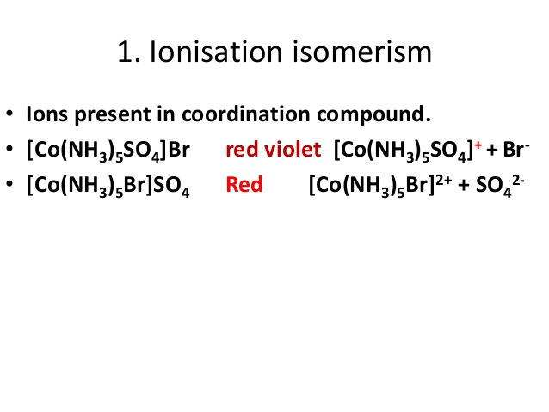
Linkage (ambidentate) isomerism: Some ligands can bond to the metal through different atoms. When an ambidentate ligand having two different donor atoms coordinates to the metal atom through either of its two donor atoms, two different complex compounds are obtained. These compounds are different because they have different structure. The most common early examples were thiocyanate, SCN- , and nitrite, NO₂.
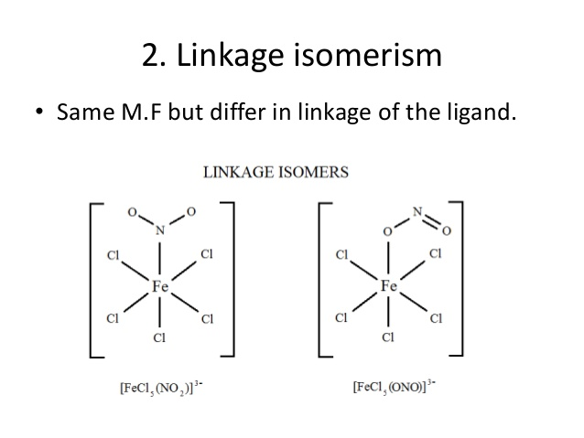
Coordination isomerism: Examples of a complete series of coordination isomers require at least two metal ions. The total ratio of ligand to metal remains the same, but the ligands attached to a specific metal ion change, (coordination isomers are obtained when some or all ligands of both the coordination spheres are interchanged with each other)
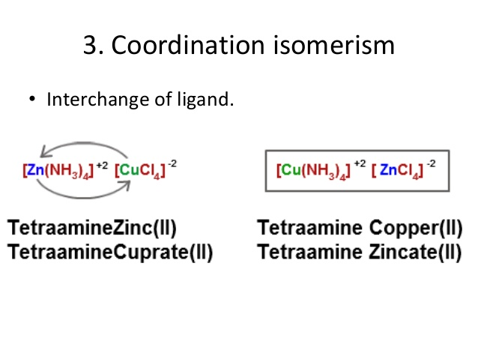
Hydrate isomerism: This type of isomerism is similar to ionization isomerism. Hydrate isomers are obtained when H₂O molecules acting as ligands are replaced by the anions present outside the coordination sphere.
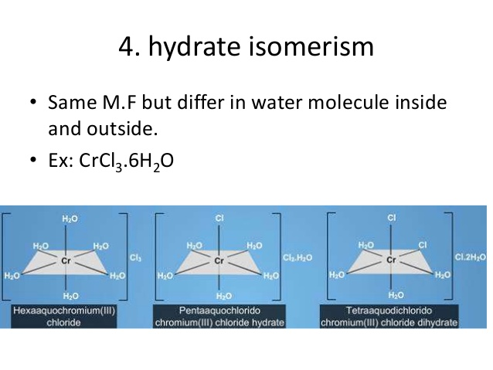
Polymerization isomerism: This type of isomerism is found in those complex compound whose formulae appear to be polymers of some simple complex compound. All these complex compounds have the same ratio of different metal atoms and ligands in them.
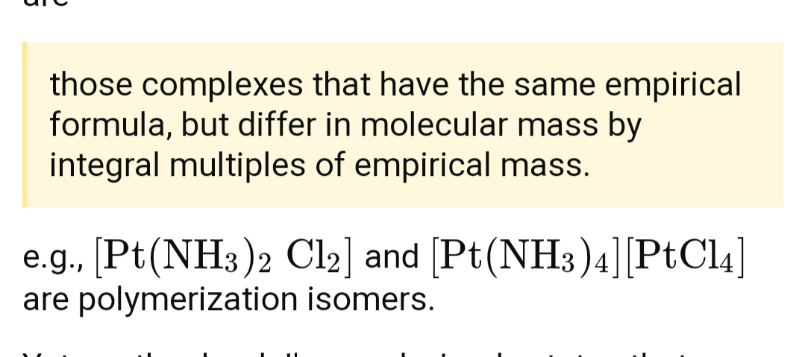
Coordination position isomerism: This type of isomerism is shown by those complex compounds which contain bridging ligands and arises when the non-bridging ligands are differently placed round the central metal atom.
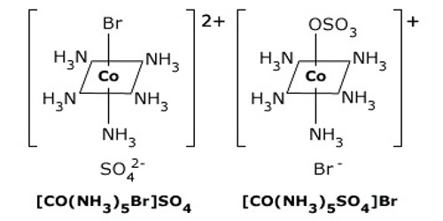
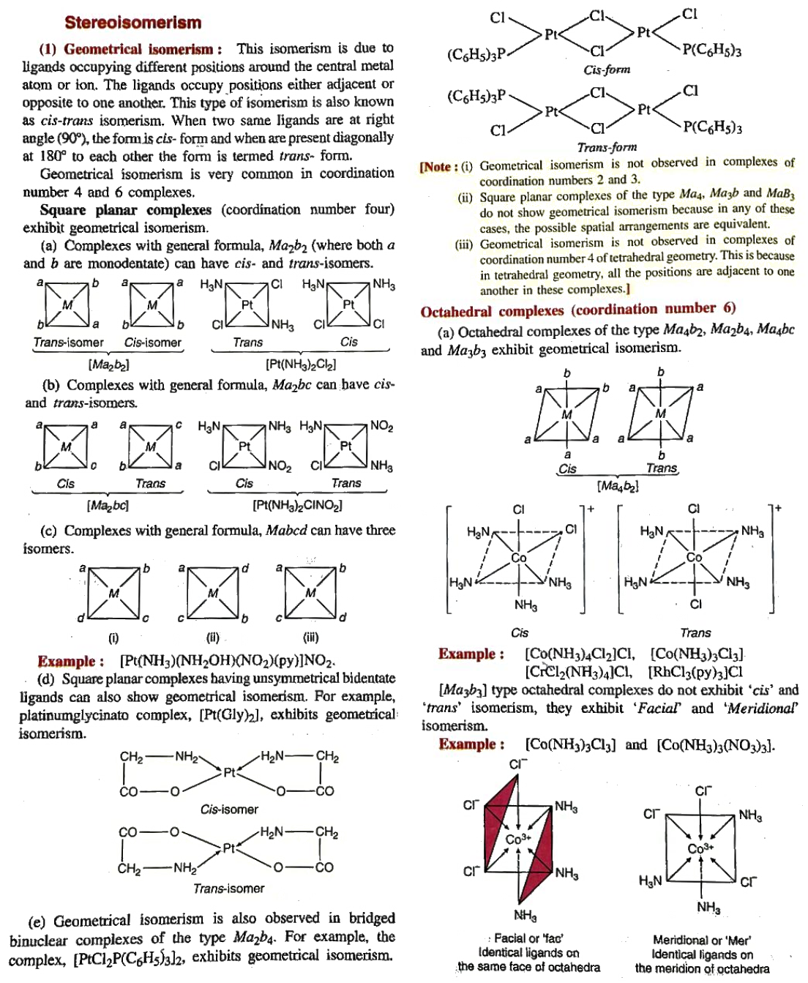
Q.7.b.
Ans. Extracting thorium from monazite sand involves a multi-step process due to the presence of various rare earth elements and radioactive materials. Here's a concise overview:
- Crushing and Grinding: Monazite sand is first crushed and ground into a fine powder to facilitate subsequent chemical processing.
- Digestion: The powdered monazite is mixed with a concentrated acid (usually sulfuric acid) to dissolve the thorium and rare earth elements. This forms a solution called "rare earth sulfate."
- Solvent Extraction: Solvent extraction is used to separate thorium from the rare earths in the sulfate solution. Various organic solvents like tributyl phosphate are employed. Thorium selectively partitions into the solvent phase while rare earths remain in the aqueous phase.
- Stripping: The thorium-loaded solvent is stripped of thorium by contacting it with a more dilute acid solution. This regenerates the aqueous thorium solution.
- Precipitation: The thorium is then precipitated from the aqueous solution as thorium hydroxide by raising the pH with an alkali, such as sodium hydroxide.
- Filtration and Drying: The thorium hydroxide precipitate is filtered and then dried to obtain thorium oxide (ThO₂).
- Further Processing: Thorium oxide can be further purified and processed to obtain high-purity thorium metal or thorium compounds, depending on the intended application.
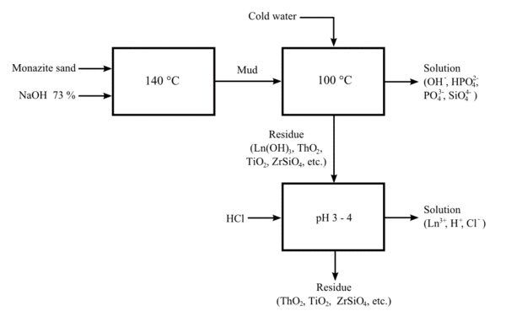
It's crucial to note that monazite sand contains radioactive elements, so this process must be conducted with strict safety measures and proper handling to minimize radiation exposure to workers and the environment. Additionally, the extraction of thorium is subject to regulatory controls and environmental considerations due to its radioactivity.

Q.7.c.
Ans. 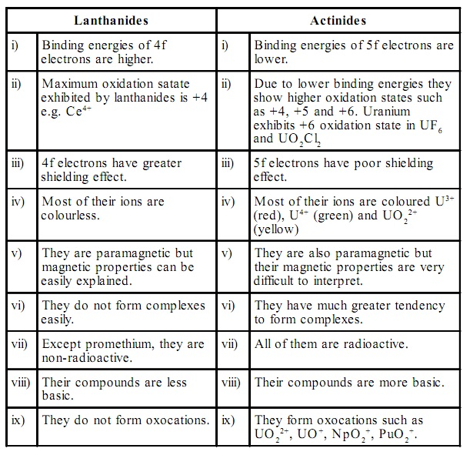
Q8.a
Ans. Kohlrausch’s law
Kohlrausch’s law states that the equivalent conductivity of an electrolyte at infinite dilution is equal to the sum of the conductance of the anions and cations.
The molar conductivity of a solution at a given concentration is the conductance of the volume of solution containing one mole of electrolyte kept between two electrodes with the unit area of cross-section and distance of unit length. The molar conductivity of a solution increases with the decrease in concentration. This increase in molar conductivity is because of the increase in the total volume containing one mole of the electrolyte. When the concentration of the electrolyte approaches zero, the molar conductivity is known as limiting molar conductivity, Ë_{m}°.
Kohlrausch observed certain regularities while comparing the values of limiting molar conductivities of some strong electrolytes. On the basis of his observations, Kohlrausch proposed “limiting molar conductivity of an electrolyte can be represented as the sum of the individual contributions of the anions and cations of the electrolyte”. This law is popularly known as Kohlrausch law of independent migration of ions. For example, limiting molar conductivity, Λ of sodium chloride can be determined with the knowledge of limiting molar conductivities of sodium ion and chloride ion.
Some important applications of Kohlrausch law of independent migration of ions are:
- Kohlrausch law helps us in the determination of limiting molar conductivities for any electrolyte. Weak electrolytes have lower molar conductivities and lower degree of dissociation at higher concentrations. The graph plotted between molar conductivity and c^{1/2} (where c is the concentration) is not a straight line for weak electrolytes. The molar conductivity of weak electrolyte increases steeply at lower concentrations. Therefore, limiting molar conductivity, Λ cannot be obtained by extrapolation of molar conductivity to zero concentration. Hence, we use the Kohlrausch law of independent migration of ions for the determination of limiting molar conductivity, Λ for weak electrolytes.
- Kohlrausch law also helps us in determining the value of dissociation constant from the value of molar conductivity and limiting molar conductivity for a weak electrolyte at a given concentration.
$$α=\frac{Λ}{Ëm°}$$

Where,
α = dissociation constant
Λ = molar conductivity
Ë_{m}° = limiting molar conductivity
Q8.b.

Ans. Transport number of ions
The performance of a battery depends heavily on the properties of its electrolyte. Total ionic conductivity is one part of this, but how the current is carried by the electrolyte has some important implications, especially when the battery is subjected to very high charge or discharge currents.
Consider the discharge of a Li-ion battery, containing an electrolyte with a simple salt such as LiPF₆, and which is completely dissociated in the solvent. Current is drawn from the cell; Li⁺ ions are extracted from the negative electrode and inserted into the positive electrode. Part of this current is carried by the transport of Li⁺ ions, and the rest is carried by the transport of PF₆⁻ in the opposite direction:
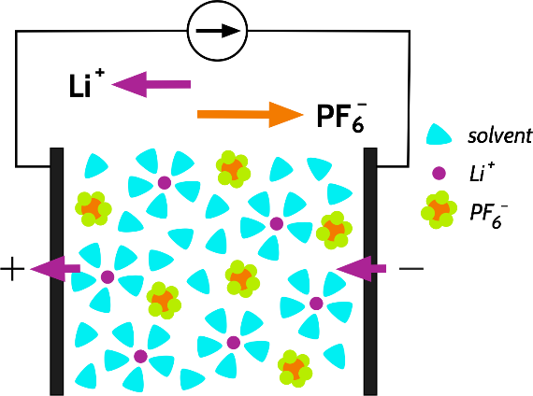
We call the fraction of the current carried by a specific species, e.g., Li⁺ or PF₆⁻, the transport number, with the symbol t₊ or t_ respectively. The sum of the transport numbers is 1, and by this definition, any transport number for a specific species must be between 0 and 1. The transport number is effectively a ratio of the mobilities of the ions, which, following the Nernst-Einstein equation also relates the partial conductivities and the diffusion coefficients to each other:
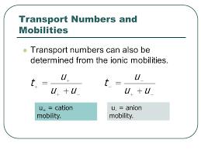
t₊ is often smaller than t₋, because the non-coordinating anion is often more free to move in the electrolyte, while the "hard" Li⁺ usually has to drag a large solvation shell with it, or is relatively tightly bound to a polymer electrolyte backbone.

Measuring t₊: the Bruce-Vincent method
The most common experimental method for measuring t₊ in a polymer electrolyte is the so-called Bruce-Vincent method, named for the work done by Colin Vincent and Peter Bruce on this subject, published in 1987.The method involves the polarisation of a symmetrical cell (i.e., an electrochemical cell with two Li metal electrodes) by a small potential difference, to induce a small concentration gradient, until the system reaches a steady state, with a concentration gradient that does not change further with time.
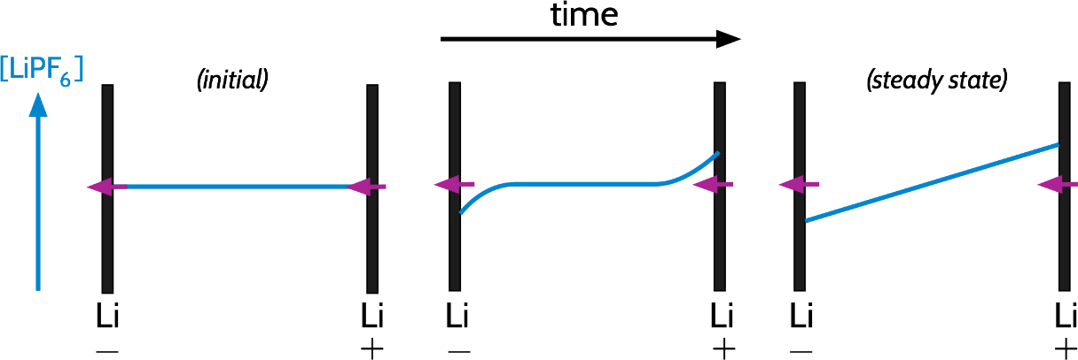
This method assumes that the ions in the electrolyte are perfectly dissociated. More specifically, that the electrolyte obeys the Nernst-Einstein equation, which relates the conductivity (and the electrical mobility) of an ion to its diffusion coefficient.
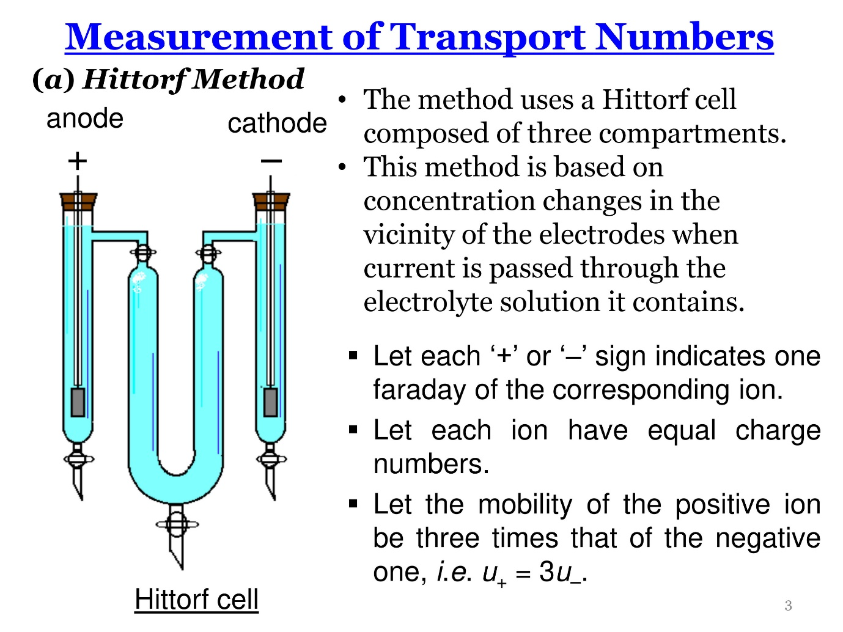
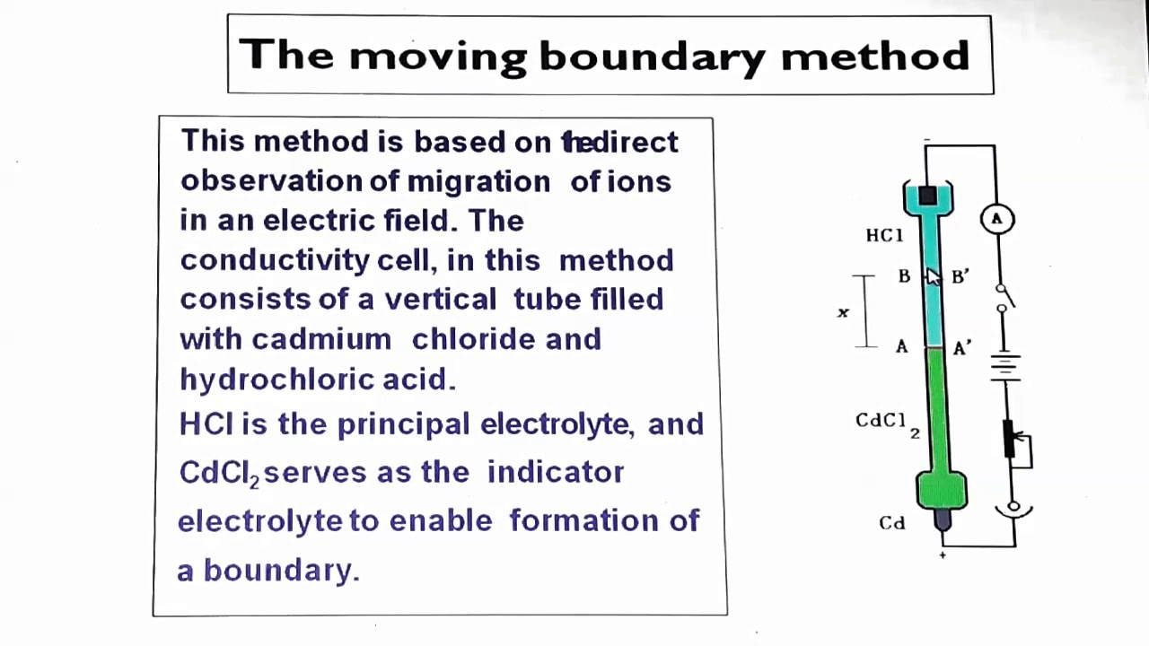
Q8.c
Ans. Specific conductance
Specific Conductance is the ability of a substance to conduct electricity. It is the reciprocal of specific resistance. Conductance means the flow of current through the liquid conductor. Specific conductance is defined as the conducting capacity of a solution of the dissolved electrolyte and the whole solution is being placed between two electrodes are 1 sq. cm and length 1 cm.
- It is denoted by Kappa
- It is the reciprocal of resistivity(⍴).
- It is also known as Conductivity.
- Ohm’s Law states that the resistance of any substance is directly proportional to its length and Inversely Proportional to its area. So, Ohm’s Law can be expressed as follows-
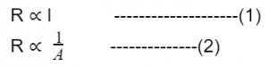
From (1) and (2)
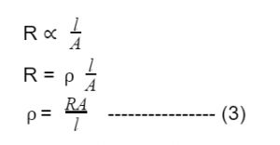
⍴: Specific Resistance, l: length, A: Area of cross-section, R: resistance
Specific conductance is determined by using a Wheatstone bridge in which a variable resistance is adjusted so that it is equal to the resistance of the unknown solution between platinized electrodes of a standardized conductivity cell.
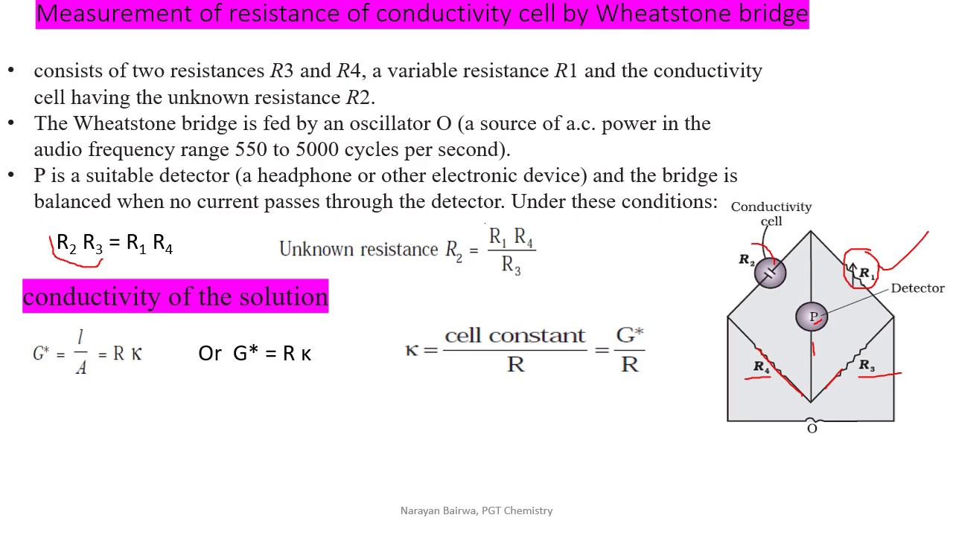

Q.2.a.
Ans. Two commonly used equations of state for real gases are the Van der Waals equation and the Redlich-Kwong equation. I'll provide these equations and highlight their important features:
- Van der Waals Equation: The Van der Waals equation is an improvement over the ideal gas equation and takes into account the finite size of gas molecules and the attractive forces between them.
$$\left(P+a\frac{n^{2}}{V^{2}}\right)\left(V-nb\right)=nRT$$
  - P: Pressure
  - V: Volume
  - n: Number of moles
  - T: Absolute temperature
  - a and b: Van der Waals constants specific to the gas
Important Features:
  - a: Accounts for the attraction between gas molecules.
  - b: Adjusts the volume to correct for the finite size of gas molecules.
  - As the pressure increases and the volume decreases (at conditions away from ideal behaviour), the correction terms (an²/V² and nb) become more significant.
  - The Van der Waals equation is a relatively simple model that improves the prediction of gas behaviour under non-ideal conditions.
- Redlich-Kwong Equation: The Redlich-Kwong equation is another equation of state that provides a better description of real gas behaviour compared to the ideal gas law.
$$P=\left(\frac{RT}{V-b}\right)-\frac{a}{T^{0.5}V(V+b)}$$
  - P: Pressure
  - V: Volume
  - n: Number of moles
  - T: Absolute temperature
  - a and b: Redlich-Kwong constants specific to the gas
Important Features:
  - a: Accounts for the strength of the intermolecular forces or the attractive interactions between gas molecules.
  - b: Adjusts for the finite volume occupied by gas molecules.
  - The Redlich-Kwong equation provides an improvement over the ideal gas law by considering both volume exclusion and attractive forces.
  - It is particularly effective for gases that are not well-represented by the ideal gas law, such as those with strong intermolecular forces.
Comparison:
- Both equations (Van der Waals and Redlich-Kwong) are equations of state that provide corrections to the ideal gas law to account for non-ideal behaviour.
- They both include correction terms for volume (b) and attraction between gas molecules (a).
- The Van der Waals equation is a simpler model and is more widely used in introductory chemistry and thermodynamics courses.
- The Redlich-Kwong equation is a more complex model but can provide a more accurate description of real gas behaviour, particularly for gases with strong intermolecular forces.
- The choice between these equations or other equations of state depends on the specific characteristics of the gas being studied and the accuracy required for a particular application.
Q.2.b.
Ans. Heisenberg's Uncertainty Principle
Heisenberg's Uncertainty Principle states that there is inherent uncertainty in the act of measuring a variable of a particle. Commonly applied to the position and momentum of a particle, the principle states that the more precisely the position is known the more uncertain the momentum is and vice versa. This is contrary to classical Newtonian physics which holds all variables of particles to be measurable to an arbitrary uncertainty given good enough equipment. Newtonian physics placed no limits on how better procedures and techniques could reduce measurement uncertainty so that it was conceivable that with proper care and accuracy all information could be defined. Heisenberg made the bold proposition that there is a lower limit to this precision making our knowledge of a particle inherently uncertain.
More specifically, if one knows the precise momentum of the particle, it is impossible to know the precise position, and vice versa. This relationship also applies to energy and time, in that one cannot measure the precise energy of a system in a finite amount of time. Uncertainties in the products of “conjugate pairs” (momentum/position) and (energy/time) were defined by Heisenberg as having a minimum value corresponding to Planck’s constant divided by 4π. More clearly:
$$∆p∆x≥\frac{h}{4π}$$
$$∆E∆t≥\frac{h}{4π}$$
Where Δ refers to the uncertainty in that variable and h is Planck's constant.
Aside from the mathematical definitions, one can make sense of this by imagining that the more carefully one tries to measure position, the more disruption there is to the system, resulting in changes in momentum. For example compare the effect that measuring the position has on the momentum of an electron versus a tennis ball. Let’s say to measure these objects, light is required in the form of photon particles. These photon particles have a measurable mass and velocity, and come into contact with the electron and tennis ball in order to achieve a value in their position. As two objects collide with their respective momenta (p=mv), they impart theses momenta onto each other. When the photon contacts the electron, a portion of its momentum is transferred and the electron will now move relative to this value depending on the ratio of their mass. The larger tennis ball when measured will have a transfer of momentum from the photons as well, but the effect will be lessened because its mass is several orders of magnitude larger than the photon.
All Quantum behaviour follows this principle and it is important in determining spectral line widths, as the uncertainty in energy of a system corresponds to a line width seen in regions of the light spectrum explored in Spectroscopy.
Q.2.c.
Ans. Born proposed in 1926, the most commonly accepted interpretation of the wavefunction that the square of the modulus is proportional to the probability density (probability per unit volume) that the electron is in the volume dτ located at r_{i}. Since the wavefunction represents the wave properties of matter, the probability amplitude P(x,t) will also exhibit wave-like behaviour. Probability density is the three-dimensional analogue of the diffraction pattern that appears on the two-dimensional screen in the double-slit diffraction experiment for electrons.
The Born interpretation therefore calls the wavefunction the probability amplitude, the absolute square of the wavefunction is called the probability density, and the probability density times a volume element in three-dimensional space (dτ) is the probability P
The probability that a single quantum particle moving in one spatial dimension will be found in a region x∈[a,b]if a measurement of its location is performed is
$$P\left(x∈\left|a,b\right|\right)=\int_{a}^{b}{|Ψ(x)|^{2}}dx$$
In three dimensions, Equation is represented differently
$$P\left(Ʈ∈\left|a,b\right|\right)=\int_{a}^{b}{|Ψ(Ʈ)|^{2}}dƮ$$
The Born interpretation of relating the wavefunction to probability forces certain demands on its mathematical behaviour of wavefunctions and not any mathematical function can be a valid wavefunction.
- The wavefunction must be a single-valued function of all its coordinates, since the probability density ought to be uniquely determined at each point in space.
- The wavefunction should be both finite as an infinite probability has no meaning.
- The wavefunction should be continuous everywhere, as expected for a physically-meaningful probability density.
Q.3.a.
Ans. Kohlrausch’s law
Kohlrausch’s law states that the equivalent conductivity of an electrolyte at infinite dilution is equal to the sum of the conductance of the anions and cations.
The molar conductivity of a solution at a given concentration is the conductance of the volume of solution containing one mole of electrolyte kept between two electrodes with the unit area of cross-section and distance of unit length. The molar conductivity of a solution increases with the decrease in concentration. This increase in molar conductivity is because of the increase in the total volume containing one mole of the electrolyte. When the concentration of the electrolyte approaches zero, the molar conductivity is known as limiting molar conductivity, Ë_{m}°.
Kohlrausch observed certain regularities while comparing the values of limiting molar conductivities of some strong electrolytes. On the basis of his observations, Kohlrausch proposed “limiting molar conductivity of an electrolyte can be represented as the sum of the individual contributions of the anions and cations of the electrolyte”. This law is popularly known as Kohlrausch law of independent migration of ions. For example, limiting molar conductivity, Λ of sodium chloride can be determined with the knowledge of limiting molar conductivities of sodium ion and chloride ion.
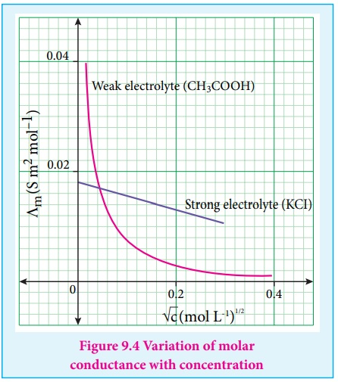
Deviation from Kohlrausch's Law
Kohlrausch's Law, or the Law of Independent Migration of Ions, assumes that ions in a solution move independently, contributing their full molar conductivity. However, in real solutions, ion-ion interactions, ion-solvent interactions, and ion-pair formation can occur, causing ions to deviate from independent behaviour. These interactions reduce the actual conductivity of the solution, leading to deviations from Kohlrausch's Law.
Q.3.b.
Ans.
The graphical relationship between the amount of the substance being adsorbed per unit concentration of the adsorbate and the applied pressure is called adsorption isotherm. Various adsorption isotherms are employed for explaining the extent of adsorption such as Freundlich adsorption isotherm and Langmuir adsorption isotherm. The Freundlich adsorption isotherm is associated with multilayer adsorption on the surface whereas, the Langmuir adsorption isotherm is associated with monolayer adsorption. Freundlich’s adsorption isotherm is empirical while Langmuir’s adsorption isotherm is theoretical. At a given temperature, the adsorption of a gas on the surface of a liquid or solid
Freundlich vs Langmuir Adsorption Isotherms
Freundlich Adsorption Isotherm | La Langmuir Adsorption Isotherm
The surface of solid adsorbent is heterogeneous for Freundlich adsorption isotherm | The surface of solid adsorbent is homogeneous for Langmuir adsorption isotherm
It is associated with multi-molecular layer adsorption | It is associated with mono-molecular layer adsorption
No equilibrium can be established for FAI | Dynamic equilibrium is established in LAI
Interaction between adsorbed molecules can occur because it is multilayered | There is no interaction between adsorbed molecules
The surface of adsorbent is not uniform | The surface of adsorbent is uniform
No chemical forces are not involved | Chemical forces are involved
Freundlich's equation is purely empirical | Langmuir's equation has theoretical basis
It does not explain chemisorption | It explains the mechanism of chemisorption
Freundlich adsorption isotherm does not give quantitative explanations | Langmuir adsorption isotherm gives quantitative explanations
It gives comparatively less satisfactory explanation of adsorption of gases on solids | It gives more satisfactory explanation of adsorption of gases on solids
Only adsorption is involved in Freundlich adsorption isotherm | Both adsorption and desorption are involved in Langmuir adsorption isotherm
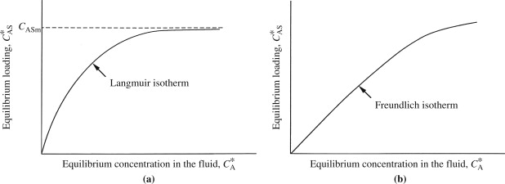
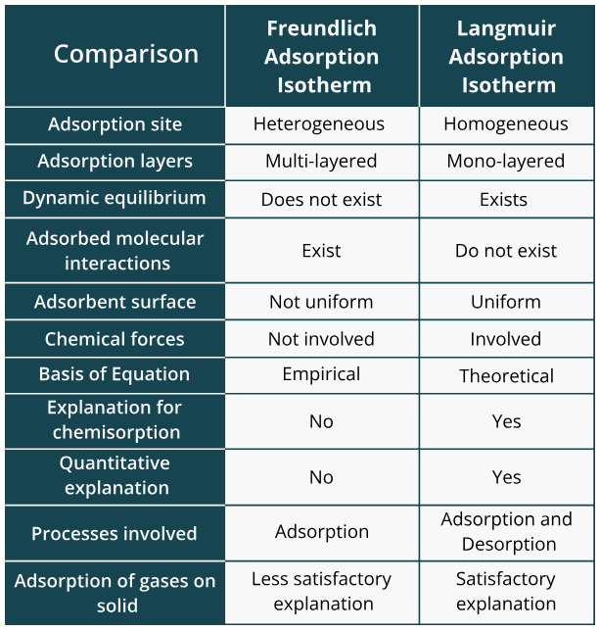
Q.4.a.
Ans. In 1899, the Swedish chemist Svante Arrhenius (1859-1927) combined the concepts of activation energy and the Boltzmann distribution law into one of the most important relationships in physical chemistry:
This shows that high temperature and low activation energy favour larger rate constants, and thus speed up the reaction. Because these terms occur in an exponent, their effects on the rate are quite substantial.
Determining the Activation Energy from the Arrhenius equation
This equation can be written in a non-exponential form that is often more convenient to use and to interpret graphically. Taking the logarithms of both sides and separating the exponential and pre-exponential terms yields
$$lnk=lnA-\frac{E_{a}}{RT}$$
Equation is in the form of y=mx+b - the equation of a straight line.
where temperature is the independent variable and the rate constant is the dependent variable. So if one were given a data set of various values of k, the rate constant of a certain chemical reaction at varying temperature T, one could graph ln(k) versus 1/T. From the graph, one can then determine the slope of the line and realize that this value is equal to −Ea/R. One can then solve for the activation energy by multiplying through by R, where R is the gas constant. This affords a simple way of determining the activation energy from values of k observed at different temperatures, by plotting lnk as a function of 1/T.
Limitations of Arrhenius equation
The Arrhenius equation is a valuable tool for explaining temperature-dependent reaction rates. However, it has limitations. Firstly, it assumes that only temperature affects reaction rates and doesn't consider other factors like pressure or concentration. Secondly, it may not accurately describe reactions with complex mechanisms or multi-step processes. Additionally, the equation assumes a linear relationship between the rate constant and temperature, which may not hold true over wide temperature ranges. Finally, it doesn't account for reactions that have temperature-dependent activation energies, making it less applicable in some cases.
Q.4.b.

Ans.

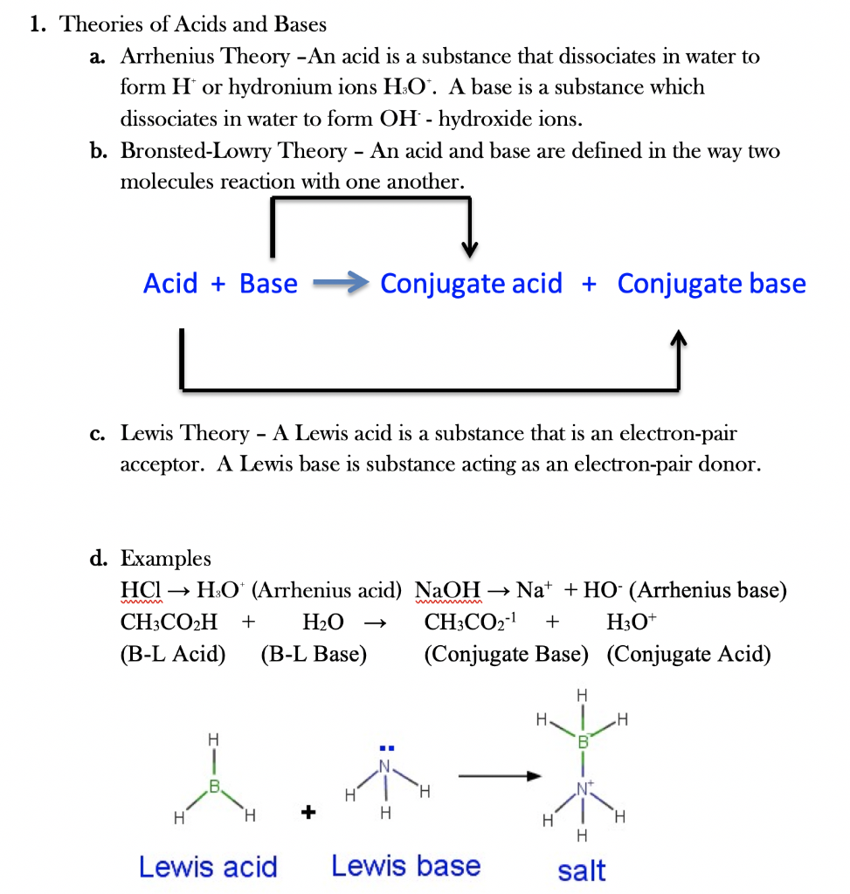
Hard and Soft Acids and Bases (HSAB) Principle
It is a qualitative concept introduced by Ralph Pearson to explain the stability of metal complexes and the mechanisms of their reactions. However, it is also possible to quantify this concept based on Klopman's FMO analysis using interactions between HOMO and LUMO.
According to HSAB principle, the Lewis acids and bases can be further divided into hard or soft or borderline types.
Hard Lewis acids are characterized by small ionic radii, high positive charge, strongly solvated, empty orbitals in the valence shell and with high energy LUMOs.
Soft Lewis acids are characterized by large ionic radii, low positive charge, completely filled atomic orbitals and with low energy LUMOs.
Hard Lewis bases are characterized by small ionic radii, strongly solvated, highly electronegative, weakly polarizable and with high energy HOMOs.
Soft Lewis bases are characterized by large ionic radii, intermediate electronegativity, highly polarizable and with low energy HOMOs.
Q.5.a.
Ans.
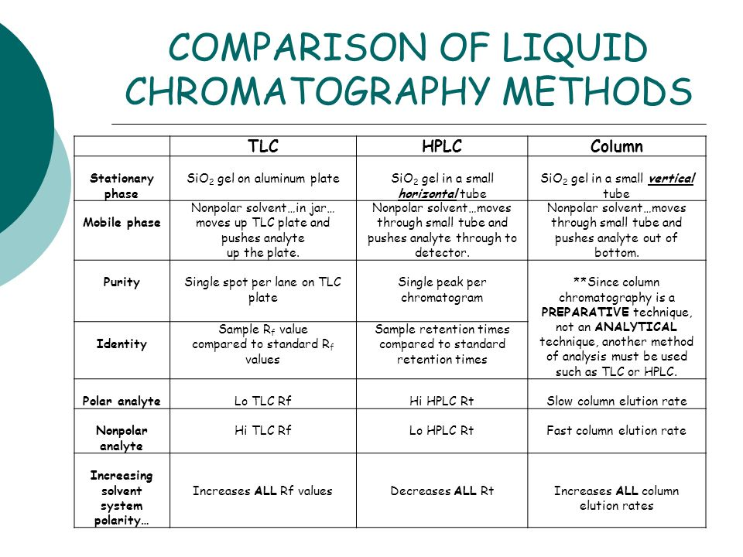
Chromatography | Advantages | Disadvantages
Column | - Any type of mixture can be separated by column chromatography  - Wide range of quantities can be separated by this technique | - Time consuming  - More amount of solvent is required
Thin layer | - Components can be separated in short times as components will elute quickly  - Solvents for TLC plate can be changed | - Plate length is limited  - Separation take place in open system
Q.5.b.
Ans. Werner, a well-known scientist, proposed his theory of coordination compounds in 1823, which describes the formation and structure of complex compounds and was later named Werner’s Theory of Coordinate Compounds.
Werner’s theory’s important postulates are as follows:
- The central metal or metal atoms in coordination compounds have two forms of valency which are primary valency and secondary valency. The oxidation state corresponds to the primary valency, while the coordinate number corresponds to the secondary valency.
- Each metal atom has a fixed number of secondary valencies, like it has a fixed coordinate number.
- The metal atom satisfies both its primary and secondary valencies. Negative ions satisfy primary valencies, but neutral molecules or negative ions satisfy secondary valencies.
- The secondary valencies are always directed towards a particular place in space, resulting in determination of geometry of the coordinate compound’s. As an example: A metal ion’s secondary valencies are grouped octahedrally around the central metal ion if it has six of them. If the metal ion contains four secondary valencies, they are organized in a tetrahedral or square planar pattern around the center metal ion. The stereochemistry of the complex ion is thus determined by the secondary valency while the primary valency is non-directional.
Cobalt has a primary valency of three and a secondary valency (coordination number) of six. Secondary valencies are depicted by thick lines, while primary valencies are represented by broken lines.
- CoCl₃.6NH₃ Complex: The coordination number of Co in this compound is 6, and all six secondary valencies are met by ammonia molecules . Cl⁻ ions satisfy the three primary valencies . These have a non-directional character. When silver nitrate is added, these chloride ions precipitate instantly. In this scenario, there are four ions: three chloride ions and one complex ion. While writing the compound’s formula, the central ion and neutral molecules or ions satisfying secondary valencies are enclosed in square brackets. Therefore, the complex can be written as [Co(NH₃)₆]Cl₃ and is depicted in fig.
- CoCl₃.5NH₃ complex: The coordination number of cobalt in this compound is also 6, but the number of NH₃ molecules is reduced to 5 from 6 and one remaining slot is now occupied by chloride ions. Because it has both primary and secondary valency, this chloride ion exhibits dual behaviour. In the figure, the secondary valency is represented by a full line, while the main valency is represented by a dotted line.
This structure satisfies cobalt’s three primary and six secondary valencies. As a result, the complex formed can be written as [CoCl(NH₃)₅]Cl₂ with five ammonia molecules and one chloride ion inside the square brackets and two chloride ions outside the brackets.
- CoCl₃.4NH₃ complex: Two chloride ions in this compound exhibit dual behaviour, satisfying both Primary and Secondary valencies. This compound will precipitate AgNO₃, which corresponds to one Cl⁻ ion, and the total number of ions, in this case is two. As a result, it can be written as [CoCl₂(NH₃)₄]Cl.
- CoCl₃.3NH₃ complex: In this molecule, three chloride ions satisfy primary and also secondary valency. At room temperature, silver nitrate does not precipitate Cl⁻. Hence, the complex compound behaves as a neutral non-conducting molecule. It may be written as [CoCl₃(NH₃)₃].
Q.6.a.
Ans. Chromatography is a laboratory technique which is frequently employed for the separation of mixtures. In this technique, the mixture that must be separated is first dissolved into a fluid (commonly referred to as the mobile phase). This fluid carries the mixture through a different structure (commonly referred to as the stationary phase). The fluid carries different components of the mixture at different speeds. Therefore, the components of the mixture are separated in the stationary phase of the chromatography setup.

Classification of Chromatography

Column Chromatography: In this type of chromatography, the stationary phase of the setup is placed inside a tube. Then, the particles of the stationary phase (which is in the solid state) are made to fill the inside with the tube. An unrestricted, open path is then prepared for the mobile phase (somewhere along the middle of the tube).
Planar Chromatography: In this type of chromatography, the stationary phase of the apparatus usually has a planar shape. Different subcategories of planar chromatography include paper chromatography (where the stationary phase is a special type of paper) and thin layer chromatography (usually abbreviated as TLC).
Ion Exchange Chromatography: This type of chromatography is also known as ion chromatography. Ion exchange chromatography involves the separation of the components of the mixture via an ion exchange mechanism. Differently charged components of the mixture are separated with the help of different ions in this separation technique.
Q.6.b.
Ans. (i) Hydrogen bonding
Hydrogen bonding is a special type of intermolecular force that occurs when a hydrogen atom is covalently bonded to a highly electronegative atom (usually nitrogen, oxygen, or fluorine) and interacts with another electronegative atom from a different molecule. This interaction results in a strong electrostatic attraction between the hydrogen atom and the electronegative atom, creating a partial positive charge on hydrogen and a partial negative charge on the electronegative atom.
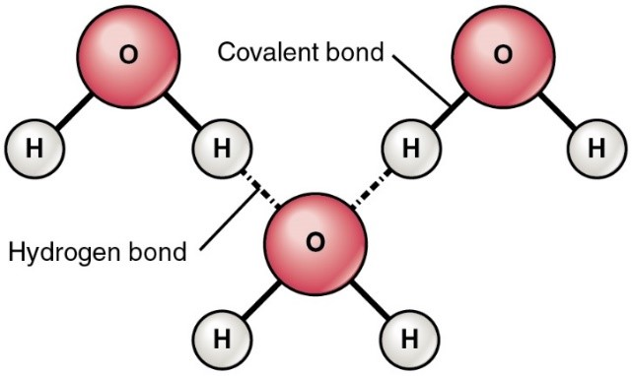
Hydrogen bonds are responsible for several important properties in chemistry and biology. They play a key role in the structure and stability of molecules like water, DNA, and proteins. In water, hydrogen bonds give rise to its high boiling point, surface tension, and unique density behaviour. In DNA, hydrogen bonds between base pairs hold the double helix structure together. In proteins, hydrogen bonds contribute to the folding and stability of the three-dimensional structures critical for their function.
Hydrogen bonds are weaker than covalent bonds but stronger than most other intermolecular forces, making them significant in determining the physical and chemical properties of many substances. Their ability to form and break easily under specific conditions, such as temperature and pressure changes, makes hydrogen bonding central to understanding various phenomena in chemistry, physics, and biology.
(ii) Hybridization in p-block elements
Hybridization in p-block elements occurs when the atoms of these elements form covalent bonds to create molecules or compounds. Hybridization involves the mixing of atomic orbitals to form new hybrid orbitals that are suitable for bonding. Here's how hybridization works in p-block elements:
- Atomic Orbitals Involved: In p-block elements, the atomic orbitals primarily involved in hybridization are the p orbitals. These p orbitals (designated as p_{x}, p_{y}, and p_{z}) are available for bonding.
- Need for Hybridization: To form stable molecules, atoms in p-block elements need to overlap their atomic orbitals to share electrons. However, the atomic p orbitals are oriented at right angles to each other (perpendicular), making direct overlap difficult. Hybridization helps in achieving the right orientation for effective overlap.
- Hybrid Orbitals: During hybridization, the p orbitals mix or hybridize to form new hybrid orbitals with appropriate orientation for bonding. The number of hybrid orbitals formed is equal to the number of atomic orbitals involved in the hybridization process. Common hybridization states in p-block elements include sp³, sp², and sp hybridization.
  - sp³ Hybridization: In this type of hybridization, one s orbital and three p orbitals (p_{x}, p_{y}, and p_{z}) mix to form four equivalent sp₃ hybrid orbitals. This occurs, for example, in compounds of carbon and silicon, such as CH₄ (methane) or SiH₄ (silane).
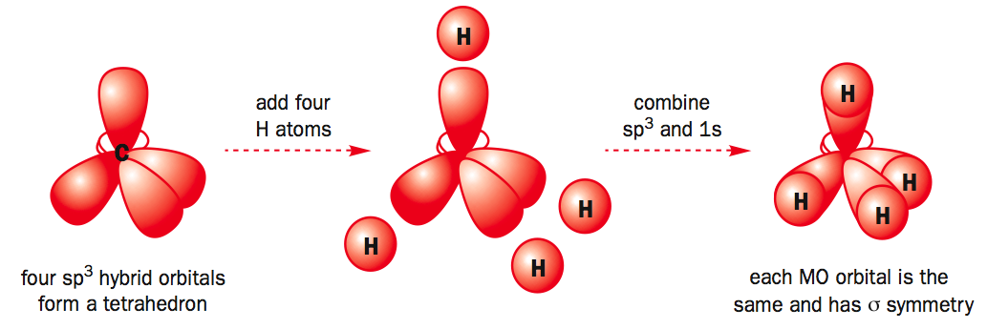
  - sp² Hybridization: Here, one s orbital and two p orbitals (p_{x} and p_{y} or p_{y} and p_{z} or p_{z} and p_{x}) mix to form three equivalent sp² hybrid orbitals. This is commonly seen in compounds of elements like nitrogen, oxygen, and boron.
  - 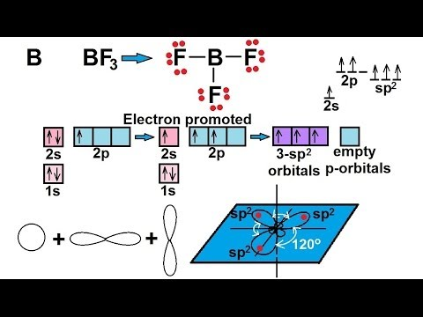
  - sp Hybridization: In sp hybridization, one s orbital and one p orbital (usually px or py or pz) combine to form two equivalent sp hybrid orbitals. This is characteristic of compounds involving carbon atoms in triple bonds, as in acetylene (C₂H₂).
  - 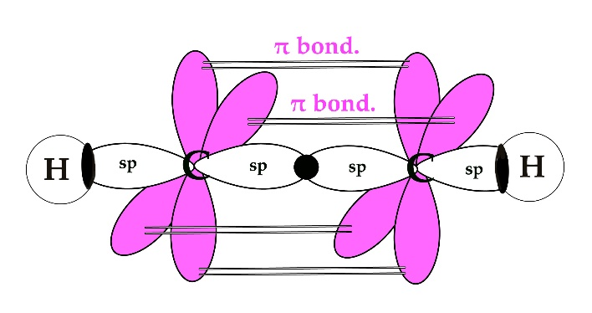
- Bond Formation: These newly formed hybrid orbitals are then used for bonding with other atoms or hybrid orbitals, creating sigma (σ) bonds. Pi (π) bonds, which involve parallel p orbitals, can also form in addition to sigma bonds in multiple bonds (e.g., double or triple bonds).
In summary, hybridization in p-block elements allows atoms to create effective overlap of their atomic orbitals, facilitating the formation of covalent bonds in various compounds. The specific type of hybridization depends on the geometry and number of bonds that an atom forms in a molecule or ion.
Q.7.a.
Ans. Crystal field theory (CFT) describes the breaking of orbital degeneracy in transition metal complexes due to the presence of ligands. CFT qualitatively describes the strength of the metal-ligand bonds. Based on the strength of the metal-ligand bonds, the energy of the system is altered. This may lead to a change in magnetic properties as well as color.
In Crystal Field Theory, it is assumed that the ions are simple point charges (a simplification). When examining a single transition metal ion, the five d-orbitals have the same energy (Figure). When ligands approach the metal ion, some experience more opposition from the d-orbital electrons than others based on the geometric structure of the molecule. Since ligands approach from different directions, not all d-orbitals interact directly. These interactions, however, create a splitting due to the electrostatic environment.
Figure: Distributing a charge of −6 uniformly over a spherical surface surrounding a metal ion causes the energy of all five d orbitals to increase due to electrostatic repulsions, but the five d orbitals remain degenerate. Placing a charge of −1 at each vertex of an octahedron causes the d orbitals to split into two groups with different energies: the d_{x}²_{−y}² and d_{z}² orbitals increase in energy, while the, d_{xy}, d_{xz}, and d_{yz} orbitals decrease in energy. The average energy of the five d orbitals is the same as for a spherical distribution of a −6 charge, however. Attractive electrostatic interactions between the negatively charged ligands and the positively charged metal ion (far right) cause all five d orbitals to decrease in energy but does not affect the splitting of the orbitals. The two e_{g} orbitals point directly at the six negatively charged ligands, which increases their energy compared with a spherical distribution of negative charge. In contrast, the three t_{2g} orbitals point between the negatively charged ligands, which decreases their energy compared with a spherical distribution of charge.

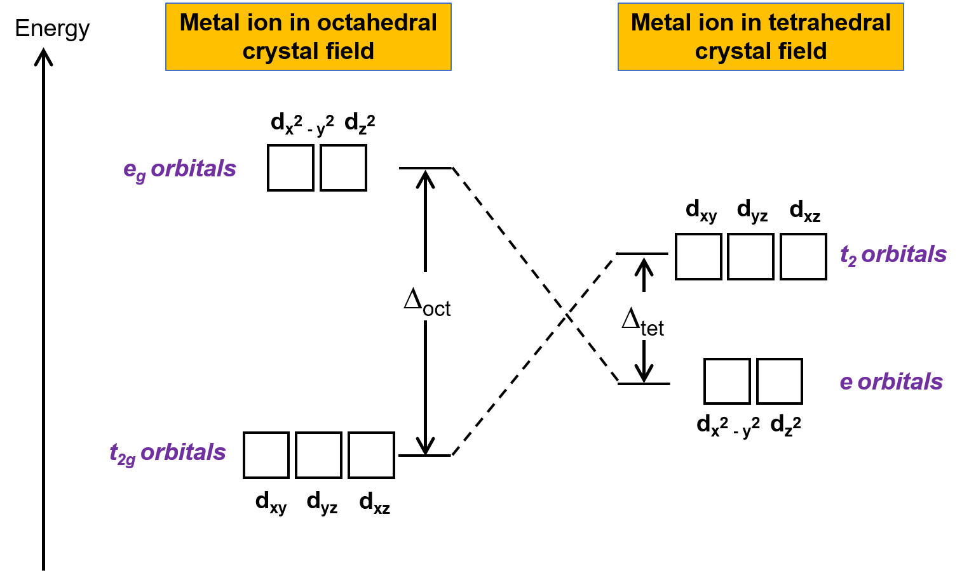
For example, consider a molecule with octahedral geometry. Ligands approach the metal ion along the x, y and z axes. Therefore, the electrons in the dz² and dx²−y² orbitals (which lie along these axes) experience greater repulsion. It requires more energy to have an electron in these orbitals than it would to put an electron in one of the other orbitals. This causes a splitting in the energy levels of the d-orbitals. This is known as crystal field splitting. For octahedral complexes, crystal field splitting is denoted by Δ_{o} (or Δ_{oct}). The energies of the dz² and dx²−y² orbitals increase due to greater interactions with the ligands. The dxy, dxz, and dyz orbitals decrease with respect to this normal energy level and become more stable.
Q.7.b.
Ans. Chemical bonding is the fundamental process that holds atoms together in compounds. There are several types of chemical bonding, each characterized by the way electrons are shared or transferred between atoms. Here, we delve into the major types of chemical bonding:
- Ionic Bonding:
Ionic bonding occurs when atoms transfer electrons to achieve a stable, full outer electron shell. This results in the formation of oppositely charged ions (cation and anion) that are held together by electrostatic forces. For example, Sodium chloride (NaCl) forms when sodium (Na) donates an electron to chlorine (Cl), creating Na+ and Cl- ions.
- Covalent Bonding:
Covalent bonding arises when atoms share electrons to attain a full outer electron shell. This sharing can be equal (nonpolar covalent) or unequal (polar covalent) depending on electronegativity differences between atoms. For example: In H₂O, oxygen (O) and hydrogen (H) atoms share electrons to form a covalent bond.
- Metallic Bonding:
Metallic bonding is characteristic of metals. In this type of bonding, valence electrons are delocalized, creating a "sea of electrons" that move freely throughout the metal lattice, holding the metal ions together. For example: In a piece of copper (Cu), the delocalized electrons are responsible for its high electrical conductivity and malleability.
- Hydrogen Bonding:
Hydrogen bonding occurs when a hydrogen atom is covalently bonded to a highly electronegative atom (e.g., oxygen, nitrogen, or fluorine) and is attracted to another electronegative atom in a different molecule. It's a strong intermolecular force. In water (H₂O), hydrogen bonds form between the hydrogen atom of one water molecule and the oxygen atom of another, giving rise to water's unique properties.

- Van der Waals Forces:
Van der Waals forces are weak intermolecular forces that result from temporary fluctuations in electron distribution, creating temporary dipoles. They include London dispersion forces, dipole-dipole interactions, and hydrogen bonding (a specific type of dipole-dipole interaction). In nonpolar molecules like methane (CH₄), London dispersion forces are responsible for the attraction between molecules.
- Coordinate Covalent Bonding:
This type of covalent bonding occurs when one atom donates both electrons for a covalent bond. It's also known as a dative bond. In ammonium ion the nitrogen atom donates both electrons in the N-H bond to form the ion.
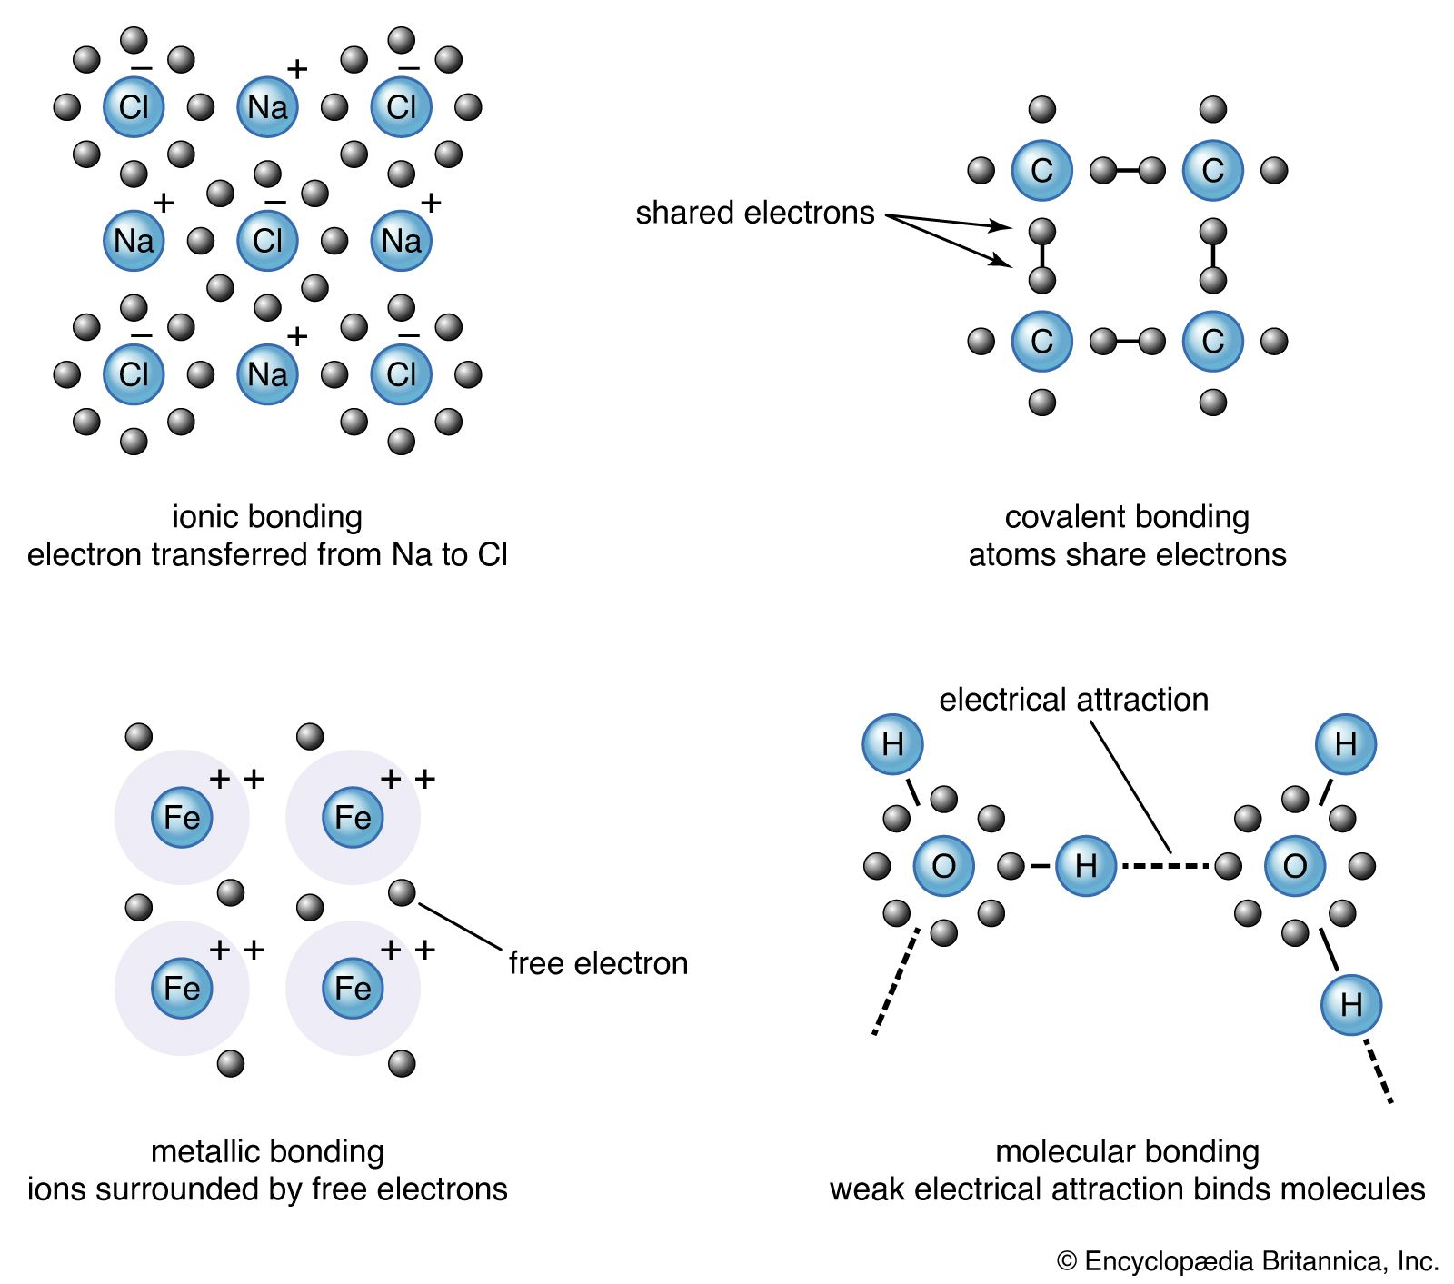
These various types of chemical bonding are essential for understanding the properties and behaviour of matter. They determine the structure, stability, and reactivity of compounds, molecules, and materials in the natural world, playing a crucial role in chemistry and its applications in fields like biology, materials science, and engineering.
Q.8.
Ans. (i) Liquid junction potential
Potential develops at any interface, or junction, where there is a separation of charge. For example, a potential can develop when a metal electrode comes in contact with a solution containing its cation. A potential of this type can be described using the Nernst Equation.
A potential can also develop when electrolyte solutions of differing composition are separated by a boundary, such as a membrane or a salt bridge (a gel-filled tube containing an inert electrolyte that connects half-cells to allow charge neutrality to be maintained).
The two solutions may contain the same ions, just at different concentrations or may contain different ions altogether. These ions have different mobilities, which means that they move at different rates.
For example, a porous glass frit may separate two solutions of NaOH:
NaOH (0.01 M) // NaOH (0.001 M)
OH⁻ moves approximately 5X faster than Na⁺ . . .
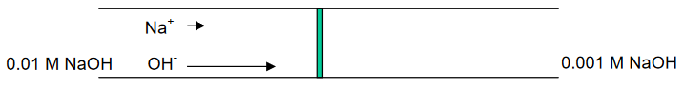
. . . developing of a potential at the interface, or boundary, between the two solutions.
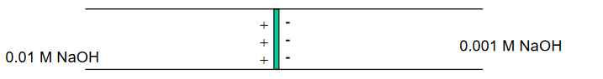
So now for an electrochemical cell containing a salt bridge, the cell potential is actually:
E_{cell} =E_{cathode}− E_{anode} + E_{junction}
Typical values for a liquid junction potential range from a few mV up to ~40 mV, depending on the identities and concentrations of the electrolyte solutions.
(ii) Potentiometry
Potentiometry is one of the methods of electroanalytical chemistry. It is usually employed to find the concentration of a solute in solution. In potentiometric measurements, the potential between two electrodes is measured using a high impedance voltmeter.
Use of a high impedance voltmeter in important, because it ensures that current flow is negligible. Since there is no net current, there are no net electrochemical reactions, hence the system is in equilibrium. At its most fundamental level, a potentiometer consists of two electrodes inserted in two solutions connected by a salt bridge (see diagram below). The voltmeter is attached to the electrodes to measure the potential difference between them. One of the electrodes is a reference electrode, whose electrode potential is known. The other electrode is the test electrode. The test electrode is usually either a metal immersed in a solution of its own ions, whose concentration you wish to discover, or a carbon rod electrode sitting a solution which contains the ions of interest in two different oxidation states.
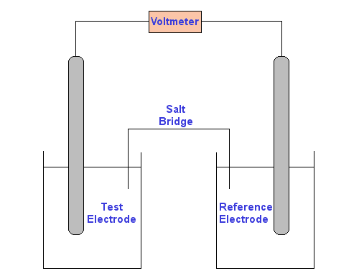
The Nernst Equation can be used to find the concentration of the test solution.
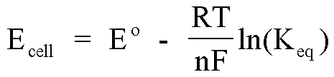
To find the concentration of Ag⁺ in a silver nitrate solution, reference electrode consists of silver metal in a known 0.1 M silver nitrate solution. Test electrode is silver metal in the silver nitrate solution to find the concentration of. Since no current flows, the cell is at equilibrium:
Ag⁺ ⇌ Ag
The solutions are linked by a 0.1 M potassium nitrate salt bridge. The metal electrodes are linked by a voltmeter. There will be a potential difference between the two solutions resulting from the different concentrations of silver ions in contact with the silver electrodes.
(iii) Collision theory of chemical reactions
According to the collision theory, “the molecules of reactants are assumed to be hard spheres and the reactions are assumed to occur only when these spheres (molecules) collide with each other”. So it was important to quantify the number of collisions occurring in order to form products so that we can have a clear picture of the reaction, and hence came the term collision frequency.
Collision Frequency can be understood as the number of collisions per second per unit volume of the reacting mixture. It is generally denoted by Z.
Let’s consider the following bimolecular elementary reaction:
P + Q → Product
Now as per the collision theory, the rate of the above reaction can be given by:
Rate=Z_{PQ} ρ e^{−Ea/RT}
Where:
- Z_{PQ} = collision frequency of reactants P and Q
- E_{a} = Activation Energy
- R = Universal Gas Constant
- T = Temperature in absolute scale
- ρ = is the steric factor
One more parameter that affected the rates of chemical reactions significantly is activation energy (E_{a}). The term activation energy was given by Arrhenius, it is the minimum amount of energy that the reactants must possess in order to form a product during a chemical reaction. As per the Arrhenius Equation, all the molecules that have energy greater than or equal to activation energy will collide to form products. But this postulate was not true for all the reactions. A significant amount of deviation was observed in reactions involving complex molecules. Some molecules having sufficient energy (activation energy) did not collide to form the product. Only a few of them made effective collisions, collisions that led to the formation of products. The scientists found that the kinetic energy of the molecules is not the only parameter that governs the reaction.
They concluded that only those molecules that have the threshold energy (activation energy) and proper orientation during the collision will form products. They introduced a probability factor P to account for the effective collisions.
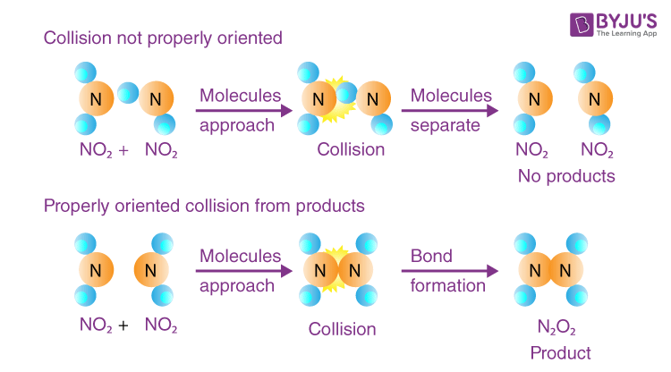
In a nutshell, we can say that the activation energy and proper orientation of the reacting molecules together determine the condition for a collision that will result in the formation of products that is an effective collision. So in collision theory, both activation energy and effective collision govern the rate of a reaction.
(iv) Transition state theory
In chemistry, transition state theory (TST) explains the reaction rates of elementary chemical reactions. The theory assumes a special type of chemical equilibrium (quasi-equilibrium) between reactants and activated transition state complexes.
TST is used primarily to understand qualitatively how chemical reactions take place. TST has been less successful in its original goal of calculating absolute reaction rate constants because the calculation of absolute reaction rates requires precise knowledge of potential energy surfaces, but it has been successful in calculating the standard enthalpy of activation (ΔH‡, also written Δ‡H^{ɵ}), the standard entropy of activation (ΔS‡ or Δ‡S^{ɵ}), and the standard Gibbs energy of activation (ΔG‡ or Δ‡G^{ɵ}) for a particular reaction if its rate constant has been experimentally determined.
The basic ideas behind transition state theory are as follows:
- Rates of reaction can be studied by examining activated complexes near the saddle point of a potential energy surface. The details of how these complexes are formed are not important. The saddle point itself is called the transition state.
- The activated complexes are in a special equilibrium (quasi-equilibrium) with the reactant molecules.
- The activated complexes can convert into products, and kinetic theory can be used to calculate the rate of this conversion.
where is the dissociation energy at absolute zero, k_{B} is the Boltzmann constant, h is the Planck constant, T is thermodynamic temperature, is vibrational frequency of the bond. This expression is very important since it is the first time that the factor k_{B}T/h, which is a critical component of TST, has appeared in a rate equation.



Q.2.a.
Ans. 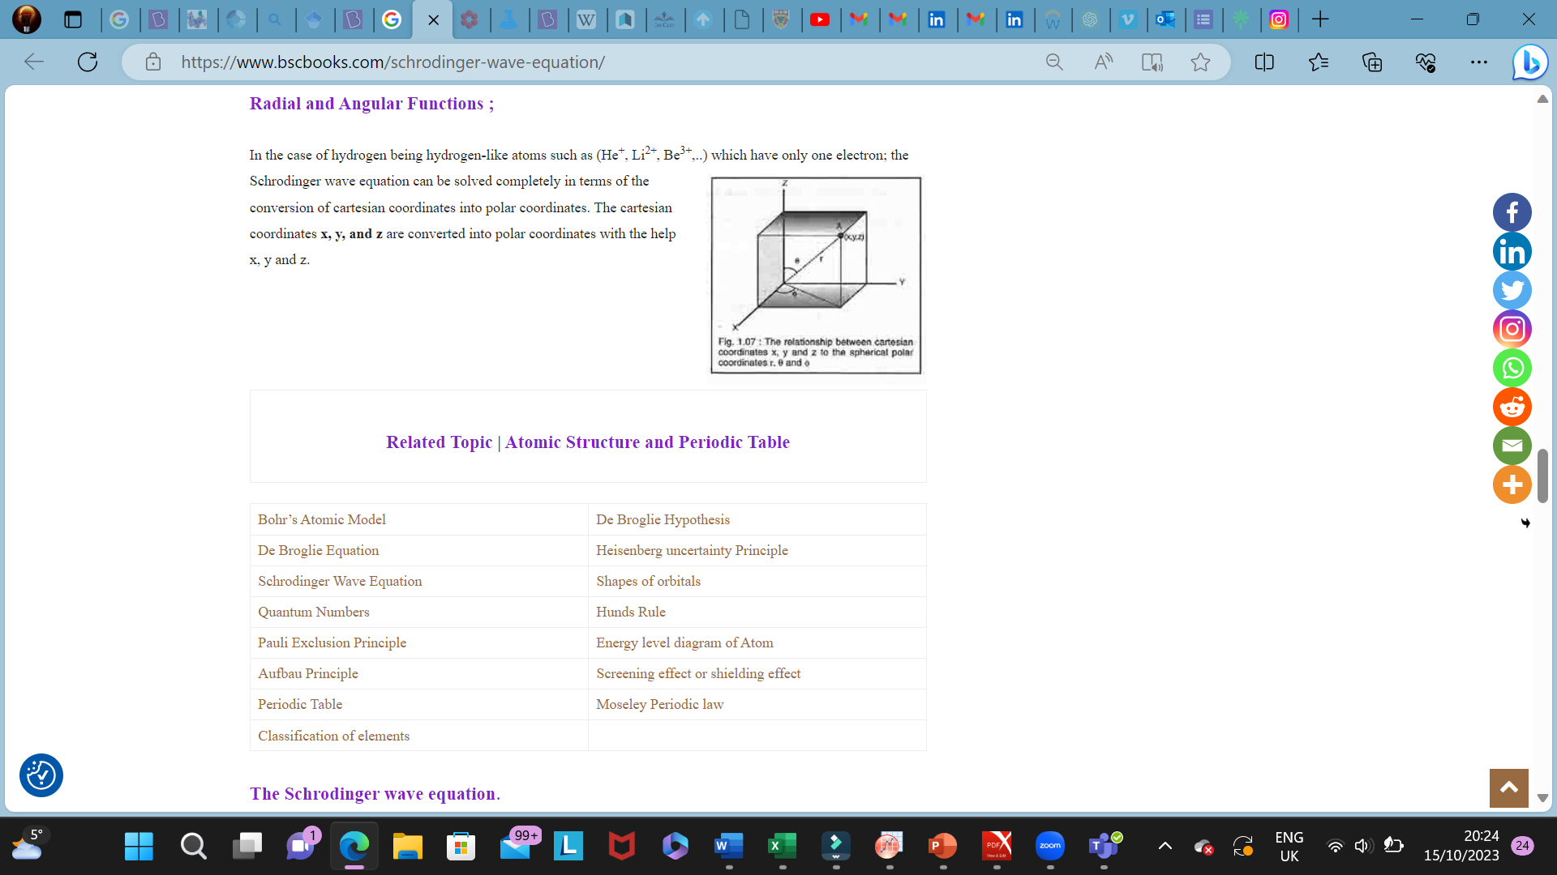
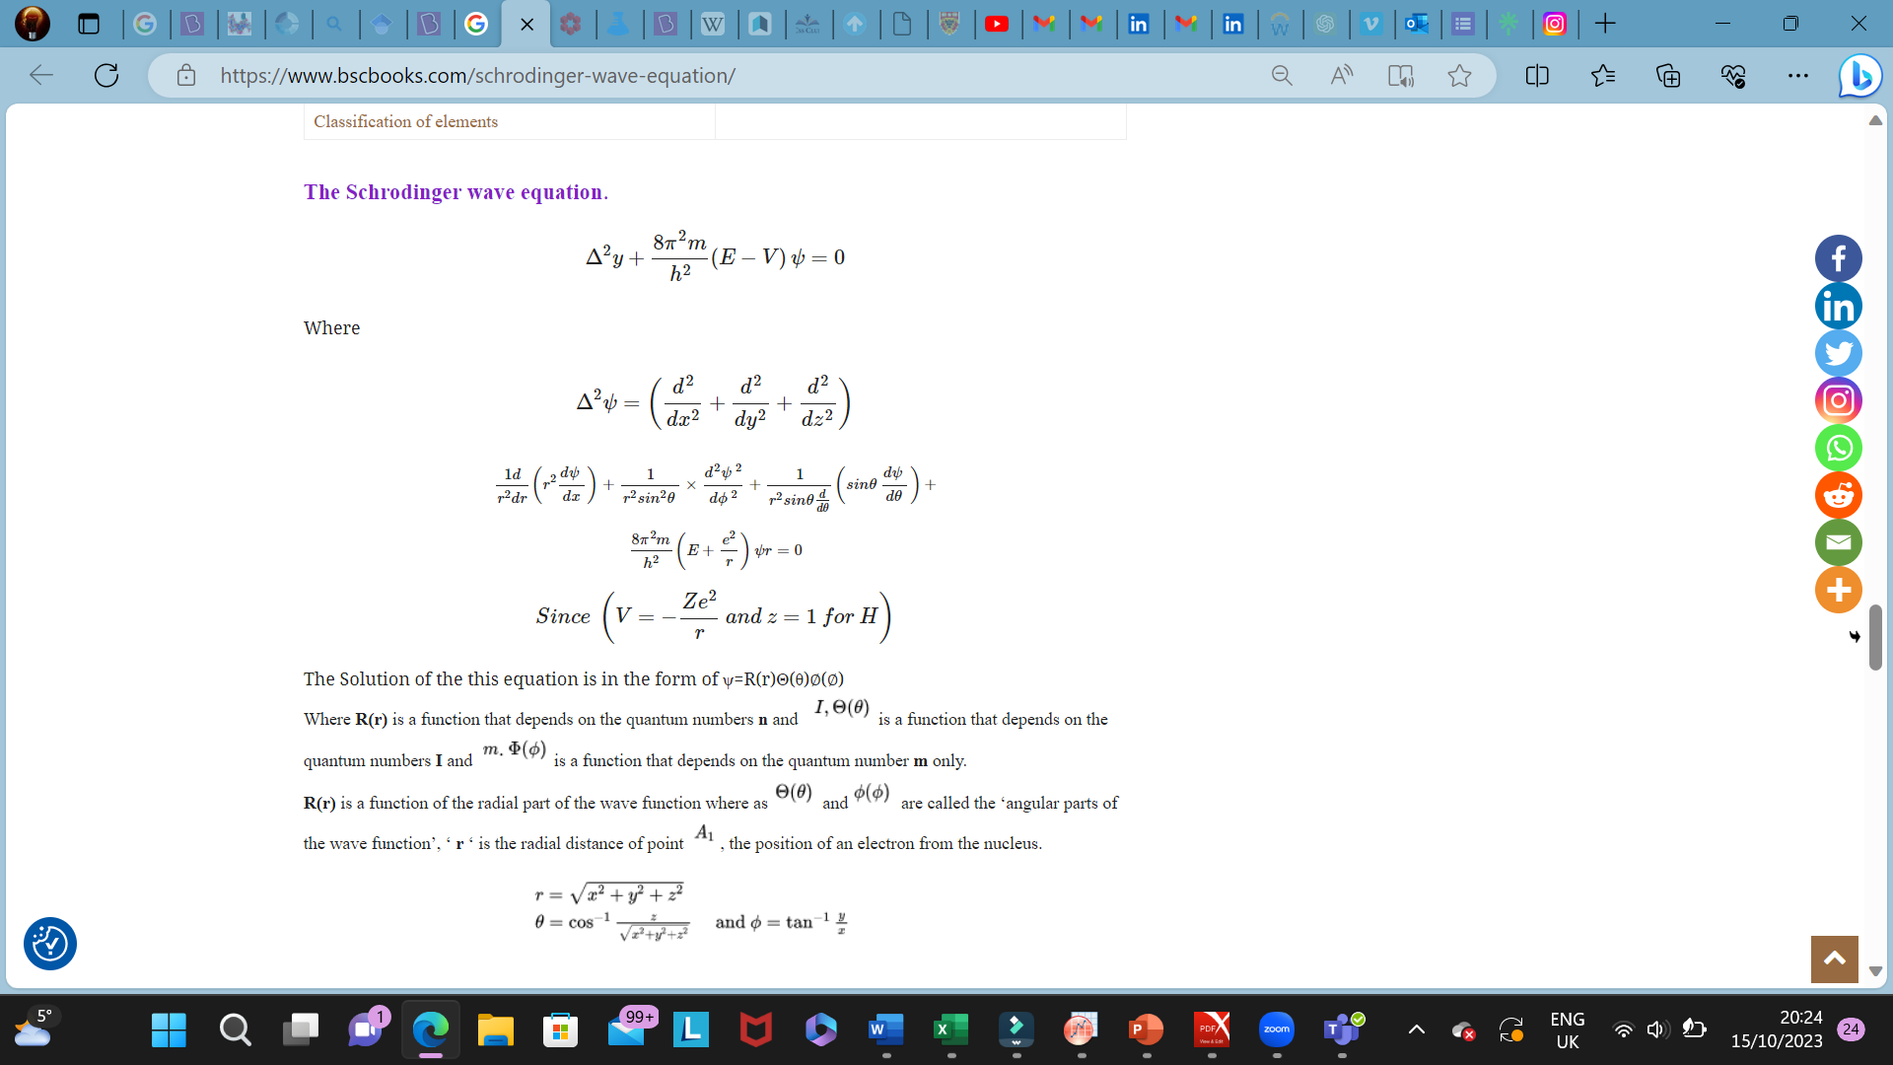
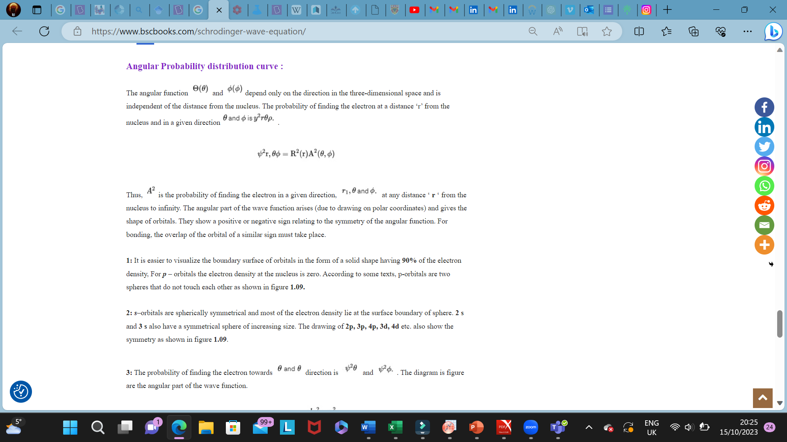
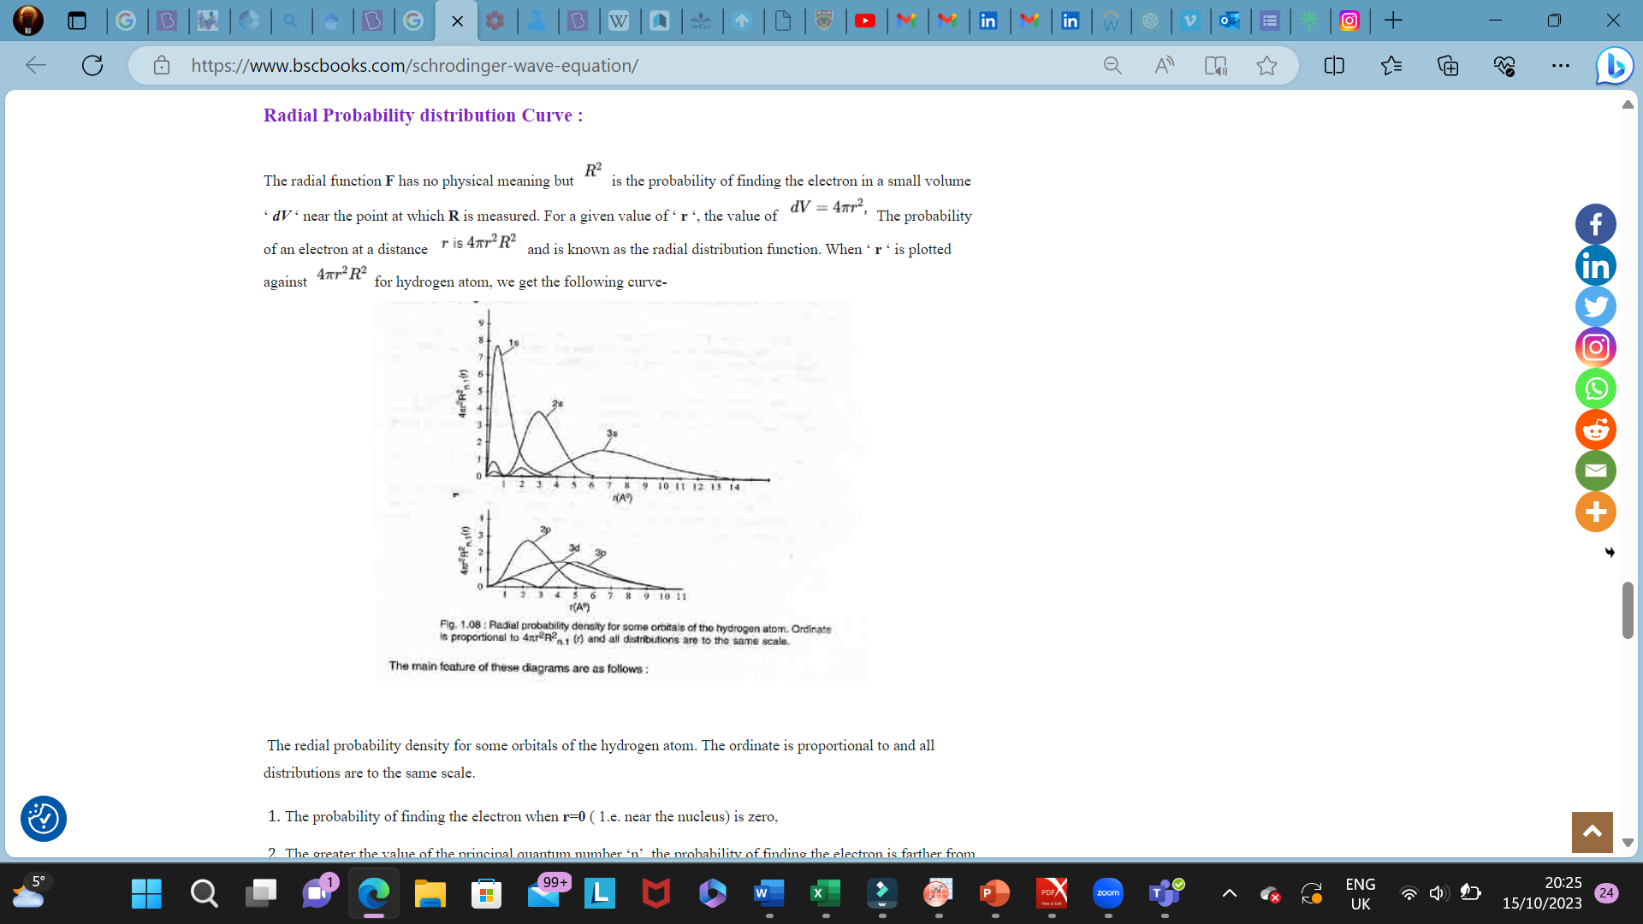
The redial probability density for some orbitals of the hydrogen atom. The ordinate is proportional to and all distributions are to the same scale.
- The probability of finding the electron when r=0 ( 1.e. near the nucleus) is zero,
- The greater the value of the principal quantum number ‘n’, the probability of finding the electron is farther from the nucleus.
The probability of finding the electron for 18 orbital is at a distance of 0.529 A from the nucleus and is in good agreement with Bohr’s first circular orbit for the hydrogen atom. The probable distance for 2s or 2p orbital is 2,1 A.
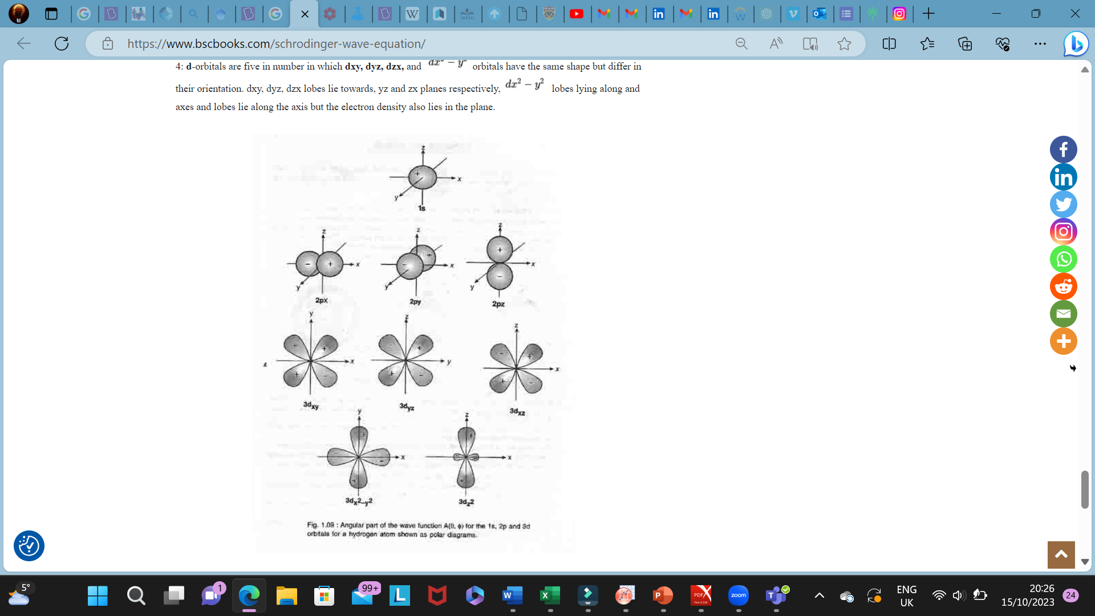
Q.2.b.
Ans. The second law of thermodynamics argues that all processes must increase the total entropy of the universe. However, the universe if often separated into the System and the Surroundings differing changes of entropy can be observed from a system level perspective. Many processes results in an increase in a system's entropy ΔS>0. Increasing the volume that a gas can occupy will increase the disorder of a gas Dissolving a solute into a solution will increase the entropy of the solute - typically resulting in an increase in the entropy of the system. Phase changes from solid to liquid, or liquid to gas, lead to an increase in the entropy of the system
Some processes result in a decrease in the entropy of a system ΔS<0:
A gas molecule dissolved in a liquid is much more confined by neighbouring molecules than when it’s in the gaseous state. Thus, the entropy of the gas molecule will decrease when it is dissolved in a liquid. A chemical reaction between gas molecules that results in a net decrease in the overall number of gas molecules will decrease the disorder of the system, and result in a decrease in the entropy
2NO(g)+O₂(g)→2NO₂(g) ΔS<0
The decrease in entropy associated with a decrease in the number of gas molecules for a chemical reaction
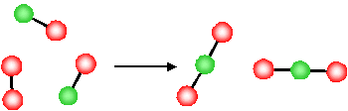
The product of this reaction (NO₂) involves the formation of a new N-O bond and the O atoms originally in a separate O₂ molecule, are now connected to the NO molecule via a new N−O bond. Since they are now physically bonded to the other molecule (forming a new, larger, single molecule) the O atoms have less freedom to move around. The reaction has resulted in a loss of freedom of the atoms (O atoms). There is a reduction in the disorder of the system (i.e. due to the reduction in the degrees of freedom, the system is more ordered after the reaction). The forms of molecular motion are ways in which molecules can store energy. The greater the molecular motion of a system, the greater the number of possible microstates and the higher the entropy.
Q.2.c.
Ans. Factors affecting rate of chemical reaction
- Concentration of reactants
Rate of a reaction is directly proportional to the concentration of reactants.
i.e. rate (r) ∝ c^{n}
Reacting molecules increase with increase in concentration. Therefore, according to the collision theory, the rate of a reaction should increase with increase in the concentration since the rate is directly proportional to the collision frequency.
- Temperature
The average kinetic energy increases with increase in absolute temperature. Hence the number of molecules with energy greater than the threshold energy also increases. As a result, the number of effective collisions between reactant molecules also increases. Therefore, usually it is observed that the rate of reaction increases with increase in temperature.
- Catalyst
Catalyst is a substance which alters the rate of a reaction without being consumed or without undergoing any chemical change during the reaction. A catalyst increases the rate of reaction by providing a new path with lower activation energy (E_{a}) for the reaction.
- Nature of reactants
Rate of a reaction depends on the nature of bonding in the reactants. Usually the ionic compounds react faster than covalent compounds. The reactions between ionic compounds in water occur very fast as they involve only exchange of ions, which were already separated in aqueous solutions during their dissolution. Whereas, the reactions between covalent compounds take place slowly because they require energy for the cleavage of existing bonds. E.g., The esterification of acetic acid occurs slowly since the breaking of bonds requires energy.
- Surface area
The rate of a reaction increases with increase in the surface area of solid reactant, if any used. The surface of a solid can be increased by grinding it to a fine powder. E.g. The reaction between zinc and hydrochloric acid occurs within seconds if the zinc metal is finely powdered. But the reaction will be slower when a zinc wire is used.
Q.3.a.
Ans. Uses of chelates
- Chelation treatment is the use of chelating agents to detoxify toxic metals like mercury, arsenic, and lead by converting them to a chemically inert state that may be expelled without further interaction with the body.
- Almost all biochemicals have the ability to dissolve certain metal cations. Proteins, polysaccharides, and polynucleic acids are thus effective polydentate ligands for a wide range of metal ions.
- Organic compounds such as the amino acids glutamic acid and histidine, organic diacids such as malate, and polypeptides such as phytochelatin are also typical chelators. In addition to these adventitious chelators, several biomolecules are specifically produced to bind certain metals.
- Almost all metalloenzymes contain metals that have been chelated, generally to peptides, cofactors, or prosthetic groups. The porphyrin rings in haemoglobin and chlorophyll are examples of chelating agents.
- Many microbial species produce water-soluble pigments that serve as chelating agents, termed siderophores. For example, species of Pseudomonas are known to secrete pyocyanin and pyoverdin that bind iron. Enterobactin, produced by E. coli, is the strongest chelating agent known.
Q.3.b.
Ans. When the coordination sphere is anionic, it is balanced by cations outside. These cations are written first followed by the naming of the coordination sphere. The following rules must be followed:
- The cation must always be written first (it could be the balancing ions or the coordination sphere).
- Ligands are written first in alphabetical order, followed by the name of the central metal.
- If the coordination sphere is anionic, we put ‘ate’ as the suffix of the metal. If the coordination sphere is cationic, the name of the metal is written as it is.
- We use prefixes di, tri, tetra, etc., to indicate the number of ligands in the compound.
- If the ligand already has any of these prefixes in the name, we use prefixes bis, tris, tetrakis, etc., to indicate the number of ligands in the compound.
- The oxidation state of the metal is written in roman numerals in parentheses after its name.
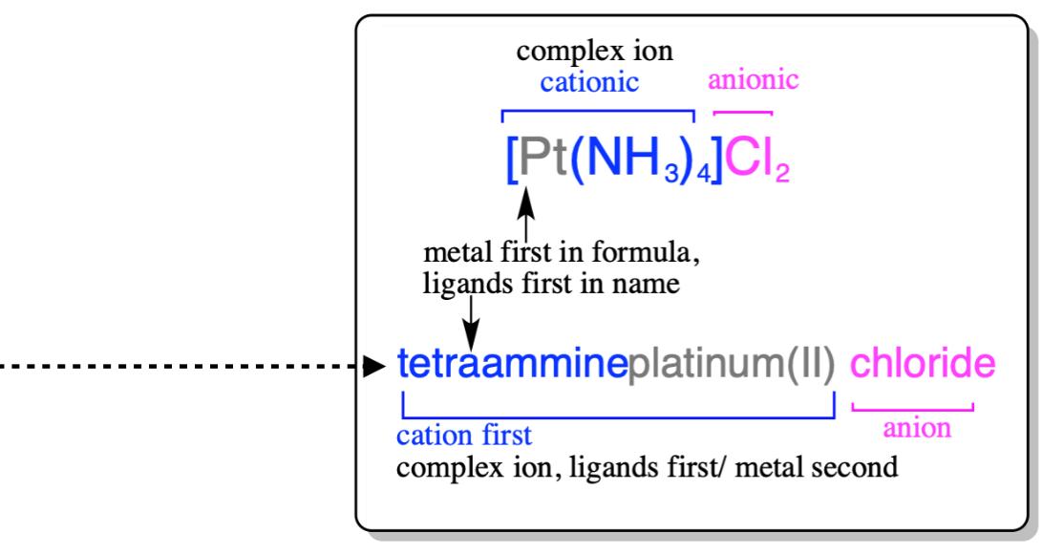
Q.3.c.
Ans. Valence bond theory(VBT) was developed by Linus Pauling. The main assumption made by him was that the metal-ligand bonds are formed by the donating of an electron pair by the ligand to the metal and thus form a coordinate bond between the metal and ligand.

Features of Valence Bond theory
1. The central metal cation or atom makes available a number of vacant s, p and or d-orbitals equal to its coordination number to form coordinate covalent bonds with ligands.
2. These vacant atomic orbitals of metal are hybridised to form a new set of equivalent bonding orbitals, called hybrid orbitals. These orbitals have the same geometry, the same energy and definite directional properties.
3. The bonding in metal complexes arises when a filled ligand orbital containing a lone pair of electrons overlaps a vacant hybrid orbital on the metal cation or atom to form a coordinate covalent bond.
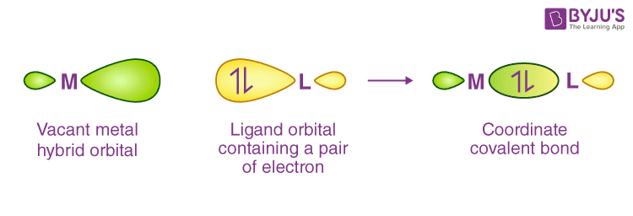
4. Each ligand has at least one orbital containing a lone pair of electrons. Pauling classified the ligands into two categories (i) Strong ligands like CN–, CO– etc. (ii) weak ligands like F–, Cl– etc.
5. Strong ligands have a tendency to pair up the d-electrons of a metal cation or atom to provide the necessary orbitals for hybridization. On the other hand, weak ligands do not have a tendency to pair up the d-electrons.
6. The d orbital used in hybridization may be either inner (n-1) d-orbitals or outer n d-orbitals. The complex formed by inner (n-1) d-orbitals, is called inner orbital complex whereas the complex formed by outer d-orbital is called outer orbital complex.
7. If unpaired electrons are present within the complex, then complex is paramagnetic in nature while if all the electrons are paired then complex is diamagnetic in nature.

Hybridization and Geometry of Complexes
Coordination Number | Types of Hybridizations | Geometry | Examples
2 | sp | Linear | [Ag(NH₃)₂]⁺
3 | sp² | Triangular planar | [HgI₃]–
4 | sp³ | Tetrahedral | [CoCl₄]²⁻
4 | sp²d | Square planar | [Ni(CN)₄]²⁻
4 | sd³ | Tetrahedral | MnO₄–, CrO₄²⁻
5 | dsp³ | Trigonal bipyramidal | Fe(CO)₅
5 | dsp³ | Square pyramidal | [Ni(CN)₅]³⁻
6 | d²sp³ | Octahedral | [Fe(CN)₆] ⁴⁻
6 | sp³d² | Octahedral | [Fe(F)₆] ³⁻

Examples of Octahedral complexes

(a) Inner Orbital Complexes:

[Co(CN)₆]³⁻ ion:
- In this complex, the oxidation state of cobalt is +3.
- The valence shell electronic configuration of Co³⁺ is 3d⁶.
- The CN– ligands are strong and therefore cause pairing of 3d-electrons.
- All six 3d-electrons are therefore paired and occupy three of the five 3d orbitals.
- The vacant 3d- orbitals combine with the vacant 4s and 4p orbitals to form six d²sp³-hybrid orbitals.
- These six hybrid orbitals overlap with six filled orbitals of ligands to form six-coordinate covalent bonds.
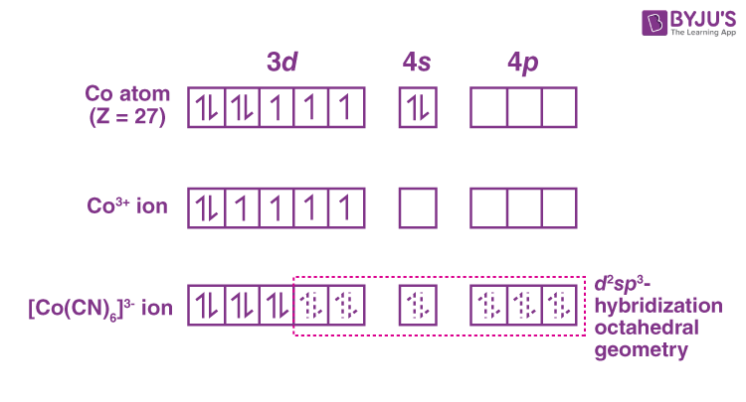

(b) Outer Orbital Complexes:

[Fe(F)₆]³⁻ ion:
- In this complex, the oxidation state of Iron(Fe) is +3.
- The valence shell electronic configuration of Fe³⁺ is 3d⁵.
- The F- ligands are weak and therefore cause no pairing of 3d-electrons.
- All five 3d-electrons are therefore occupied on five 3d orbitals.
- The vacant 4s- orbitals combine with the vacant 4p and two vacant 5d orbitals mixed with each other to form six sp³d²-hybrid orbitals.
- These six hybrid orbitals overlap with six filled orbitals of ligands to form six-coordinate covalent bonds.
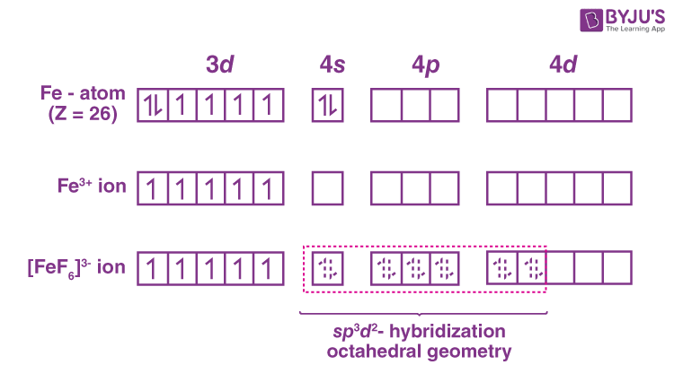

Examples of tetrahedral complexes

[NiCl₄]²⁻ ion:
- In this complex ion, the oxidation state of Ni is +2.
- The valence shell electronic configuration is 3d⁸.
- Since Cl– is a weak ligand, therefore no pairing of electrons will occur in 3d-orbitals.
- None of the five 3d- orbitals is vacant.
- Vacant 4s and 4p orbitals combine to give four sp³ hybrid orbitals.
- These four hybrid orbitals form bonds with four ligands by sharing four pairs of electrons.
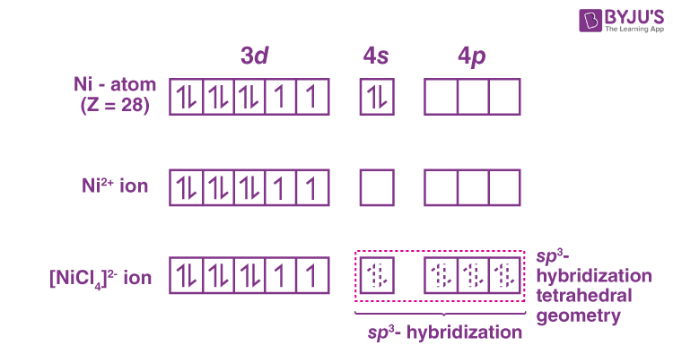

[Ni(CN)₄]²⁻ ion:
- In this complex ion, the oxidation state of Ni is +2.
- The valence shell electronic configuration is 3d⁸.
- Since CN– is a strong ligand, therefore these ligands cause to pair up the two unpaired electrons in one d-orbital resulting in a vacant 3d-orbital.
- This vacant 3d-orbital gets hybridised with the vacant 4s and two 4p orbitals to give four dsp² hybrid orbitals.
- These four hybrid orbitals form bonds with four ligands by sharing four pairs of electrons.

Limitations of Valence Bond Theory
- It could not explain the nature of ligands.
- It could not explain why the pairing of electrons occurs in the presence of strong ligands.
- It could not explain the colour and electronic spectra of complexes.
- It could not explain reaction rates and the mechanism of reactions of complexes.
- This theory does not provide any quantitative interpretation data about the thermodynamic and kinetic stability of coordination complexes.
Q.4.a.
Ans. Einstein’s photoelectric equation establish the ‘Particle Nature’ of electron. It is based on conservation of energy. Einstein received Noble prize for photoelectric equation. The photoelectric effect is a phenomenon in which electrons are ejected from the surface of a metal when light is incident on it. These ejected electrons are called photoelectrons. It is important to note that the emission of photoelectrons and the kinetic energy of the ejected photoelectrons is dependent on the frequency of the light that is incident on the metal’s surface. The process through which photoelectrons are ejected from the surface of the metal due to the action of light is commonly referred to as photoemission.
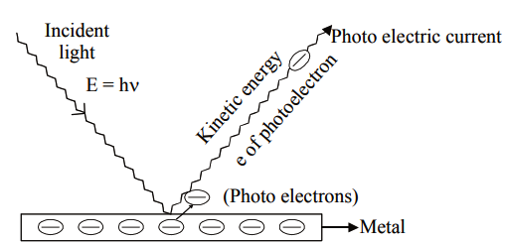
“Total incident energy of light is used into two forms, same part of the energy is used as a work function and remaining part of the energy is used as a kinetic energy of photo electrons."
Mathematically, Einstein equation can be written as,
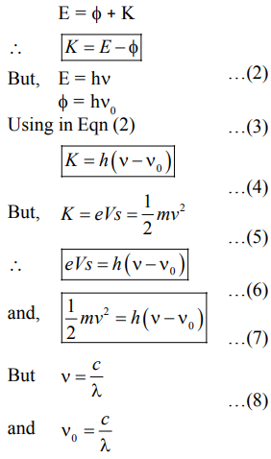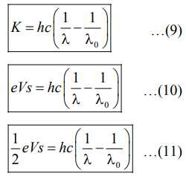
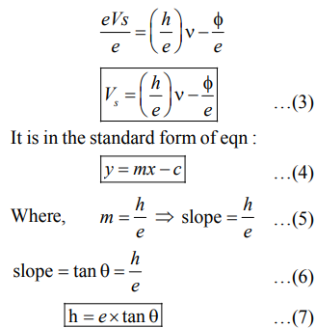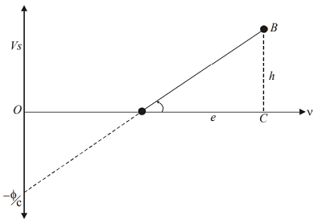
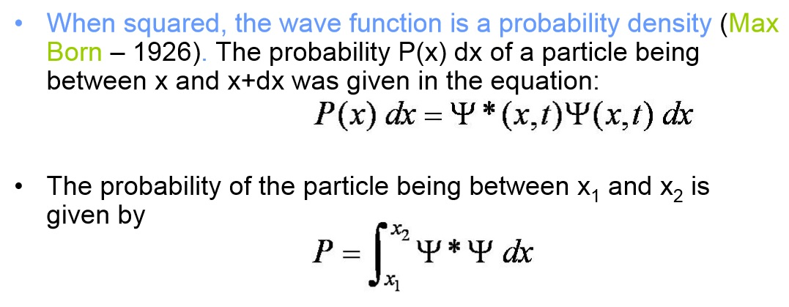
Q.4.b.
Ans. Eigen value and eigen functions
The wavefunction for a given physical system contains the measurable information about the system. To obtain specific values for physical parameters, for example energy, you operate on the wavefunction with the quantum mechanical operator associated with that parameter. The operator associated with energy is the Hamiltonian, and the operation on the wavefunction is the Schrodinger equation. Solutions exist for the time independent Schrodinger equation only for certain values of energy, and these values are called "eigenvalues*" of energy.
Corresponding to each eigenvalue is an "eigenfunction*". The solution to the Schrodinger equation for a given energy involves also finding the specific function which describes that energy state. The solution of the time independent Schrodinger equation takes the form
The eigenvalue concept is not limited to energy. When applied to a general operator Q, it can take the form
if the function ψ_{i} is an eigenfunction for that operator. The eigenvalues q_{i} may be discrete, and in such cases we can say that the physical variable is "quantized" and that the index i plays the role of a "quantum number" which characterizes that state.
Q.4.c.
Ans. The particle in a box problem is a common application of a quantum mechanical model to a simplified system consisting of a particle moving horizontally within an infinitely deep well from which it cannot escape. The solutions to the problem give possible values of E and ψ that the particle can possess. E represents allowed energy values and ψ(x) is a wavefunction, which when squared gives us the probability of locating the particle at a certain position within the box at a given energy level.
The potential energy is 0 inside the box (V=0 for 0<x<L) and goes to infinity at the walls of the box (V=∞ for x<0 or x>L). We assume the walls have infinite potential energy to ensure that the particle has zero probability of being at the walls or outside the box. Doing so significantly simplifies our later mathematical calculations as we employ these boundary conditions when solving the Schrödinger Equation.

Q.5.a.
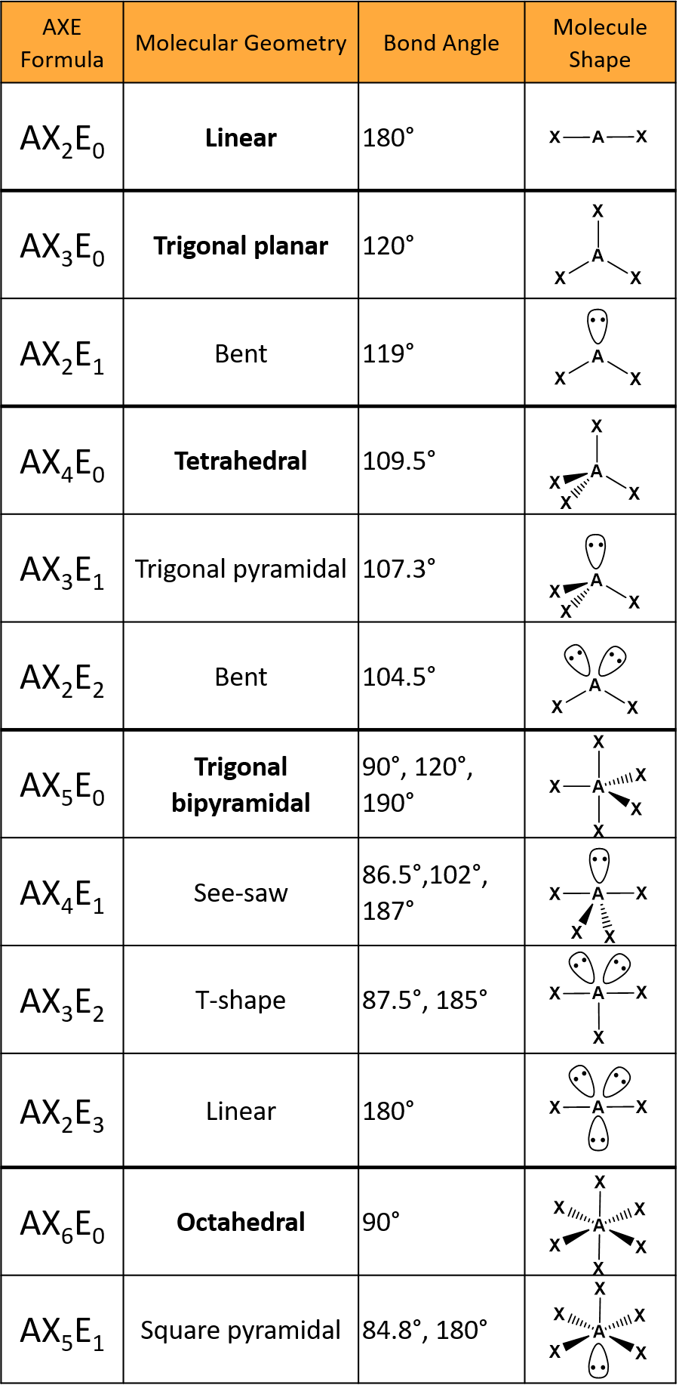
Q.5.b.

Ans. Experimental methods to determine rate of chemical reaction

Graphical method
This method is used when there is only one reactant. The concentrations of the reactants are measured by some suitable method. A graph is plotted between concentration and time. The instantaneous rates of the reaction at different times are calculated by finding out the slopes of the tangents corresponding to different times. The rate of reaction is plotted versus concentration,[A] or (concentration)², [A]² and so on. If rate of reaction remains constant in rate versus concentration graph, it means that the rate is independent of the concentration of the reactant, i.e.
Rate = k [A]⁰ = k
Therefore, the reaction is of zero order. If we get straight line by plotting graph of rate versus (concentration)^{n}, where n =1, 2, 3…. so on, then
Rate = k[A]^{n}
and the order of reaction is n.
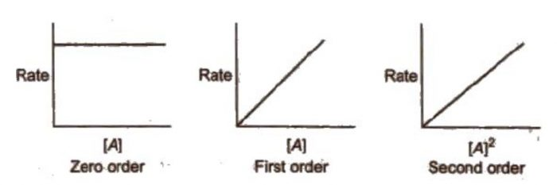
  - Use of integrated rate equation
The kinetic data is fitted to different integrated rate equation. Wherever the data fit with the equation for the correct order of the reaction, it will give constant value of rate constant for all data points (concentrations at different times).
For a general reaction:
A ———> Products
the integrated rate equation for zero, first and second order reactions are below given:
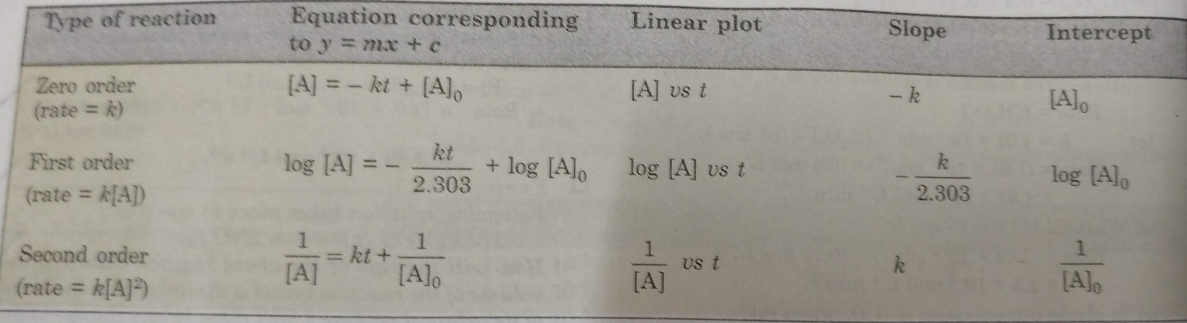
The straight lines are obtained for a plot of [A] versus t for a zero order reaction.
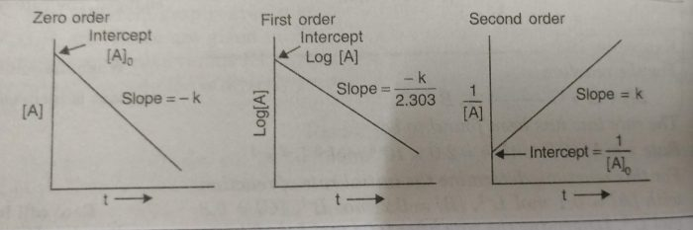
  - Initial Rate Method
The graphical methods cannot be applied for the reaction which involve more than one reactant. The rates of such reactions can be determined by initial rate method. The initial rate of the reaction i.e. the rate at the beginning of the reaction is measured. The rate over an initial time interval that is short enough so that concentration of the reactants do not change appreciably from their initial values. This corresponds to slope of the tangent to the concentration versus time graph at t=0. The initial concentration of only one reactant is changed and the rate is determined again. From this order with respect to that particular reactant is calculated. The procedure is repeated with respect to each reactant until the overall rate law is fully determined. The sum of the individual orders with respect to each reactant gives the order of the reaction.
pA + qB + rC ——-> Products
The general form of the rate law may be written as :
Rate = k[A]^{p} [B]^{q} [C]^{r}
Then initial rate of the reaction may be given as :
r₀ = Rate = k [A]₀^{p} [B]_{o}^{q} [C]_{o}^{r}
If [B] and [C] are kept constant, then
r_{o}= k_{o}[A]_{o}^{p} where k_{o}= k [B]_{o}^{q} [C]_{o}^{r}
The value of p can be determined by inspecting the rate at different values of [A].If we know the initial rates at two different concentration of A.
(r₀)₁=k_{o}[A_{o}]₁^{p}
(r₀)₂ = k_{o} [A_{o}]₂^{p}
where (r₀)₁ and (r₀)₂ are initial rate of reactions when the initial concentration of A are [A_{o}]₁ and [A_{o}]₂

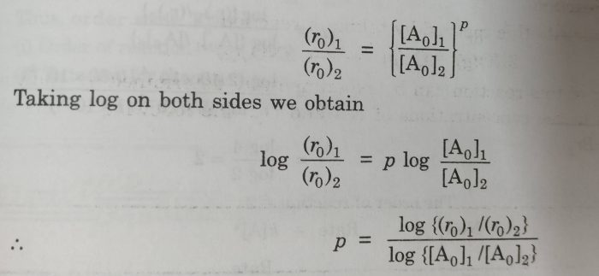
n= p+ q+ c
2A + 2B ———> products
Rate = k[A]^{p}[B]^{q}
(Rate)₀= k [A]_{o}^{p}[B]_{o}^{q}

(4) Ostwald Isolation Method
The total order of the reaction is then equal to the sum of the orders of reaction for individual reactants. This method is based on the principle that if the concentration of all but one reactant are taken in excess , then during the course of the reaction, the concentration of those reactants taken in excess will remain almost constant and hence variation in rate will correspond to the concentration of that reactant whose concentration is small. This process is repeated one by one and order with respect to each reactant is determined.
The overall order will be the sum of all these orders.
aA + bB + c C ———> Products
Suppose we isolate A by taking B and C in large excess and get order of reaction with respect to A. Similarly , we isolate B by taking A and C in B and and C. Overall order of reaction
n= p+ q+ r
Q.5.c.
Ans. The heat that flows across the boundaries of a system undergoing a change is a fundamental property that characterizes the process. It is easily measured, and if the process is a chemical reaction carried out at constant pressure, it can also be predicted from the difference between the enthalpies of the products and reactants. The quantitative study and measurement of heat and enthalpy changes is known as thermochemistry.

Thermochemical Equations and Standard States
In order to define the thermochemical properties of a process, it is first necessary to write a thermochemical equation that defines the actual change taking place, both in terms of the formulas of the substances involved and their physical states (temperature, pressure, and whether solid, liquid, or gaseous.
Here is the complete thermochemical equation for the vaporization of water at its normal boiling point:
H₂O(ℓ,373K,1atm)→H₂O(g,373K,1atm) ΔH=40.7kJmol⁻
The quantity 40.7 is known as the enthalpy of vaporization (often referred to as “heat of vaporization”) of liquid water. Any thermodynamic quantity such as ΔH that is associated with a thermochemical equation always refers to the number of moles of substances explicitly shown in the equation. The thermochemical equations for reactions taking place in solution must also specify the concentrations of the dissolved species.
Since most thermochemical equations are written for the standard conditions of 298 K and 1 atm pressure, we can leave these quantities out if these conditions apply both before and after the reaction. If, under these same conditions, the substance is in its preferred (most stable) physical state, then the substance is said to be in its standard state.
Thus the standard state of water at 1 atm is the solid below 0°C, and the gas above 100°C. A thermochemical quantity such as ΔH that refers to reactants and products in their standard states is denoted by ΔH∘.

Calorimetry: Measuring ΔH in the laboratory
Thermal quantity that can be observed directly is the heat q that flows into or out of a reaction vessel, and that q is numerically equal to ΔH° only under the special condition of constant pressure. Moreover, q is equal to the standard enthalpy change only when the reactants and products are both at the same temperature, normally 25°C. The measurement of q is generally known as calorimetry.
The most common types of calorimeters contain a known quantity of water which absorbs the heat released by the reaction. Because the specific heat capacity of water (4.184 J g⁻¹ K⁻¹) is known to high precision, a measurement of its temperature rise due to the reaction enables one to calculate the quantity of heat released.
In all but the very simplest calorimeters, some of the heat released by the reaction is absorbed by the components of the calorimeter itself. It is therefore necessary to "calibrate" the calorimeter by measuring the temperature change that results from the introduction of a known quantity of heat. The resulting calorimeter constant, expressed in J K⁻¹, can be regarded as the “heat capacity of the calorimeter”. The known source of heat is usually produced by passing a known quantity of electric current through a resistor within the calorimeter.
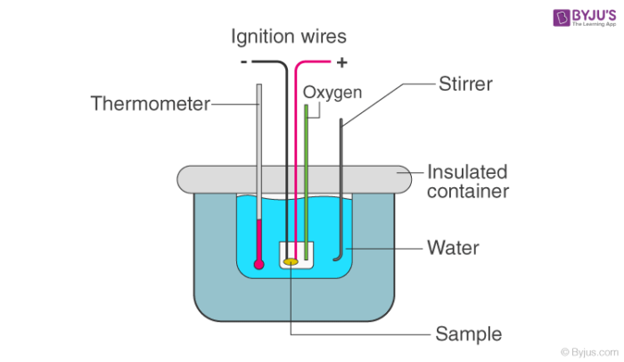

Q.6.a.
Ans. 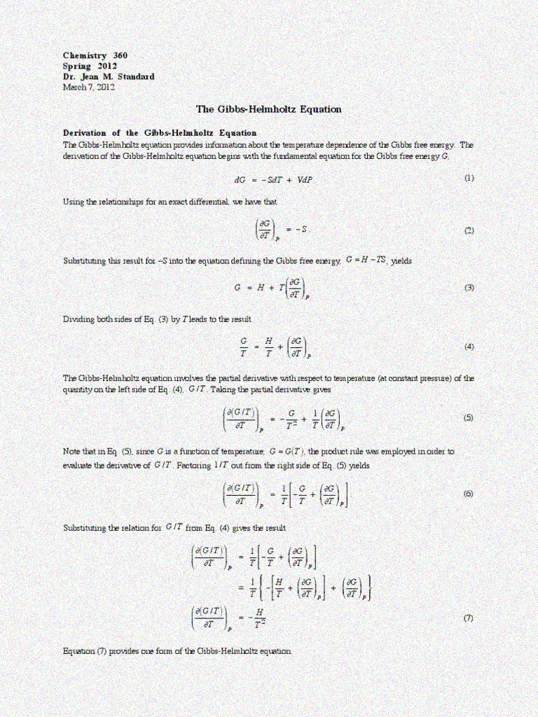

Q.6.b.
Ans. In thermodynamics, an isothermal process is a type of thermodynamic process in which the temperature T of a system remains constant: ΔT = 0. This typically occurs when a system is in contact with an outside thermal reservoir, and a change in the system occurs slowly enough to allow the system to be continuously adjusted to the temperature of the reservoir through heat exchange
Isothermal Reversible Expansion Work of an IDEAL Gas
Consider an ideal gas confined in a cylinder with a frictionless piston. The reversible
expansion of gas takes place in a finite number of infinitesimally small intermediate steps. If the P_{ext} is infinitesimally less than internal
pressure of gas ‘P’ by ‘dP’. Then gas expands reversibly and piston moves
through a distance ‘dl’.
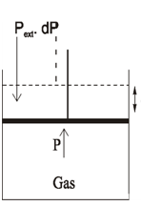
Since dP is so small, for all practical purposes.
P_{ext.} – P_{gas} = P
One work done by gas in one infinitesimal step (dw) can be expressed as;
dw = P.dV. [ w = PV]
dw = PdV.
If the gas expands from V₁ t oV₂ during isothermal
reversible expansion. The total amount of work done would be equal to
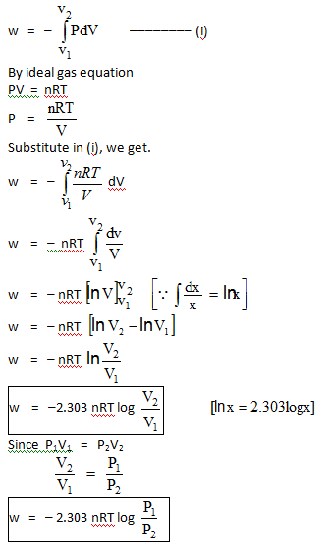
Q.6.c.
Ans. The fugacity was introduced by G. N. Lewis in 1901, and became widely used after the appearance of Thermodynamics, a very influential textbook by Lewis and Randall in 1923. Lewis describes the need for such a function in terms of an analogy with temperature in the attainment of equilibrium between phases. Just as equilibrium requires that heat must flow such that temperature is the same in all parts of the system, so matter must flow such that chemical potentials are also equalized. He referred to the flow of matter from one phase to another as an “escaping tendency,” such as a liquid escaping to the gas form to achieve an equilibrium vapor pressure. He pointed out that in fact vapor pressure is equilibrated between phases under many conditions (and in fact is the basis for the isopiestic method of activity determinations), and could serve as a good measure of escaping tendency if it behaved always as an ideal gas.
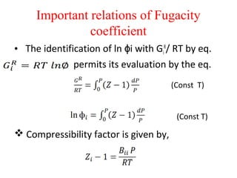
The chemical potential is of course another measure of “escaping tendency,” but Lewis pointed out that there are “certain respects in which this function is awkward.” This refers to the fact that µ → −∞ as a → 0, because activity is defined as µ − µ° = RT ln a. Lewis defined a function which would be much like a vapor pressure, which would be equilibrated between phases at equilibrium, even in nonideal cases, and even if no vapor phase actually existed.
Q.7.a.
Ans. Common ion effect
The phenomenon in which the degree of dissociation of any weak electrolyte is suppressed by adding a small amount of strong electrolyte containing a common ion is called a common ion effect.
Example – 1: (Dissociation of a Weak Acid)
Ionization of weak electrolyte acetic acid (CH₃COOH) is suppressed by adding strong electrolyte sodium acetate (CH₃COONa) containing common acetate ion (CH₃COO–) Suppose, CH₃COOH is treated with water. It dissociates and an equilibrium exists as follows,
CH₃COOH_{(aq)} ⇌ CH₃COO–_{(aq)} + H⁺_{(aq)}
By applying the law of mass action,
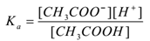
Where ‘K_{a}’ is the dissociation constant of acid.
If a small amount of a strong electrolyte like sodium acetate (CH₃COONa) is added to the aqueous solution of CH₃COOH, it gets dissociated and equilibrium exists, as
CH₃COONa_{(aq)} → CH₃COO–_{(aq)} + Na⁺_{(aq)}
Here CH₃COO– ions are common hence their concentration increases. According to Le-Chatelier’s principle, equilibrium shifts towards the left. To keep the value of K_{a} constant, the concentration of CH₃COOH molecules is increased. In this way ionisation of CH₃COOH is suppressed by adding CH₃COONa. Thus the pH of the solution increases.
Example – 2: (Dissociation of a Weak Base):
Ionisation of weak electrolyte Ammonium hydroxide (NH₄OH) is suppressed by adding strong electrolyte Ammonium chloride (NH₄Cl) containing common ammonium ion Suppose, an electrolyte Ammonium hydroxide (NH₄OH) is treated with water. It dissociates and an equilibrium exists as follows,
NH₄OH_{(aq)} ⇌ NH₄⁺_{(aq)} + OH–_{(aq)}
By applying the law of mass action,
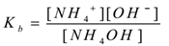
Where ‘K_{b}’ is dissociation constant of the base (NH₄+)
If a small amount of a strong electrolyte like Ammonium chloride (NH₄Cl) is added to the aqueous solution of NH₄OH, it gets dissociated and equilibrium exists, as
NH₄Cl_{(aq)} → NH₄⁺_{(aq)} + Cl–_{(aq)}
Here NH₄⁺ ions are common hence their concentration increases. According to Le-Chatelier’s principle, equilibrium shifts towards the left. To keep the value of K_{b} constant, the concentration of NH₄OH molecules is increased. In this way ionisation of NH₄OH is suppressed by adding NH₄Cl. Thus the pH of the solution decreases.
Applications of Common Ion Effect
Purification of Common Salt
The addition of common ion to a saturated solution of salt causes the precipitation of salt. When the ionic product exceeds the solubility product, precipitation takes place. A saturated solution of common salt, free from suspended impurities is taken and HCl gas is passed through it. In a saturated solution of impure NaCI, equilibrium exists as follows,
NaCl_{(aq)} → Na⁺_{(aq)} + Cl–_{(aq)}
If pure HCI gas is passed through this solution, being strong electrolyte, it dissociates almost completely and equilibrium exists,
HCl_{(aq)} → H⁺_{(aq)} + Cl–_{(aq)}
Now Cl– is a common ion. The concentration of CI– ions (common ions) is increased. According to Le-Chatelier’s principle equilibrium shifts towards the left. Dissociation of NaCI is suppressed and pure NaCI is precipitated as solid salt. Thus pure NaCI can be precipitated by passing HCI gas in the saturated solution of impure NaCI.
Salting Out of Soap
The addition of common ion to a saturated solution of salt causes the precipitation of salt. When the ionic product exceeds the solubility product, precipitation takes place. Soap is sodium salt of higher fatty acids (RCOONa). It is prepared by hydrolysis of oils with NaOH. In saturated soap solution there exist an equilibrium,
ROONa_{(aq)} → RCOO–_{(aq)} + Na⁺_{(aq)}
If a small amount of NaCl is added to the saturated soap solution, it dissociated as
NaCl_{(aq)} → Na⁺_{(aq)} + Cl–_{(aq)}
Concentration of Na⁺ ions (common ion) increases. Due to the common ion effect, dissociation of soap is decreased and soap gets precipitated and then can be easily removed from the soap solution. This process of getting solid soap from soap solution, by adding salt like NaCI is called salting out of soap.
Washing of precipitate:
Washing of the precipitate means removing impurities from precipitate by suitable liquid / solvent. If a precipitate is washed with water, a part of the precipitate may go into solution. Hence in gravimetric analysis, the precipitate is washed with washing solution containing little strong electrolyte having common ion. Due to common ion effect dissociation of precipitate in washing solution is suppressed. Precipitate is washed without dissolving in washing solution.
Examples:
- Precipitate of BaSO₄ is washed with water containing little H₂SO₄ because of SO₄— ions (common ions), the solubility of BaSO₄ precipitate is decreased and there is no loss of precipitate during washing.
- Cus precipitate is washed with dilute H₂S solution.
- ZnS precipitate is washed with dilute H₂S solution
- PbCl₂ precipitate is washed with dilute HCl solution.
Q.7.b.
Ans. pH, pK_{a}, pK_{b}, K_{a}, and K_{b} are used in chemistry to describe how acidic or basic a solution is and to gauge the strength of acids and bases. The pH scale is the most familiar measure of acidity and basicity, but pK_{a}, pK_{b}, K_{a}, and K_{b} are better for predicting acid and base strength and their reactions. Here are definitions of each term, simple formulas used to calculate them, and an explanation of how they differ from one another.
pH is “power of hydrogen” where the H is the element symbol. A “p” in front of a value also indicates the -log of the value. So, pH is the negative log of hydrogen ion concentration, while pKa is the negative log of the K_{a} value. The capital letter “K” stands for a constant. In this case, it refers to the equilibrium constant. Upper and lower case letters “A” or “a” and “B or “b” stand for acid and base, respectively.

pH and the Equilibrium Constant
pKa, pKb, Ka, and Kb are all equilibrium constants. Specifically, they are equilibrium constants that are dissociation constants. Usually, they are expressed in units of moles per liter (mol/L).
pKa, Ka, pKb, and Kb are used to predict whether a chemical species will donate or accept protons (hydrogen cations) at a given pH value. In other words, the equilibrium constants indicate acid and base strength and describe the level of ionization of an acid or a base. pKa and Ka describe acids, while pKb and Kb describe bases. Like pH, the pKa and Ka values account for hydrogen ion concentration. Like pOH, the pKb and Kb values account for hydroxide ion concentration. When dealing with equilibrium constant, remember adding water to an aqueous acid or base solution does not change its equilibrium constant. Ka and Kb are related by the ion constant for water (Kw):
K_{w} = K_{a} x K_{b}
pH is a measure of hydrogen ion concentration [H+], which in turn is a gauge of how acidic or basic a chemical solution is. Ordinarily, the pH scale runs from 0 to 14, although it’s actually possible to get negative values and ones exceeding 14. A pH value around 7 is neutral (neither acidic nor basic), a pH value less than 7 is acidic, and a pH value greater than 7 is basic. The pH value tells whether a chemical is an acid or a base, but it doesn’t indicate the strength of the acid or base. pH is related to pOH, which is the power of the hydroxide ion [OH-] and is used when discussing bases. The formulas to calculate pH and pOH are:
$$pH=-\log\left[H^{+}\right]$$
$$pOH=-\log\left[{OH}^{-}\right]$$
At 25 $℃ pH+pOH=14$
pKa and Ka
K_{a} is the acid dissociation constant. pK_{a} is just the -log of this constant. An acid dissociates according to the general equation:
HA + H₂O ⇆ A– + H₃O⁺
K_{a} = [H⁺][A⁻]/ [HA]
pK_{a} = – log K_{a}
at half the equivalence point,
pH = pK_{a} = -log K_{a}
A large K_{a} value indicates a strong acid because it means an acid largely dissociates into its ions. A large Ka value also means the reaction arrow favours the formation of production. In contrast, a small Ka value means only a small amount of acid dissociates, indicating a weak acid. A small Ka value means the reaction favours the reactants rather than the products. Most weak acids have Ka values between 10⁻² to 10⁻¹⁴.
pK_{a} gives the same information, but in a different way. The smaller the pKa value, the stronger the acid. Or, the larger the pK_{a} value, the weaker the acid. Weak acids typically have pK_{a} values between 2 and 14.
pK_{b} and K_{b}
K_{b} is the base dissociation constant and pKb is the -log of this constant. A base dissociates according to the general equation:
HB + H₂O ⇆ B⁺ + OH–
Where:
Kb = [B+][OH-]/[BOH]
pKb = -log Kb
The base dissociation constants are interpreted just like the acid dissociation constants. A large K_{b} value means a base has largely dissociated and indicates a strong base. A small pK_{b} value indicates a strong base, while a large pKb value indicates a weak base.
pK_{a} and pK_{b} are related using a simple equation:
pK_{a} + pK_{b} = 14
Q.7.c.
Ans. Chemical equilibria
Hydrogen and iodine gases react to form hydrogen iodide according to the following reaction:
H_{2(g)}+I_{2(g)}⇌2HI_{(g)}
Forward reaction: H_{2(g)}+I_{2(g)}→2HI_{(g)}
Reverse reaction: 2HI_{(g)}→H_{2(g)}+I_{2(g)}
Initially, only the forward reaction occurs because no HI is present. As soon as some HI has formed, it begins to decompose back into H₂ and I₂. Gradually, the rate of the forward reaction decreases while the rate of the reverse reaction increases. Eventually the rate of combination of H₂ and I₂ to produce HI becomes equal to the rate of decomposition of HI into H₂ and I₂. When the rates of the forward and reverse reactions have become equal to one another, the reaction has achieved a state of balance. Chemical equilibrium is the state of a system in which the rate of the forward reaction is equal to the rate of the reverse reaction.
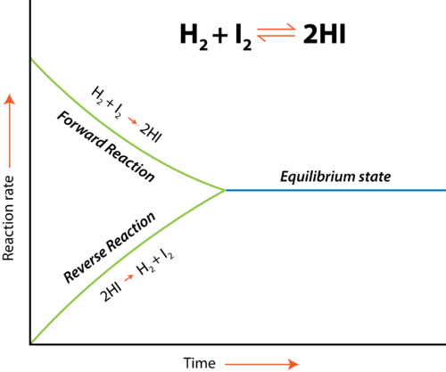
Chemical equilibrium can be attained whether the reaction begins with all reactants and no products, all products and no reactants, or some of both. The figure below shows changes in concentration of H₂, I₂, and HI for two different reactions. In the reaction depicted by the graph on the left (A), the reaction begins with only H₂ and I₂ present. There is no HI initially. As the reaction proceeds towards equilibrium, the concentrations of the H₂ and I₂ gradually decrease, while the concentration of the HI gradually increases. When the curve levels out and the concentrations all become constant, equilibrium has been reached. At equilibrium, concentrations of all substances are constant.
In reaction B, the process begins with only HI and no H₂ or I₂. In this case, the concentration of HI gradually decreases while the concentrations of H₂ and I₂ gradually increase until equilibrium is again reached. Notice that in both cases, the relative position of equilibrium is the same, as shown by the relative concentrations of reactants and products. The concentration of HI at equilibrium is significantly higher than the concentrations of H₂ and I₂. This is true whether the reaction began with all reactants or all products. The position of equilibrium is a property of the particular reversible reaction and does not depend upon how equilibrium was achieved.

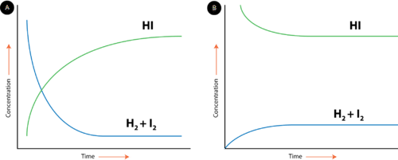
Figure : Equilibrium between reactants and products is achieved regardless of whether the reaction starts with the reactants or products.
Conditions for Equilibrium and Types of Equilibrium
Chemical equilibrium is a dynamic process. The forward and reverse reactions continue to occur even after equilibrium has been reached. However, because the rates of the reactions are the same, there is no change in the relative concentrations of reactants and products for a reaction that is at equilibrium. The conditions and properties of a system at equilibrium are summarized below.
- The system must be closed, meaning no substances can enter or leave the system.
- Equilibrium is a dynamic process. Even though we don't necessarily see the reactions, both forward and reverse are taking place.
- The rates of the forward and reverse reactions must be equal.
- The amount of reactants and products do not have to be equal. However, after equilibrium is attained, the amounts of reactants and products will be constant.
Equilibrium Constant
Consider the hypothetical reversible reaction in which reactants A and B react to form products C and D. This equilibrium can be shown below, where the lowercase letters represent the coefficients of each substance.
aA+bB⇌cC+dD
As we have established, the rates of the forward and reverse reactions are the same at equilibrium, and so the concentrations of all of the substances are constant. Since that is the case, it stands to reason that a ratio of the concentration for any given reaction at equilibrium maintains a constant value. The equilibrium constant (K_{eq}) is the ratio of the mathematical product of the products of a reaction to the mathematical product of the concentrations of the reactants of the reaction. Each concentration is raised to the power of its coefficient in the balanced chemical equation. For the general reaction above, the equilibrium constant expression is written as follows:
$$K_{eq}=\frac{{[C]}^{c}{[D]}^{d}}{{[A]}^{a}{[B]}^{b}}$$
The concentrations of each substance, indicated by the square brackets around the formula, are measured in molarity units (mol/L).
The value of the equilibrium constant for any reaction is only determined by experiment. As detailed in the above section, the position of equilibrium for a given reaction does not depend on the starting concentrations and so the value of the equilibrium constant is truly constant. It does, however, depend on the temperature of the reaction. This is because equilibrium is defined as a condition resulting from the rates of forward and reverse reactions being equal. If the temperature changes, the corresponding change in those reaction rates will alter the equilibrium constant.

Q.8.a.
Ans. Debye-Hückel theory - activity coefficient of solutions
The long range and strength of the Coulomb interaction between ions typically dominates the non-ideal behaviour of ionic solutions. It is as well the reason that even for extremely diluted solutions these non idealities have to be taken into account. Opposite charges attract each other. Thus it is more likely that anions are found closely to cations, and vice versa. Although the overall solution is electrically neutral counter ions are on average more likely to be found close to any ion. This spherical haze of counter ions (ionic atmosphere) around a central ion has on (time) average the same charge but with opposite sign than the central ion, leading to a shielding of the central ion, as schematically shown in Figure below
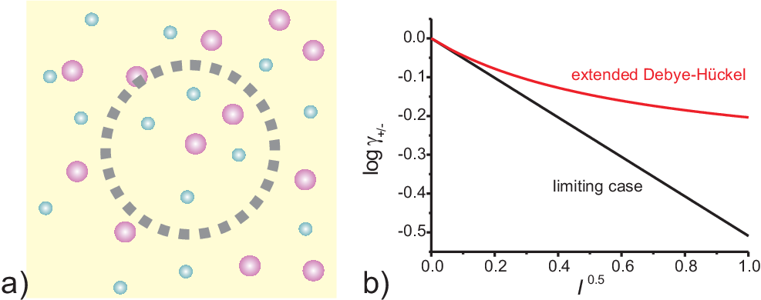
Figure: a) Schematic drawing of the short range order of ions in a solution; b) Debye-Hückel limiting case (red straight line) and the result of extended Debye Hückel theory
The corresponding lowering of the energy is described by the difference to the ideal molar Gibbs energy, and thus is identical to $RTlnγ_{±}$
At very low concentration the activity coefficient can be calculated from the Debye-Hückel limiting law
$$logγ_{±}=|z_{+}z_{-}|A\sqrt{I}$$
where $z_{+} and z_{-}$ are the number of charged cations and anions, A is a constant (depending on temperature and solvent properties; e.g. A=0.509 for aqueous solution at 25 C), and I is the dimensionless ionic strength, defined as
$$I=\frac{1}{2}\sum_{i}{Z_{i}^{2}}(\frac{m_{i}}{m^{o}})$$
These expressions hold for
- Strong electrolytes
- Low concentration (up to 10⁻² mol/L)
- Low charges
For higher concentration the extended Debye Hückel (or Davies) equation can be used:
$$logγ_{±}=\frac{|z_{+}z_{-}|A\sqrt{I}}{I+B\sqrt{I}}+CI$$
The following table shows some typical activity coefficients $γ_{±}$ in water at 298 K.
b/bº | KCl | CaCl₂
0.001 | 0.966 | 0.888
0.01 | 0.902 | 0.732
0.1 | 0.770 | 0.524
1 | 0.607 | 0.725

Q.8.b.
Ans. Nernst equation
Imagine now that the current is flowing at the reference electrode. At this electrode a species’ amount of n is converted. This conversion leads to a change of the surface or the concentration of the solution surrounding the electrode. The Nernst equation shows a clear correlation between the potential E of an electrode and its surrounding:
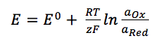
E⁰ is the standard potential of the redox couple Red and Ox. R is the gas constant and T the temperature. The activity of the oxidized and reduced form of the species a_{Ox} and a_{Red} in the surrounding solution is not always easy to predict. This often leads to a simplification of the equation:
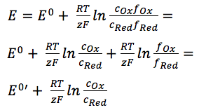Equation 3.5
The two activity coefficients f_{Ox} and f_{Red} are included in the resulting potential E^{0’}, which is called the formal potential. Since it contains parameters that depend on the environment, such as temperature and activity coefficients, E^{0’} cannot be listed but needs to be determined for each experiment, if necessary. Most experiments in analytical chemistry are performed at room temperature (295 K). This makes another simplification possible. Out of convenience also the ln will be transferred to the log.
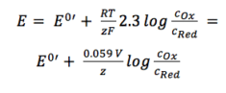
For practical application equation is the most used form of the Nernst equation. For many applications one can assume that E⁰ is roughly the same as E^{0’}, because both of the activity coefficients are close to one. In this form the correlation between the surrounding of an electrode and its potential is visible more easily. The change of the solution surrounding the reference electrode, due to a flowing current, leads to a change of the potential that is supposed to be our fixed reference point. But we cannot limit the current flow through the reference electrode (RE), because all limitations should be caused by the process that we want to investigate, that is the process at the working electrode (WE).
Q.8.c.
Electrochemical series: Arranging redox equilibria in order of their E° values
The electrochemical series is built up by arranging various redox equilibria in order of their standard electrode potentials (redox potentials). The most negative E° values are placed at the top of the electrochemical series, and the most positive at the bottom.
Each E° value shows whether the position of the equilibrium lies to the left or right of the hydrogen equilibrium. That difference in the positions of equilibrium causes the number of electrons which build up on the metal electrode and the platinum of the hydrogen electrode to be different. That produces a potential difference which is measured as a voltage.

equilibrium | E° (volts)
 | -3.03
 | -2.92
 | -2.87
 | -2.71
 | -2.37
 | -1.66
 | -0.76
 | -0.44
 | -0.13
 | 0
 | +0.34
 | +0.80
 | +1.50
Obviously if one standard hydrogen electrode is connected to another one, there will be no difference whatsoever between the positions of the two equilibria. The number of electrons built up on each electrode will be identical and so there will be a potential difference of zero between them.
Oxidation / reduction and the electrochemical series
Oxidation and reduction in terms of electron transfer
When solid magnesium forms its ions, it loses electrons. The magnesium is being oxidised.
When the copper(II) ions gain electrons to form copper, they are being reduced.
Reducing agents and oxidising agents
A reducing agent reduces something else. That must mean that it gives electrons to it.
Magnesium is good at giving away electrons to form its ions. Magnesium must be a good reducing agent. An oxidising agent oxidises something else. That must mean that it takes electrons from it.
Copper doesn't form its ions very readily, and its ions easily pick up electrons from somewhere to revert to metallic copper. Copper(II) ions must be good oxidising agents.
Metals at the top of the series are good at giving away electrons. They are good reducing agents. The reducing ability of the metal increases as you go up the series.
Metal ions at the bottom of the series are good at picking up electrons. They are good oxidising agents. The oxidising ability of the metal ions increases as you go down the series.

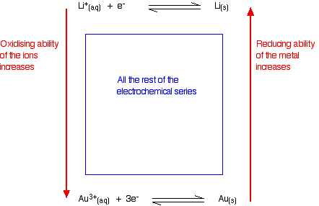

Judging the oxidising or reducing ability from E° values
The more negative the E° value, the more the position of equilibrium lies to the left - the more readily the metal loses electrons. The more negative the value, the stronger reducing agent the metal is. The more positive the E° value, the more the position of equilibrium lies to the right - the less readily the metal loses electrons, and the more readily its ions pick them up again. The more positive the value, the stronger oxidising agent the metal ion is.


Q.2.b.
Ans. Heisenberg's Uncertainty Principle
Heisenberg's Uncertainty Principle states that there is inherent uncertainty in the act of measuring a variable of a particle. Commonly applied to the position and momentum of a particle, the principle states that the more precisely the position is known the more uncertain the momentum is and vice versa. This is contrary to classical Newtonian physics which holds all variables of particles to be measurable to an arbitrary uncertainty given good enough equipment. Newtonian physics placed no limits on how better procedures and techniques could reduce measurement uncertainty so that it was conceivable that with proper care and accuracy all information could be defined. Heisenberg made the bold proposition that there is a lower limit to this precision making our knowledge of a particle inherently uncertain.
More specifically, if one knows the precise momentum of the particle, it is impossible to know the precise position, and vice versa. This relationship also applies to energy and time, in that one cannot measure the precise energy of a system in a finite amount of time. Uncertainties in the products of “conjugate pairs” (momentum/position) and (energy/time) were defined by Heisenberg as having a minimum value corresponding to Planck’s constant divided by 4π. More clearly:
$$∆p∆x≥\frac{h}{4π}$$
$$∆E∆t≥\frac{h}{4π}$$
Where Δ refers to the uncertainty in that variable and h is Planck's constant.
Aside from the mathematical definitions, one can make sense of this by imagining that the more carefully one tries to measure position, the more disruption there is to the system, resulting in changes in momentum. For example compare the effect that measuring the position has on the momentum of an electron versus a tennis ball. Let’s say to measure these objects, light is required in the form of photon particles. These photon particles have a measurable mass and velocity, and come into contact with the electron and tennis ball in order to achieve a value in their position. As two objects collide with their respective momenta (p=mv), they impart theses momenta onto each other. When the photon contacts the electron, a portion of its momentum is transferred and the electron will now move relative to this value depending on the ratio of their mass. The larger tennis ball when measured will have a transfer of momentum from the photons as well, but the effect will be lessened because its mass is several orders of magnitude larger than the photon.
All Quantum behaviour follows this principle and it is important in determining spectral line widths, as the uncertainty in energy of a system corresponds to a line width seen in regions of the light spectrum explored in Spectroscopy.

Q.2.c.
Ans. 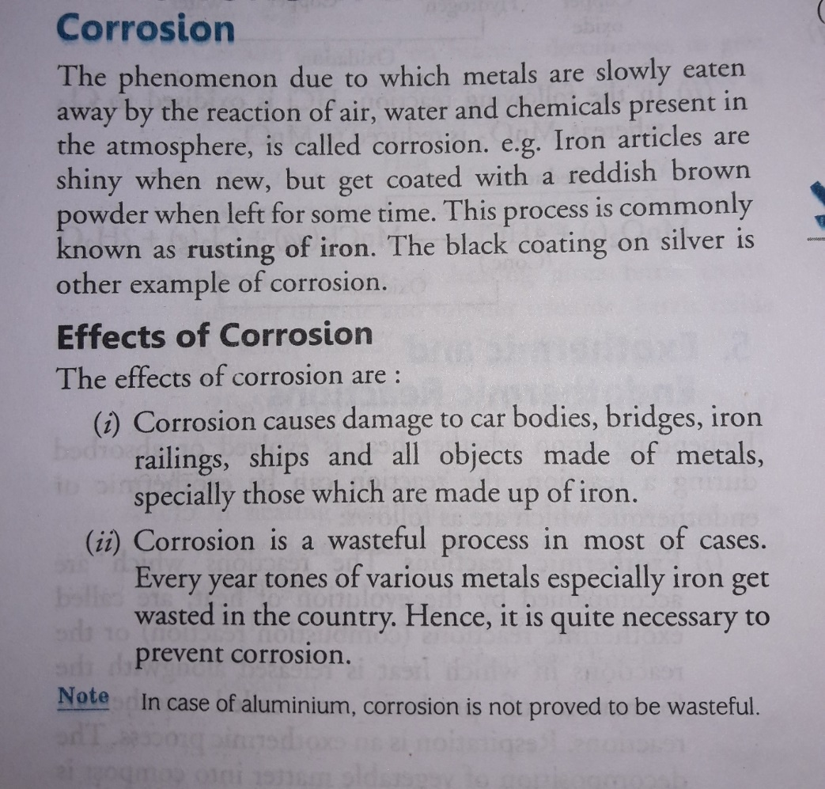


Q.3.a.
Ans.
Q.3.b.
Ans. Jahn Teller theorem
The Jahn-Teller Theorem (named after Hermann Arthur Jahn and Edward Teller), was published in 1937 and essentially means that:
"any non-linear molecular system in a degenerate electronic state will be unstable and will undergo distortion to form a system of lower symmetry and lower energy thereby removing the degeneracy"
In an octahedral crystal field, the t_{2g} orbitals occur at lower energy than the e_{g} orbitals. This is a reflection of the orientation of the orbitals since the t_{2g} are directed between bond axes while the e_{g} point along bond axes. The shielding effect this has on the electrons is used to explain why the Jahn-Teller effect is generally only important for odd number occupancy of the e_{g} level.
The effect of Jahn-Teller distortions is best documented for Cu(II) complexes (with 3 electrons in the e_{g} level) where the result is that most complexes are found to have elongation along the z-axis.
Q.3.c.

Ans. Column Chromatography
When the mobile phase along with the mixture that needs to be separated is introduced from the top of the column, the movement of the individual components of the mixture is at different rates. The components with lower adsorption and affinity to the stationary phase travel faster when compared to the greater adsorption and affinity with the stationary phase. The components that move fast are removed first whereas the components that move slowly are eluted out last.
The adsorption of solute molecules to the column occurs in a reversible manner. The rate of the movement of the components is expressed as:
R_{f} = the distance travelled by solute/ the distance travelled by the solvent
R_{f} is retardation factor
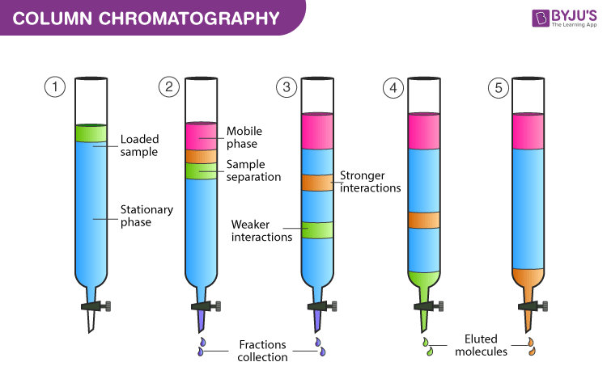
Column Chromatography Diagram
Elution is a chemical process that involves removing a material’s ions by ion exchange with another material. The chromatographic technique of extracting an adsorbed substance from a solid adsorbing media using a solvent. The eluent is the solvent or mobile phase that passes through the column. When the polarity of the eluent matches the polarity of the molecules in the sample, the molecules desorb from the adsorbent and dissolve in the eluent.
The fraction of the mobile phase that transports the sample components is known as eluent. The mixture of solute and solvent that exits the column is known as an eluate. The eluate is made up of the mobile phase and analytes. A substance that separates and moves constituents of a mixture through the column of a chromatograph. The eluent in liquid chromatography is a liquid solvent whereas in gas chromatography is a carrier gas.

Column Chromatography Procedure
Mobile phase – This phase is made up of solvents and it performs the following functions:
- It acts as a solvent-sample mixture that can be introduced in the column.
- It acts as a developing agent – helps in the separation of components in the sample to form bands.
- It acts as an eluting agent – the components that are separated during the experiment are removed from the column
- Some examples of solvents used as mobile phases based on their polarity are – ethanol, acetone, water, acetic acid, pyridine, etc.
Stationary phase – It is a solid material which should have good adsorption properties and meet the conditions given below:
- Shape and size of particle: Particles should have a uniform shape and size in the range of 60 – 200μ in diameter.
- Stability and inertness of particles: high mechanical stability and chemically inert. Also, no reaction with acids or bases or any other solvents was used during the experiment.
- It should be colourless, inexpensive and readily available.
- Should allow free flow of mobile phase
- It should be suitable for the separation of mixtures of various compounds.

Column Chromatography Experiment
- The stationary phase is made wet with the help of solvent as the upper level of the mobile phase and the stationary phase should match. The mobile phase or eluent is either solvent or a mixture of solvents. In the first step the compound mixture that needs to be separated, is added from the top of the column without disturbing the top level. The tap is turned on and the adsorption process on the surface of silica begins.
- Without disturbing the stationary phase solvent mixture is added slowly by touching the sides of the glass column. The solvent is added throughout the experiment as per the requirement.
- The tap is turned on to initiate the movement of compounds in the mixture. The movement is based on the polarity of molecules in the sample. The non-polar components move at a greater speed when compared to the polar components.
- For example, a compound mixture consists of three different compounds viz red, blue, green then their order based on polarity will be as follows blue>red>green
- As the polarity of the green compound is less, it will move first. When it arrives at the end of the column it is collected in a clean test tube. After this, the red compound is collected and at last blue compound is collected. All these are collected in separate test tubes.
Q.4.a.
Ans.
Valence Bond theory describes covalent bond formation as well as the electronic structure of molecules. The theory assumes that electrons occupy atomic orbitals of individual atoms within a molecule, and that the electrons of one atom are attracted to the nucleus of another atom. This attraction increases as the atoms approach one another until the atoms reach a minimum distance where the electron density begins to cause repulsion between the two atoms. This electron density at the minimum distance between the two atoms is where the lowest potential energy is acquired, and it can be considered to be what holds the two atoms together in a chemical bond.
Postulates of Valence Bond Theory
The important postulates of the valence bond theory are listed below.
- Covalent bonds are formed when two valence orbitals (half-filled) belonging to two different atoms overlap on each other. The electron density in the area between the two bonding atoms increases as a result of this overlapping, thereby increasing the stability of the resulting molecule.
- The presence of many unpaired electrons in the valence shell of an atom enables it to form multiple bonds with other atoms. The paired electrons present in the valence shell do not take participate in the formation of chemical bonds as per the valence bond theory.
- Covalent chemical bonds are directional and are also parallel to the region corresponding to the atomic orbitals that are overlapping.
- Sigma bonds and pi bonds differ in the pattern that the atomic orbitals overlap in, i.e. pi bonds are formed from sidewise overlapping whereas the overlapping along the axis containing the nuclei of the two atoms leads to the formation of sigma bonds.
The formation of sigma and pi bonds is illustrated below.
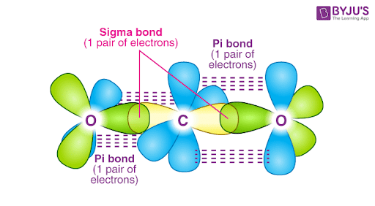
It can be noted that sigma bonds involve the head-to-head overlapping of atomic orbitals whereas pi bonds involve parallel overlapping.
Number of Orbitals and Types of Hybridization
According to VBT theory the metal atom or ion under the influence of ligands can use its (n-1)d, ns, np, or ns, np, nd orbitals for hybridization to yield a set of equivalent orbitals of definite geometry such as octahedral, tetrahedral, square planar and so on. These hybrid orbitals are allowed to overlap with ligand orbitals that can donate electron pairs for bonding.
Coordination Number | Type of Hybridisation | Distribution of Hybrid Orbitals in Space
4 | sp³ | Tetrahedral
4 | dsp² | Square planar
5 | sp³d | Trigonal bipyramidal
6 | sp³d² | Octahedral
6 | d²sp³ | Octahedral
Q.4.b.
Ans.
In certain cases, molecules can be represent by more than one reasonable Lewis structure that differ only in the location of π electrons. Electrons in σ bonds have a fixed location and so they are said to be localised. In contrast, π electrons that can be drawn in different locations are said to be delocalised. Collectively these Lewis diagrams are then known as resonance structures or resonance contributors or resonance canonicals. The "real" structure has characteristics of each of the contributors, and is often represented as the resonance hybrid (think of a hybrid breed which is a mixed breed). In a way, the resonance hybrid is a mixture of the contributors.
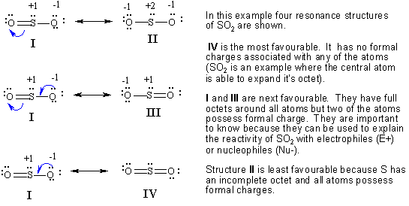
Q.4.c.
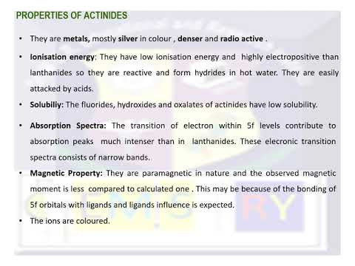
Q.5.a.
Ans.
Einstein’s photoelectric equation establish the ‘Particle Nature’ of electron. It is based on conservation of energy. Einstein received Noble prize for photoelectric equation. The photoelectric effect is a phenomenon in which electrons are ejected from the surface of a metal when light is incident on it. These ejected electrons are called photoelectrons. It is important to note that the emission of photoelectrons and the kinetic energy of the ejected photoelectrons is dependent on the frequency of the light that is incident on the metal’s surface. The process through which photoelectrons are ejected from the surface of the metal due to the action of light is commonly referred to as photoemission.
“Total incident energy of light is used into two forms, same part of the energy is used as a work function and remaining part of the energy is used as a kinetic energy of photo electrons."
Mathematically, Einstein equation can be written as,
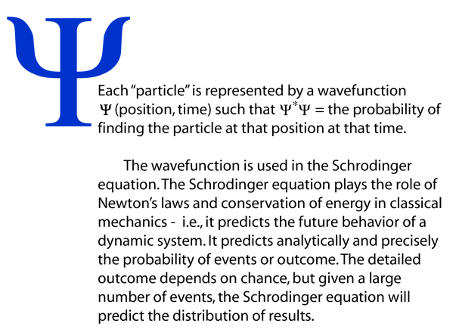
Q.5.b.
Ans.
Q.5.c.
Ans. Fuel cells work like batteries, but they do not run down or need recharging. They produce electricity and heat as long as fuel is supplied. A fuel cell consists of two electrodes—a negative electrode (or anode) and a positive electrode (or cathode)—sandwiched around an electrolyte. A fuel, such as hydrogen, is fed to the anode, and air is fed to the cathode. In a polymer electrolyte membrane fuel cell, a catalyst separates hydrogen atoms into protons and electrons, which take different paths to the cathode. The electrons go through an external circuit, creating a flow of electricity. The protons migrate through the electrolyte to the cathode, where they reunite with oxygen and the electrons to produce water and heat
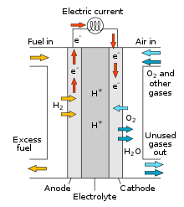
Types of Fuel Cells
Although the basic operations of all fuel cells are the same, special varieties have been developed to take advantage of different electrolytes and serve different application needs. The fuel and the charged species migrating through the electrolyte may be different, but the principle is the same. An oxidation occurs at the anode, while a reduction occurs at the cathode. The two reactions are connected by a charged species that migrates through the electrolyte and electrons that flow through the external circuit.
POLYMER ELECTROLYTE MEMBRANE FUEL CELLS
Polymer electrolyte membrane (PEM) fuel cells, also called proton exchange membrane fuel cells, use a proton-conducting polymer membrane as the electrolyte. Hydrogen is typically used as the fuel. These cells operate at relatively low temperatures and can quickly vary their output to meet shifting power demands. PEM fuel cells are the best candidates for powering automobiles. They can also be used for stationary power production. However, due to their low operating temperature, they cannot directly use hydrocarbon fuels, such as natural gas, liquefied natural gas, or ethanol. These fuels must be converted to hydrogen in a fuel reformer to be able to be used by a PEM fuel cell.
DIRECT-METHANOL FUEL CELLS
The direct-methanol fuel cell (DMFC) is similar to the PEM cell in that it uses a proton conducting polymer membrane as an electrolyte. However, DMFCs use methanol directly on the anode, which eliminates the need for a fuel reformer. DMFCs are of interest for powering portable electronic devices, such as laptop computers and battery rechargers. Methanol provides a higher energy density than hydrogen, which makes it an attractive fuel for portable devices.
ALKALINE FUEL CELLS
Alkaline fuel cells use an alkaline electrolyte such as potassium hydroxide or an alkaline membrane that conducts hydroxide ions rather than protons. Originally used by the National Aeronautics and Space Administration (NASA) on space missions, alkaline fuel cells are now finding new applications, such as in portable power.
PHOSPHORIC ACID FUEL CELLS
Phosphoric acid fuel cells use a phosphoric acid electrolyte that conducts protons held inside a porous matrix, and operate at about 200°C. They are typically used in modules of 400 kW or greater and are being used for stationary power production in hotels, hospitals, grocery stores, and office buildings, where waste heat can also be used. Phosphoric acid can also be immobilized in polymer membranes, and fuel cells using these membranes are of interest for a variety of stationary power applications.
MOLTEN CARBONATE FUEL CELLS
Molten carbonate fuel cells use a molten carbonate salt immobilized in a porous matrix that conducts carbonate ions as their electrolyte. They are already being used in a variety of medium-to-large-scale stationary applications, where their high efficiency produces net energy savings. Their high-temperature operation (approximately 600°C) enables them to internally reform fuels such as natural gas and biogas.
SOLID OXIDE FUEL CELLS
Solid oxide fuel cells use a thin layer of ceramic as a solid electrolyte that conducts oxide ions. They are being developed for use in a variety of stationary power applications, as well as in auxiliary power devices for heavy-duty trucks. Operating at 700°C–1,000°C with zirconia-based electrolytes, and as low as 500°C with ceria-based electrolytes, these fuel cells can internally reform natural gas and biogas, and can be combined with a gas turbine to produce electrical efficiencies as high as 75%.
COMBINED HEAT AND POWER FUEL CELLS
In addition to electricity, fuel cells produce heat. This heat can be used to fulfill heating needs, including hot water and space heating. Combined heat and power fuel cells are of interest for powering houses and buildings, where total efficiency as high as 90% is achievable. This high-efficiency operation saves money, saves energy, and reduces greenhouse gas emissions.
REGENERATIVE OR REVERSIBLE FUEL CELLS
This special class of fuel cells produces electricity from hydrogen and oxygen, but can be reversed and powered with electricity to produce hydrogen and oxygen. This emerging technology could provide storage of excess energy produced by intermittent renewable energy sources, such as wind and solar power stations, releasing this energy during times of low power production.
Q.6.a.
Ans. An electron-deficient compound is one in which the central atom’s octet is incomplete due to a lack of electrons. The number of electrons in these compounds is insufficient to form conventional electron-pair bonds between the linked atoms.
Example: Electron-deficient compounds, such as B₂F₆, Al₂Cl₆, and others, have less than 8 electrons in their valence shells. Electron excess compounds, on the other hand, are those with more In order to engage all of their valence orbitals in bonding, the atoms in electron deficient compounds sometimes form three-centre two-electron (3c-2e) bonds. In a 3c-2e bond, the two electrons are shared by three atoms with each atom contributing one orbital to the formation of the bond. than 8 electrons in the valence shells, such as SF₆, O₈F₈, and so on.
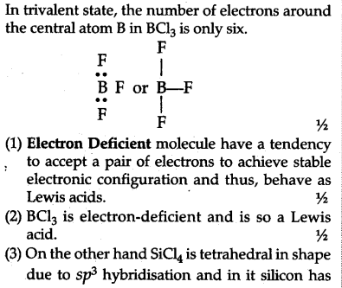
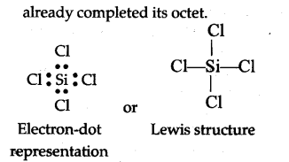
Q.6.b.
Ans. Valence Shell Electron Pair Repulsion Theory (VSEPR)
Lewis’ concept is unable to explain the shapes of molecules. VSEPR theory provides a simple procedure to predict the shapes of covalent molecules. Scientists Sidgwick and Powell in 1940, proposed a simple theory based on the repulsive interactions of the electron pairs in the valence shell of the atoms. The above theory was further developed and redefined by Nyholm and Gillespie (1957). The main postulates of VSEPR theory
are as given below:
- The number of valence shell electron pairs (bonded and non-bonded) around the central atom determine the shape of a molecule.
- Pairs of electrons in the valence shell repel one another because their electron clouds are negatively charged.
- These pairs of electrons occupy such positions in space that reduce repulsion to a minimum and thus maximize the distance between them.
- The valence shell of the central atom is considered as a sphere with the electron pairs localizing on the spherical surface. These electron pairs are at maximum distance from one another.
- The two or three electron pairs of multiple bonds are treated as a single super pair.
- When two or more resonance structures can represent a molecule, the VSEPR model is applicable to such a structure.
The repulsive interaction of electron pairs decreases in order.
Lone pair (Ip) – Lone pair (Ip) > Lone pair (lp) – Bond pair (bp) > Bond pair – bond pair (bp)
Nyholm and Gillespie clearly explained the difference between lone pairs and bonding pairs of electrons. The lone pair is localised on the central atom and is attracted to one nucleus. Each bonded pair is shared between two atoms and thus attracted by two nuclei. Because of this, the lone pairs of electrons in a molecule occupy more space as compared to the bonding pairs of electrons. This results in greater repulsion between
lone pairs of electrons as compared to the lone pair-bond pair and bond pair-bond pair repulsions. These repulsions result in a deviation from the expected shape (idealised) and alterations in bond angles in molecules. VSEPR theory is helpful to predict the geometrical shapes of molecules.
Here we have two categories
- molecules in which the central atom has no lone pairs
- molecules in which the central atom has one or more lone pairs.
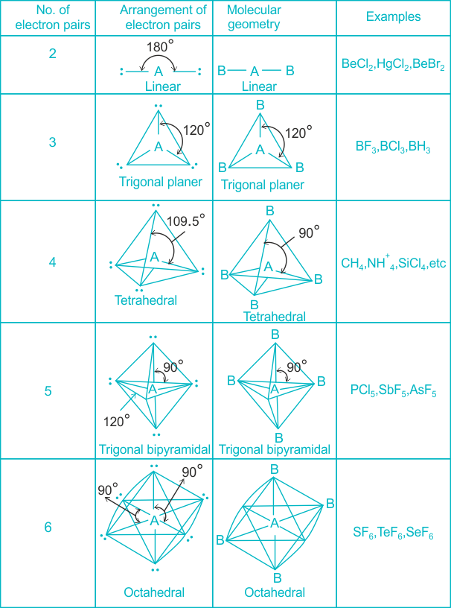
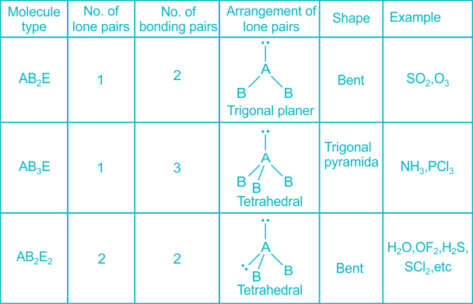
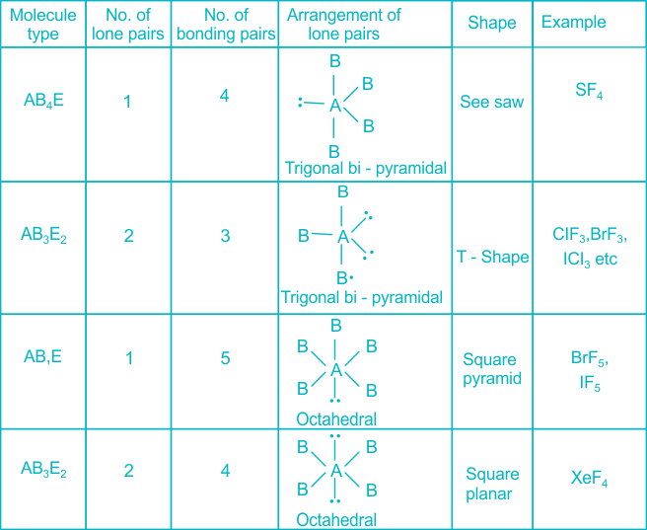
The VSEPR model is able to predict the geometry of a large number of molecules. It is more applicable for compounds of p-block elements.
Q.6.c.

Ans. The oxidation state of lanthanides
The oxidation state of all lanthanide elements is +3. Some metals were formerly thought to have +2 oxidation states. A few lanthanide metals exhibit +4 oxidation states on rare occasions.
The oxidation state of lanthanides is affected by the stability of the f-subshell in such a way that the +4 oxidation state of cerium is preferred because it acquires a noble gas configuration, but it reverts to a +3 oxidation state and thus acts as a strong oxidant and can even oxidise water, though the reaction is slow.
Q.7.a.
Ans. Nernst equation
Imagine now that the current is flowing at the reference electrode. At this electrode a species’ amount of n is converted. This conversion leads to a change of the surface or the concentration of the solution surrounding the electrode. The Nernst equation shows a clear correlation between the potential E of an electrode and its surrounding:
E⁰ is the standard potential of the redox couple Red and Ox. R is the gas constant and T the temperature. The activity of the oxidized and reduced form of the species a_{Ox} and a_{Red} in the surrounding solution is not always easy to predict. This often leads to a simplification of the equation:
Equation 3.5
The two activity coefficients f_{Ox} and f_{Red} are included in the resulting potential E^{0’}, which is called the formal potential. Since it contains parameters that depend on the environment, such as temperature and activity coefficients, E^{0’} cannot be listed but needs to be determined for each experiment, if necessary. Most experiments in analytical chemistry are performed at room temperature (295 K). This makes another simplification possible. Out of convenience also the ln will be transferred to the log.
For practical application equation is the most used form of the Nernst equation. For many applications one can assume that E⁰ is roughly the same as E^{0’}, because both of the activity coefficients are close to one. In this form the correlation between the surrounding of an electrode and its potential is visible more easily. The change of the solution surrounding the reference electrode, due to a flowing current, leads to a change of the potential that is supposed to be our fixed reference point. But we cannot limit the current flow through the reference electrode (RE), because all limitations should be caused by the process that we want to investigate, that is the process at the working electrode (WE).
Q.7.b.
Ans. Kohlrausch’s law
Kohlrausch’s law states that the equivalent conductivity of an electrolyte at infinite dilution is equal to the sum of the conductance of the anions and cations.
The molar conductivity of a solution at a given concentration is the conductance of the volume of solution containing one mole of electrolyte kept between two electrodes with the unit area of cross-section and distance of unit length. The molar conductivity of a solution increases with the decrease in concentration. This increase in molar conductivity is because of the increase in the total volume containing one mole of the electrolyte. When the concentration of the electrolyte approaches zero, the molar conductivity is known as limiting molar conductivity, Ë_{m}°.
Kohlrausch observed certain regularities while comparing the values of limiting molar conductivities of some strong electrolytes. On the basis of his observations, Kohlrausch proposed “limiting molar conductivity of an electrolyte can be represented as the sum of the individual contributions of the anions and cations of the electrolyte”. This law is popularly known as Kohlrausch law of independent migration of ions. For example, limiting molar conductivity, Λ of sodium chloride can be determined with the knowledge of limiting molar conductivities of sodium ion and chloride ion.
Some important applications of Kohlrausch law of independent migration of ions are:
- Kohlrausch law helps us in the determination of limiting molar conductivities for any electrolyte. Weak electrolytes have lower molar conductivities and lower degree of dissociation at higher concentrations. The graph plotted between molar conductivity and c^{1/2} (where c is the concentration) is not a straight line for weak electrolytes. The molar conductivity of weak electrolyte increases steeply at lower concentrations. Therefore, limiting molar conductivity, Λ cannot be obtained by extrapolation of molar conductivity to zero concentration. Hence, we use the Kohlrausch law of independent migration of ions for the determination of limiting molar conductivity, Λ for weak electrolytes.
- Kohlrausch law also helps us in determining the value of dissociation constant from the value of molar conductivity and limiting molar conductivity for a weak electrolyte at a given concentration.
$$α=\frac{Λ}{Ëm°}$$

Where,
α = dissociation constant
Λ = molar conductivity
Ë_{m}° = limiting molar conductivity
Q.7.c.
Ans. Thermal energy relates direction to motion at the molecular level. As the temperature rises, molecules move faster and collide more vigorously, greatly increasing the likelihood of bond cleavages and rearrangements. Whether it is through the collision theory, transition state theory, or just common sense, chemical reactions are typically expected to proceed faster at higher temperatures and slower at lower temperatures.
In 1890 it was common knowledge that higher temperatures speed up reactions, often doubling the rate for a 10-degree rise, but the reasons for this were not clear. Finally, in 1899, the Swedish chemist Svante Arrhenius (1859-1927) combined the concepts of activation energy and the Boltzmann distribution law into one of the most important relationships in physical chemistry:
This is another form of the exponential decay law. What is "decaying" here is not the concentration of a reactant as a function of time, but the magnitude of the rate constant as a function of the exponent –E_{a} /RT. RT is the average kinetic energy, it becomes apparent that the exponent is just the ratio of the activation energy E_{a} to the average kinetic energy. The larger this ratio, the smaller the rate (hence the negative sign). This means that high temperature and low activation energy favour larger rate constants, and thus speed up the reaction. Because these terms occur in an exponent, their effects on the rate are quite substantial.
Determining the Activation Energy from the Arrhenius equation
can be written in a non-exponential form that is often more convenient to use and to interpret graphically. Taking the logarithms of both sides and separating the exponential and pre-exponential terms yields
$$lnk=lnA-\frac{E_{a}}{RT}$$

Equation is in the form of y=mx+b - the equation of a straight line.
where temperature is the independent variable and the rate constant is the dependent variable. So if one were given a data set of various values of k, the rate constant of a certain chemical reaction at varying temperature T, one could graph ln(k) versus 1/T. From the graph, one can then determine the slope of the line and realize that this value is equal to −Ea/R. One can then solve for the activation energy by multiplying through by -R, where R is the gas constant. This affords a simple way of determining the activation energy from values of k observed at different temperatures, by plotting lnk as a function of 1/T.
Q.8.a.
Ans. Crystal field theory (CFT) describes the breaking of orbital degeneracy in transition metal complexes due to the presence of ligands. CFT qualitatively describes the strength of the metal-ligand bonds. Based on the strength of the metal-ligand bonds, the energy of the system is altered. This may lead to a change in magnetic properties as well as color.
Basic Concept
In Crystal Field Theory, it is assumed that the ions are simple point charges (a simplification). When applied to alkali metal ions containing a symmetric sphere of charge, calculations of bond energies are generally quite successful. The approach taken uses classical potential energy equations that take into account the attractive and repulsive interactions between charged particles (that is, Coulomb's Law interactions).
$$E∝\frac{q_{1}q_{2}}{r}$$
with
- E the bond energy between the charges and
- q₁ and q₂ are the charges of the interacting ions and
- r is the distance separating them.
This approach leads to the correct prediction that large cations of low charge, such as K⁺ and Na⁺, should form few coordination compounds. For transition metal cations that contain varying numbers of d electrons in orbitals that are NOT spherically symmetric, however, the situation is quite different. The shapes and occupations of these d-orbitals then become important in building an accurate description of the bond energy and properties of the transition metal compound.
When examining a single transition metal ion, the five d-orbitals have the same energy (Figure). When ligands approach the metal ion, some experience more opposition from the d-orbital electrons than others based on the geometric structure of the molecule. Since ligands approach from different directions, not all d-orbitals interact directly. These interactions, however, create a splitting due to the electrostatic environment.
Figure: Distributing a charge of −6 uniformly over a spherical surface surrounding a metal ion causes the energy of all five d orbitals to increase due to electrostatic repulsions, but the five d orbitals remain degenerate. Placing a charge of −1 at each vertex of an octahedron causes the d orbitals to split into two groups with different energies: the d_{x}²_{−y}² and d_{z}² orbitals increase in energy, while the, d_{xy}, d_{xz}, and d_{yz} orbitals decrease in energy. The average energy of the five d orbitals is the same as for a spherical distribution of a −6 charge, however. Attractive electrostatic interactions between the negatively charged ligands and the positively charged metal ion (far right) cause all five d orbitals to decrease in energy but does not affect the splitting of the orbitals. The two e_{g} orbitals point directly at the six negatively charged ligands, which increases their energy compared with a spherical distribution of negative charge. In contrast, the three t_{2g} orbitals point between the negatively charged ligands, which decreases their energy compared with a spherical distribution of charge.
For example, consider a molecule with octahedral geometry. Ligands approach the metal ion along the x, y and z axes. Therefore, the electrons in the dz² and dx²−y² orbitals (which lie along these axes) experience greater repulsion. It requires more energy to have an electron in these orbitals than it would to put an electron in one of the other orbitals. This causes a splitting in the energy levels of the d-orbitals. This is known as crystal field splitting. For octahedral complexes, crystal field splitting is denoted by Δ_{o} (or Δ_{oct}). The energies of the dz² and dx²−y² orbitals increase due to greater interactions with the ligands. The dxy, dxz, and dyz orbitals decrease with respect to this normal energy level and become more stable.
Electrons in Orbitals
According to the Aufbau principle, electrons are filled from lower to higher energy orbitals (Figure). For the octahedral case above, this corresponds to the d_{xy}, d_{xz}, and d_{yz} orbitals. Following Hund's rule, electrons are filled in order to have the highest number of unpaired electrons. For example, if one had a d³ complex, there would be three unpaired electrons. If one were to add an electron, however, it has the ability to fill a higher energy orbital ( d_{z²} or d_{x²-y²}) or pair with an electron residing in the d_{xy}, d_{xz}, or d_{yz} orbitals. This pairing of the electrons requires energy (spin pairing energy). If the pairing energy is less than the crystal field splitting energy, ∆₀, then the next electron will go into the d_{xy}, d_{xz}, or d_{yz} orbitals due to stability. This situation allows for the least amount of unpaired electrons, and is known as low spin. If the pairing energy is greater than ∆₀, then the next electron will go into the d_{z}² or d_{x}²-_{y}² orbitals as an unpaired electron. This situation allows for the most number of unpaired electrons, and is known as high spin. Ligands that cause a transition metal to have a small crystal field splitting, which leads to high spin, are called weak-field ligands. Ligands that produce a large crystal field splitting, which leads to low spin, are called strong field ligands.
Figure: Low Spin, Strong Field (∆_{o}˃P) High Spin, Weak Field (∆_{o}˂P)Splitting for a d4 complex under a strong field (left) and a weak field (right). The strong field is a low spin complex, while the weak field is a high spin complex.
As mentioned above, CFT is based primarily on symmetry of ligands around a central metal/ion and how this anisotropic (properties depending on direction) ligand field affects the metal's atomic orbitals; the energies of which may increase, decrease or not be affected at all. Once the ligands' electrons interact with the electrons of the d-orbitals, the electrostatic interactions cause the energy levels of the d-orbital to fluctuate depending on the orientation and the nature of the ligands. For example, the oxidation state and the strength of the ligands determine splitting; the higher the oxidation state or the stronger the ligand, the larger the splitting. Ligands are classified as strong or weak based on the spectrochemical series:
I⁻ < Br⁻ < Cl⁻ < SCN⁻ < F⁻ < OH⁻ < ox²⁻< ONO⁻ < H₂O < SCN⁻ < EDTA⁴⁻ < NH₃ < en < NO₂⁻ < CN⁻
Note that SCN⁻ and NO₂- ligands are represented twice in the above spectrochemical series since there are two different Lewis base sites (e.g., free electron pairs to share) on each ligand (e.g., for the SCN⁻ ligand, the electron pair on the sulphur or the nitrogen can form the coordinate covalent bond to a metal). The specific atom that binds in such ligands is underlined.
In addition to octahedral complexes, two common geometries observed are that of tetrahedral and square planar. These complexes differ from the octahedral complexes in that the orbital levels are raised in energy due to the interference with electrons from ligands. For the tetrahedral complex, the d_{xy}, d_{xz}, and d_{yz} orbitals are raised in energy while the d_{z²}, d_{x²-y²} orbitals are lowered. For the square planar complexes, there is greatest interaction with the d_{x²-y²} orbital and therefore it has higher energy. The next orbital with the greatest interaction is d_{xy}, followed below by d_{z²}. The orbitals with the lowest energy are the d_{xz} and d_{yz} orbitals. There is a large energy separation between the d_{z²} orbital and the d_{xz} and d_{yz} orbitals, meaning that the crystal field splitting energy is large. We find that the square planar complexes have the greatest crystal field splitting energy compared to all the other complexes. This means that most square planar complexes are low spin, strong field ligands.
Description of d-Orbitals
To understand CFT, one must understand the description of the lobes:
- d_{xy}: lobes lie in-between the x and the y axes.
- d_{xz}: lobes lie in-between the x and the z axes.
- d_{yz}: lobes lie in-between the y and the z axes.
- d_{x}²-y²: lobes lie on the x and y axes.
- d_{z2}: there are two lobes on the z axes and there is a donut shape ring that lies on the xy plane around the other two lobes.
Figure: Spatial arrangement of ligands in the an octahedral ligand field with respect to the five d-orbitals.
Octahedral Complexes
In an octahedral complex, there are six ligands attached to the central transition metal. The d-orbital splits into two different levels (Figure ). The bottom three energy levels are named dxy, dxz, and dyz (collectively referred to as t_{2g}). The two upper energy levels are named dx²−y² , and dz² (collectively referred to as eg).
The reason they split is because of the electrostatic interactions between the electrons of the ligand and the lobes of the d-orbital. In an octahedral, the electrons are attracted to the axes. Any orbital that has a lobe on the axes moves to a higher energy level. This means that in an octahedral, the energy levels of e_{g} are higher (0.6∆_{o}) while t₂g is lower (0.4∆_{o}). The distance that the electrons have to move from t₂g from eg and it dictates the energy that the complex will absorb from white light, which will determine the colour. Whether the complex is paramagnetic or diamagnetic will be determined by the spin state. If there are unpaired electrons, the complex is paramagnetic; if all electrons are paired, the complex is diamagnetic.
Tetrahedral Complexes
In a tetrahedral complex, there are four ligands attached to the central metal. The d orbitals also split into two different energy levels. The top three consist of the dxy, dxz, and dyz orbitals. The bottom two consist of the dx²−y² and dz² orbitals. The reason for this is due to poor orbital overlap between the metal and the ligand orbitals. The orbitals are directed on the axes, while the ligands are not.
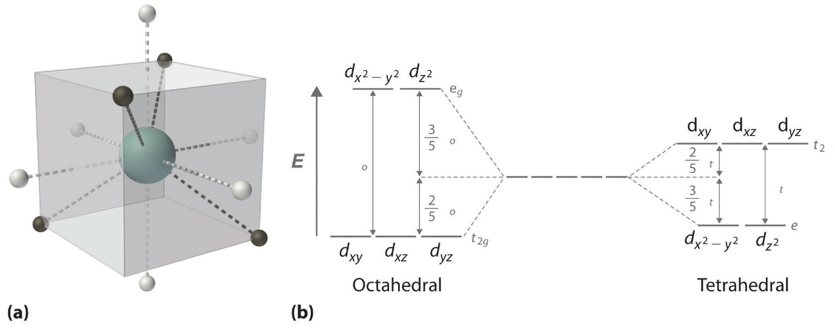Figure: (a) Tetrahedral ligand field surrounding a central transition metal (blue sphere). (b) Splitting of the degenerate d-orbitals (without a ligand field) due to an octahedral ligand field (left diagram) and the tetrahedral field (right diagram).
Consequentially, Δt is typically smaller than the spin pairing energy, so tetrahedral complexes are usually high spin.
Square Planar Complexes
In a square planar, there are four ligands as well. However, the difference is that the electrons of the ligands are only attracted to the xy plane. Any orbital in the xy plane has a higher energy level (Figure). There are four different energy levels for the square planar (from the highest energy level to the lowest energy level): d_{x}²_{-y}², d_{xy}, d_{z}², and both d_{xz} and d_{yz}.
Figure: Splitting of the degenerate d-orbitals (without a ligand field) due to an square planar ligand field.
The splitting energy (from highest orbital to lowest orbital) is Δsp and tends to be larger than Δo. Moreover, Δsp is also larger than the pairing energy, so the square planar complexes are usually low spin complexes.
Q.8.b.
In 1923, G.N. Lewis from UC Berkeley proposed an alternate theory to describe acids and bases. His theory gave a generalized explanation of acids and bases based on structure and bonding. Through the use of the Lewis definition of acids and bases, chemists are now able to predict a wider variety of acid-base reactions. Lewis' theory used electrons instead of proton transfer and specifically stated that an acid is a species that accepts an electron pair while a base donates an electron pair.
Figure: A Lewis Base (B) donates it electrons to a Lewis Acid (A) resulting in a coordinate covalently bonded compound, also known as an adduct.
The reaction of a Lewis acid and a Lewis base will produce a coordinate covalent bond (Figure). A coordinate covalent bond is just a type of covalent bond in which one reactant gives it electron pair to another reactant. In this case the lewis base donates its electrons to the Lewis acid. When they do react this way the resulting product is called an addition compound, or more commonly an adduct.
Lewis Acids
Lewis acids accept an electron pair. Lewis Acids are Electrophilic meaning that they are electron attracting. When bonding with a base the acid uses its lowest unoccupied molecular orbital or LUMO (Figure).
- Various species can act as Lewis acids. All cations are Lewis acids since they are able to accept electrons. (e.g., Cu²⁺, Fe²⁺, Fe³⁺)
- An atom, ion, or molecule with an incomplete octet of electrons can act as an Lewis acid (e.g., BF₃, AlF₃).
- Molecules where the central atom can have more than 8 valence shell electrons can be electron acceptors, and thus are classified as Lewis acids (e.g., SiBr₄, SiF₄).
- Molecules that have multiple bonds between two atoms of different electronegativities (e.g., CO₂, SO₂)
Lewis Bases
Lewis Bases donate an electron pair. Lewis Bases are Nucleophilic meaning that they “attack” a positive charge with their lone pair. They utilize the highest occupied molecular orbital or HOMO (Figure). An atom, ion, or molecule with a lone-pair of electrons can thus be a Lewis base. Each of the following anions can "give up" their electrons to an acid, e.g., OH⁻, CN⁻, CH3COO⁻, :NH³, H₂O, CO:. Lewis base's HOMO (highest occupied molecular orbital) interacts with the Lewis acid's LUMO (lowest unoccupied molecular orbital) to create bonded molecular orbitals. Both Lewis Acids and Bases contain HOMO and LUMOs but only the HOMO is considered for Bases and only the LUMO is considered for Acids (Figure).
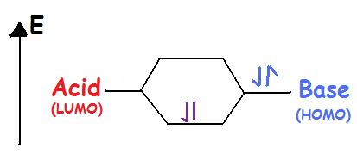
Figure: Lewis Acids have vacant orbitals so they are in a lower energy level. While Lewis bases have lone pair electrons to share and thus occupy a higher energy level.
Complex Ion / Coordination Compounds
Complex ions are polyatomic ions, which are formed from a central metal ion that has other smaller ions joined around it. While Brønsted theory can't explain this reaction Lewis acid-base theory can help. A Lewis Base is often the ligand of a coordination compound with the metal acting as the Lewis acid.
Al³⁺+6H₂O⇌[Al(H₂O)₆]³⁺
The aluminium ion is the metal and is a cation with an unfilled valence shell, and it is a Lewis Acid. Water has lone-pair electrons and is an anion, thus it is a Lewis Base.
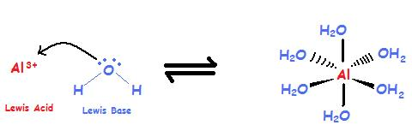
Figure: Aluminium ion acts as a Lewis acid and accepts the electrons from water, which is acting
Q.8.c.
Ans. Thin layer chromatography (TLC) is a chromatographic technique used to separate the components of a mixture using a thin stationary phase supported by an inert backing. It may be performed on the analytical scale as a means of monitoring the progress of a reaction, or on the preparative scale to purify small amounts of a compound. TLC is an analytical tool widely used because of its simplicity, relative low cost, high sensitivity, and speed of separation. TLC functions on the same principle as all chromatography: a compound will have different affinities for the mobile and stationary phases, and this affects the speed at which it migrates. The goal of TLC is to obtain well defined, well separated spots.
After a separation is complete, individual compounds appear as spots separated vertically. Each spot has a retention factor (R_{f}) which is equal to the distance migrated over the total distance covered by the solvent.
The R_{f} value can be used to identify compounds due to their uniqueness to each compound. When comparing two different compounds under the same conditions, the compound with the larger R_{f} value is less polar because it does not stick to the stationary phase as long as the polar compound, which would have a lower R_{f} value.
R_{f} values and reproducibility can be affected by a number of different factors such as layer thickness, moisture on the TLC plate, vessel saturation, temperature, depth of mobile phase, nature of the TLC plate, sample size, and solvent parameters. These effects normally cause an increase in R_{f} values. However, in the case of layer thickness, the R_{f} value would decrease because the mobile phase moves slower up the plate.
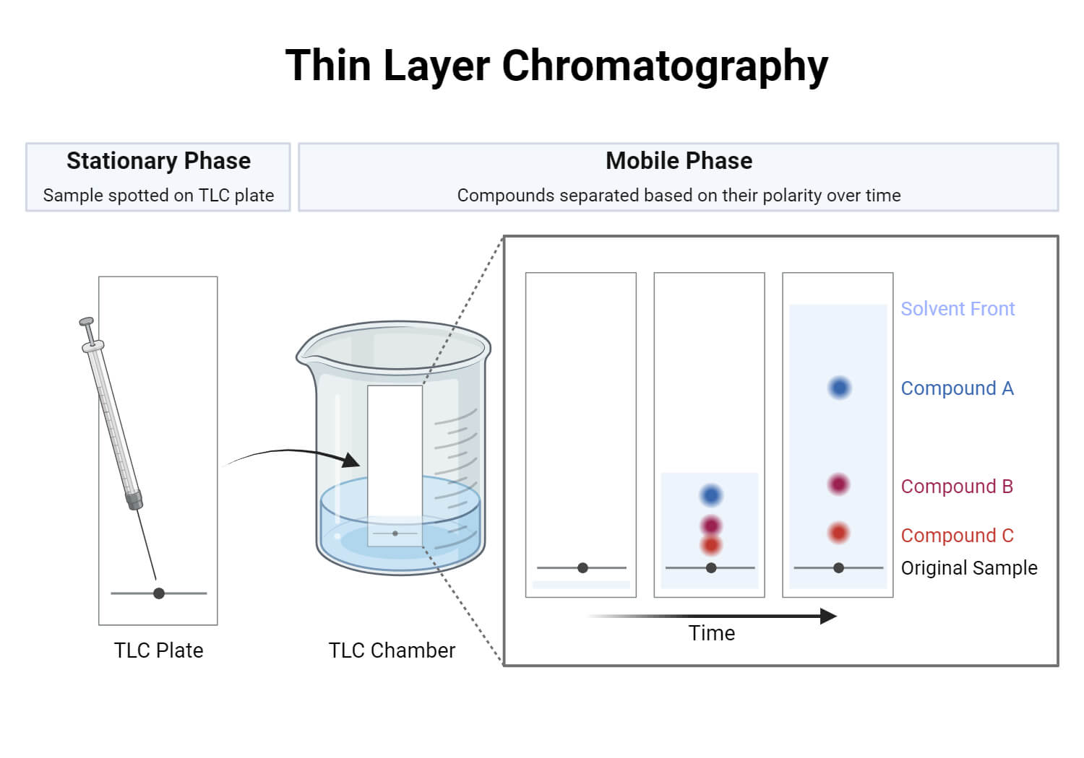

 Q.2.a.
Ans. (i) $rate=k[{NO}_{2}]^{2}$
(ii) One molecule of NO₂ act as a catalyst in above reaction as we can see in the mechanism that it is used in 1st step of reaction but generated in the 2nd step. A catalyst by definition is the one which speeds up reaction without been consumed in the reaction.
(iii) A molecule of NO₃ is generated in the first step and consumed in the 2nd step so it is intermediate in this reaction and it also don’t appear in the overall equation.
Q.2.b.
Ans. Thermal energy relates direction to motion at the molecular level. As the temperature rises, molecules move faster and collide more vigorously, greatly increasing the likelihood of bond cleavages and rearrangements. Whether it is through the collision theory, transition state theory, or just common sense, chemical reactions are typically expected to proceed faster at higher temperatures and slower at lower temperatures.
In 1890 it was common knowledge that higher temperatures speed up reactions, often doubling the rate for a 10-degree rise, but the reasons for this were not clear. Finally, in 1899, the Swedish chemist Svante Arrhenius (1859-1927) combined the concepts of activation energy and the Boltzmann distribution law into one of the most important relationships in physical chemistry:
This is another form of the exponential decay law. What is "decaying" here is not the concentration of a reactant as a function of time, but the magnitude of the rate constant as a function of the exponent –E_{a} /RT. RT is the average kinetic energy, it becomes apparent that the exponent is just the ratio of the activation energy E_{a} to the average kinetic energy. The larger this ratio, the smaller the rate (hence the negative sign). This means that high temperature and low activation energy favour larger rate constants, and thus speed up the reaction. Because these terms occur in an exponent, their effects on the rate are quite substantial.
Determining the Activation Energy from the Arrhenius equation
can be written in a non-exponential form that is often more convenient to use and to interpret graphically. Taking the logarithms of both sides and separating the exponential and pre-exponential terms yields
$$lnk=lnA-\frac{E_{a}}{RT}$$

Equation is in the form of y=mx+b - the equation of a straight line.
where temperature is the independent variable and the rate constant is the dependent variable. So if one were given a data set of various values of k, the rate constant of a certain chemical reaction at varying temperature T, one could graph ln(k) versus 1/T. From the graph, one can then determine the slope of the line and realize that this value is equal to −Ea/R. One can then solve for the activation energy by multiplying through by -R, where R is the gas constant. This affords a simple way of determining the activation energy from values of k observed at different temperatures, by plotting lnk as a function of 1/T.
Q.3.a.
Ans. The phenomenon where an explosion is considered adiabatic (i.e., with negligible heat transfer) despite the rapidly expanding gaseous products not being at the same temperature as their surroundings and despite the boundary permitting heat transfer, can be explained by examining the timescales and mechanisms involved in the explosion.
- Rapid Expansion: Explosions involve the release of a large amount of energy in a very short period. This leads to the rapid expansion of gases, creating a shockwave. While the temperature of the explosion products may be high initially, their expansion causes a rapid drop in temperature due to adiabatic cooling.
- Timescale: Adiabatic processes occur without the transfer of heat, but they do allow for the exchange of energy in other forms, such as work. In an explosion, the timescale for the initial expansion and cooling is extremely short. Heat transfer takes time, and the speed at which gases expand during an explosion often outpaces the rate at which significant heat exchange can occur between the gases and their surroundings.
- Insulating Effect: Explosions are typically characterized by a sudden release of energy, and the medium through which the explosion propagates (e.g., air) can act as a barrier to heat transfer. The shockwave created by the explosion can form a temporary boundary that insulates the rapidly expanding gases from their surroundings. As a result, the actual heat exchange may be much less than what might be expected if the system were allowed to equilibrate slowly.
- Local Variations: While the explosion products may not be at the same temperature as their surroundings, there can be significant temperature variations within the expanding gases. Some regions may be hotter than others, and heat transfer between these regions and the surroundings can be limited by the shockwave and the speed of expansion.
- Effective Adiabatic Process: In practical terms, for the purpose of analysing explosions, it is often convenient to treat the process as adiabatic even if there is some heat transfer. This simplification is valid in many cases because the heat transfer is relatively small compared to the other energy changes involved in the explosion. The heat transfer is often secondary to the expansion and pressure changes.
In summary, while it may appear that there is heat transfer in an explosion due to the temperature differences between the expanding gases and their surroundings, the rapid nature of the explosion, the insulating effects of the shockwave, and the relatively small amount of heat transfer compared to other energy changes justify the approximation of treating the explosion as adiabatic for analytical and modeling purposes
Q.3.b.
Ans. A Carnot cycle is defined as an ideal reversible closed thermodynamic cycle. Four successive operations are involved: isothermal expansion, adiabatic expansion, isothermal compression, and adiabatic compression. During these operations, the expansion and compression of the substance can be done up to the desired point and back to the initial state.
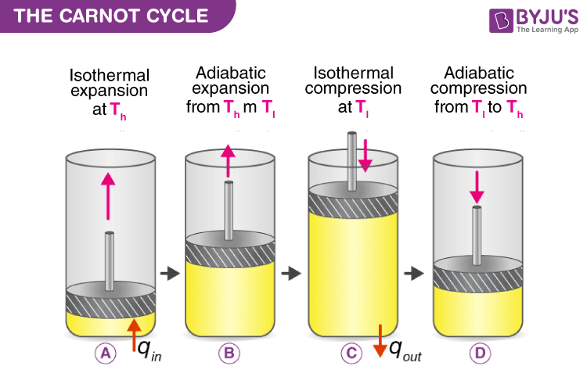
Following are the four processes of the Carnot cycle:
- In (a), the process is reversible isothermal gas expansion. In this process, the amount of heat absorbed by the ideal gas is q_{in} from the heat source at a temperature of T_{h}. The gas expands and does work on the surroundings.
- In (b), the process is reversible adiabatic gas expansion. Here, the system is thermally insulated, and the gas continues to expand and work is done on the surroundings. Now the temperature is lower, T_{l}.
- In (c), the process is a reversible isothermal gas compression process. Here, the heat loss q_{out} occurs when the surroundings do the work at temperature T_{l}.
- In (d), the process is reversible adiabatic gas compression. Again the system is thermally insulated. The temperature again rises back to T_{h} as the surrounding continue to do their work on the gas.

Steps involved in a Carnot Cycle
For an ideal gas operating inside a Carnot cycle, the following are the steps involved:

Step 1:
Isothermal expansion: The gas is taken from P₁, V₁, T₁ to P₂, V₂, T₂. Heat Q₁ is absorbed from the reservoir at temperature T₁. Since the expansion is isothermal, the total change in internal energy is zero, and the heat absorbed by the gas is equal to the work done by the gas on the environment, which is given as:
$$w_{1→2}=q_{1}=μ×R×T_{1}×ln\frac{V_{1}}{V_{2}}$$

Step 2:
Adiabatic expansion: The gas expands adiabatically from P₂, V₂, T₁ to P₃, V₃, T₂.
Here, work done by the gas is given by:
$$w_{2→3}=\frac{μR}{μ-1}{(T}_{1}-T_{2})$$

Step 3:
Isothermal compression: The gas is compressed isothermally from the state (P₃, V₃, T₂) to (P₄, V₄, T₂).
Here, the work done on the gas by the environment is given by:
$$w_{3→4}=μ×R×T_{2}×ln\frac{V_{3}}{V_{4}}$$

Step 4:
Adiabatic compression: The gas is compressed adiabatically from the state (P₄, V₄, T₂) to (P₁, V₁, T₁).
Here, the work done on the gas by the environment is given by:
$$w_{4→1}=\frac{μR}{μ-1}{(T}_{1}-T_{2})$$

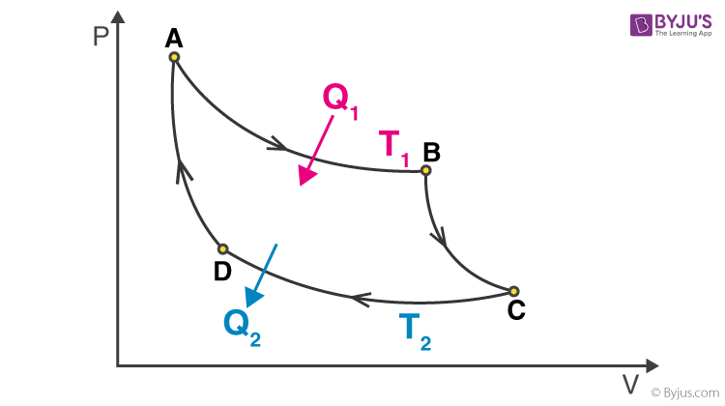

Q.4.a.
Ans. The Schrödinger equation for a particle in a three-dimensional (3-D) box potential is given by:
$$\frac{-ħ^{2}}{2m}\left(\frac{∂^{2}Ψ}{{∂x}^{2}}+\frac{∂^{2}Ψ}{{∂y}^{2}}+\frac{∂^{2}Ψ}{{∂z}^{2}}\right)+V\left(x,y,z\right)=EΨ$$
In this case, the potential energy V(x,y,z) is zero within the box (finite well) and infinite outside of it. The box has sides of length Lx​, Ly​, and Lz​ in the x, y, and z dimensions, respectively.
To solve the Schrödinger equation, we'll need to separate variables by assuming a product solution of the form:
$$Ψ\left(x,y,z\right)=X\left(x\right).Y\left(y\right).Z(z)$$
Substituting this into the Schrödinger equation, we obtain three separate ordinary differential equations (ODEs), one for each dimension:
Now each function has its own variable:
X(x) is a function of variable x only
Y(y) is a function of variable y only
Z(z) is a function of variable z only
$$\frac{∂^{2}Ψ}{{∂x}^{2}}=YZ\frac{∂^{2}X}{{∂x}^{2}}⇒\frac{1}{X}\frac{∂^{2}X}{{∂x}^{2}}$$
$$\frac{∂^{2}Ψ}{{∂y}^{2}}=XZ\frac{∂^{2}Y}{{∂y}^{2}}⇒\frac{1}{Y}\frac{∂^{2}Y}{{∂y}^{2}}$$
$$\frac{∂^{2}Ψ}{{∂z}^{2}}=XY\frac{∂^{2}Z}{{∂z}^{2}}⇒\frac{1}{X}\frac{∂^{2}Z}{{∂z}^{2}}$$
E is an energy constant, and is the sum of its components. For this to work, each term must equal its own constant. For example,
$$(\frac{-ħ^{2}}{2m}\frac{∂^{2}X}{{∂x}^{2}})+(\frac{-ħ^{2}}{2m}\frac{∂^{2}Y}{{∂y}^{2}})+(\frac{-ħ^{2}}{2m}\frac{∂^{2}Z}{{∂z}^{2}})=EΨ$$
ε_{x}+ε_{y}+ε_{z}=E
$\frac{∂^{2}X}{{∂x}^{2}}+\frac{2m}{ħ^{2}}E_{x}$=0$≈\frac{∂^{2}Ψ}{{∂x}^{2}}=-\frac{{4π}^{2}}{λ^{2}}$
Use the normalization wavefunction equation for each variable:
$Ψ\left(x\right)=\int_{0}^{a}{\sqrt{\frac{2}{a}}}\sin{\frac{nπx}{a}}$ if 0$≤x≤a$
if a$≤x≤0$
Normalization wavefunction equation for each variable
$$X\left(x\right)=\sqrt{\frac{2}{a}}sin{\frac{n_{x}πx}{a}} Y\left(y\right)=\sqrt{\begin{aligned} \\ \frac{2}{b}\end{aligned}}sin{\frac{n_{y}πy}{b}} Z\left(z\right)=\sqrt{\frac{2}{c}}sin{\frac{n_{z}πx}{c}}$$
The limit of three quantum numbers is:
$n_{x}=n_{y}=n_{x}=$1,2,3,...∞
For each constant use the de Broglie Energy equation:
$$ε_{x}=\frac{n_{x}^{2}h^{2}}{8ma^{2}}$$
Do the same for other variables . Combine Equations to find the wavefunctions inside a 3D box.
$$Ψ\left(r\right)=\sqrt{\frac{8}{V}}sin({\frac{n_{x}πx}{a}}). sin({\frac{n_{y}πy}{b}).} sin({\frac{n_{z}πx}{c}})$$
Hence, value of energy will be given by following equation:
$$E_{x}(n_{x},n_{y},n_{z})=\frac{h^{2}}{8m}(\frac{n_{x}^{2}}{a^{2}}+\frac{n_{y}^{2}}{b^{2}}+\frac{n_{z}^{2}}{c^{2}})$$
Q.4.b.
Ans. Einstein’s photoelectric equation establish the ‘Particle Nature’ of electron. It is based on conservation of energy. Einstein received Noble prize for photoelectric equation. The photoelectric effect is a phenomenon in which electrons are ejected from the surface of a metal when light is incident on it. These ejected electrons are called photoelectrons. It is important to note that the emission of photoelectrons and the kinetic energy of the ejected photoelectrons is dependent on the frequency of the light that is incident on the metal’s surface. The process through which photoelectrons are ejected from the surface of the metal due to the action of light is commonly referred to as photoemission.
“Total incident energy of light is used into two forms, same part of the energy is used as a work function and remaining part of the energy is used as a kinetic energy of photo electrons."
Mathematically, Einstein equation can be written as,

Q.4.c.
Ans.
Q.5.a.
Ans. Nernst equation
Imagine now that the current is flowing at the reference electrode. At this electrode a species’ amount of n is converted. This conversion leads to a change of the surface or the concentration of the solution surrounding the electrode. The Nernst equation shows a clear correlation between the potential E of an electrode and its surrounding:
E⁰ is the standard potential of the redox couple Red and Ox. R is the gas constant and T the temperature. The activity of the oxidized and reduced form of the species a_{Ox} and a_{Red} in the surrounding solution is not always easy to predict. This often leads to a simplification of the equation:
Equation 3.5
The two activity coefficients f_{Ox} and f_{Red} are included in the resulting potential E^{0’}, which is called the formal potential. Since it contains parameters that depend on the environment, such as temperature and activity coefficients, E^{0’} cannot be listed but needs to be determined for each experiment, if necessary. Most experiments in analytical chemistry are performed at room temperature (295 K). This makes another simplification possible. Out of convenience also the ln will be transferred to the log.
For practical application equation is the most used form of the Nernst equation. For many applications one can assume that E⁰ is roughly the same as E^{0’}, because both of the activity coefficients are close to one. In this form the correlation between the surrounding of an electrode and its potential is visible more easily. The change of the solution surrounding the reference electrode, due to a flowing current, leads to a change of the potential that is supposed to be our fixed reference point. But we cannot limit the current flow through the reference electrode (RE), because all limitations should be caused by the process that we want to investigate, that is the process at the working electrode (WE).
Q.5.b.
Ans. . pH, pK_{a}, pK_{b}, K_{a}, and K_{b} are used in chemistry to describe how acidic or basic a solution is and to gauge the strength of acids and bases. The pH scale is the most familiar measure of acidity and basicity, but pK_{a}, pK_{b}, K_{a}, and K_{b} are better for predicting acid and base strength and their reactions. Here are definitions of each term, simple formulas used to calculate them, and an explanation of how they differ from one another.
pH is “power of hydrogen” where the H is the element symbol. A “p” in front of a value also indicates the -log of the value. So, pH is the negative log of hydrogen ion concentration, while pKa is the negative log of the K_{a} value. The capital letter “K” stands for a constant. In this case, it refers to the equilibrium constant. Upper and lower case letters “A” or “a” and “B or “b” stand for acid and base, respectively.
pH and the Equilibrium Constant
pKa, pKb, Ka, and Kb are all equilibrium constants. Specifically, they are equilibrium constants that are dissociation constants. Usually, they are expressed in units of moles per liter (mol/L).
pKa, Ka, pKb, and Kb are used to predict whether a chemical species will donate or accept protons (hydrogen cations) at a given pH value. In other words, the equilibrium constants indicate acid and base strength and describe the level of ionization of an acid or a base. pKa and Ka describe acids, while pKb and Kb describe bases. Like pH, the pKa and Ka values account for hydrogen ion concentration. Like pOH, the pKb and Kb values account for hydroxide ion concentration. When dealing with equilibrium constant, remember adding water to an aqueous acid or base solution does not change its equilibrium constant. Ka and Kb are related by the ion constant for water (Kw):
K_{w} = K_{a} x K_{b}
pH is a measure of hydrogen ion concentration [H+], which in turn is a gauge of how acidic or basic a chemical solution is. Ordinarily, the pH scale runs from 0 to 14, although it’s actually possible to get negative values and ones exceeding 14. A pH value around 7 is neutral (neither acidic nor basic), a pH value less than 7 is acidic, and a pH value greater than 7 is basic. The pH value tells whether a chemical is an acid or a base, but it doesn’t indicate the strength of the acid or base. pH is related to pOH, which is the power of the hydroxide ion [OH-] and is used when discussing bases. The formulas to calculate pH and pOH are:
$$pH=-\log\left[H^{+}\right]$$
$$pOH=-\log\left[{OH}^{-}\right]$$
At 25 $℃ pH+pOH=14$
pKa and Ka
K_{a} is the acid dissociation constant. pK_{a} is just the -log of this constant. An acid dissociates according to the general equation:
HA + H₂O ⇆ A– + H₃O⁺
K_{a} = [H⁺][A⁻]/ [HA]
pK_{a} = – log K_{a}
at half the equivalence point,
pH = pK_{a} = -log K_{a}
A large K_{a} value indicates a strong acid because it means an acid largely dissociates into its ions. A large Ka value also means the reaction arrow favours the formation of production. In contrast, a small Ka value means only a small amount of acid dissociates, indicating a weak acid. A small Ka value means the reaction favours the reactants rather than the products. Most weak acids have Ka values between 10⁻² to 10⁻¹⁴.
pK_{a} gives the same information, but in a different way. The smaller the pKa value, the stronger the acid. Or, the larger the pK_{a} value, the weaker the acid. Weak acids typically have pK_{a} values between 2 and 14.
pK_{b} and K_{b}
K_{b} is the base dissociation constant and pKb is the -log of this constant. A base dissociates according to the general equation:
HB + H₂O ⇆ B⁺ + OH–
Where:
Kb = [B+][OH-]/[BOH]
pKb = -log Kb
The base dissociation constants are interpreted just like the acid dissociation constants. A large K_{b} value means a base has largely dissociated and indicates a strong base. A small pK_{b} value indicates a strong base, while a large pKb value indicates a weak base.
pK_{a} and pK_{b} are related using a simple equation:
pK_{a} + pK_{b} = 14
Q.5.c.
Ans. Kohlrausch’s law
Kohlrausch’s law states that the equivalent conductivity of an electrolyte at infinite dilution is equal to the sum of the conductance of the anions and cations.
The molar conductivity of a solution at a given concentration is the conductance of the volume of solution containing one mole of electrolyte kept between two electrodes with the unit area of cross-section and distance of unit length. The molar conductivity of a solution increases with the decrease in concentration. This increase in molar conductivity is because of the increase in the total volume containing one mole of the electrolyte. When the concentration of the electrolyte approaches zero, the molar conductivity is known as limiting molar conductivity, Ë_{m}°.
Kohlrausch observed certain regularities while comparing the values of limiting molar conductivities of some strong electrolytes. On the basis of his observations, Kohlrausch proposed “limiting molar conductivity of an electrolyte can be represented as the sum of the individual contributions of the anions and cations of the electrolyte”. This law is popularly known as Kohlrausch law of independent migration of ions. For example, limiting molar conductivity, Λ of sodium chloride can be determined with the knowledge of limiting molar conductivities of sodium ion and chloride ion.
Some important applications of Kohlrausch law of independent migration of ions are:
- Kohlrausch law helps us in the determination of limiting molar conductivities for any electrolyte. Weak electrolytes have lower molar conductivities and lower degree of dissociation at higher concentrations. The graph plotted between molar conductivity and c^{1/2} (where c is the concentration) is not a straight line for weak electrolytes. The molar conductivity of weak electrolyte increases steeply at lower concentrations. Therefore, limiting molar conductivity, Λ cannot be obtained by extrapolation of molar conductivity to zero concentration. Hence, we use the Kohlrausch law of independent migration of ions for the determination of limiting molar conductivity, Λ for weak electrolytes.
- Kohlrausch law also helps us in determining the value of dissociation constant from the value of molar conductivity and limiting molar conductivity for a weak electrolyte at a given concentration.
$$α=\frac{Λ}{Ëm°}$$

Where,
α = dissociation constant
Λ = molar conductivity
Ë_{m}° = limiting molar conductivity
Q.6.a.
Ans. Mechanical phase separation is a process in which two or more immiscible phases (such as a liquid and a solid, liquid and liquid, or gas and liquid) are separated from each other based on their physical properties. There are several methods for achieving mechanical phase separation, and here are three common ones:
- Gravity Settling
Gravity settling is one of the simplest methods for separating immiscible phases based on their differences in density. In this process, a mixture of the phases is allowed to stand still in a container or a settling tank. Due to the difference in density, the heavier phase (usually a solid or denser liquid) will settle to the bottom, while the lighter phase (usually a less dense liquid) will rise to the top. This separation is used in processes such as wastewater treatment, where solids settle to the bottom and are removed as sludge, leaving the clarified liquid above.
- Centrifugation
Centrifugation is a more efficient and quicker method for mechanical phase separation, especially when dealing with smaller particles or denser suspensions. In a centrifuge, the mixture is placed in a rapidly spinning container. The centrifugal force generated by the rotation causes the denser phase to move outward and settle at the bottom while the lighter phase moves towards the center. This method is widely used in laboratories and various industries, including food processing, pharmaceuticals, and oil drilling, for separating solids from liquids or separating immiscible liquids.
- Filtration
Filtration is a mechanical separation method used to separate a solid phase from a liquid or gas phase by passing the mixture through a porous barrier or medium known as a filter. The filter allows the passage of one phase (usually the liquid or gas) while retaining the other phase (usually the solid). The choice of filter medium depends on the nature of the phases and the desired separation. Common filter media include paper, cloth, sand, activated carbon, and various types of membranes. Filtration is used in a wide range of applications, including water purification, air filtration, and industrial processes.
These methods are essential in various industries and laboratory settings for separating phases in mixtures, ensuring the quality of products, and meeting environmental and safety standards. The choice of method depends on factors like the properties of the phases to be separated, the required level of separation, and the efficiency of the chosen technique.
Q.6.b.
Ans. . Hard and Soft Acids and Bases (HSAB) Principle
It is a qualitative concept introduced by Ralph Pearson to explain the stability of metal complexes and the mechanisms of their reactions. However, it is also possible to quantify this concept based on Klopman's FMO analysis using interactions between HOMO and LUMO.
According to HSAB principle, the Lewis acids and bases can be further divided into hard or soft or borderline types.
Hard Lewis acids are characterized by small ionic radii, high positive charge, strongly solvated, empty orbitals in the valence shell and with high energy LUMOs.
Soft Lewis acids are characterized by large ionic radii, low positive charge, completely filled atomic orbitals and with low energy LUMOs.
Hard Lewis bases are characterized by small ionic radii, strongly solvated, highly electronegative, weakly polarizable and with high energy HOMOs.
Soft Lewis bases are characterized by large ionic radii, intermediate electronegativity, highly polarizable and with low energy HOMOs.
The Borderline Lewis acids and bases have intermediate properties.
In short, Hard acids and bases are small and non-polarizable, whereas Soft acids and bases are larger and more polarizable.
According to HSAB concept, hard acids prefer binding to the hard bases to give ionic complexes, whereas the soft acids prefer binding to soft bases to give covalent complexes. It is sometimes referred to as Hard-Soft Interaction Principle (HSIP).
The large electronegativity differences between hard acids and hard bases give rise to strong ionic interactions. The electronegativities of soft acids and soft bases are almost same and hence have less ionic interactions. i.e., the interactions between them are more covalent. The interactions between hard acid - soft base or soft acid - hard base are mostly polar covalent and tend to be more reactive or less stable. The polar covalent compounds readily form either more ionic or more covalent compounds if they are allowed to react.
According to FMO analysis, the interactions between acids and bases are controlled by the relative energies of the participating frontier molecular orbitals (FMO) i.e., HOMO and LUMO.
Greater the energy gap between the HOMO & LUMO, harder is the species.
Quantitatively the absolute hardness of a species is determined by following equations.
Q.7.a.
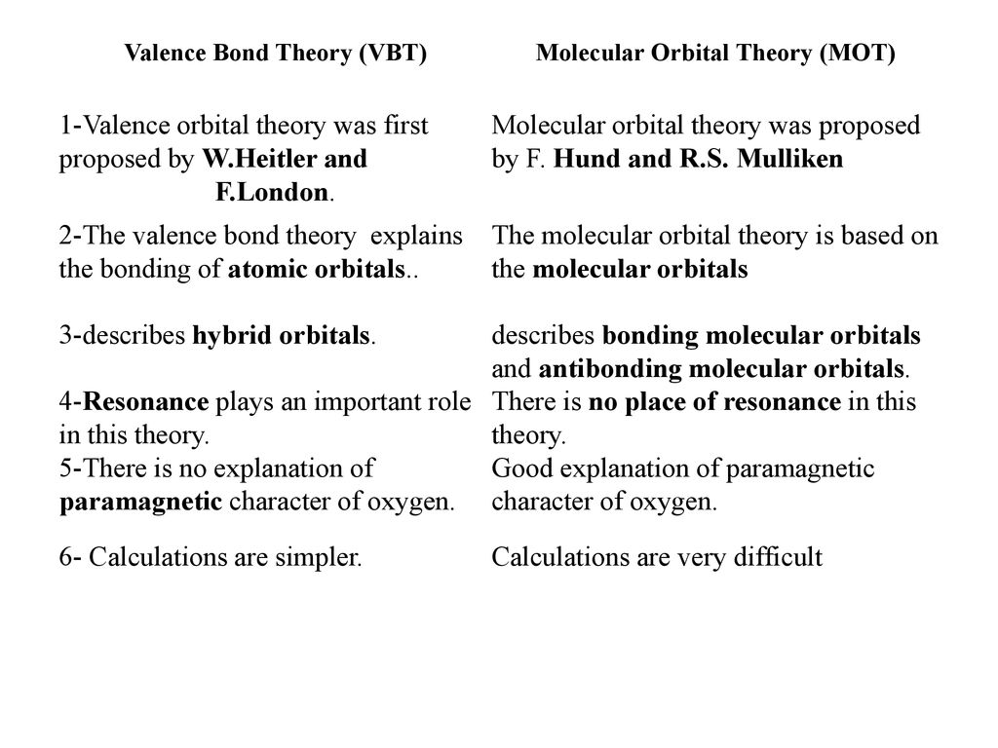
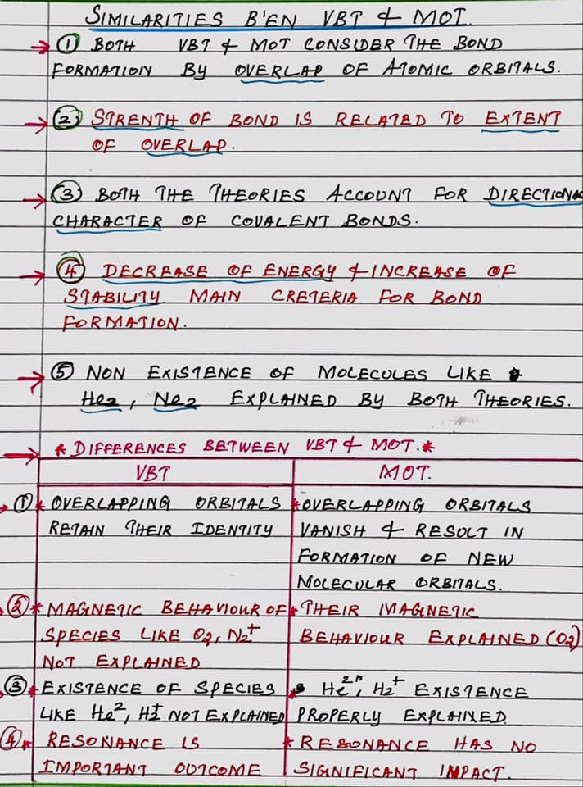

Q.7.b.
Ans.
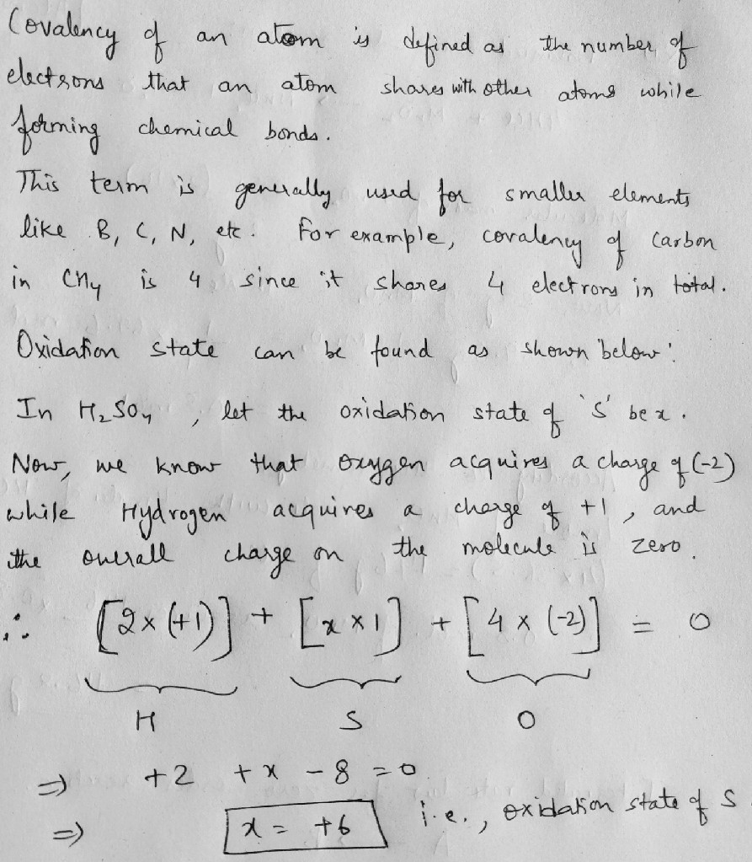

Q.7.c.
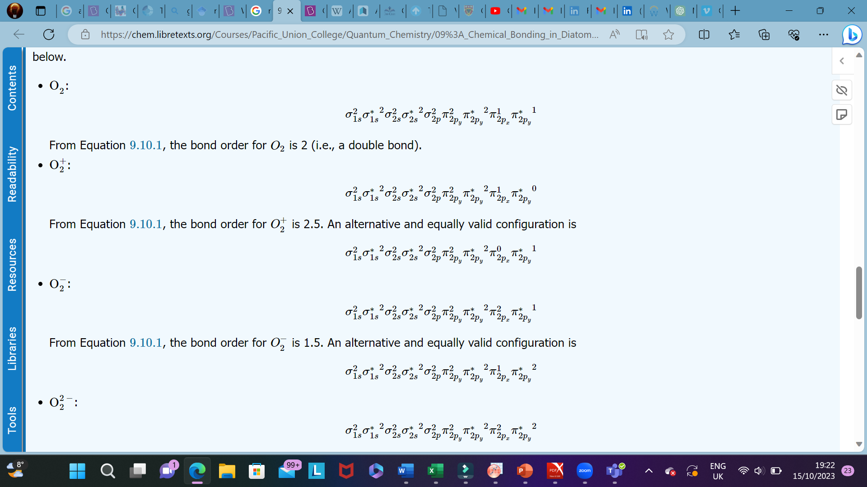
Q.8.a.
Ans. Crystal field theory (CFT) describes the breaking of orbital degeneracy in transition metal complexes due to the presence of ligands. CFT qualitatively describes the strength of the metal-ligand bonds. Based on the strength of the metal-ligand bonds, the energy of the system is altered. This may lead to a change in magnetic properties as well as color.
Basic Concept
In Crystal Field Theory, it is assumed that the ions are simple point charges (a simplification). When applied to alkali metal ions containing a symmetric sphere of charge, calculations of bond energies are generally quite successful. The approach taken uses classical potential energy equations that take into account the attractive and repulsive interactions between charged particles (that is, Coulomb's Law interactions).
$$E∝\frac{q_{1}q_{2}}{r}$$
with
- E the bond energy between the charges and
- q₁ and q₂ are the charges of the interacting ions and
- r is the distance separating them.
This approach leads to the correct prediction that large cations of low charge, such as K⁺ and Na⁺, should form few coordination compounds. For transition metal cations that contain varying numbers of d electrons in orbitals that are NOT spherically symmetric, however, the situation is quite different. The shapes and occupations of these d-orbitals then become important in building an accurate description of the bond energy and properties of the transition metal compound.
When examining a single transition metal ion, the five d-orbitals have the same energy (Figure). When ligands approach the metal ion, some experience more opposition from the d-orbital electrons than others based on the geometric structure of the molecule. Since ligands approach from different directions, not all d-orbitals interact directly. These interactions, however, create a splitting due to the electrostatic environment.
Figure: Distributing a charge of −6 uniformly over a spherical surface surrounding a metal ion causes the energy of all five d orbitals to increase due to electrostatic repulsions, but the five d orbitals remain degenerate. Placing a charge of −1 at each vertex of an octahedron causes the d orbitals to split into two groups with different energies: the d_{x}²_{−y}² and d_{z}² orbitals increase in energy, while the, d_{xy}, d_{xz}, and d_{yz} orbitals decrease in energy. The average energy of the five d orbitals is the same as for a spherical distribution of a −6 charge, however. Attractive electrostatic interactions between the negatively charged ligands and the positively charged metal ion (far right) cause all five d orbitals to decrease in energy but does not affect the splitting of the orbitals. The two e_{g} orbitals point directly at the six negatively charged ligands, which increases their energy compared with a spherical distribution of negative charge. In contrast, the three t_{2g} orbitals point between the negatively charged ligands, which decreases their energy compared with a spherical distribution of charge.
For example, consider a molecule with octahedral geometry. Ligands approach the metal ion along the x, y and z axes. Therefore, the electrons in the dz² and dx²−y² orbitals (which lie along these axes) experience greater repulsion. It requires more energy to have an electron in these orbitals than it would to put an electron in one of the other orbitals. This causes a splitting in the energy levels of the d-orbitals. This is known as crystal field splitting. For octahedral complexes, crystal field splitting is denoted by Δ_{o} (or Δ_{oct}). The energies of the dz² and dx²−y² orbitals increase due to greater interactions with the ligands. The dxy, dxz, and dyz orbitals decrease with respect to this normal energy level and become more stable.
Electrons in Orbitals
According to the Aufbau principle, electrons are filled from lower to higher energy orbitals (Figure). For the octahedral case above, this corresponds to the d_{xy}, d_{xz}, and d_{yz} orbitals. Following Hund's rule, electrons are filled in order to have the highest number of unpaired electrons. For example, if one had a d³ complex, there would be three unpaired electrons. If one were to add an electron, however, it has the ability to fill a higher energy orbital ( d_{z²} or d_{x²-y²}) or pair with an electron residing in the d_{xy}, d_{xz}, or d_{yz} orbitals. This pairing of the electrons requires energy (spin pairing energy). If the pairing energy is less than the crystal field splitting energy, ∆₀, then the next electron will go into the d_{xy}, d_{xz}, or d_{yz} orbitals due to stability. This situation allows for the least amount of unpaired electrons, and is known as low spin. If the pairing energy is greater than ∆₀, then the next electron will go into the d_{z}² or d_{x}²-_{y}² orbitals as an unpaired electron. This situation allows for the most number of unpaired electrons, and is known as high spin. Ligands that cause a transition metal to have a small crystal field splitting, which leads to high spin, are called weak-field ligands. Ligands that produce a large crystal field splitting, which leads to low spin, are called strong field ligands.
Figure: Low Spin, Strong Field (∆_{o}˃P) High Spin, Weak Field (∆_{o}˂P)Splitting for a d4 complex under a strong field (left) and a weak field (right). The strong field is a low spin complex, while the weak field is a high spin complex.
As mentioned above, CFT is based primarily on symmetry of ligands around a central metal/ion and how this anisotropic (properties depending on direction) ligand field affects the metal's atomic orbitals; the energies of which may increase, decrease or not be affected at all. Once the ligands' electrons interact with the electrons of the d-orbitals, the electrostatic interactions cause the energy levels of the d-orbital to fluctuate depending on the orientation and the nature of the ligands. For example, the oxidation state and the strength of the ligands determine splitting; the higher the oxidation state or the stronger the ligand, the larger the splitting. Ligands are classified as strong or weak based on the spectrochemical series:
I⁻ < Br⁻ < Cl⁻ < SCN⁻ < F⁻ < OH⁻ < ox²⁻< ONO⁻ < H₂O < SCN⁻ < EDTA⁴⁻ < NH₃ < en < NO₂⁻ < CN⁻
Note that SCN⁻ and NO₂- ligands are represented twice in the above spectrochemical series since there are two different Lewis base sites (e.g., free electron pairs to share) on each ligand (e.g., for the SCN⁻ ligand, the electron pair on the sulphur or the nitrogen can form the coordinate covalent bond to a metal). The specific atom that binds in such ligands is underlined.
In addition to octahedral complexes, two common geometries observed are that of tetrahedral and square planar. These complexes differ from the octahedral complexes in that the orbital levels are raised in energy due to the interference with electrons from ligands. For the tetrahedral complex, the d_{xy}, d_{xz}, and d_{yz} orbitals are raised in energy while the d_{z²}, d_{x²-y²} orbitals are lowered. For the square planar complexes, there is greatest interaction with the d_{x²-y²} orbital and therefore it has higher energy. The next orbital with the greatest interaction is d_{xy}, followed below by d_{z²}. The orbitals with the lowest energy are the d_{xz} and d_{yz} orbitals. There is a large energy separation between the d_{z²} orbital and the d_{xz} and d_{yz} orbitals, meaning that the crystal field splitting energy is large. We find that the square planar complexes have the greatest crystal field splitting energy compared to all the other complexes. This means that most square planar complexes are low spin, strong field ligands.
Description of d-Orbitals
To understand CFT, one must understand the description of the lobes:
- d_{xy}: lobes lie in-between the x and the y axes.
- d_{xz}: lobes lie in-between the x and the z axes.
- d_{yz}: lobes lie in-between the y and the z axes.
- d_{x}²-y²: lobes lie on the x and y axes.
- d_{z2}: there are two lobes on the z axes and there is a donut shape ring that lies on the xy plane around the other two lobes.
Figure: Spatial arrangement of ligands in the an octahedral ligand field with respect to the five d-orbitals.
Octahedral Complexes
In an octahedral complex, there are six ligands attached to the central transition metal. The d-orbital splits into two different levels (Figure ). The bottom three energy levels are named dxy, dxz, and dyz (collectively referred to as t_{2g}). The two upper energy levels are named dx²−y² , and dz² (collectively referred to as eg).
The reason they split is because of the electrostatic interactions between the electrons of the ligand and the lobes of the d-orbital. In an octahedral, the electrons are attracted to the axes. Any orbital that has a lobe on the axes moves to a higher energy level. This means that in an octahedral, the energy levels of e_{g} are higher (0.6∆_{o}) while t₂g is lower (0.4∆_{o}). The distance that the electrons have to move from t₂g from eg and it dictates the energy that the complex will absorb from white light, which will determine the colour. Whether the complex is paramagnetic or diamagnetic will be determined by the spin state. If there are unpaired electrons, the complex is paramagnetic; if all electrons are paired, the complex is diamagnetic.
Tetrahedral Complexes
In a tetrahedral complex, there are four ligands attached to the central metal. The d orbitals also split into two different energy levels. The top three consist of the dxy, dxz, and dyz orbitals. The bottom two consist of the dx²−y² and dz² orbitals. The reason for this is due to poor orbital overlap between the metal and the ligand orbitals. The orbitals are directed on the axes, while the ligands are not.
Figure: (a) Tetrahedral ligand field surrounding a central transition metal (blue sphere). (b) Splitting of the degenerate d-orbitals (without a ligand field) due to an octahedral ligand field (left diagram) and the tetrahedral field (right diagram).
Consequentially, Δt is typically smaller than the spin pairing energy, so tetrahedral complexes are usually high spin.
Square Planar Complexes
In a square planar, there are four ligands as well. However, the difference is that the electrons of the ligands are only attracted to the xy plane. Any orbital in the xy plane has a higher energy level (Figure). There are four different energy levels for the square planar (from the highest energy level to the lowest energy level): d_{x}²_{-y}², d_{xy}, d_{z}², and both d_{xz} and d_{yz}.
Figure: Splitting of the degenerate d-orbitals (without a ligand field) due to an square planar ligand field.
The splitting energy (from highest orbital to lowest orbital) is Δsp and tends to be larger than Δo. Moreover, Δsp is also larger than the pairing energy, so the square planar complexes are usually low spin complexes.
Q.8.b.
Ans. 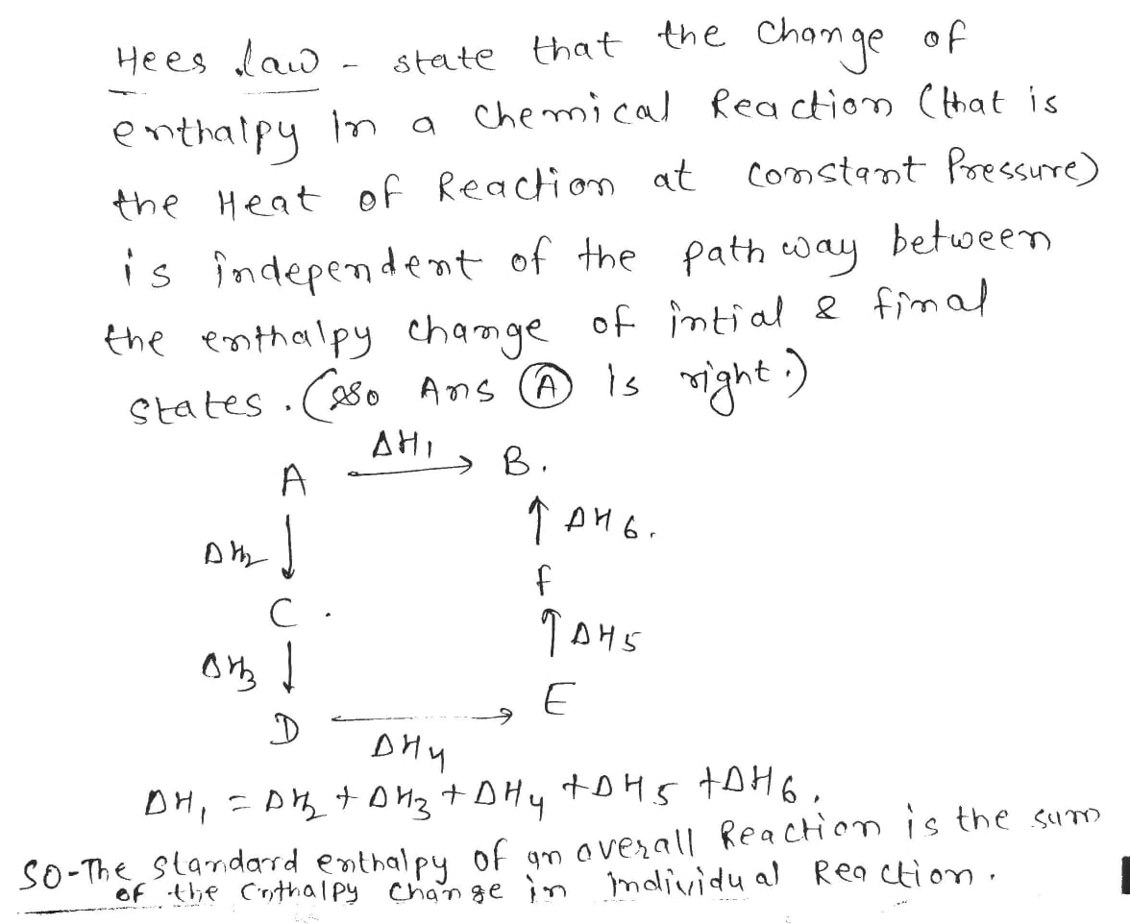
Electrophoresis
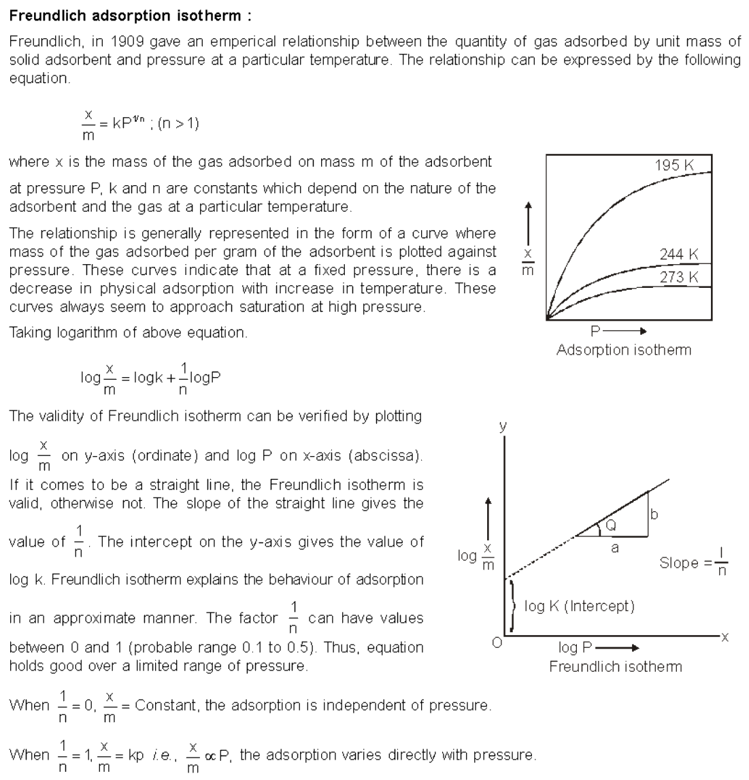

Topic | Chapter | Year repeated (marks)
Schrodinger wave equation | Quantum Chemistry | 2016 (14) , 2017 (16), 2020 (05), 2021 (15), 2022 (10), 2023 (10)
Wave function/Born interpretation of wave function | Quantum Chemistry | 2016 (06), 2020 (05), 2022 (06), 2023 (02)
Arrhenius equation | Chemical kinetics | 2017 (10), 2018 (08), 2019 (05), 2020 (10), 2022 (05), 2023 (08)
Gibbs free energy | Thermodynamics | 2017 (06), 2020 (05), 2021 (07),
3rd law of thermodynamics/spontaneity of reaction | Thermodynamics | 2016 (08) , 2017 (04), 2018 (10), 2019 (07), 2021 (05)
Adsorption isotherms | Surface Chemistry | 2016 (08) , 2017 (16), 2020 (10), 2021 (10), 2023 (05)
Transition state theory/ collision theory | Chemical Kinetics | 2016 (08) , 2017 (10), 2020 (10), 2021 (10),
Phase rule | Thermodynamics | 2016 (06) , 2019 (10), 2020 (05), 2021 (10), 2022 (10)
VBT/VSEPR, MOT | Chemical Bonding | 2016 (12) , 2018 (21), 2020 (06), 2023 (14)
Solubility/ common ion effect | Chemical Equilibrium | 2016 (08) , 2017 (04), 2020 (05), 2021 (08)
Crystal field theory | d-block Elements | 2016 (10) ,2020 (10), 2021 (10), 2022 (08), 2023 (05)
Jahn Teller theorem | d-block Elements | 2016 (06) , 2017 (10), 2021 (10), 2022 (06),
Acid-base theories | Acid-base theories | 2017 (16), 2019 (08), 2020 (10), 2021 (10), 2022 (06), 2023 (10)
Acid-base catalysis/ buffers | Acid-base theories | 2016 (06) , 2019 (06), 2021 (10)
Order of reaction | Chemical kinetics | 2017 (10), 2019 (10), 2021 (05), 2023 (12)
Kohlrauch law | Electrochemistry | 2017 (10), 2019 (07) 2020 (10), 2022 (07), 2023 (04)
Factors affecting rate of chemical reaction | Chemical kinetics | 2018 (05), 2021 (05),
Warner theory | d-block Elements | 2017 (06), 2020 (10), 2021 (10)
Photoelectric effect | Quantum Chemistry | 2021 (10), 2022 (08), 2023 (08)
Heisenberg uncertainty principle | Quantum Chemistry | 2020 (05), 2021 (10), 2022 (05)
Nernst equation | Electrochemistry | 2021 (07), 2020 (05), 2022 (08), 2022 (10), 2023 (10)
Electrophoresis | Electrochemistry | 2018 (07), 2020 (05), 2021 (10), 2023 (05)
Transport number | Electrochemistry | 2018 (10), 2019 (07), 2021 (10), 2022 (10),

Preparing for the Central Superior Services (CSS) chemistry paper can be a challenging task, but with the right approach, you can increase your chances of success. Here are some preparation tips for CSS chemistry:
- Understand the Syllabus: Start by thoroughly understanding the CSS chemistry syllabus. Knowing what topics are covered will help you focus your efforts on the most important areas.
- Get the Right Study Materials: Invest in quality textbooks, reference materials, and study guides that cover the CSS chemistry syllabus comprehensively. Make sure your materials are up-to-date.
- Time Management: Create a study schedule that allocates time for each topic based on its weightage in the exam. Stick to your schedule to ensure you cover all the necessary material.
- Conceptual Understanding: Instead of rote memorization, focus on understanding the core concepts. CSS chemistry questions often require you to apply your knowledge, not just recite facts.
- Solve Past Papers: Practice with previous CSS chemistry papers. This will help you get familiar with the exam pattern and the types of questions that are frequently asked.
- Take Mock Tests: Consider taking mock tests or practice quizzes to simulate exam conditions. This can help you manage your time effectively during the real exam.
- Stay Updated: Chemistry is a dynamic field. Stay up-to-date with the latest developments, especially in areas that are commonly tested.
- Use Visual Aids: Create visual aids like charts, diagrams, and concept maps to help you better understand and remember complex topics.
- Group Study: Collaborate with fellow CSS aspirants for group study sessions. Discussing and explaining concepts to others can reinforce your own understanding.
- Seek Guidance: If you encounter difficulties with specific topics, don't hesitate to seek help from teachers, mentors, or subject matter experts.
- Practice Numerical Problems: CSS chemistry often includes numerical problems. Regularly practice solving these to improve your problem-solving skills.
- Stay Healthy: A healthy body and mind are essential for effective study. Get enough sleep, eat well, and incorporate regular physical activity into your routine.
- Manage Stress: CSS preparation can be stressful. Employ stress management techniques such as meditation, deep breathing exercises, or pursuing a hobby to relax.
- Review and Revise: Regularly review and revise the material you've covered. This is crucial for long-term retention of knowledge.
- Stay Positive: Maintaining a positive attitude and self-belief can make a significant difference in your preparation and performance on exam day.
- Simulate Exam Conditions: Before the actual exam, practice under timed conditions to get a feel for the real test and build your confidence.
- Stay Informed: Keep track of any updates or changes in the CSS exam format, syllabus, or rules through official sources.
Remember that CSS chemistry is not just about memorizing facts but demonstrating a deep understanding of the subject. Effective preparation involves consistent effort, critical thinking, and problem-solving skills. Good luck with your CSS chemistry exam preparation!

