**ECO and History**

* In 1985, the [Economic Cooperation Organization (ECO)](http://www.eco.int/) was established by **Iran, Pakistan, and Turkey** to promote economic, technical, and cultural cooperation.
* ECO is the successor organization of Regional Cooperation for Development (RCD) which remained in existence since 1964 up to 1979

|  |
| --- |
| * The Regional Cooperation for Development (RCD) was established as a tripartite arrangement between Pakistan, Turkey and Iran in 1964 * The aim of RCD was to strengthen their cooperation in the fields of socio-economic development, trade, transportation, communications, railway, industry, and banking among member states * However, a number of financial, political and administrative difficulties made progress slow  1. This development was disturbed due to the Iranian Islamic revolution in the late 70s and the reservation of the new government in Iran, the organization was dissolved in 1979 |

**Member Structure**

* In 1992, the Organization was expanded to include seven new members, namely: [Afghanistan](https://aric.adb.org/afghanistan), [Azerbaijan](https://aric.adb.org/azerbaijan), [Kazakhstan](https://aric.adb.org/kazakhstan), [Kyrgyz Republic](https://aric.adb.org/kyrgyz-republic), [Tajikistan](https://aric.adb.org/tajikistan), [Turkmenistan](https://aric.adb.org/turkmenistan), and [Uzbekistan](https://aric.adb.org/uzbekistan)

|  |
| --- |
| * Due to their historical cultural and religious similarities with the people of Turkey, Pakistan and Iran, six newly independence nations of central Asian - Azerbaijan, Kazakhstan, Kyrgyzstan Tajikistan, Turkmenistan and Uzbekistan, applied for the membership of ECO along with Afghanistan |

* **objectives of ECO include;**

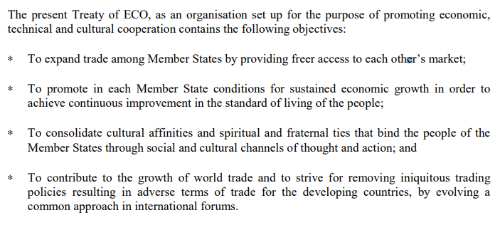

**Structure of ECO:**

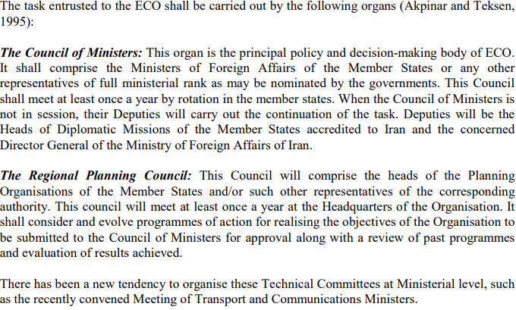

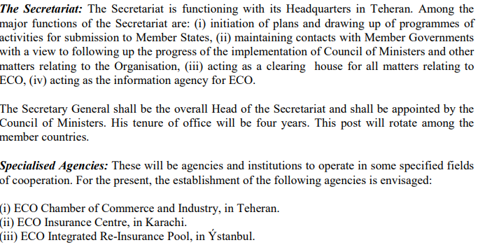

|  |
| --- |
| Fields of Focus  Transport and telecommunication. • Trade and investment. • Energy, minerals and environment. • Agriculture industry and tourism. • Human resources and sustainable development. • Project and economic research and statistics |

**Achievements of ECO:**

1. In 1991, member states of organization have lunched **ECO preferential trade arrangement**. The main objective of the agreement was to enlarge trade cooperation among member states through mutual exchange of concessions. The arrangement provide for a 10 percent import tariff reduction on listed goods.
2. Framework Agreement on **ECO Cooperation (ECOFAT**), which established a basis for the expansion of intra-regional trade. The Framework Agreement envisaged the eventual adoption of an accord providing for the gradual removal of regional trade obstacles like customs duties, and tariff among the member states.
3. Another trade agreement **ECO Trade Agreement (ECOTA**) was signed in the 2nd Ministerial meeting on Commerce / Foreign Trade at Islamabad in July 2003. The basic principle of ECOTA is to gradually elimination of non-tariff barriers as well as progressive removal of tariffs in the region.
4. **Transit Transport Framework Agreement (TTFA) and a Memorandum of Understanding (MOU)** help combat the cross-border trafficking of illegal goods

**Pakistan and ECO**

(Reference to 13th Summit held in Islamabad in 2017)

1. **“Islamabad Declaration**”

* which was adopted unanimously during the Summit focused on the Summit theme of Connectivity as a dynamic concept that encompasses multiple dimensions including transit transport such as **rail, road, ports and shipping and cyber linkages**
* The Declaration acknowledged and welcomed, China Pakistan Economic Corridor (CPEC) as a far-reaching initiative that would act as catalyst for the development of the entire region.
* The Declaration reiterated commitment to promote Intra-ECO trade as an instrument of enhanced economic cooperation and revitalization in the region.

(Reference to 14th Summit held in virtually in 2021)

* Points of focus:

1. COVID-19 and its regional implications and ways to tackle it + robust and resilient Health Care to cater the pandemic
2. need to build an integrated network and transport system between the major economies
3. implement all cross-border projects, especially the [*TAPI*](https://tribune.com.pk/story/2264618/turkmenistan-to-begin-tapi-gas-pipeline-construction) and other gas pipeline projects
4. Simplifying border procedures and making ECO trade agreements operational.